MHL.JGW.LCA0788

3 December 2002

Dr Kathleen Dermody
Secretary
Senate Economics Legislation Committee
The Senate
Parliament House
Canberra ACT 2600

By Email: kathleen.dermody@aph.gov.au
bronwyn.meredith@aph.gov.au

Dear Dr Dermody

Inquiry into the Trade Practices Amendment (Liability for Recreational Services) Bill 2002

Thank you for the opportunity to appear before the Senate Economics Legislation Committee on 27 November 2002. Please find attached additional comments from
Mr Charles Vandervord, Member, Law Council Accident Compensation Committee.

Mr Vandervord’s additional comments are to be read with the Law Council’s original submission of 20 November 2002, but have not been considered by the Council of the Law Council.

Please advise when the Law Council has permission from the Committee to publish the attached additional comments. The contact officer in the Law Council Secretariat is
Mr James Greentree-White.

Yours sincerely
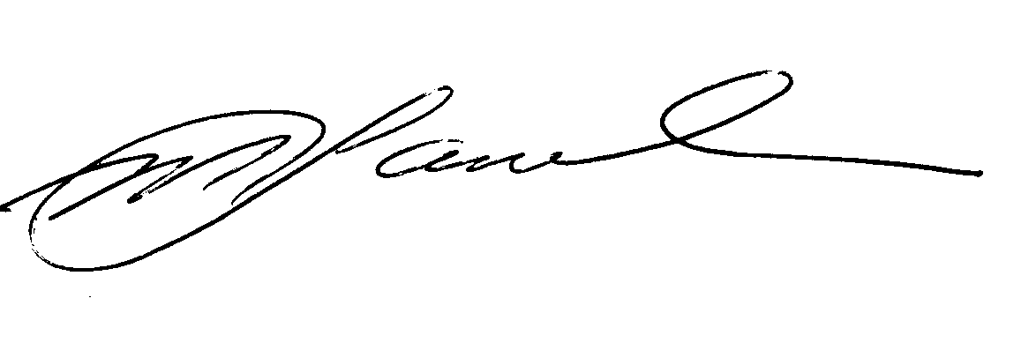
Michael Lavarch
Secretary-General

