LCA0788

20 November 2002

Dr Kathleen Dermody
Secretary
Senate Economics Legislation Committee
Parliament House
Canberra ACT 2600

By Email: kathleen.dermody@aph.gov.au
geoffrey.dawson@aph.gov.au

Dear Dr Dermody

Inquiry into the Trade Practices Amendment (Liability for Recreational Services) Bill 2002

Thank you for your letter of 25 October 2002 inviting the Law Council to make a submission to the above inquiry. As discussed with our Mr James Greentree-White on 6 November 2002, this submission has been delayed to allow the Law Council to take into account decisions made at the Ministerial Meeting on Public Liability Insurance on 15 November 2002.

Please find the Law Council’s submission attached. The Law Council is circulating this submission within its committees and member organisations. However, no public disclosure will be made until advice is received that the Senate Economics Legislation Committee has provided approval for this.

The Law Council wishes to assist the Senate Economics Legislation Committee in its deliberations, and would appreciate the opportunity to appear at a hearing. The contact officer in the Law Council Secretariat is Mr James Greentree-White.

Yours sincerely
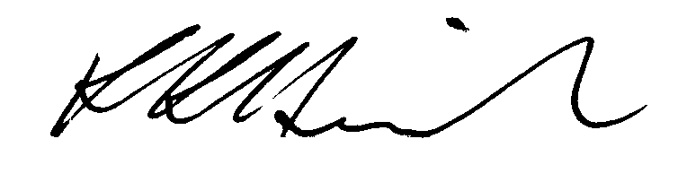
Ron Heinrich

