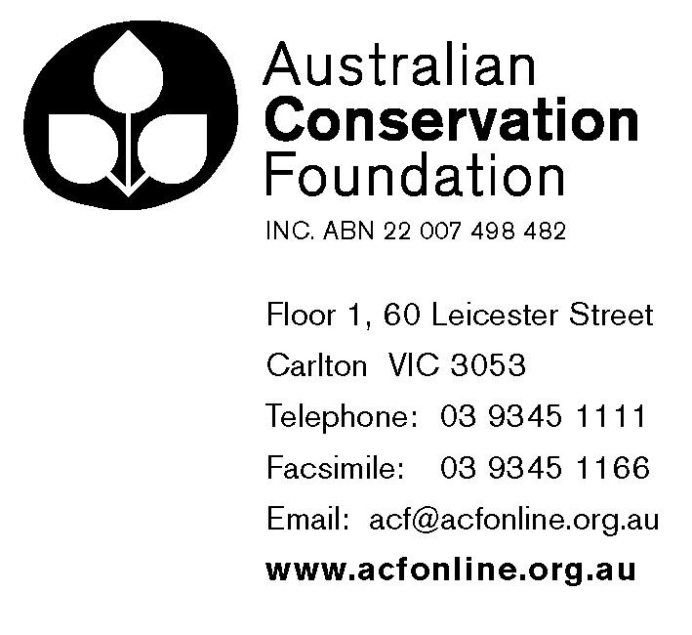
26 March 2004

The Secretary
Senate Economics Legislation Committee
Room SG.64
Parliament House
Canberra ACT 2600

Submission to the Senate Economics Legislation Committee
Tax Laws Amendment (2004 Measures No.1) Bill 2004

Dear Secretary,

The Australian Conservation Foundation (ACF) welcomes the opportunity to comment on the Tax Laws Amendment (2004 Measures No.1) Bill 2004.

ACF’s comments concern (1) the proposed deductibility of certain contributions relating to fundraising events (Schedule 7 of the Bill); (2) the proposed endorsement requirements for charities (Schedule 10 of the Bill); and (3) the proposed disclosure of the tax endorsement status of charities (Schedule 10 of the Bill).

1. Deductibility of contributions relating to fundraising

ACF congratulates the Government for proposing to allow deductions for the charitable portion of a contribution, where the donor receives a relatively minor benefit in return. This is a much-needed reform that would improve the flexibility and effectiveness of charitable fundraising.

However, there are certain provisions in the Bill that will severely limit the ability of charitable donors, as a practical matter, to take advantage of the proposed deduction. The submission of ACROD in this Inquiry sets out some of the major concerns with the thresholds specified in the Bill. ACF supports the viewpoints expressed by ACROD on those matters.

In addition, there is no principled reason to limit the (partial) deductibility of contributions to discrete, one-off fundraising “events”. A taxpayer who chooses to donate $200 annually to a charity, receiving a $20 magazine subscription in return, is in the exact same position as a taxpayer who contributes $200 to attend an annual fundraising dinner worth $20 at market value. There is no reason to prefer one method of fundraising over another, or to discriminate between these two taxpayers.

2. Proposed endorsement requirements for charities

ACF is not opposed in principle to endorsement of eligibility for charitable tax benefits. However, any such legislation should take into account the administrative burden on charities and on the ATO. In addition, endorsement requirements should be applied evenly to for-profit as well as non-profit organisations.

With the proposed new categories of endorsements, many charities will have to seek no fewer than four tax benefit endorsements at the Commonwealth level alone. With two or three additional endorsements (for payroll tax and stamp duty exemptions, among others) in each state in which a charity operates, it is easily possible that a national charity will have to seek and maintain 10 to 20 tax endorsements of various sorts. The proliferation of endorsements highlights the need for rationalisation and simplification of charitable tax exemption laws.

The imposition of this administrative burden on the ATO and on charities, which will have to divert resources that otherwise could be used to further their charitable purposes, should not be undertaken lightly. The wisdom of the new endorsement requirements is questionable in the absence of any evidence that the current self-assessment regime for those benefits is not working.

Finally, the proposed endorsement requirements should be seen in the context of a tax system that is, on the whole, based on self-assessment. If endorsement is required for charitable exemptions from GST, for example, it can legitimately be asked why endorsements should not also be required to access other GST exemptions (such as for the supply of transport, or precious metals, or things for consumption outside of Australia, and so forth).

3. Proposed disclosure of charitable tax endorsement status

ACF fully supports disclosure of tax benefits throughout the private and non-profit sectors. Disclosure of charitable tax endorsements should be accompanied by provisions for the disclosure of tax benefits accessed by private companies as well.

4. About ACF

The Australian Conservation Foundation, one of Australia’s leading non-government environmental organisations, is a member-based group that campaigns to protect, restore and sustain the environment. For nearly forty years, we have voiced the desire of Australians to conserve the natural environment, uniting progress and environmental protection. ACF takes a solution-oriented approach to environmental issues, and seeks to form partnerships with community groups, governments and business to achieve ecologically sustainable outcomes. ACF’s work includes natural heritage protection, water resource management and global warming, endangered species, uranium mining, sustainable cities and corporate environmental responsibility.
Many thanks for your time and consideration of this submission. Should you require any further information or if we can be of any assistance in the Inquiry, please feel free to contact me, on (03) 9345 1173 or c.berger@acfonline.org.au.

Yours Sincerely,

Charles Berger
Law & Corporate Responsibility Coordinator

Australian Conservation Foundation Inc.
Floor 1, 60 Leicester Street
Carlton VIC 3053

Tel: (03) 9345 1111
Fax: (03) 9345 1166
Web: www.acfonline.org.au

