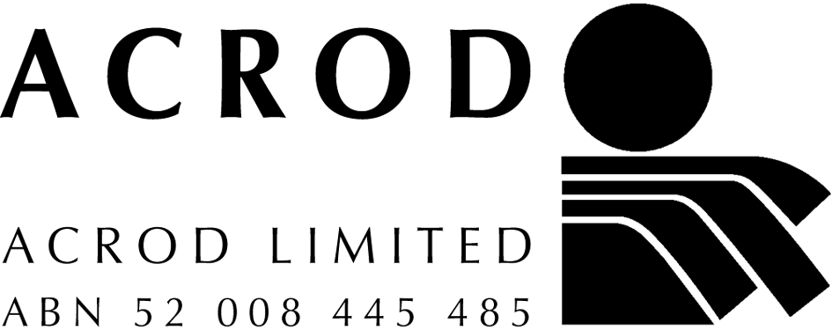
Tel: (02) 6282 4333
TTY: (02) 6282 4333
Fax: (02) 6281 3488
Email:
acrodnat@acrod.org.au

Postal:
PO Box 60
CURTIN ACT 2605

Location:
ACROD House
33 Thesiger Court
DEAKIN ACT 2600

National Industry Association for Disability Services

Submission to the SENATE ECONOMICS LEGISLATION COMMITTEE

TAX LAWS AMENDMENT (2004 MEASURES No.1) BILL 2004

25 March 2004

INTRODUCTION

ACROD welcomes the opportunity to comment on the text of the Tax Laws Amendment (2004 Measures No.1) Bill 2004.

The following points in relation to Chapter 7, Deductions for contributions relating to fundraising events are offered to the Government as practical suggestions for improved application and community benefit from this important initiative.

COMMENTS

It is common in fundraising events and charity auctions in Australia for individuals and businesses to contribute amounts that significantly exceed the values of the benefits that they receive in return. Such philanthropic actions are extremely important for a great number of charities of varying sizes. The Government is, therefore, to be commended for its initiative in proposing to provide tax concessions for such philanthropy.

However, it is of concern that the practical application of the proposed legislation will be severely limited. This would be an unfortunate outcome for the Government and a lost opportunity to enhance the community benefits that would otherwise flow from the initiative. The following points are offered to demonstrate the expected limitations of the proposed legislation.

- Minimum level of contributions

While the Bill proposes that only contributions exceeding $250 would qualify as deductible contributions, and this amount seems reasonable, it is unlikely that the value of a benefit costing $300, for example, would be less than 10% of this amount, or $30. It is typical for fundraising events to include a meal and some form of entertainment and, in most cases, the value of the benefit would be greater than this. A three-course meal and entertainment to a reasonable standard might be valued at between $50 and $100, and this would require a minimum contribution of between $500 and $1000 for tax concessions to apply.

- Benefit not exceeding 10%

Any amounts that are provided through philanthropy are to be encouraged, and the requirement that the benefit not exceed 10% of the contribution is severely limiting, particularly having regard to point 1. While we understand that some limits need to apply for reasons of practicality, we suggest that a maximum benefit of 50% would be reasonable and practical.

- Benefits not exceeding $100

The application of a maximum benefit value of $100, in addition to the 10% maximum, would seem to eliminate the opportunity for tax concessions to apply to most charity auctions. For philanthropic reasons, attendees often bid and pay amounts far exceeding the value of an auction item. The $100 value limit would mean that a travel prize donated to the charity with a value of $200 and sold at auction for $3000, would not qualify.

- GST on the excess over value

We understand that GST would continue to apply to the full contribution, despite at least 90% of this amount qualifying as a deductible amount. In effect this applies a tax to a payment that is predominately in the nature of a gift. We suggest that qualifying payments should be GST-free.
- Deduction limited to individuals

In light of the limitations on minimum deductible contributions, and the likely further restrictions outlined in point 1, few individuals could afford to make such contributions. By limiting the deduction to individuals, an opportunity to encourage corporate philanthropy is lost. It should be noted that should this initiative be extended to corporations, to the extent of the value of the benefits provided, no tax deductions would apply for entertainment (or fringe benefits tax would apply, if provided to an employee or associate). Only the amounts paid in excess of the value of the benefits provided would be deductible.

It would seem that, where individuals (or corporations) are able and prepared to pay the cost of more than two benefits, the opportunity for philanthropy would be reduced by limiting the deduction available.

Contact:
Greg Smith, Chair, ACROD Tax Group
Phone: 02 9680 2164, 0405 191 905
Email: greg.smith@charitax.com.au
ABOUT ACROD

ACROD is the national peak body for disability services. Its purpose is to equip and enable its members to develop quality services and life opportunities for Australians with disabilities.

ACROD’s membership includes over 550 non-government, non-profit organisations, which collectively operate several thousand services for Australians with all types of disabilities, including intellectual, physical, psychiatric and sensory. ACROD's members are located in every State and Territory in Australia and range in size from very small to very large.

In seeking to achieve its purpose, ACROD provides a wide range of advice and information to the disability services sector through a monthly newsletter, newsfaxes, e-mail networks, conferences and seminars. Its consultative structures include a system of issues-based National Committees and State Sub-Committees, forums and interest groups that operate by correspondence/email, teleconferences and face-to-face meetings. ACROD's submissions to Government are developed in consultation with members.

ACROD provides advice to governments and works with governments on all significant disability matters. It is currently represented on more than 20 Commonwealth Government (or quasi-Government) reference groups, working parties and advisory groups, and on numerous State and Territory committees.

ACROD has a National Secretariat in Canberra and offices in every State and Territory that focus on State issues in disability. The organisation as a whole is governed by a national Board that includes the elected Chair from each State/Territory Division as well as representatives elected directly by members.

ACROD
National Industry Association for Disability Services
PO Box 60 CURTIN ACT 2605
Phone: 02 6282 4333

Fax: 02 6281 3488
Email: acrodnat@acrod.org.au

