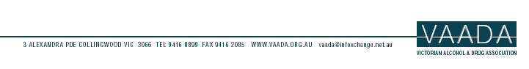

The Secretary
Economics Legislation Committee
Department of the Senate
Parliament House
Canberra ACT 2600

10th October, 2002

Dear Sir/Madam,

Thank you for the opportunity to make a submission to the Senate Economics Legislation Committee on the provisions of the Excise Tariff Amendment Bill (No. 1) 2002 and the Customs Tariff Amendment Bill (No. 2) 2002.
In summary, VAADA believes that given the high economic and social costs of alcohol consumption in Australia there is strong evidence that a percentage of excise and taxation collected on alcohol products should be redirected into public health initiatives to address alcohol related harm.
VAADA supports the proposed Excise Amendment Bill (No. 1) 2002 and the Customs Tariff Amendment Bill (No. 2) 2002.

Please find our submission attached. If you require any further information please do not hesitate to contact me.

Yours Sincerely

Carol Bennett
Executive Officer
VAADA

