

Submission to the Senate Economics Committee Inquiry into

Superannuation Contributions Splitting

16 Oct 03

Introduction.
As an organisation that has previously represented the surcharge concerns of flight crew, doctors, maritime officers and engineers, SOS supports in principle the Government proposal to allow Superannuants to split their superannuation contributions with their spouse. In our view, this proposal will improve retirement incomes, especially for those families where the spouse works part time either by choice or by necessity.

For younger couples, SOS expects that contributions splitting will have significant tax advantages that will further encourage discretionary investment in superannuation. However, for mid life and older couples, the taxation advantages will not be as great and this requires further deliberation. Amendments to proposed legislation that would allow the splitting of already existing member benefits is, in our opinion, worthy of this committee’s consideration.

The explanatory memorandum for the 2003 Taxation Laws Amendment Bill outlines four implementation options, three of which facilitate improved access to death and disability insurance, albeit with a reduction in proposed taxation benefits. Whilst access to insurance may be desirable, this SOS submission questions the benefits of this assertion. Whether or not, non public-offer funds will ever be persuaded to provide cover for other than their employees is a matter of serious conjecture.

SOS understands that Government is aware that current taxation of superannuation does produce some inequities. In our view income splitting provides an opportunity to help ameliorated some of these inequities. Potential benefits become clearer when superannuation is considered in context with existing social security entitlements and this submission contends that these issues need to be taken into account when determining “exactly what” should be split.

Continual changes to the superannuation regulatory environment have reduced the consumers’ faith in superannuation. In the view of this Society, the introduction of splitting will require further financial education at the community level if the already entrenched perception, “it’s all to hard”, is not to be exacerbated.

Retirement Savings Requirements.
A recent ISFA report (Retirement Incomes & Long Term Savings) estimated that the difference in income between what Australians expect to have in retirement, and what current compulsory and/or voluntary superannuation contributions and the age pension will produce to be $600 billion.

Although this finding undoubtedly concerns Government, does Government have the will to give effect to the OECD accepted view that desirable income in retirement is at least 60 to 65% of pre-retirement earnings?

Whilst access to two ETP low-rate thresholds and two reasonable benefit limits will clearly provide taxation advantages for many, will splitting only future contributions enable many couples already in their late forties or early fifties to attain even 60% of their pre-retirement earnings? As the Government’s own Intergenerational Report of 2002-03 found, desired changes in national retirement policy need to be made now.

Should, as SOS believes ASFA’s research indicates, a typical Australian expect post retirement income of around $30,000 per annum indexed; Calculations by SOS’s actuary indicate that superannuation savings in excess of $500,000 will be required by such individuals/families.

Splitting the Surcharge.
Prior to the advent of Surcharge Tax, typical public-sector and corporate superannuation schemes enabled numerous long-term superannuants to achieve post retirement income of the 60 to 65% of pre-retirement income. Projections carried out for the AIPA (Australian and International Pilots Association) found that new hire pilots will only have sufficient retirement savings to generate approximately 35% of their pre-retirement income whilst their presently retiring colleagues can expect to achieve approximately 50% of their pre-retirement income. The difference being largely attributable to surcharge tax.

Many salaried and Surchargeable Australians, who have fully contributed throughout their working life to the PAYE tax system, need to “effectively split” their surcharge levy if they are to have any chance of attaining the desired 60% benchmark in retirement.

The current proposal states that any surcharge liability will remain with the splitting spouse. In our view, the intention to in effect, significantly reduce the taxation treatment of both the superannuation tax-free threshold and the RBL’s is inconsistent with the intention not to ameliorate the surcharge liability.

SOS is aware that considerable pressure has be put on all political parties to rescind what is seen by some, as already excessive concessional superannuation taxation for supposed high-income earners. However, the super surcharge affects many who are only earning around two times the average weekly wage.

In our view these surcharge arguments do not adequately account for the fact that Surchargeable Australians are expected in general, to be independent of the government pension and will probably not receive much, if anything, in the way of government support.

In our opinion, developing national superannuation policy that results in consistent policy outcomes that enables all Australians to save sufficient for a post retirement income of at least 60%, of one’s pre-retirement income requires that the superannuation contributions splitting be effectively extended to the superannuant’s surcharge liability.

Splitting all Benefits.
Given that current long-term superannuants have had the benefit of lower superannuation taxes and transitional RBL’s; SOS accepts the antidotal evidence that those over 55 have received comparatively generous grandfathered benefits.

SOS further accepts that the proposal to split future superannuation contributions will significantly improve the potential for younger couples to generate a retirement income around the 65% benchmark, especially those who have thirty plus years until retirement.

An industry report by ISFA indicates that mid life couples often have insufficient retirement savings to generate an adequate retirement income and will have to rely upon social security. It is our view that this cohort have had little, if any, benefit from past lower superannuation taxation and will not receive the long term compounding benefits of thirty plus years of contributions splitting. SOS suggests that, notwithstanding some increase in cost to Government, that splitting existing benefits will enable this group of people to receive equitable consideration. Without this concession, this group of people may be precluded from financial independence in retirement simply because they are neither old enough nor young enough to benefit from changes in superannuation legislation – a discriminatory outcome.

SOS is aware that, prima facie, this option could unduly burden government revenue. If however the future costs of providing a government pension are concurrently considered, we believe that the long-term cost will be significantly less than expected.

Already proposed options.
The Government’s Explanatory Memorandum states that option 4 will maximise tax benefits for couples, but also states that options 1 and 2 best met Government’s objectives.

The author concludes that the Government’s considered position is based upon improved access to cost- effective insurance and better access for the receiving spouse during the accumulation phase that options 1 and 2 provide.

Given the recent introduction of superannuation family law, SOS questions the need to offset potential retirement income for potential access to superannuation. This is especially true we believe, as cohabiting families don’t require it, and divorced families already have appropriate access to superannuation savings under the new family law provisions.

SOS questions the assertion that options 1 and 2 will necessarily provide the receiving spouse with improved access to cost-effective insurance. The author is aware that although group insurance can provide economy of scale discounts, potential for adverse selection will probably require insurance underwriting, thereby negating potential economies of scale.

The insurance market is a competitive market, and SOS is aware that some of its affiliated associations have found that individual member policies can be at least as cost effective as some group policies. In our view, market experience does not support the recommendation of splitting options based upon perceived improvements in access to cost-effective insurance.

Based upon the above reasoning, this Society believes that the most appropriate choice is the one that has maximum potential to raise retirement incomes. In the Government’s own words this is option 4.

Education.
Whilst contributions splitting doesn’t appear to raise significantly existing superannuation complexities, it is an opportunity to rectify what ISFA has identified as ‘very low levels of planning for retirement’

SOS agrees with the view that the introduction of spouse splitting also provides significant potential to raise retirement incomes by focusing attention of the benefits of timely education and advice. SOS reaffirms its earlier requests to the Senate Superannuation Committee and requests that the Senate Economics Committee confirms its support for Government funding necessary to assist all superannuation funds in the provisioning of what is essentially fundamental community education and information.

SOS recommendations:
- Amend proposed legislation to ameliorate the impact of surcharge tax on superannuation contributions by reducing the splitting spouse’s adjusted taxable income by the amount of receiving spouse’s contributions.
- Amend proposed legislation to permit the split all ETP’s at the end. This Society notes that ASFA’s 2002 paper on splitting included an alternative proposal to split at the end and supports the principles of the ASFA concept other than the July 2003 starting date.

Conclusion.
Whilst the proposal to split superannuation contributions can be expected to effectively raise retirement incomes for many, these improvements are expected to be slow in coming. SOS supports the above enhanced splitting initiatives primarily because they can help remedy the retirement savings gap for a significant number of Australians in a more timely manner.

This Society would like to thank all Senators for the opportunity to make know its views.

Prepared by

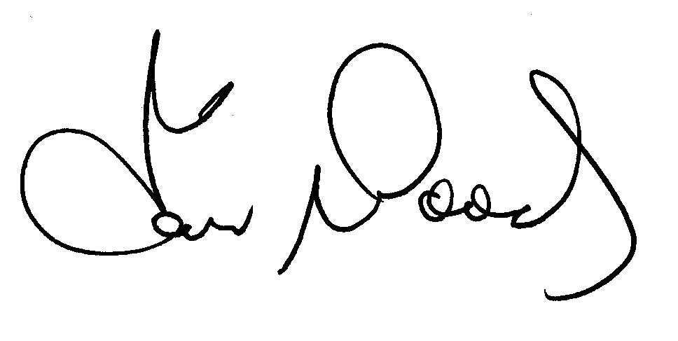Captain Ian Woods, BEc
SOS President

