Inquiry into the impact of public liability and professional indemnity insurance cost increases

1-18 Gillard St.,
East Brighton 3187

October 3rd 2002.

The Committee,

Ladies and Gentleman.

Thank you for this opportunity to make this submission.

I write to you after having to retire from work and career to assist my partner, who tragically, whilst we were living in Canberra, caught a floating virus during March 1999. In spite of being a fully active and very fit Ballet Dancer and Teacher, succumbed to the dreadful effect of the virus, that put her into a coma for 12 weeks, and left its residue in the form of totally debilitating Myoclonic spasms, which causes her to still, to be in Hospital, only able to come home on Saturday nights.

It has been very draining, physically, emotionally, financially and totally dream shattering experience for us both.

I have not cared to hear about compensation as I want to focus on our future, it remains for me to look after her as best I can with the assistance of the State and Federal Health Systems.

We experienced support from the Canberra Hospital, but just when she may have been showing signs of some improvement, her Rehabilitation time expires, and as she is a “Slow to Recover” patient, and as we were Melbourne people on loan to Canberra, we elected to return and as there is no other suitable facility available for her in the Health System, placed in a Aged Nursing Home.

Having to place my partner, in her youthful condition, in an aged Care facility is the closest thing I have experienced to inhumanity by one Australian to another. It is terrible and I do not believe any Member of Parliament who has had personal experience of this dreadful system, could tolerate it remaining in a Country where we pride ourselves on our humanity and compassion.

My suggestion:

Is based on this experience which co-in sided with, what I considered to be, some terrible legal liability judgments made to litigants, who were able to extract some incredible payments from the courts when on the publicised information, their actions would have contributed to their situation. The smoking case and a surfer diving into the shallows whilst on drugs come to mind.

It is our Communities through our Governments responsibility to look after all our disabled, weather they are from the rich or poor, inflicted or accidental, an act of fate or a criminal event.

The Community as a whole are best equipped to look after these people, facilities can be built and supplied and people can be trained to tend to their requirements. Those that may be able to have some quality of life at home can have their carer supported structurally, physically and mentally. Families can be sustained to ensure people are adequately fed, clothed and schooled, easing the concerns of the patient who may have been the breadwinner.

I want consideration be given to extra funds be given into a Health Disability System,

Firstly, from the Insurance Companies, in the way of a levy on all policies underwritten.

Secondly, from the policyholders or facilities that is as fault by way of litigation and instead of the money going to an individual, the money goes to the Health Disability System.

The second part of this will be initiated by a body, that will review all patients circumstance as they arise, and if there is negligence to be proven, they take action and the punitive damages are recovered for the Fund, ensuring that the policy holders have an incentitive to maintain proper care to ensure their premium cost do not increase.

The benefits of this would be,

- A structural advance in facilities for the disabled.
- Insurance revenue will be directed towards financing this project.
- There is no capping on payouts and the whole disabled community receives the benefit.
- Equality in treatment for all.
- Centralisation of facilities and research structures to enable advancements in rehabilitation and treatment.
- Little or no incentive to legal bodies to Ambulance Chase.
- Enough business for legal firms to be employed by the Fund to instigate responsible claims.

I can visualise the situation as I have tried to explain, I hope it is of sufficient interest to your committee.

There is no amount of money that can replace my partner. I make her payments from her very much-appreciated pension and I live on a small earning and credit card currently and I get by. No amount of money can replace anybody. Millions paid to one individual isn’t necessarily the best result for them, it may be that this is just a measure of sympathy to them or punishment for the circumstance.

Thank you for your efforts and my best wishes for your valued decisions,

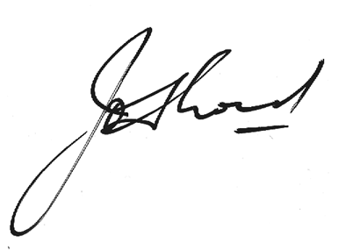

John Lord
Phone 03 95921418
0407727127

