Australian Ultralight Federation Inc
ABN 40 070 931 645
U35/59 Wollongong St
PO Box 1265, Fyshwick ACT 2609
Ph: 02 6280 4700 Fax: 02 6280 4775
Email: admin@auf.asn.au

27 August 2002

Secretary
Senate Economics References Committee
Room SG.64
Parliament House
CANBERRA ACT 2600

Re: Inquiry into the impact of Public Liability and Professional Indemnity insurance cost increases.

BACKGROUND

The Australian Ultralight Federation (AUF) is a non-profit making association that promotes, regulates and administers over 4700 recreational ultralight pilots and some 1700 aircraft. It is currently under responsibilities that were devolved to the AUF by the Civil Aviation Safety Authority (CASA) in 1988.

During the 18 years the AUF has been in existence it has experienced a good growth rate in members, aircraft and the number of training facilities and clubs. However the current climate of high costs and limited availability in the areas of liability and indemnity insurance is a cause of great concern to the AUF for its continuing future and the future of recreational and sport aviation as a whole.

The AUF has always closely administered all accident and incident reports, thus allowing it to make changes to training, operating and technical requirements and to ensure that relevant information is promulgated to its members to prevent further injury or damage. This attitude has meant that recreational ultralight flying is creating and living up to an image of safe affordable flying that needs to be recognised by the insurance industry.

IMPACT ON RECREATIONAL ULTRALIGHT FLYING

As part of the National problem of sporting organisation liability, AUF Members and AUF Flight Schools are no longer able to obtain passenger and/or student indemnity cover.
This is having a severe effect on the flight schools with a number already closing as their present policies expire and all are considering their ongoing viability. The result is a dramatic reduction in the number of new student pilots and therefore members.
In addition, due to the increasing costs and difficulty in obtaining any related insurance, many existing pilot members are either unable to hire aircraft for recreational use or are being priced out of recreational flying altogether.
Also Australian industry manufacturers are having orders cancelled and many potential sales are not proceeding, as customers become aware of the difficulties that are arising from the cost or lack of insurance available.

PROPOSED SOLUTIONS

The Government has proposed an amendment to the Trade Practices Act, which would give legal effect to waivers of liability enabling voluntary assumption of risk by venture sports participants. Due to their nature, flying activities can be dangerous and participants can be injured. It is our belief that provided this is unambiguously explained to participants and they have signed a waiver of liability, that individuals should be able to voluntarily assume risk and that the courts should accept this.
Another option would be a cap on damage awards and removal of lump sum awards, replacing these by reasonable periodic payments would greatly assist in encouraging insurance underwriters to re-enter this field and offer policies at reasonable prices.

PROOF OF NEGLIGENCE

The AUF has professional training and operating standards in place to maximise the safety of pilot trainees, qualified pilots, passengers and the general public. Despite this in today's climate, courts are most likely to find negligence and make awards in circumstances where the school or operator has acted wholly within the law and existing AUF standards.

CONCLUSION

The current rise in costs for public liability and professional indemnity insurance will, if allowed to proceed unchecked, result in the closure of all AUF training facilities. Therefore reducing membership numbers with the eventual demise of the AUF causing an increase in the number of unregulated, untrained and uninsured pilots in the skies.
If courts recognise that individuals are able to voluntarily assume risk and third party claims are capped in some way, much of the pressure would be relieved from insurance companies thus negating the need for premium increases.

Yours sincerely

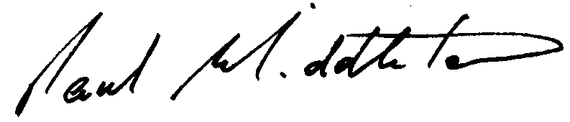

Paul Middleton
EXECUTIVE DIRECTOR

