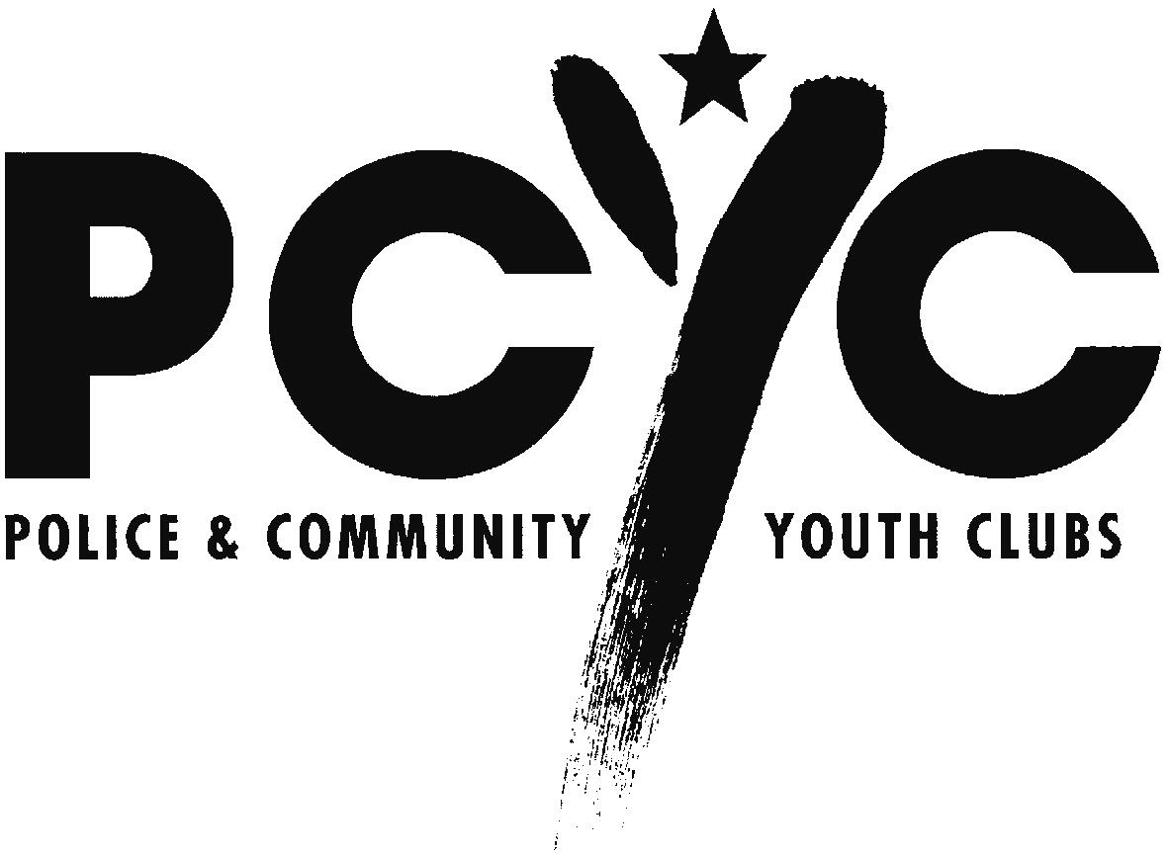

Mr. Peter Hallahan
Secretary
Senate Economic References Committee
Room SG.64
Parliament House
CANBERRA ACT 2600

Dear Mr Hallahan,

Inquiry into public liability insurance and professional indemnity insurance

In response to the Committee's invitation to interested parties to make a submission on this matter, I enclose a submission from Police & Community Youth Clubs NSW on public liability insurance.

Attached to the submission is a table that we wish to remain confidential to the Committee. This table is marked 'CONFIDENTIAL: FOR COMMITTEE USE ONLY'. A version of the table with the confidential data removed is attached to the submission proper for public release.

I would be pleased to expand on any matter in this submission should the Committee wish to seek additional information.

Yours sincerely,

Peter F Beaumont
Acting Chief Executive Officer

15 August 2002

