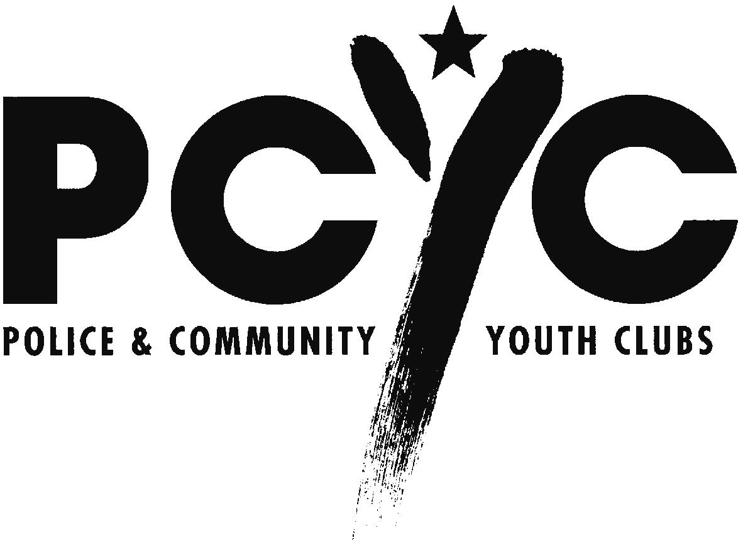

Police & Community Youth Clubs NSW Ltd

Inquiry into the impact of public liability and professional indemnity insurance cost increases

Submission to the Senate Economics References Committee

Police & Community Youth Clubs NSW Ltd (PCYC NSW) wishes to address the impact of public liability insurance on sporting and community organisatons.

PCYC NSW is a community based charity working with young people in New South Wales. It is actively supported with resources and funding by the NSW Police Force. PCYC currently has fifty-six clubs in metropolitan and regional NSW and at 31 December 2001 it had 33,247 members.

Attached to this submission is a table that spells out PCYC's experience with public liability insurance since April 1997 until this year. The comments made in this submission are drawn from that data.

- Public liability insurance costs have increased from $65,000 to $825,000.
- This is an increase of 1,272 percent or sixty-six per cent compounded annually.
- Costs include premiums and an annual risk management fee of $24,000, paid since April 2000, to undertake an annual 'risk audit' that translates into a reduced premium level.

- The premium rate per 1000 members has increased from $1069 to $24,825.
- This is an increase of 2,321 percent over five years or eighty-eighty per cent compounded annually.
- The premium rate per location has increased from $954 to $12,505.
- This is an increase of 1,311 percent over five years or sixty-seven per cent compounded annually.

- The excess on the policy has changed from 'Nil' to $25,000 since 1997.
- This year the minimum excess offered by the underwriter was $25,000, a considerable increase from the previous excess of $500.

- A large number of insurers have been approached by our insurance brokers each year but for the current year only one underwriter was prepared to quote on our public liability business.

For the current year, the premium per member is about $25. For members, annual fees vary by club but for junior members, aged under eighteen, the subscription is about $10 and for senior members, it is about $25. Junior members comprise about two-thirds of the membership of PCYC.

- In 1997, junior members paid about $2 in membership fees, with fees varying by club.
- $1 of the fee covered public liability insurance.
- The remaining $1 was available as a contribution to other club expenses.

- In 2002, junior members pay about $10 in membership fees.
- PCYC pays GST on membership fees, so $9.10 is available to PCYC.
- This $9.10 is a contribution towards public liability insurance costs of $25 per member.
- The remaining $16 of the premium has to be met from other funding sources.
- The result is that junior members, a key reason for PCYC's existence, are a net drain on PCYC funds because of the size of the public liability insurance premiums.

The recent increase in public liability insurance premiums means that all funds received from membership subscriptions are insufficient to cover the public liability insurance premiums. This means that the other running costs of PCYC have to be met from public funds provided by the Government or from the fund raising efforts of individual clubs. There is no guarantee that the additional funds will be forthcoming from these sources and, if it is not, then the services PCYC offers to the young people of NSW could be curtailed.

One consequence of the increases in public liability insurance has been that the range of activities offered by some clubs has been curtailed as a direct result of the underwriters restricting the range of permitted activities under the public liability insurance policy.

It will be noted that the reported membership of PCYC NSW has declined from 60,664 to 33,247 since 1997. In the past, membership numbers were not closely audited but now, in part because public liability insurance is based on membership numbers, individual clubs more closely monitor their membership numbers. It is the view of PCYC NSW that the core membership has not changed greatly over the five-year period and that the current membership numbers of 33,247 accurately reflect the active membership level.

A table follows showing the PCYC's experience with Public Liability insurance. All the comments made in this submission have been drawn from the data in this table. Following the table are two graphs, one showing the premiums paid and the other showing premiums paid and claims made under the public liability policy.

15 August 2002

