Liability and Indemnity Insurance for the Fire Protection Industry

Joint

Submission to the Senate Economics Reference Committee

Inquiry into Public Liability and Professional Indemnity Insurance

From

Fire Protection Association Australia

and

Fire Contactors Federation

JULY 2002
Contact:
Ross Hodge
FPA Australia
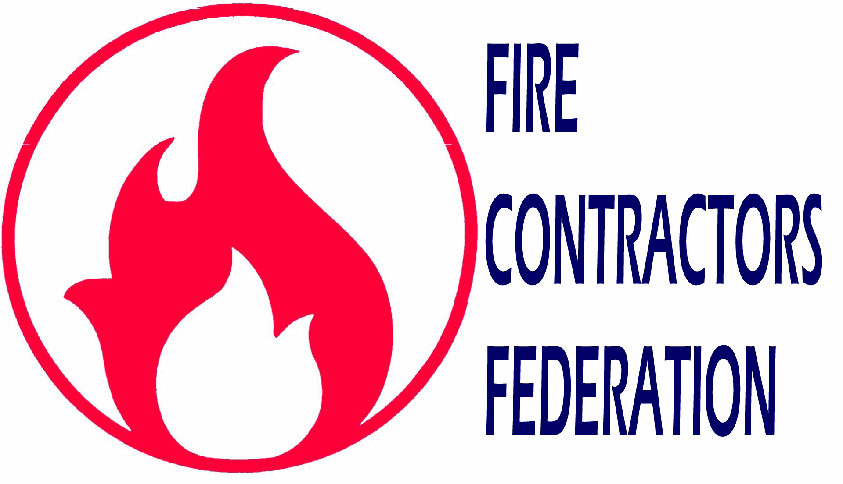
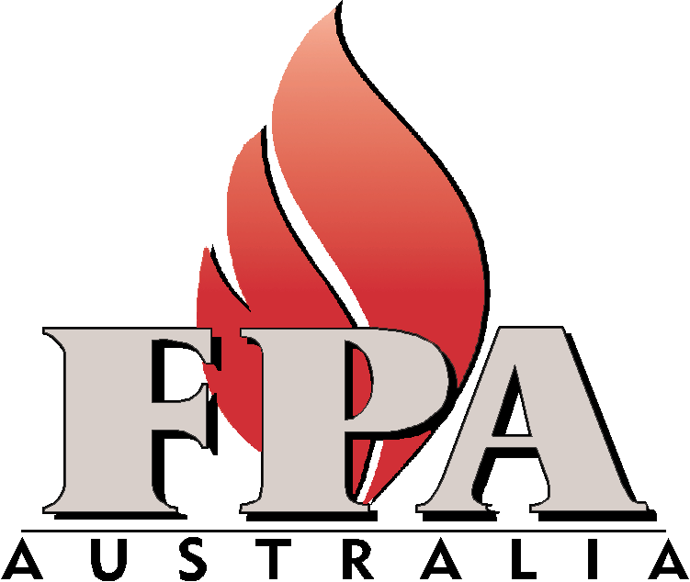
PO Box 1049, Box Hill, VIC, 3128
Tel (03) 9890 1544 fax (03) 9890 1577
Email: rossh@fpaa.com.au

- Summary

The current situation with Public Liability and Professional Indemnity insurance does not benefit the community, businesses, government(s) or the insurance industry itself. When an industry such as fire protection that has as its primary focus the minimisation of harm to life, property and the environment has its viability threatened because of inexplicable rises in insurance costs, it is obvious something is terribly wrong. All sectors of the fire protection industry are facing a crisis due to rising insurance premiums. Many members of Fire Protection Association Australia and the Fire Contactors Federation have been in business or involved in the industry for decades without an insurance claim history challenging their competence. Those same members are now facing crippling increases in Public Liability & Professional Indemnity insurances regardless of their unblemished work histories.

It is quite apparent that insurers have offset the threat of claims from professional high-risk groups against a broader base of practitioners who do not pose such a high level of liability, and that could arguably be justified as the fundamental basis on which the insurance industry operates by, i.e. spreading the risk. The past several years have seen many natural disasters and some not so natural with the worst being 11 September 2001, World Trade Center. Complicit in this is the collapse of several major insurance companies that specifically dealt in liability and Indemnity insurance. Unfortunately, the insurance industry appears to be responding with very little rationale. There must be a balance in their approach to dealing with the changing times. The basis for some rises in premiums could be arguably acceptable. However, those increases must also have some correlation with the level of claims and risk associated with the work practices of the various disciplines of industries and professions.

The consequences of the insurance industry’s response to Liability and Indemnity insurance will ultimately be to the detriment of the community, business, governments and the insurance industry itself if the current crisis is allowed to continue unchecked. With significant premium rises of between 200 to 450 percent and in some exceptions even higher, the passing on of costs and the potential for withdrawal of some professional services altogether, will be to the detriment of the economy.

The media and the government have focused on indemnity insurance for the medical industry, warranty insurance in the building industry and public liability insurance for community-based events. Now there are other emerging insurance dilemmas, which are just as catastrophic for the community, particularly in the areas of essential services. In this case the basis of this submission is on behalf of the fire protection industry

It is up to the government to drive reform to arrest the alarming trends of obtaining PL & PI cover and install confidence in industries that contribute much to the safety and security of peoples lives and their assets. Governments need to urgently implement reforms in PL & PI insurances in regards to:
- Joint and Several Liability
- Limiting the time frame for liability
- Limiting level of liability

If the current insurance crisis is allowed to continue unchecked without any reforms, the consequences will have far reaching impacts on the economy, employment and quality of life for many Australians. There is also the risk of taking extremely conservative approaches in many industries through over design and little or no innovation. Ultimately this approach will be costly for consumers and do little for the development of new technologies.

There is no one single solution to fix the current PL & PI insurance crisis. It will require a combination of changes and reforms to provide affordable insurance relevant to the level of associated risk. The most important decision is to start responding to the crisis as soon as possible in order to attain a sustainable outcome based on a national approach.

2. Introduction to the Fire Protection Association Australia
Fire Protection Association Australia (FPA Australia) is a not for profit Technical and Educational organisation who’s charter is to enhance the understanding of fire risk and the advancement of fire safety. Our mission is to protect the Australian community from fire, through education and representation. The association was formed in 1997 following the merger of two allied organisations with origins going back over seventy five years.

With over 1500 individual and corporate members, FPA Australia, membership covers many disciplines, including:

- Structural Engineers;
- Building Surveyors;
- Building Certifiers;
- Building Inspectors;
- Consultants in Fire Emergency response procedures planning and training;
- Manufacturers of fire protection equipment;
- Installers of fire protection equipment and services; and
- Contractors that service and maintain fire protection equipment.

The Association’s prime objective is to promote the best possible safety for the community. FPA Australia also provides a wide range of services to its members through the national office and state committees, as well as a range of national technical committees. Through the technical committee structure, members of FPA Australia contribute significantly to the development and implementation of building codes and regulations and standards pertaining to emergency response procedures, and fire protection equipment design, manufacturing and installation.

Each year FPA Australia facilitates Australia’s major Fire Protection conference as well as conducting regular seminar series focusing on the continuous improvement of fire protection services and the dissemination of knowledge in this broad area. A quarterly journal and regular newsletters are also provided for members to keep them abreast of both local and international issues and developments relevant to their industry. All corporate members of FPA Australia are signatory to an industry code of practice.

3. Fire Contractors Federation

Fire Contractors Federation (“the Federation”) was formed in 1926 and represents the commercial and residential sprinkler pipefitting sector of the fire protection industry. It operates nationally.

As an industrial registered organisation, with the Australian Industrial Relations Commission, the primary role is Industrial Relations. However, the Federation also addresses the training requirements, legal, contractual and Occupational Health and Safety aspects of the industry.

The membership sees their role as delivering life safety to the Australian community and the Federation is charged with ensuring the operating environment is equitable and conducive to the conduct of business for this sector of the fire protection industry.

4. Fire Protection Industry-The Operational Environment
The Fire Protection Industry operates in a heavily regulated environment. Many sectors of industry require licenses, specific qualifications or demonstrated competencies to be able to work. Licensed companies in many jurisdictions are also required to employ licensed persons and carry specific levels of liability, indemnity and warranty insurance cover.

There are also many buildings codes, regulations and standards to conform with to have work approved. It is a very professional and committed industry responsible for minimising the harm to life, property and the environment.

The individuals who operate businesses or are employed in the industry have a broad range of skills and qualifications. The industry itself takes a key role in driving much of the change for the continuous improvement in fire protection equipment and associated services. In fact the time and resources contributed by individuals from within the industry through participating in the many technical, standards and regulatory committees throughout Australia would be counted in the many $millions each year.

The industry recognises the level of increased high awards for damages and the escalating level of litigation and claims against some professions have contributed significantly to increased PL & PI insurance premiums. However, the purpose of the fire protection industry and the services and products it provides in protecting our most valuable assets are at considerable odds with the current stance of the insurance companies. Pressure on industry from the spiralling cost of insurance will result in reduced competition and increase the cost of fire protection. Without a viable and effective fire protection industry the insurance industry will be further exposed to higher claims.

5. Renewal of Premiums
FPA Australia and the Federation are of the view that the approach of the insurance companies has been most unsatisfactory verging on unethical in the process they have undertaken for renewing our members PL & PI insurances. Our main concerns are:
- Late or eleventh hour provision of cover
- Non-claim incidents being listed against industry
- Negative perceptions towards the term “fire” in business names
- Provision of short term cover

Late or eleventh hour provision of cover
A considerable number of members have raised the issue of protracted negotiations with insurance companies to obtain cover. In many instances the negotiations have commenced a considerable time before the existing policy has expired. However the insurance companies appear to have deliberately strung out negotiations until the final 24 hours of the existing policies expiring before offering cover at a steeply increased premium on the previous year’s cover. At this point of time business operator are faced with a decision of whether to shut down operations or continue to operate uninsured.

One particular member in this situation, had barely twelve hours left until existing cover expired. They were offered a policy for professional indemnity cover, with the premium increasing from $6,000 to $52,000. This particular company had never made a claim against their PI insurance. Another two separate examples provided by businesses of varying sizes and operating in different sectors of the industry being offered ‘last minute cover’ with rises, were increases from $1,800 to $5,800 and from $32,000 to $126,000. None of these companies had any history of claims against them. Generally, fire protection businesses that were able to obtain PL & PI insurances have been faced with paying for increases of between 200-450%. Both the offices of the FPA Australia and the Federation have received many other examples of late offers for insurance cover at exorbitant premium increases.

Non-claim incidents being listed against industry
Industry has a responsibility to advise insurers of incidents that could have the potential to become a claim. There is a considerable amount of evidence that reported incidents which never materialised into claims are being treated by the insurers as actual claims. A number of the Federation and FPA Australia members have provided examples of when renewing policies and not listing reported incidents (some from many years back) where no subsequent claims were made or are outstanding, are now having the insurers question them for not disclosing them as actual claims.

In media coverage of the insurance problems confronting the fire protection industry, an insurance company representative stated there was a problem from water damage to buildings from installed equipment. This was given as a reason for industry experiencing some of its insurance problems. The reality is that building damage from fire protection equipment such as sprinklers and hydrants that have failed due to faulty design, manufacturing or installation, is absolutely minimal. When damage has occurred from this equipment it is usually from the result of other activities in the building, including vandalism. Unfortunately because any damage is the consequence of accidental or misuse of fire protection equipment insurance companies consider it to be a “fire industry” related problem.

Negative Perceptions towards the term “Fire” in Business Names
There is plenty of anecdotal evidence that insurers are treating any businesses with the word “Fire” in their business title as being high risk when it comes to taking out PL & PI insurances regardless of their history of claims. It seems absurd that an industry that operates in the best interest of the community with a focus on minimising the harm to people and their assets from fire can be penalised for using the word ‘fire’ when it is applicable to their trading name.

There is an obvious need to categorise claims to identify what are the high-risk sectors of professions and industries responsible for generating claims against PL & PI insurance. The nature or causes of the claims should also be made available to clarify liability. There is a suggestion that the fire protection industry is also bearing the outcome of claims against other professions and trades that have resulted from working installed fire protection equipment.

Reforms in PL &PI insurances should ensure that there is some delineation provided in clarifying responsibility for professional liability for claims. The nature of the industry or profession that is identified as being negligent or incompetent needs to be identified instead of punishing an industry by association through word or name, i.e. “fire”.

Provision of short-term cover
Many businesses have found that when they have been able to re-insure for PL & PI they have only been able to receive cover for a limited period, e.g. 1 July to 30 September. While a short-term cover could be argued as being a better result than not obtaining cover at all, it is creating a lot of uncertainty and insecurity in the industry. Insurers only providing short-term cover make it difficult for businesses to operate confidently and commit to securing long term contracts and providing security for their employees. In committing to property and vehicles leases and investments in infrastructure required to conduct successful businesses they require a higher level of certainty than being offered PL & PI insurance for three months.

The provision of short-term cover provides an insight into the turmoil inside the insurance industry. When an insurer that has been providing a company with cover for many years suddenly can only extend that cover for a short term, it suggests the insurance industry internally must have a very clouded picture of any long-term vision and strategic direction. Without the intervention of governments and reform to the areas of PL & PI insurances, the current short-term modus of operandi of the insurance companies will continue to threaten the future of viable and effective businesses.

6. Rises in Premiums
Unfortunately due to time constraints before preparing this submission FPA Australia and the Federation were not in a position to survey its members to identify all the impacts of premiums to present details in a chart or graph. Nevertheless, it would still not be an understatement to say that increased insurance premiums are the single major issue impacting on the viability of many businesses conducted by the members of FPA Australia.

Many individual members have provided the offices of FPA Australia and the Federation with examples of the rises in premiums they have experienced. Since late last year the problem of obtaining PL & PI insurance and huge hikes in premiums has increasingly become a major concern for FPA Australia and the Federation members. As previously stated, both Associations believes that the word “fire” in a business name has become a contributing factor to increases in member’s premiums, rather than the level of liability risk for the individual, or company, or the actual sector of industry they work in.

7. Causes of Premium Rises
It is obvious that events such as 11 September and the collapse of insurance companies that had large portfolios of liability and indemnity insurances have been contributing factors to rises in premiums. The escalation in the amount of legal proceedings and size of the awards for damages has to also be recognised as a contributing factor. To remain in business insurers have to spread their own exposure to risk over their policyholders to remain profitable.

It is unfortunate that professionals whose services have limited risk to claims are being “knocked down and out” when their own level of exposure to liability is very limited. The insurers appear to be making decisions based on assessments that appear to have little fact or hard evidence to support them. A simple cause and effect study of the insurance industry could provide a lot of insight into how much insurers are harming the future of the very industries/professions/practitioners that might in fact provide their best long-term lifelines.

8. Consequences of Rises
The consequences from the extreme increases in insurance premiums across the fire protection industry will ultimately be to the detriment of the general community, business, government and ironically insurance companies. As an industry committed to minimising harm to life, property and the environment, it is in everyone’s best interests to have fire protection at an affordable price. Without a viable and effective fire protection industry the insurance industry itself would be exposed to higher claims.

Wider implications from the insurance crisis facing industry will be:
- A shortage of qualified people either working or entering the industry;
- No certifying of new equipment and services; and
- A decrease in fire protection maintenance.

Shortage of qualified people
Many long-standing businesses in the fire protection industry are faced with the dilemma of closing their businesses, scaling down their operations (reducing employee number), working without with the appropriate insurance cover, or trying to pass on the increased costs to consumers. None of these scenarios are acceptable in maintaining a viable and effective fire protection industry. Apart from many businesses either closing down or reducing staff, new companies starting up are facing even bigger hurdles. There have been instances provided of recently commenced or businesses starting up not even being considered for re-insurance or new insurance cover respectively.

No certifying of new equipment and services
An important function in the fire protection industry is the role of certifiers who are responsible for approving the new equipment and services law. A lack of certifiers will have a major impact on finalising construction projects as they are responsible for approving fire protection equipment and services installed in new buildings prior to occupation. They provide independent assessment of installations to ensure all codes, regulations and standards have been met. Certifiers have been subject to crippling insurance rises, yet they are not responsible for manufacturing or installation of equipment and services, only for compliance with government legislation.

Decrease in fire protection maintenance
To ensure that certain types of commercial and residential buildings conform to legislatives requirements, regular maintenance and servicing of fire protection equipment must be undertaken. Maintenance contractors have been subject to steep premium increases and because many have long-term contracts they are not in the position to pass the costs on to consumers. Many have found the increases prohibitive to operating a viable business and are closing down. Subsequently it will become increasingly difficult to maintain servicing requirements leading to OH&S and work-cover issues from unsafe/un-serviced buildings. Those building owner/managers who can find contractors to perform the required maintenance work will be paying considerably higher rates to offset the costs of increased premiums.

Increased insurance premiums will result in the withdrawal of some critical technical skills and lead to skills shortages in other sectors of the industry. Instead of being up with the world leaders in fire protection, we will risk becoming the world laggers in an industry that is vital in protecting people’s lives and assets. Without a viable and effective fire protection industry the insurance industry itself could be exposed to higher claims.

These are just some examples of how the insurance crisis facing the fire protection industry will be felt by the wider community. There will be negative spin offs across all sectors from all disciplines that make up the industry.

9. Resolutions
To bring about a resolution to the current PL & PI insurances crisis, reforms need to be implemented by all governments. The past ten years has seen Australians increase in propensity towards a more litigious society. It is now time to ensure there is a balance with this trend between protecting the rights of the community and still providing affordable insurances that won’t cripple businesses. It is unfortunate there has been such a deterioration in the insurance industry, that a call for reform is necessary. However the threat to viable successful businesses from spiralling insurance premiums, that have no correlation between the cost of claims and the price of premiums, is unacceptable.

FPA Australia and the Federation are of the view that the government must now introduce reforms to ensure the fire protection, and like industries, which provide essential services can continue to provide a high level of quality protection for people and their assets. It is not in the best interests of the public to force professionals out of practice when it is not their competence that is in doubt.
Both the Federation and FPA Australia believe the following areas need to be addressed through reforms:
- Joint and Several Liability
- Limiting the time for liability
- Limiting level of liability

Joint and Several Liability
It is unacceptable to have professionals caught up in legal actions when they have not contributed to the loss that a claim is being pursued for. When a professional can be caught up in joint actions because they have a level of capacity to pay rather that because they are a contributing factor, then reforms must be introduced to limit damages on a contributing liability basis. The level of damage awarded against a professional must be proportional with that party’s contribution to the problem.

A system based on awarding damages on a proportional liability basis would be fair to all parties. The plaintiff would still be able to pursue fair and reasonable compensation for loss or damage, while the party (or parties) involved would be liable for damages based on a level of contribution to the problem.

Limiting the timeframe for liability
FPA Australia believes the public interests should be protected when purchasing goods or services to ensure what they are receiving meets minimum standards and last for an acceptable period of time. In providing this level of security for consumers there must be also be a balance in the level of liability placed on the supplier of those goods or services. The length of time a practitioner is liable has previously not been an issue for this industry. However if this is what is required to allow insurers to provide cover at an equitable prices we would support this position.

The length of time a practitioner is responsible for the products or services they provide needs to be defined. A defining period for the commencement and conclusion of when a professional’s exposure to liability of faults, could reduce the level of risk for many practitioners.

Without providing the supplier of goods or services with a clear time frame for which the cover for indemnity of their products is counterproductive to innovation and progressive development. With the current levels of increases in PL & PI insurance professionals and practitioners will tend to “play safe” and take conservative approaches to their work rather than introduce new and potentially better products and services.

Establishing the time for which a professional is required to provide liability cover for a service or product should provide insurers with a lot more clarity in the level of potential exposure when setting premium costs than currently exists. The current open ended situation where a professional can be liable long after they have either retired or left the business must contribute significantly to higher premiums. Establishing defined periods for liability could contribute much to stabilising and even lowering the costs of PI cover.

Further to this point, the warranty cover required by practitioners in some industries has already been reduced from 10 to six years with government support.
Limiting level of liability
Limiting or capping the level of liability will contribute considerably to the affordability of insurances. The current environment of unlimited liability is a major contributor to the undue burden being placed on professional practitioners. It also creates the situation where a practitioner can be exposed to high claims due to capacity to pay rather than the level of contribution to any loss or damage. This could force professionals out of business on the grounds of their capacity to pay rather than a judgement against their actual competence.

FPA Australia regards the position taken by insurers, to deem high risk any company with the words ‘fire’ in its business name, as being unacceptable. There appears to be no correlation between claims against the industry and the rise in premiums. FPA Australia does however support reducing the level of exposure and subsequent risk by limiting the quantum of liability. Limiting the level of liability would provide more certainty for both the claimant and the practitioner.

In limiting the level of liability, reforms could take into account certain aspects or conditions that could be imposed to maintain high professional standards. Requirements that could be considered would be: licensing, registration, competency assessment, risk management practices, membership to professional organisations, signatories to codes of practice and ongoing professional development.

10. Conclusion
While media interest with PL & PI insurance has focused mainly on the medical profession, building warranty, leisure activity companies and the cancelling of community events, examples are now emerging where many other professions and industries are reaching crisis points. When industries that provide essential services that would normally class them as “friends” of the insurance industry are being virtually put out of business by crippling rises in their premiums, it is time for the government to take action and responsibility.

A consistent approach needs to be taken by governments to introducing reforms that provide certainty for; the community; the purchasers of goods and services; the suppliers of those goods and services; and the insurance industry. The reforms need to ensure there is a balance in the rights and expectations of all parties who may become involved in a PL or PI claim. Many events, and changing community attitudes, have contributed to the current situation. The fallout and costs, to be borne by all, will continue to spiral out of control if the game does not have some new rules introduced.

