1 July 2002

Dr Kathleen Dermody
Committee Secretary
Australian Senate – Economics Committee
Parliament House
CANBERRA ACT 2600

Dear Dr Dermody

Re: Inquiry Into Public Liability & Professional Indemnity Insurance

Thank you for your invitation to provide a submission regarding the above reference to the Senate Economics Committee.

By way of background, Insurance Australia Group is Australia’s largest general insurer with more than four million customers. Our business is concentrated in the private household sector and our emerging presence in commercial insurance is mainly in the area of providing packaged insurance for small to medium businesses. Thus we have relatively little or no involvement in the specific insurance products covered by these terms of reference.

However, the current problems of access and affordability to these products have underscored the critical role of insurance in facilitating daily community life. As a leading participant in the insurance business, IAG understands its responsibility to the community and welcomes the challenge of contributing to the development of sustainable solutions.

In many respects the problems being experienced in public liability and professional indemnity are very similar to those that have arisen on more than one occasion in the past in the two major classes of long tail insurance, compulsory third party and workers compensation. We have a wealth of experience in successfully managing these products, which may be of assistance to the Committee.

There is now considerable evidence that the current market “crisis” is a response to many years of under-pricing. In analysing these trends, it is critical to understand that a policy written today is not priced on the basis of the current cost of claims but on an estimate of claims costs when claims under that policy will, on average, be paid out. Typically on the long tail classes, the average claim takes three to four years to finalise (and often much longer, such as in the case of seriously injured children when it may take a decade or more before their condition stabilises).
Premiums are therefore based on the expected growth of average claims costs over the average duration of the claim, and then discounted for the expected investment earnings on claim reserves over that period. Under-pricing (and potentially over-pricing) occurs when these estimates prove to be seriously inaccurate.

With the benefit of hindsight, it is now clear that a number of insurers seriously under-estimated the growth rate in claims costs for much of the 1990s. The impact on profitability for some was masked, for a time, by buoyant but unsustainable investment profits. Evidence before the HIH Royal Commission also suggests that the failure of at least one leading participant to adequately report claims experience also distorted the market.

Recent analysis by leading actuarial firms suggests real growth rates of between seven and 12 per cent (ie: above wage inflation, wages being the major economic cost driver for long tail classes) in the cost of claims major liability classes over the past decade. In other words, a trend was established where claims costs would double in real terms every five to 10 years.

Today’s premiums reflect the market’s adjustment to that reality and some expectation that this trend will continue to impact on claims going forward. They also reflect a shortage of global capital, particularly since the events of 11 September 2001, and a preference to allocate the available capital to under-write less volatile, and therefore less risky, products. Where capital has been made available, it expects a return commensurate with the relatively higher level of uncertainty attached to liability products in Australia.

A sustainable solution therefore requires a concerted effort by all stakeholders to embed much greater certainty and stability to the underlying cost drivers of long tail insurance classes. It means a legislative framework that clearly aligns the expectations of those with legitimate claims to the financial capacity of those who pay the premiums. It means a regulatory framework with the tools and resources to actively monitor trends in the liability classes and to take the initiative in responding to early signs of instability. And it means a clear understanding by all stakeholders of their role in ensuring stability and sustainability.

Our experience in compulsory third party and workers compensation suggests that a sustainable environment for long tail insurance classes needs to be based on the following principles:

- Fully funded premiums, to ensure that claims will be met and to avoid inter-generational subsidies between today’s risks and tomorrow’s premiums

- Premiums which are affordable by all sections of the community needing indemnity

- Early notification of injury/loss

- A clear initial focus on maximising recovery and restoration of pre-accident condition

- Medical treatment consistent with best practice in the broader health sector and no different to that available outside the compensable environment

- Full or close to full economic compensation for serious injuries or major losses

- Limited compensation for less serious matters to preserve available resources

- Controls on fees charged by service providers to discourage over-servicing (both legal and medical)

- Individual assessment of entitlement within an objective framework, eg: by binding assessment of the degree of injury/loss by accredited experts

- Specialist informal dispute resolution procedures to minimise resort to the adversarial court system

- Strong prevention and risk management infrastructure with clear alignment to actual claims experience

Many of these principles have been embraced in the initial legislative responses of Governments, which can be expected to reduce the upward pressure on premiums. The degree of their effectiveness remains somewhat uncertain due to the untried nature of some measures and differences between jurisdiction, but most measures do represent some progress in the right direction.

The initial legislative responses must be seen only as a first step. We note that Governments have announced a number of other measures that, if implemented effectively, will play a critical role - in establishing a more stable and sustainable environment for liability insurances. In particular, we support:

- The establishment of a comprehensive national database for all personal injury (and potentially other types) liability claims. This will provide, for the first time, a complete picture of the economic cost base for liability insurances and emerging trends in particular areas.

- Bringing the prudential supervision of medical defence organisations under the General Insurance Act. The same prudential and reporting standards should apply to all providers of general insurance, regardless of ownership structure, to ensure consistency in the management of long tail classes and full funding of all premium pools. Where a guarantee acts as a substitute for dedicated capital (eg: from State or Local Government), the value of the guarantee should be clearly identified on the balance sheet of the parent entity.

- Productivity Commission review of claims management practices. This will assist in developing a best practice culture in the management of long tail liabilities.

Today marks the start of a new era for insurance regulation in Australia with the commencement of the new General Insurance Act. IAG strongly supported these changes as a solid foundation for the development of a secure, sustainable Australian insurance industry. Actuarial modelling suggests that the new capital requirements will reduce the likelihood of another HIH failure from a one in 15-year event to something in the order of one in 200 years.

However, more needs to be done to build a regulatory framework capable of nurturing a world-class insurance industry. In particular, there needs to be a clear recognition and definition of the ongoing roles of all tiers of Government in providing a stable environment. This will involve recognition of the inter-dependencies between the federal prudential function and the underlying cost base driven by the State and Territory legal and regulatory framework. It means a clear understanding that the capital required by national solvency standards and the cost of insurance generally is a function of the level of volatility in the broader claims environment.

The work of recent ministerial forums and inter-Governmental working parties needs to be built on and permanent mechanisms put in place to facilitative a co-operative approach to our industry. We welcome the interest of the Senate Economic Committee and believe it can play a constructive role in building a more sustainable framework. We are also preparing a more comprehensive submission on these issues to the HIH Royal Commission for lodgement by 15 July and undertake to forward a copy of that submission to the Committee for its consideration.

Yours sincerely
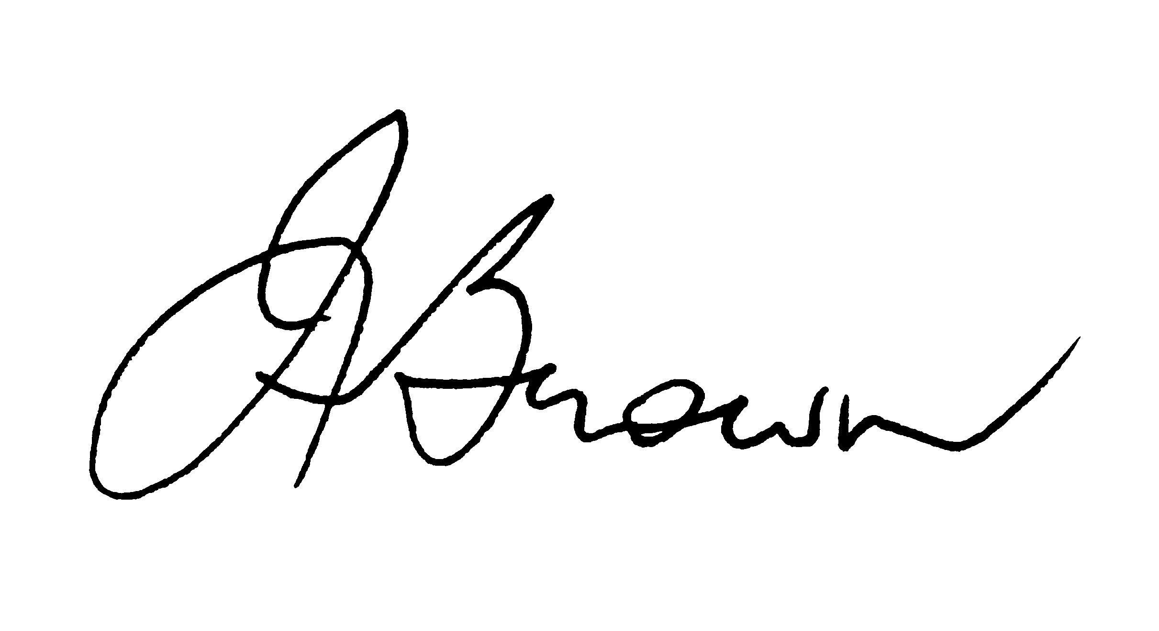
Ian Brown
Deputy Chief Executive Officer
Insurance Australia Group Limited

Ref IB – Ltr Senate Economics Committee 010702

