The Secretary  Senate Economics References Committee  Room SG.64  PARLIAMENT HOUSE CANBERRRA 2600 | 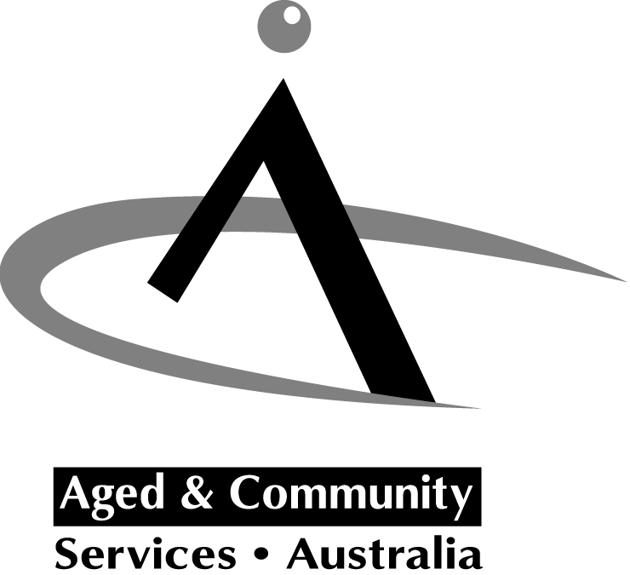

Submission to the Senate Inquiry into the impact of public liability and professional indemnity insurance cost increases

I write to you on behalf of the aged and community care industry to raise concerns with the current trends in public liability and other insurances and their implications for our sector.

Aged and Community Services Australia (ACSA) is the national peak body for not-for-profit church, charitable and community providers of aged and community care services. ACSA’s 1400 member organisations provide residential and community care services to over 200,000 older people, people with disabilities and their carers throughout Australia.

The services provided by our members (including residential care, district nursing, personal care, house cleaning and maintenance, delivered meals etc) are vital to the well being of older people and younger people with disabilities and an important social service to Australian society. Service providers are currently being hit with massive increases – as much as 250% - in public liability insurance.
Organisations have limited capacity to afford such increases. Most services receive limited Commonwealth and/or State Government funding which barely covers the cost of direct service delivery. While Government funding is indexed annually the current Commonwealth formula applied (COPO) does not recognise the real costs of delivering such care services and is not specifically increased to take account of such significant shifts in business costs. In addition the level of insurance required may be a fixed condition of Government funding and does not necessarily reflect the actual risk profile of such services.

As funding for such services is limited, many organisations find it necessary to undertake fund raising activities to support their endeavours. Public liability insurance costs for fund raising activities are proving prohibitive. This is effectively a double disadvantage for organisations, as they will be affected by general premium increases as well as increases on insurance for specific fund raising events. These increases will limit the ability to supplement their income to provide quality aged and community care services.

While the overall increase in public liability premiums is of major concern there are a number of other associated issues that would also impact on the ability of organisations to continue to provide high quality services.

There have been media reports that outline other insurance difficulties such as the unwillingness of insurance agencies to cover the work of volunteers over the age of 65/70. Many services are delivered in partnership with volunteers. Of particular note is the Meals on Wheels service which has been in operation since 1946 in Australia. This is a service heavily reliant on volunteers as either cooks and/or for the delivery of meals to individuals living in the community. Such a restriction on insuring older volunteers is likely to severely limit the provision of meals or result in significant cost increases to Government to enable workers to be employed to deliver meals.

This move is out of step with a society that is now beginning to consider older people’s economic contribution. The National Strategy for an Ageing Australia expresses a desire to increase the retirement age. If insurance for older volunteers (who form the bulk of the volunteer workforce) and workers is denied (or is prohibitively expensive) it will undermine this strategy in its infancy.

The increases in public liability insurance costs are the subject of much media and community attention but other forms of insurance are also experiencing significant increases. Residential care providers are also facing increases to the fraud insurance they are required, by Government, to have. Organisations are reporting anything from a doubling of the premium up to an 800% increase for this insurance. The level of insurance required is set by Government and does not bear any direct relation to the actual risk of such an occurrence or allow for organisations to manage this risk in another way.

The combination of dramatic increases to these insurances will place continued operation at risk for many providers.

We are not yet seeing the full effect of higher insurance premiums as many organisations will renew their insurances, and therefore receive the final and accurate price, in June and July.

Action is needed now. It is our understanding that the Ministerial Summit on Public Liability Insurance suggested that September may be a more likely time frame for solutions to the crisis. While the solutions proposed by the Ministerial Summit may create longer term relief they will not alleviate the financial pressure organisations are experiencing now or address the very real threat that small and local providers (such as community transport, social support services) may be forced to close. Once lost it is difficult for such services to be replaced. The impact of closures of reduced services on the lives of isolated and vulnerable older people, younger people with disabilities and their carers will be significant.

As an industry body we will be exploring what can be done from this level, but Government must either act proactively now or undertake some short term measure, such as bulk purchasing of public liability for funded agencies or increasing funding to recognise the cost to services. A longer term solution that should be considered is a Productivity Commission inquiry into the social and economic costs of public liability insurance. ACSA also believes that the rising costs of litigation could be addressed through legislative means.

If you have any queries or would like to discuss our submission please don’t hesitate to contact me on (03) 9686 3460.

Yours sincerely
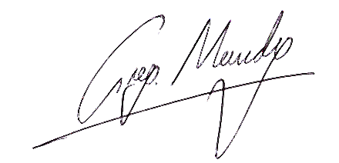
GREG MUNDY
Chief Executive Officer

cc. Minister for Ageing

