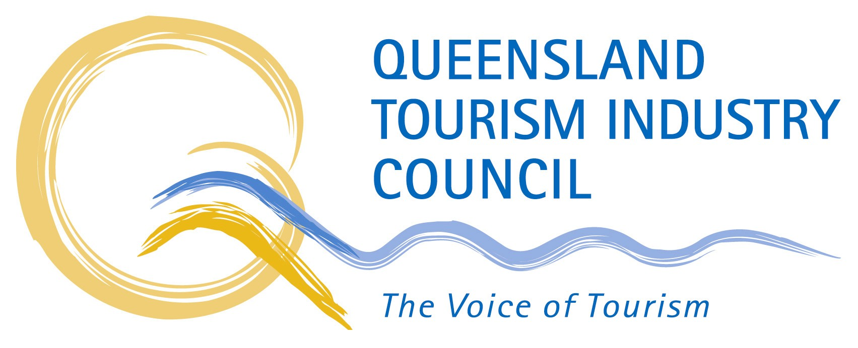

Queensland Tourism Industry Council
Level 11, 30 Makerston Street

Brisbane QLD 4000
PO Box 13162
George Street Post Shop Qld 4003
Telephone (07) 3236 1445
Facsimile (07) 3236 4552
email info@qtic.com.au
website www.qtic.com.au

The Secretary
Senate Economic Reference Committee
Room SG.64
Parliament House
CANBERRA QLD 2600

Email: economics.sen@aph.gov.au

15 May 2002

Dear Madam/Sir

Inquiry into the impact of public liability and
professional indemnity insurance cost increases

The issues covered by your inquiry are of serious concern to the tourism industry, including a large number of tourism operators in Queensland who we represent. We welcome the opportunity to provide this submission to you. I also appreciate the consideration given over the phone to allow us to send this to you two days after the closing date. This enables us to include the attached executive summary of a report which was completed only today.

The Queensland Tourism Industry Council (QTIC) is the industry’s peak representative body in Queensland, based on voluntary business membership. We represent more than 3,000 regional members, and have in our membership all of Queensland’s Regional Tourism Organisations (RTOs), as well as all key sectoral tourism organisations. A brief profile of QTIC is attached for your information.

Over the last few months we have been collecting anecdotal evidence from operators in Queensland who are experiencing problems with their public liability cover. Not only has it become evident that most renewal notices issued this year contained significant premium increases but, in a growing number of cases, cover was refused outright.

Both scenarios appear to be unrelated to the claims history of a business or to the individual risk profile of the operator. Not surprisingly, about a dozen Queensland tourism operators that we are aware of have ceased operating to date.

In response to the liability issues that have arisen, QTIC has engaged in a dialogue with the Insurance Task Force of the Queensland State Government and has initiated discussions with insurance brokers/insurers to investigate the state-of-play and possible solution scenarios.

We recognise that no single measure will address all issues, nor is it the responsibility of a single agency to deal with all aspects of the problems confronting affected businesses.

We suggest that federal and state governments have an opportunity to review the legislative and regulatory frameworks that relate to public liability claims. In particular, it needs to be investigated if legislative measures could be taken that:

- reduce or eliminate frivolous claims;
- limit awarded payouts to reasonable and predicable levels;
- structure payout schedules efficiently; and
- provide effective indemnity protection for no-fault accidents, through arrangements between service providers and customers.

To the extent possible, governments have a role to play in making the risks associated with public liability more manageable and more predicable.

Beyond that, the industry collectively, and operators individually, also need to take steps to respond to the current liability protection issues. Risk cover, including public liability, remains largely a commercial proposition between operators and insurance providers.

In order to facilitate better commercial outcomes for our industry, we have liaised with a range of stakeholders to canvass available options. Without pre-empting our future strategy, we are particularly interested in exploring a possible group insurance scheme for the tourism industry in Queensland. The model being considered is based on the approach proposed by the Queensland Government for the not-for-profit community sector. However, a tourism industry scheme would be industry-driven, without direct involvement of the government.

To gain a better understanding of the scope and nature of the public liability problem confronting the industry, QTIC has commissioned a research/survey project in Queensland. The project is jointly financed by the CRC for Sustainable Tourism, the Queensland Government and QTIC.

An executive summary of the survey results are attached for your information.

The results of the survey, which is not a census, have to be treated with some caution, particularly given that a majority of operators in the industry have yet to receive annual insurance renewal notices for this year.

As part of the executive summary, we have also included some of the particularly salient comments received from operators in response to the survey. Like the rest of the findings they do highlight the urgency and extent of the problem confronting tourism businesses.

The survey results will assist QTIC in progressing discussions with possible partners in an industry-based public liability insurance scheme. We would envisage that any possible scheme would also take into consideration the role of effective risk-management measures that may be promoted in the industry.

It is too early to speculate what form a preferred group insurance scheme for the Queensland tourism industry may take, or if it will become a reality. However, there is strong commitment from all parties currently involved to test the opportunities.

Apart from the economies of scale and the risk distribution that a group scheme could offer to an insurer, we are also hopeful that under such a scheme insurers would be able to asses the risk profile of operators in a more realistic manner.

We are under no illusion that a group scheme will be able to reverse all of the premium increases that have occurred recently. Much of the increases must be attributed to a global adjustment in the insurance market, particularly for liability cover. Nevertheless, we believe that a well-supported group scheme would deliver savings and – importantly – may provide cover for operators who currently cannot find an insurer for their operation.

In conclusion, I would like to restate that QTIC firmly believes that the public liability issue poses one of the greatest threats our industry ever encountered. Stakeholders, including governments, need to explore all available avenues to address the issues. Measures taken through possible industry-wide group insurance schemes will be more likely to succeed if they are supported by effective federal and state legislative frameworks.

Please contact QTIC on 07 3236 1445 if we can provide any further information to you. We look forward to the outcomes of your inquiry.

Yours sincerely

Daniel Gschwind
Chief Executive

Encl.



As the peak body for tourism, the State’s second largest industry, QTIC provides a focal point for the tourism industry and advocates its needs to governments.

Based on its membership of more than 3,000 regional members, QTIC represents the interests of the tourism industry, including business operators from all sectors of the industry and professional service providers.

All 14 official Regional Tourism Organisations (RTOs) are members of QTIC as are all major sectoral tourism bodies, covering accommodation, transport and tour operators.

An elected board has responsibility over QTIC. The 2002 Board is made up as follows:

Mr Gary Smith Managing Director Tourism Leisure Corporation
Chairman

Dr Ken Chapman Managing Director Skyrail Pty Ltd
Vice Chairman

Mr Denis Kenny General Manager Outback Qld Tourism Authority
Chairman RTO Managers

Mr Ron Chapman Executive Director Caravan Industry Australia (Qld)

Ms Clare McFarlane Managing Director Aries Tours

Mr Phillip Harding General Manager Noosa Blue Resort

Mr Bob Brett General Manager Gold Coast Tourism Bureau

Mr John Atkin Proprietor The Falls

Mr Greg Holmes General Manager HMAA of Qld

