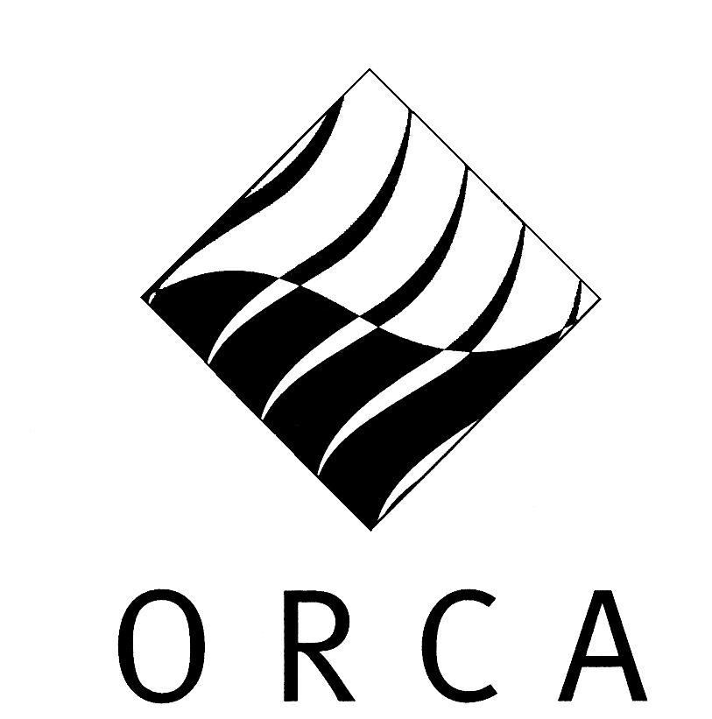
outdoor recreation council of australia incorporated

Wayne Miller
Avondale College
PO Box 19
Cooranbong NSW 2265

Bus. 02 4980 2279
Mob. 0414 506 905

13 May 2002

The Economics References Committee
Australian Senate
Parliament House
Canberra ACT 2600

Introduction
The Outdoor Recreation Council of Australia Inc. (ORCA), is the national peak organisation for outdoor recreation in Australia. Recognised by industry and all levels of government, ORCA represents the interests of all those involved in outdoor recreation, from volunteer, non-profit groups, training providers and land managers, to commercial and activity-based organisations. Representation is achieved through a network of peak bodies in each state/territory, each of which provides a range of services to the industry at the local level.

Inquiry into public liability insurance and professional indemnity insurance
ORCA endorses this inquiry by the Economics References Committee as a significant event that indicates a genuine desire by the Senate to address the present insurance crisis. We have a growing list of case studies indicating significant hardship for operatives within our jurisdiction due to excessive hikes in the cost of insurance and in many cases an inability to secure insurance at any price. Perfect claims histories and the associated minimal exposure to risk seem to have little bearing on premiums. The capping of claims has been suggested as a means of providing affordable public liability insurance. We welcome discussion of this difficult issue. We believe that statutory protection from liability should be provided for landholders, particularly where access for outdoor recreation was deliberately and explicitly sought and participants could be assumed to take reasonable care for their own safety. We endorse the suggestion that a ban be placed on aggressive advertising by the legal profession designed to entice litigants with a no-win no-pay outcome.

ORCA presently has a funding proposal before the Department of Industry, Tourism and Resources to advance the ORCA National Outdoor Leader Registration Scheme (NORLS) and Organisation Accreditation Scheme. These schemes represent significant risk management strategies for businesses that provide Outdoor Recreation, Tourism and Adventure Tourism opportunities in Australia. Increasingly within Australia, land managers, insurance agencies, Education Departments and employers are seeking an easy, descriptive way to define the skills required by those operating outdoor adventure activities. NOLRS will provide an easily recognised national standard at a time when demand for accountability, responsibility, and quality of service continues to increase.

ORCA supports submissions made by its affiliates such as the Queensland Outdoor Recreation Federation (QORF) and the Outdoor Recreation Industry Council of New South Wales (ORIC). We look forward to the Committee’s report on the 27th of August.

Yours sincerely

Wayne Miller

President, Outdoor Recreation Council of Australia

Dean, Faculty of Art, Design and Technology
Senior Lecturer in Physical Education

