Australian Stock Exchange Limited
ABN 98 008 624 691
Exchange Centre
Level 6, 20 Bridge Street
Sydney NSW 2000

PO Box H224
Australia Square
NSW 1215

Telephone 61 2 9227 0867
Facsimile 61 2 9227 0947
Internet http://www.asx.com.au
DX 10427 Stock Exchange Sydney

10 December 2002

by email

The Secretary
Senate Economics Committee
Suite SG.64
Parliament House
CANBERRA ACT 2600

Dear Dr Dermody,

Inquiry into the Financial Sector Legislation Bill 2002

I refer to your letter to Mr Richard Humphry dated 26 November 2002, and to my conversation with you on 2 December 2002.

Thank you for the opportunity to comment on ‘fit and proper’ standards for directors and senior management of ADIs and authorised NOHCs.

ASX supports the move to align Australia’s system of banking supervision with the Core Principles for Effective Banking Supervision, issued by the Basic Committee on Banking Supervision in relation to ‘fit and proper’ requirements.

ASX supports Option 3 because it represents a sensible balance between preserving the fundamental responsibilities and accountability of the Board and senior management while reserving necessary power to the supervisor to take action if required. Option 3 also provides a flexible approach, which can be more responsive to changed circumstances than the more prescriptive and interventionist approach of Option 2.

Thank you again for the opportunity to comment.

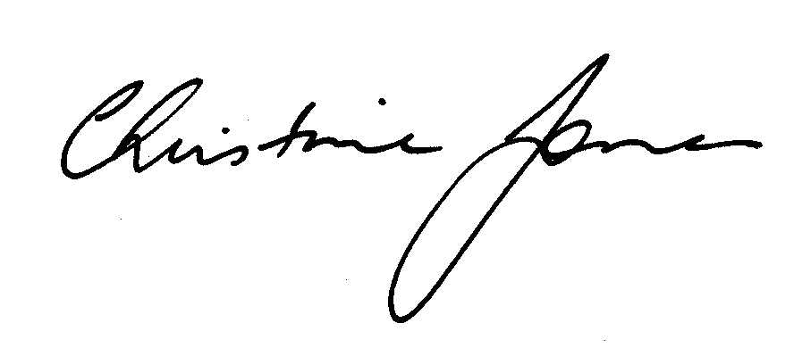
Yours sincerely,
Christine Jones
General Counsel

cc Richard Humphry

