Chapter 3

ECONOMIC Models OF THE Petroleum Industry

Introduction
- Mr Joel Fitzgibbon, MP, when he introduced the current bill on 30 August 1999, stated that the aim of the bill was to ‘bring petrol prices down’ and reduce the ‘gap separating city and country fuel prices’. Mr Fitzgibbon stated that these aims would be achieved by ‘giving service station operators the opportunity to shop around for their fuel’.
- This chapter examines the economic workings of the petroleum industry, particularly the effect that the current inability of some service station operators ‘to shop around for fuel’ has on petrol prices.

Economic models of the petroleum industry
- Mr Fitzgibbon claimed a ‘major oil company oligopoly’ controls petrol prices in Australia. The current bill presumes that this oligopoly, comprised of the four oil majors, has produced ‘tied supply’ arrangements which inhibit competition at the wholesale level of the industry thereby increasing retail petrol prices.
- It is certainly true that franchisees’ contracts with their franchisors (the oil companies) prevent franchisees from seeking alternative sources of fuel. This prohibition on seeking alternative sources of fuel allows franchisors to dictate prices to franchisees. However, as was made clear in the previous chapter, the major oil companies control some, but by no means all petrol outlets.
- Mr James Starkey, Executive Director, Australian Institute of Petroleum (AIP) gave evidence to the effect that even though there are now only four domestic refiner marketers the majority of service stations are not tied exclusively to those four companies in the sort of franchise arrangements detailed in the preceding chapter. According to Mr Starkey, only some 40 per cent of service stations were tied to the refiner marketers. The term ‘oligopoly’ is therefore too strong a word to denote the retailing activities of the oil majors in Australia.
- Mr Fitzgibbon himself mentioned that the benefits of competition had accompanied the advent of ‘Woolworths and other independents’ retailing petrol. The petroleum industry in Australia therefore cannot be a strict oligopoly, controlled entirely by the four oil majors, rather the industry is a hybrid, exhibiting elements of both an oligopoly and a fully competitive market. This hybrid is generally known in economic theory as the dominant firm model.
- In the dominant firm model, the dominant firm, in this case the oil majors as a group, attempts to behave as a monopolist by producing too little product and charging too high a price for it, so as to maximise its own profits. This behaviour results in a loss for consumers. This loss in the dominant firm model, however, is not the loss that would be suffered by consumers in a pure monopoly situation because the behaviour of the dominant firm is tempered by the fact that at the market fringe small companies, in this case the independents, are competing. The price faced by consumers therefore lies somewhere between the price that would be set by a monopolist and the price that would result from a competitive marketplace.
- The dominant firm model is an appropriate way of looking at the retail price of petrol in metropolitan and larger country areas. The situation with regard to retailing petrol in rural and remote areas, however, is different.

Petroleum industry in country areas
- It is important to make a distinction between different types of country areas. It would be overly simplistic to lump all country areas into the same category as low volume/higher price environments. Caltex informed the Committee that, while ‘some’ country towns have relatively high pump prices, the retail price of petrol in many country towns is ‘highly competitive’. The ‘main driver’ of competition in these towns, according to Caltex, is the independent chains, in particular Woolworths. Caltex data suggested that country towns in which Woolworths is operating tend to have lower priced petrol than others.
- Independents are constrained by economic considerations to operating in larger regional centres. Consumers in rural and remote areas, by contrast with those in larger country centres, face relatively higher retail petrol prices.
- The density of service stations in rural and remote areas is far less than that of service stations in city areas, and even in populous regional areas. Distances between service stations in rural and remote areas mean, in many cases, that a particular service station possesses a monopoly on the supply of petrol in a particular region. If the service station behaves as a monopolist, and there is no economic reason why it should not, then it will maximise its profits to the detriment of consumers.
- Even in rural areas with several service stations within a reasonable distance of one another, there would be a tendency on the part of the members of this small group of service stations to match one another’s prices, rather than compete, because consumers would not readily be able to avoid buying fuel from a member of the group. The behaviour of such service stations would therefore more closely match the behaviour of the type of oligopoly referred to by Mr Fitzgibbon his speech to the House of Representatives on the bill. The service stations in such an oligopoly will tend to match the pricing behaviour of a monopolist.
- One of the factors that allows the oligopoly to continue to operate is that start up costs in the petroleum retailing industry are large. The cost of purchasing a site, pumps etc is considerable. Moreover, during the start up phase of any new entrant to the industry the established members of the oligopoly may engage in predatory pricing, that is, they may use their superior resources to retail petrol at a loss for the purpose of driving their new competitor out of business.

Price structure
- The basic aim of increased competition in the petrol market is to drive down the price faced by consumers (or increase the quality of service provided to consumers). Elementary economic theory suggests that reduced prices should flow naturally from increased competition. This, however, assumes the existence of a sufficient margin in the cost structure of petrol for price cuts. A pertinent question is - is there currently sufficient profit in petrol prices to allow prices to fall in response to increased competition?
- The oil majors maintained throughout this inquiry that their profitability from refining is low. This assertion is supported by the survey undertaken by Ernst and Young in 1999 (see paragraph 3.25). Accordingly the price movement at the wholesale level produced by greater competition is likely to be small in percentage terms in relation to the total price paid by the consumer, particularly if high crude oil prices continue.
- The following example from Shell illustrates the relative cost make up of petrol prices:
Sydney petrol price = 95.7 cents per litre
comprised of:
Tax (incl. GST) 46.8 cents
Refinery Price 45.1 cents
Shell/retail margin 3.8 cents
- Added to these costs, and this particularly affects country consumers, are transport costs, and distributors’ and dealers’ margins.
- As can be seen the major proportion of the price of fuel is either tax/excise and or the wholesale or refinery oil price. The tax/excise component of the price of fuel is determined by the Government and prevailing economic conditions; this part of the price of fuel is therefore beyond the control of the oil companies. The wholesale or refinery price is set to match the prices quoted by the overseas oil producers and is heavily influenced by, for example, the price of crude oil set by the oil cartel OPEC. Domestic based oil companies therefore have limited scope to influence the wholesale or refinery price.

Petrol taxes
- Since July 2000, the tax on petrol comprises a set excise rate and the Goods and Services Tax (GST) of ten per cent. Until March 2001, the excise rate was adjusted twice a year for inflation. At the time of writing the combined excise and GST amounted to 46.6 cents per litre. According to Shell, tax increases on petrol – from six cents per litre in 1980 to the current level – have mainly driven the rise in petrol prices, until the recent increase in the world price of oil.

Refinery price
- Until 1 August 1998 the Australian Competition and Consumer Commission (ACCC), and before it the Prices Surveillance Authority, set ‘indicator price levels’ for petrol and distillate. These indicator prices were import parity prices based on bulk ex-refinery prices in Singapore to which was added the notional cost of freighting fuel to Australia. Singaporean prices were chosen because Singapore, a major oil refining centre, would be likely to be the source of fuel imported to Australia.
- Australian petrol is largely based on oil refined in Australia. Import parity pricing meant that Australian consumers paid the international price of fuel, that is, they paid a price equivalent to what they would have to pay if all fuel had to be imported. The rationale for this was that Australia, by refraining from selling fuel at a price lower than the international price, conserved its scarce oil reserves.
- Import parity pricing is no longer enforced but economic forces dictate that it continues to be used. If petrol, for example, were to be sold in Australia at a price markedly less than its wholesale price in Singapore, then the oil majors would simply export fuel from Australia to Singapore. The wholesale or refinery price in Australia thus continues to be set by the import parity pricing formula.
- Import parity prices are influenced by international factors (for example, as can be seen in the diagram below, the refinery price closely tracks the well price of crude oil). These international factors are obviously outside the control of Australian-based oil companies. Thus the increase in the Singapore refinery price, due to fires causing lost capacity in Kuwait and Indonesia, impacted greatly on Australian petrol prices in 2000.
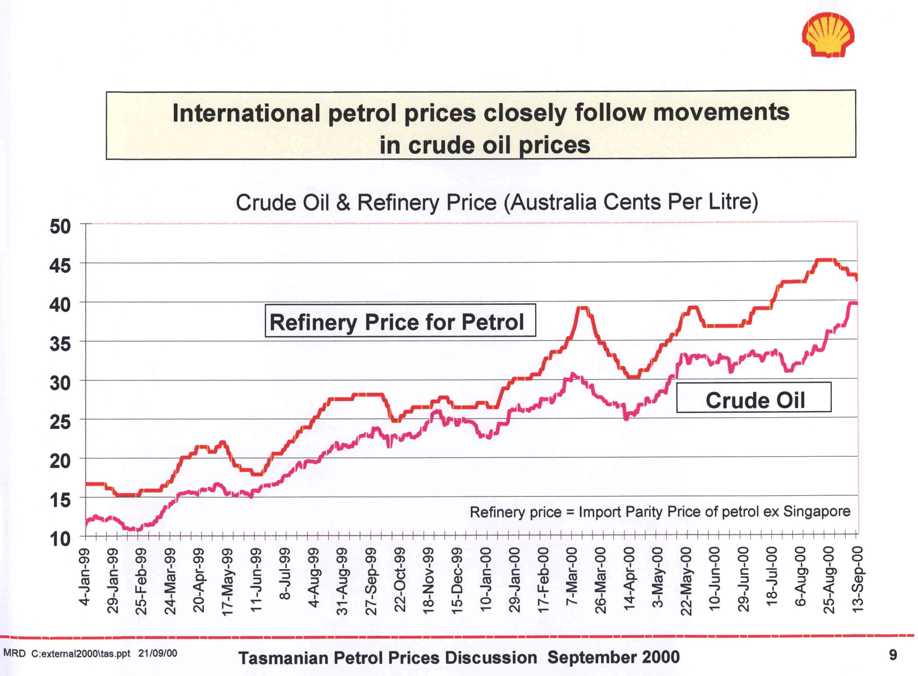

- Shell, and the other oil majors, based on the foregoing information, appear to have little scope for reducing wholesale margins to such an extent that there would be any significant reduction in petrol prices. While this proposition may be true to a large extent, the widespread existence of price support, discussed later in this Chapter, indicates that at least part, albeit a small part, of the wholesale price of fuel in Australia is an artificial construct which is determined by the oil majors.

Oil companies’, distributors’ and dealers’ margins
- The oil majors contend that their profit margins are slim, reflecting what they consider to be the intensely competitive Australian petrol retailing market. Shell cited an Ernst and Young survey which calculated that in 1999 the downstream oil industry in Australia averaged a return of less than four per cent on assets which approximates to less than one cent per litre. Shell provided the following diagram to the Chair of the Committee illustrating the decline of the oil majors’ profit margins.
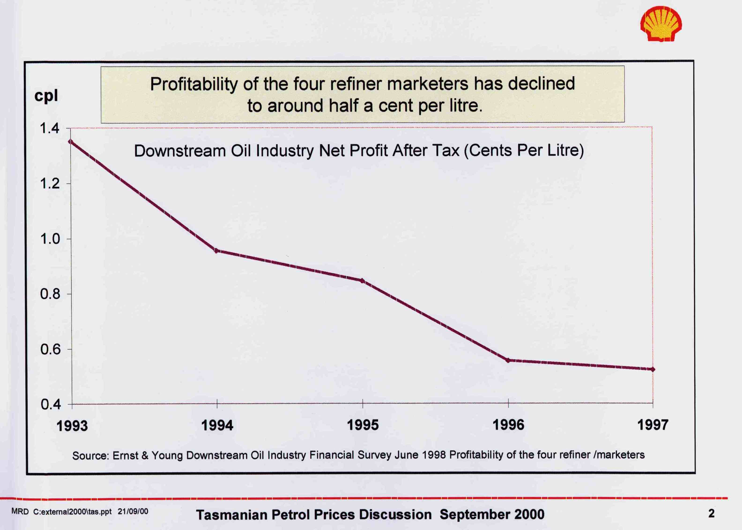
- Distributors’ and dealers’ margins are particularly pertinent to country prices and so are discussed below.

Factors influencing country petrol prices
- One of the stated aims of Mr Fitzgibbon in introducing his bill is to reduce the gap between city and country prices. It is therefore worth noting the factors that have produced the city/country price differential.
- As was noted in the previous chapter, the bulk of service stations operating under franchise arrangements are in metropolitan areas. Most rural petrol stations are operated either under distributor arrangements or by owner/operators. As rural areas tend to receive supplies from distributors rather than direct from oil terminals, the cost of distributors’ operations adds another cost into the bowser price in rural areas.
- Retailing petrol in rural and remote areas also involves higher transport costs relative to retailing operations in cities. According to Shell, the average difference between country and city freight costs is, for example in NSW, 1.9 cents per litre.
- Another factor influencing petrol prices in rural and remote areas is the low volume of petrol sold by many service stations in such areas. As Professor Fels of the ACCC noted:
Low volume service stations usually require higher retail margins to remain viable. It is difficult to envisage that the ability of a low volume branded franchisee to resource some part of its supply requirement from lower cost suppliers will lead to substantial reductions in retail prices, particularly in country areas.
- Unlike metropolitan markets, where price wars can be triggered by discounting in one area spreading quickly across a city, discounting in country areas generally fails to attract sufficiently high increases in volume for it to be a viable practice. As a consequence, as Professor Fels noted, country areas do not share the intensely competitive environment that characterises metropolitan markets.
- One solution could be to increase the volume of service stations by having fewer sites. However, the loss of small business and employment opportunities could cause further difficulties in country communities.
- In rationalising the number of country service stations, a balance must be reached to ensure a healthy level of competition is maintained. Too few sites may reduce competition and allow service stations in particular regions to behave as monopolists.
- The oil majors support Professor Fels’ statement. Shell indicated that country stations generally sell less than half the fuel of a metropolitan site; Mobil claimed the volume is on average one third of city sales. According to Caltex, in country stations:
Relatively higher prices do not mean that these prices are excessive or unfair as volumes are typically much lower than in the city, there is less non-fuel income, driveway service is common and credit is often extended on generous terms – as a result, costs per litre are high.
- Lower volumes of petrol sales translate into higher margins for country stations to remain viable.
For example, to recoup wage costs of $100,000, a typical metropolitan site requires a fuel margin of 2.5 cents per litre. In a typical country service station which sells only half as much fuel, 5.0 cents per litre is required to fund the same cost.
- Lower volumes in the main and higher services have the combined effect of both pushing retail margins up and diminishing competitive pressures in country areas. Based on Shell figures, a comparison showed that, on average, stations in country NSW had a retail margin of 8.8 cents per litre (at petrol costing 76.7 cents per litre), whereas the Sydney retail margin was 5.9 cents per litre (at petrol costing 73.0 cents per litre).

Price support
- Price support is a payment offered to some franchisees by oil companies for a specific period during which an oil company virtually underpins a service station operator’s profit margin to ensure that the site remains viable even though petrol is being retailed at a price below the wholesale price. The Committee heard evidence from site owners to the effect that price support constrains owners from setting their own retail prices due to the threat of the company withdrawing support.
- Evidence was presented showing that city sites received considerable price support. In material provided to the Committee, Mobil indicated that:
In looking at the capital city markets, for the period from March 1999 to today, there has only been an occasional day and only in some markets where no price support was provided by Mobil to its franchisees. Effectively across all capital cities, we have provided support 98% of the time since March 1999.
- However, Mr Pynt of the SSA told the Committee that there is very little price support available to country operators.
- Mr McKenzie of Shell distinguished between two groups of retailers. The independent chains and owner dealers who comprise 60 per cent of sites supplied and franchisees. Typically, owner dealers and independents negotiate a wholesale price and then ‘are on their own’.
- Mr McKenzie, however, remarked that there is a ‘strong interdependence’ between Shell and its franchisees:
The nature of the pricing arrangement is such that [franchisees] effectively have their fuel margin underpinned at a 3c minimum margin. In some markets they can get more than that, but, when the market price falls through price support, Shell will ensure that they get a minimum margin of 3c a litre.
- Interestingly the oil majors maintained that tied supply was a necessary prerequisite for franchisee price support. They argued that they could not, and therefore presumably would not, offer price support when they could not be guaranteed that they were offering price support in respect of their own products rather than those of competitors.
- Mr McKenzie of Shell informed the Committee that while Shell cannot control the retail price, Shell does ‘have an influence on the retail price because [Shell] controls the wholesale price’. This statement would seem to imply that the oil majors do have some room to manoeuvre with regard to setting the wholesale price of fuel.

Barriers to entry of independents
- As was noted by Caltex, the presence of independents in country areas tends to drive down the retail price of petrol. The entry of independents into the country market is, however, problematical.
- Professor Fels of the ACCC also referred to difficulties in establishing new sites in country areas, noting several impediments including:
… one within the current legislative framework: something more needs to be done regarding planning restrictions on new entry into rural areas by service stations. We believe that one of the causes of the lack of competition in many rural areas is the fact that it is fairly difficult in some towns and areas for new players to enter markets because there are planning objections often orchestrated by incumbent service station operators.
- Professor Fels reiterated that under planning laws it is quite hard for independents to break into country towns and suggested that ‘more pressure’ be applied to enable the entry of independents into rural areas.
Recommendation
The Committee recommends that the Government commence discussions with a view to making local government authorities more amenable to facilitating the entry of independents into rural areas.
- Mr Kevin of Liberty Oil expressed the view that the major problem in country areas is a lack of competition. Further, he stated that Liberty had unsuccessfully sought to purchase sites in regional areas but have been discouraged by covenants applied to oil company sites to prevent the sites being reused as a service station.
- Liberty Oil considers the disparity between country and city prices of concern in that it appears to have grown wider. Oil companies explain that using multi-site operations enables greater efficiencies and lower costs. However Mr Kevin suggested that there is no evidence that these efficiencies are reaching the country motorist.
- Liberty concluded that in its view the majors are determined to keep prices high in regional areas by ensuring the competition from independent players is restricted. Mr Kevin continued:
This is evidenced by the way the major oil companies sell sites and ensure that they do not reappear as a service station as they are sold with restrictive covenants. This is having a real effect on the ability of independents to enter these regional markets and should be investigated by the Committee.

Rebate schemes
- Rebate schemes are another factor influencing the price of a variety of fuels in various areas. One of these schemes is the Diesel Fuel Rebate Scheme.

Diesel Fuel Rebate Scheme
- The Diesel Fuel Rebate Scheme provides a rebate for customs or excise duty that a consumer has paid in relation to diesel, or a ‘like’ fuel, which has been used in certain off-road business activities. These business activities include:
- mining
- agriculture
- forestry
- fishing
- rail transport
- marine transport
- electricity generation for residential premises, and
- the operation of hospitals, nursing and aged care homes and other medical institutions.
- As part of the new tax system reform package, the Commonwealth Government has introduced other fuel rebate schemes to assist certain industries. These are:
- the Diesel & Alternative Fuels Grants Scheme; and
- the Fuel Sales Grants Scheme.

Diesel & Alternative Fuels Grants Scheme
- This scheme is referred to as the on-road scheme and it applies to fuel used by transport vehicles from 1 July 2000. Generally the grant is available to businesses and other entities for on-road use of vehicles using diesel and alternative fuels as long as such vehicles have a gross vehicle mass (GVM) of 4.5 tonnes or more and are registered for use on public roads.
- This scheme aims to assist rural and regional users in particular and therefore eligibility for a grant is restricted to vehicle trips undertaken, at least in part, outside a defined metropolitan area. Trips undertaken entirely within a defined metropolitan area are not eligible for a grant.

Fuel Sales Grants Scheme
- The Fuel Sales Grants Scheme provides a grant to fuel retailers for the sale of petrol and diesel to consumers in regional and remote areas, where fuel prices are generally higher.
- For regional areas, the grant rate will be one cent per litre, and for defined remote areas two cents per litre. If fuel has been sold consistently in a remote areas at more than $1.20 per litre then fuel retailers in that area may apply to the ATO for an additional grant. Eligible regional and remote zones have been defined and maps of the areas are available on the ATO’s website.
- The ACCC will monitor this scheme using the price exploitation provisions of the Trade Practices Act.

State Rebate Schemes
- In 1997 the High Court ruled that the Commonwealth’s Constitution gave the Commonwealth Government the exclusive right to levy excise. The Court found that a tobacco franchise fee was in reality an excise and therefore no State or Territory had the right to collect such a fee. This decision cast such doubt upon the validity of the States and Territories imposing franchise fees on fuel and liquor that the States and Territories also ceased to collect them.
- The franchise fees on fuel (and also tobacco and liquor) were levied by the different States and Territories at different rates. Motorists in different States and Territories thus faced different retail prices
- The Commonwealth Government now collects all fuel excise, which is levied at a uniform rate throughout Australia, and remits it to the States and Territories. The States and Territories in turn rebate appropriate amounts to service stations so that the end result is that consumers pay a price roughly equivalent to what they would have paid had State and Territory excises not been found to be invalid.
- The net result of the High Court’s decision in 1997 is therefore that the States and Territories use rebate schemes to replicate the pre-1997 situation by the use of rebate schemes. Since the pre-1997 fuel franchise fees imposed by the States and Territories differed widely the rebate schemes also differ widely and therefore impact on retail petrol prices in a variety of ways.

First Reading Speech, House of Representatives Hansard, 30 August 1999, p 9333.
First Reading Speech, House of Representatives Hansard, 30 August 1999, p 9333.
That is, the supplier or franchisor (usually an oil company) has exclusive supply rights - the franchisee is therefore “tied” to the franchisor.
Evidence, p. E200.
Stanley Fischer and Rudiger Dornbusch, Economics, McGraw-Hill, Singapore, 1983, p 253.
Fischer and Dornbusch, Economics, p 253.
Submission No. 44, Caltex, pp.5-6.
Submission No. 44, Caltex, p.5 and Chart 6, ‘Price versus Number of Sites showing impact of Woolworths’.
First Reading Speech, House of Representatives Hansard, 30 August 1999, p 9333.
Fischer and Dornbusch, Economics, p 253.
As of 28 September 2000.
Note that the Government abolished excise indexation in March 2001, Prime Minister’s Press Conference, 1 March 2001.
‘World Prices’ at www.shell.com.au/petrol pricing.
Inquiry into the Petroleum Products Declaration, Australian Competition and Consumer Commission, 1996, Volume 2, Appendix G, p 27.
Inquiry into the Petroleum Products Declaration, p 26.
Correspondence to Senator Murphy from Ms Wendy Lyons, Shell, 13 October 2000, p. 9.
Information from the BP website at www.bp.com.au/YourBPStore/Fuel_Pricing/r_price.htm
‘Frequently Asked Questions’ at www.shell.com.au/petrol pricing (28 September 2000). Caltex’s Half Year Financial Result for June 2000 reported a net profit on petroleum fuels of 0.7 cents per litre after tax; Caltex Australia Ltd, Half Year Financial Result For the Half-Year Ended 30 June 2000, 25 August 2000, p. 4.
Correspondence to Senator Murphy from Ms Wendy Lyons, Shell, 13 October 2000, p. 2.
Submission No.41, AIP, p. 6.
Submission, No. 45, Shell, p. 13.
Evidence, p. E195.
Evidence, p. E187.
Submission No. 45, Shell, p. 13.
‘The Facts About Petrol Pricing’, www.mobil.com.au, p. 1.
Submission No. 44, Caltex, p. 6.
‘Frequently Asked Questions’ at www.shell.com.au/petrol pricing (28 September 2000).
‘Country prices’ at www.shell.com.au/petrol pricing (29 September 2000).
Evidence, p. E4-5.
Mobil, correspondence to the Committee, 20 July 2000, p. 2.
Evidence, p. E27.
Evidence, p. E160.
Evidence, p. E160.
Evidence, p. E160.
Submission No. 44, Caltex, p.5 and Chart 6, ‘Price versus Number of Sites showing impact of Woolworths’.
Evidence, p. E214.
Evidence, p. E187.
Submission No. 29, Liberty Oil, p. 2.
Submission No. 29, Liberty Oil, p. 3.
Information obtained from various facts sheets on the ATO tax reform web site.
Information obtained from various facts sheets on the ATO tax reform web site.
Ha and anor v State of New South Wales & ors; Walter Hammond & Associates v State of New South Wales & ors (HC) 1997.

