Summary

Did effective tax rates for large companies increase during the 1990s, and if so what were the revenue benefits?

- Yes. The estimated revenue benefits are set out below.

- Broadly-based measures of effective tax rates available for large companies indicate a generally significant and fairly steady increase over the period 1991/92 – 1997/98:

- the ratio of tax payable to total assets increased: from 0.6% to 0.7%
- the ratio of tax payable to total income increased: from 1.5% to 1.7%
- the ratio of tax payable to sales increased: from 2.4% to 2.5%

- The revenue benefits of these increases are estimated to have been worth over the period 1991/92 – 1997/98:

- for the increase in the ratio involving total assets: $5.5 billion in tax payable
- for the increase in the ratio involving total income: $4.3 billion in tax payable
- for the increase in the ratio involving total sales: $3.5 billion in tax payable
Note: these estimates are not additive.

Have total company collections been increasing faster than nominal GDP?

- Yes. This is demonstrated in the attached chart for the period 1986/87 – 1998/99 (see page 15).

- Over the most recent 5-year period, 1993/94 – 1998/99, total company collections increased by some 63%.

- This increase becomes 50% after ‘discounting’ for the increase in the company tax rate from 33% to 36% during this period.

- By contrast, nominal GDP increased by some 33% over the same 5-year period.

Estimated Changes In 'Effective Tax Rates'
For Large Companies:
Their Implications For The Revenue,
1991/92 - 1997/98

Background
Typically in public discussion, the effective tax rate applying to companies is computed as the ratio of some measure of Tax Paid to Accounting Profit. However, this is only one of numerous equally valid measures. There is no such measure as the effective tax rate.

Ideally, the choice of measure should reflect the particular question being addressed. Moreover, when changes in effective tax rates are being considered the ATO has found it is necessary to examine several different measures simultaneously.

This is because it is unlikely that all relevant measures of effective tax rates will be moving in the same direction over the same period of time. Such divergence reflects the often complex interplay between changing market conditions and the tax system. For example, most if not all measures of effective tax rates are influenced by losses ‘carried-forward’ from previous years as well as by current market conditions.

It is only when all relevant measures of effective tax rates have increased (decreased) that it can be concluded without further analysis that effective tax rates have unambiguously improved (deteriorated) over the period in question. Otherwise, further analysis will be required to draw meaningful conclusions. These will need to take into account the underlying reasons for the changes in each of the measures, and the relationships between them.

In this context, it is important to appreciate that measures of effective tax rates involving ‘profitability’ can be quite volatile over short periods of time, and so identifying any single trend here can be difficult. This problem arises largely because changes in profitability are the net result of changes in income less deductions. The problem is less likely to arise where the effective tax rate measure does not involve such a net result, for example a measure based on total assets, total income or sales.

Most analyses of effective tax rates seek to make comparisons against the statutory tax rate. Thus it is appropriate to use tax return data to compute effective tax rates by changing either or both of the top/ bottom lines in the following equivalent formulae which produce the general statutory tax rate for companies (currently 36%):

Gross Tax/ Taxable Income or

(Tax Assessed + Rebates)/ Taxable Income

(Note: The terminology here is the same as that used in the 1998/99 company income tax return form.)

We have already provided the Committee with a chart showing a general upward trend in one measure of an effective tax rate for large, SME and all companies over the period 1992/93 – 1996/97 (see page 15 of Response To Question On Notice, dated 30 August 1999). This measure is computed as the ratio of taxable income to total assets. The chart is attached again in this present response (see page 13).

The following further set of three overall effective tax rates estimated for large companies from tax return data for the period 1991/92 – 1997/98 are likely to be the most appropriate for responding to the questions raised by the Senate Committee on 9 February, which put a stronger focus on links to the revenue (see chart on page 7).

The use of ‘tax payable’, rather than ‘taxable income’ in each of these three effective tax rates is appropriate since it provides the most direct link to the revenue. This is because ‘tax payable’ takes into account rebates and various kinds of tax credits, including foreign tax credits.
(Note: Tax Payable = [Gross Tax – Rebates – Credits] = [Tax Assessed – Credits].)

- (Tax Payable)/ Total Assets
- (Tax Payable)/ Total Income
- (Tax Payable)/ Total Sales

These are broadly-based measures of effective tax rates and are therefore of particular importance, reflecting the link between tax and levels of economic activity.

By contrast, for the reasons noted above, we have not included estimates for the corresponding effective tax rate involving profits. This measure proved to be extremely volatile over the period for which data are available (1991/92 – 1996/97). It would appear there was a downward trend over this period for this measure. However, without considerable further analysis we are unable to draw any meaningful implications for the revenue from it.

Estimated Changes In Effective Tax Rates 1991/92 – 1997/98
Estimates of changes in effective tax rates over this period have to allow for the impact of changes in the statutory tax rate (down from 39% to 33% in 1993/94, and up to 36% in 1995/96). The following ‘normalised’ estimates have been calculated on the basis that the 36% rate applied over the whole period.

In summary, the attached charts and table indicate that each of the three selected effective tax rates can be viewed as either having held steady or improved throughout the period.

The charts reflect the fact that over the period:

(Normalised) tax payable grew by some 71%
Total assets grew by some 59%
Total income grew by some 54%
Total sales grew by some 62%

Inferences
Collectively, these movements in effective tax rates largely account for the significant and fairly steady increase in the average (normalised) amount of tax payable by large companies over the whole of the period 1991/92 to 1997/98. The increase here was from $411 million in 1991/92 to $665 million in 1997/98 (see chart on page 8).

However, whilst this observation is valid, it should be noted that the above types of effective tax rates have three significant limitations. These limitations reflect the limitations of tax return data.

First, effective tax rates based on tax return data cannot capture the impacts of tax avoidance and evasion, such as profit shifting, which take the form of under-reported taxable income.

Second, effective tax rates based on tax return data cannot capture the impact of compliance initiatives (including audits) which result in amendments to the amounts reported in tax returns.

Broader analyses, such as comparisons of tax collection trends against GDP are required to address these two limitations. Our previous submission, referred to above contains such a comparison (see page 17 of that submission). It is attached again in this present response (see page 15), together with further comments below.

Third, the estimates are necessarily based on an aggregation not on a consolidation of tax return data across group companies. Thus, for each year, intra group transactions result in an unknown degree of ‘double counting’ of income and expenses in the aggregated tax return data. Such double counting is likely to be particularly troublesome for analyses of aggregated effective tax rates involving profitability. (Note: There is no ‘double counting’ in relation to ‘tax payable’.)

Revenue Implications
The following table provides estimates of that part of the revenue (measured as tax payable) covering the period 1991/92 – 1997/98 which can be attributed to the estimated year-by-year changes in the selected effective tax rates for large companies. 1991/92 is used as the base year for making these estimates.

Generally, such revenue estimates (i) cannot be totalled across different types of effective tax rates, and (ii) have been calculated on the basis that the 36% company tax rate had applied over the whole period.

Effective Tax Rate Measure:  Tax Payable/ | 1991/92  Estimated  Rate (%) | 1997/98  Estimated  Rate (%) | 1991/92 – 1997/98  Additional Tax Payable
Effective Tax Rate Measure:  Tax Payable/ | 1991/92  Estimated  Rate (%) | 1997/98  Estimated  Rate (%) | $billions | (%) Actual Tax Payable
Total Assets | 0.6 | 0.7 | 5.5 | 6.6
Total Income | 1.5 | 1.7 | 4.3 | 5.2
Total Sales | 2.4 | 2.5 | 3.5 | 4.2

Have Total Company Collections Been Increasing Faster Than Nominal GDP?

The notes following the chart on page 17 of our previous response indicated that comparisons involving recent trends in total company collections (as distinct from tax payable) need to take into account the ‘bring forward’ revenue effects accompanying the introduction of the quarterly instalment payment (COIN) regime in 1994/95.

Treasury Budget Paper No. 1 of 1994/95 indicates at page 4.32 that “the temporary boost to revenue from bringing forward company tax payments” would have no significant impact in 1997/98 and subsequent years. Therefore a comparison of revenue collections in 1993/94 and 1998/99 is not substantially affected by the ‘bring forward’ of collections which occurred in the intervening years.

Over the 5-year period 1993/94 – 1998/99:

- Total company collections increased by some 63%.

- This increase becomes 50% after ‘discounting’ for the increase in the company tax rate from 33% to 36% which occurred during this period.

- By contrast, nominal GDP increased by some 33% over the same period.
(Note: Comparisons of trends in collections against trends in real GDP are not meaningful.)

This comparison of trends in company collections and in nominal GDP provides strong supporting evidence of a broadly-based improvement in effective tax rates.

Part of this improvement is due to such factors as improving levels of sales, profit margins, etc.

But some of this improvement is undoubtedly due to the various compliance initiatives undertaken by the ATO during this period, including those undertaken in support of tax policy changes.

Our previous submission documented these compliance initiatives. In addition, at Wednesday’s hearing we gave recent examples of some of the impacts on the revenue arising from our focus on international transfer pricing. We pointed out that, overall, the tax paid by the group of companies involved in this project more than doubled, to some $166 million, over a three-year period. In addition, there are those compliance initiatives which reduce the amount of losses available for future use by taxpayers. For example, as a result of our transfer pricing work, the losses available for future use by two major exporters have been reduced by $330 million – equivalent to about $100 million in future tax payable.

We are unable to provide an estimate of the relative importance of the various drivers of the observed broadly-based improvement in effective tax rates. As the Commissioner for Taxation indicated in his opening remarks on Wednesday 9 February, the estimating challenges here are very considerable and continue to be faced by all tax administrations.

Normalised tax payable relative to various benchmarks — Large companies
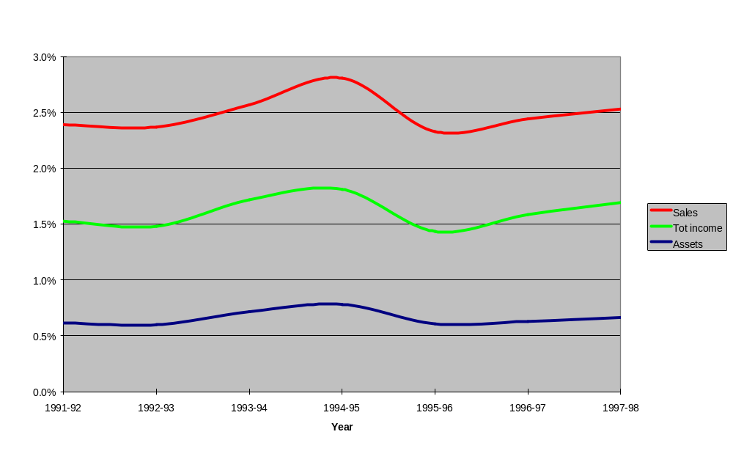

Average normalised tax payable, rebates and gross tax
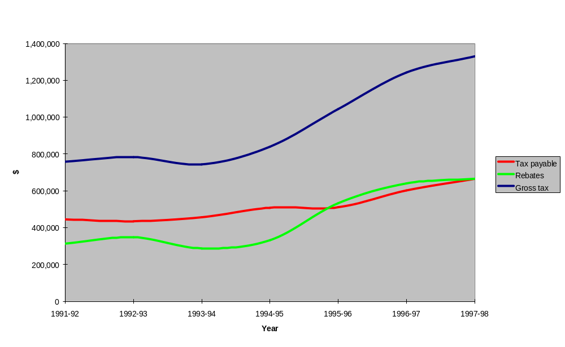
Economic Growth and Tax Performance — Large Companies

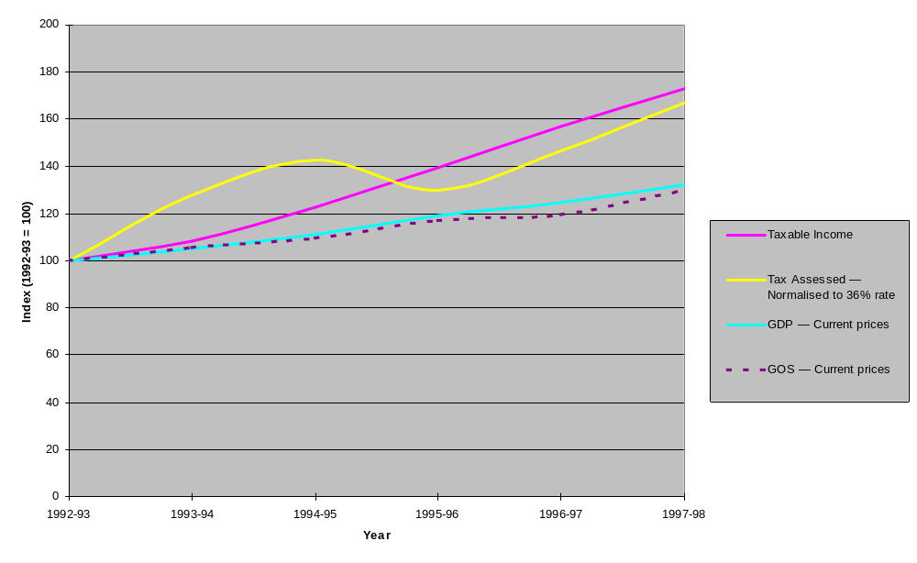

Rationale
- In the absence of significant structural, behavioural and tax rate changes, the tax performance of companies should broadly reflect the general movements in economic activity. This chart therefore compares the tax performance of Large companies with the growth in nominal gross domestic product (GDP) and gross operating surplus (GOS). Large companies are those with total income of $10 million or more.

Main points
- Since the tax rate changed twice over the period, the data for tax assessed have been normalised at 36%.
- On this basis, the overall tax performance of large companies has been very strong, as evidenced by the growth in both their taxable income and tax assessed, relative to GDP and GOS.
- The significant divergence between the patterns of growth in tax assessed and taxable income is largely explained by the increased importance of
section 46 rebates over the period. The increased importance of these rebates reflects growth in dividend flows between companies.

Further comments
- The ratio of GOS to GDP has declined since peaking in 1993-94, reflecting the impact of low inflation and weak commodity prices on corporate profits. In 1997-98 (not shown in the above graph) the ratio rebounded, as indicated in the following table:

Per cent | 1993-93 | 1993-94 | 1994-95 | 1995-96 | 1996-97 | 1997-98
The share of GDP provided by GOS | 31.1 | 31.2 | 30.7 | 30.5 | 29.8 | 30.5

Indexed raw data
- Problems in presenting graphical comparisons of different tax performance indicators arise where there are significant differences in their absolute sizes (eg. $100 billion v $100 million; 60% v 6%). These problems are often effectively addressed by converting the raw data into comparable indexes.

- In the above chart, indexes are constructed by dividing the current values of indicators by the corresponding base period values and multiplying them by 100. The resultant index value of (say) 120 means that the growth in the performance indicator from its base period value has been 20 per cent.

- 1992-93 was chosen as the index base year as the reliability of the indicators is less in earlier periods.

Economic Growth and Tax Performance — Small & Medium Companies

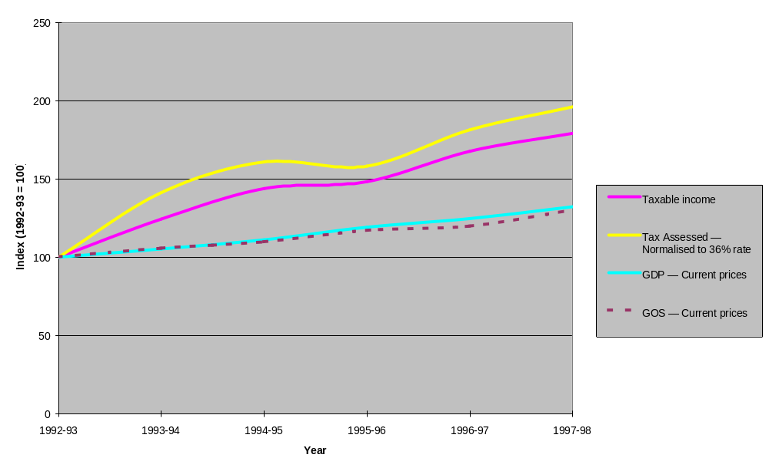

Rationale
- The tax performance of small & medium-sized companies (SMEs) provides another general benchmark against which the tax performance of large companies can be assessed. This chart therefore compares the tax performance of SME companies with the growth in nominal GDP and GOS.

Main points
- The tax performance of SMEs also has been very strong, as evidenced by the growth in their taxable income and tax assessed relative to growth in GDP and GOS.
- Unlike the preceding chart for large companies, taxable income and tax assessed have similar trend lines for SMEs. This is explained by their generally simpler structures and the resulting smaller receipts of inter-company dividends.

Indexed raw data
- Problems in presenting graphical comparisons of different tax performance indicators arise where there are significant differences in their absolute sizes (eg. $100 billion v $100 million; 60% v 6%). These problems are often effectively addressed by converting the raw data into comparable indexes.

- In the above chart, indexes are constructed by dividing the current values of indicators by the corresponding base period values and multiplying them by 100. The resultant index value of (say) 120 means that the growth in the performance indicator from its base period value has been 20 per cent.

- 1992-93 was chosen as the index base year as the reliability of the indicators is less in earlier periods.

Company Tax Performance — Taxable Income Relative to Assets, by Company Type
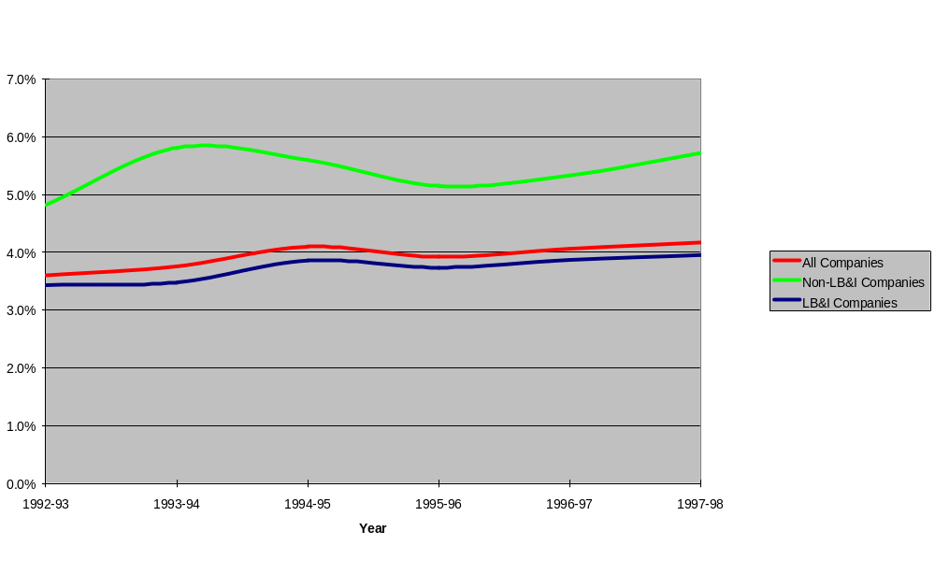

Rationale
- This chart provides a picture of company taxpayers’ taxable income performance relative to their total assets. The ratio here is calculated as Taxable Income/Total Assets. A high ratio, prima facie, indicates strong tax performance relative to assets.

Main points
- A significant proportion of SME companies have few physical assets and rely mainly on the intellectual capital and personal effort of their owners to provide a profit. This explains the generally higher tax performance, relative to assets, of SMEs compared with large companies.
- The ratio for large companies increased steadily over the period, from 3.4% to 4.0%. By contrast, the ratio for SME companies was more volatile, increasing from 4.8% to 5.8%, falling back to 5.2% and then recovering to finish the period at 5.7%.

Further comments
- Caution should be exercised in drawing fine inferences from these ratios as the accuracy of the reported value of total assets varies considerably, particularly for SMEs.
- In addition, large public companies have an incentive to show high asset backing whereas SMEs associated with high wealth individuals have an incentive to minimise their reported assets so as to maintain a low profile.

Growth in Tax Collections, Tax Assessed and GDP
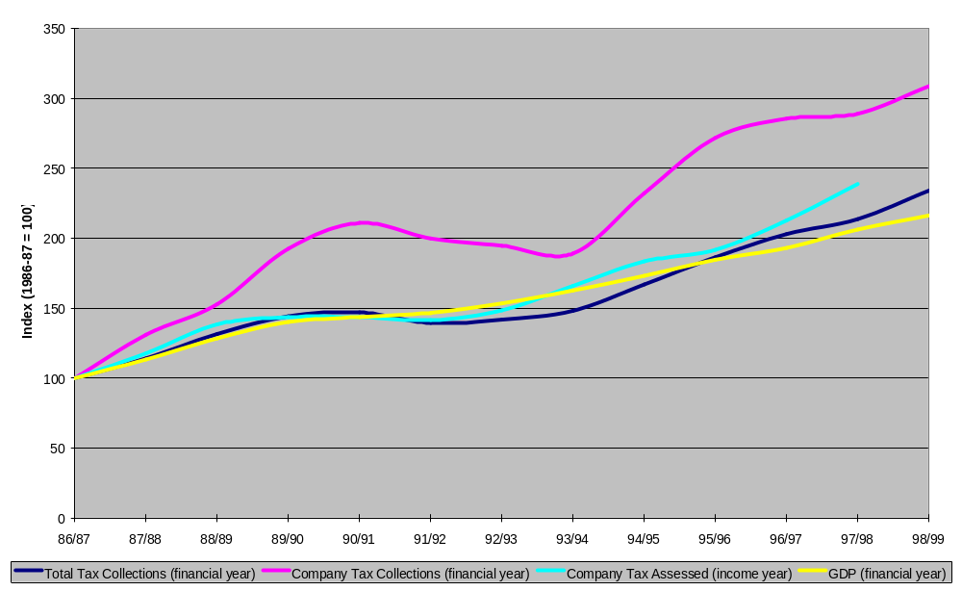

Main points
- The growth in total collections and company tax assessed both dipped below GDP growth in the period immediately after the recession in 1990-91, when prior year losses were used to lower tax liability.
- However, over the full period 1986-87 to 1997-98, both company tax assessed and total tax collections grew faster than nominal GDP, by nearly 16% and 4% respectively. In addition, during 1998-99, growth in company collections have kept pace with growth in GDP.
- Growth in company collections, as distinct from total collections, has a different evolution, well above that of GDP and the other series. This is explained by significant changes to the company tax instalment system, which involved a permanent bring-forward of tax collections. These were:
- the introduction of the 85% - 15% instalment system, affecting the 1989-90 and 1990-91 financial years; and
- the introduction of the quarterly instalment system, affecting the 1994-95 through 1996-97 financial years.
- Their effects were valued in the budget papers of the time as follows:

 | 1989-90 | 1990-91
Introduction of the 85% - 15% instalment system | $885m | $150m

 | 1994-95 | 1995-96 | 1996-97
Introduction of the quarterly instalment system | $600m | $1.62bn | $1.69bn

