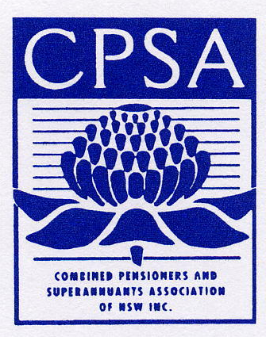 | COMBINED PENSIONERS AND SUPERANNUANTS  ASSOCIATION OF NEW SOUTH WALES INC.
 | Level 3, 25 Cooper Street  Surry Hills NSW 2010 | Telephone: (02) 9281 3588  Facsimile: (02) 9281 9716  Country callers: 1800-451 488  TTY: (02) 9281 3893  Email: cpsa@cpsa.org.au  Website: www.cpsa.org.au

The Secretary
Mr Michael McLean
Senate Environment, Communications, Information Technology and the Arts Legislation Committee
Parliament House
Canberra ACT 2600

Our Ref: GFT.100
19th September 2003.

Dear Sir,

Re: SUBMISSION – Telstra (Transition to Full Private Ownership) Bill 2003

Combined Pensioners & Superannuants Association of NSW Inc (CPSA) was founded in 1931. CPSA is a non-profit, non-party-political membership association which represents pensioners of all ages, superannuants and low-income retirees. CPSA has 130 Branches and 7 Affiliates with a combined membership of over 12,500 people living in all parts of NSW.

Members of CPSA range from younger people on the Disability Support Pension (DSP) and sole parents through to Age Pensioners, superannuants and low-income retirees. Because these people, by definition, are on low fixed incomes, they have a close interest in the preservation of their telephone services which is most important to them. CPSA is also concerned about other low income earners who are not pensioners or superannuants. Working families (with children) who are not well off also need free or greatly reduced-cost access to essential services.

Past experiences indicate that privatisation will mean the loss of Government regulation and the loss of a range of free services to the consumer. A government-run telephone service allows consumers to access a wide range of emergency and essential services including health and family matters.

Please find attached our submission to the Telstra (Transition to Full Private Ownership) Bill 2003. Lack of knowledge of the Senate Enquiry until Friday, September 12, 2003 has given us little time to prepare a more comprehensive submission. We know of other organisations in the same position. We believe an important piece of proposed legislation warrants better advertising.

Yours sincerely

Bruce Hutton
State Vice President

