Mr Michael McLean
Secretary
Senate ECITA Legislation Committee
Parliament House
CANBERRA ACT 2600

Dear Mr McLean

The Australian Greenhouse Office provides policy support for the Renewable Energy (Electricity) Act 2000 (the Act), the Renewable Energy (Electricity) Charge Act 2000 and the Renewable Energy (Electricity) Regulations 2001, collectively known as the Mandatory Renewable Energy Target (MRET).

The Renewable Energy (Electricity) Act 2000 is a world first in mandating market-based trading system for renewable energy and a number of countries are using this legislation as a model. The mandatory renewable energy target is a critical plank in the Government’s greenhouse response and equally a significant and important step towards achieving sustainability in energy supply.

Since the measure commenced on 1 April 2001, nearly 170 power stations have been accredited, encompassing small and large producers using a wide range of fuel types.
Development and market design of the measure was based on extensive consultation and research over a two year period and was the subject of robust debate in the Senate. The legislation is complex and its implementation has revealed a number of minor deficiencies that, collectively, need early resolution to maintain the integrity of the scheme.
The Renewable Energy (Electricity) Bill 2002, introduced into Parliament on
27 June 2002, initiates administrative amendments to address these issues and also seeks to provide for greater efficiency and effectiveness in the administration of the legislation.

The scope of the current amendments are set out in the Renewable Energy (Electricity) Bill 2002, the explanatory memorandum and Dr Kemp’s Second Reading Speech. Further elaboration on the major amendments can be found in the Attachment.

Yours sincerely

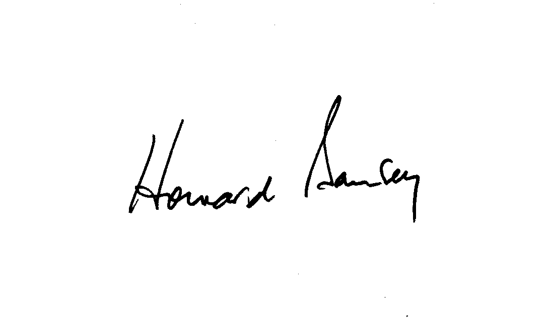

Howard Bamsey
Chief Executive
Australian Greenhouse Office
22 October 2002

