11 October 2002

Secretary
Senate ECITA References Committee
Parliament House
Canberra ACT 2600

Dear Sir/Madam,

Submission to Inquiry into the Renewable Energy (Electricity) Amendment Bill 2002

This submission focuses on Amendments 2 & 47 contained in the Bill. It also supports the submission of the Australian Business Council for Sustainable Energy.

Amendment 2

Amendment 2 provides for a minor change to Section 3, which defines the objects of the Act. This amendment is supported.

However, it is argued that this amendment does not materially address other shortcomings of Section 3 which should be modified to fully reflect the Government's objectives for the Act. Specifically, the objectives of the Act should include "to contribute to the development of an internationally competitive renewable energy industry".

In the Prime Minister's statement entitled "Safeguarding the Future: Australia's Response to Climate Change" dated 20 November 1997, it is stated that mandatory targets for the uptake of renewable energy in power supplies "will also contribute to the development of internationally competitive industries which could participate effectively in the burgeoning Asian energy market".

This objective is reinforced in the Act's Second Reading Speech of Dr Stone in the House of Representatives on 22 June 2000. He stated that the Act's multiple objectives included "providing an ongoing base for the development of commercially competitive renewable energy … [and] … contributing to the development of internationally competitive industries which could participate effectively in overseas energy markets".

The Senate Committee's inquiry into the Act in 2000 supported the Government's objectives.

Given the above evidence of broad bipartisan support for the Act contributing to the development of an internationally competitive renewable industry, it is recommended that as part of Amendment 2, Section 3 be expanded to include:

"Insert:
(d) to contribute to the development of an internationally competitive renewable energy industry".

Amendment 47

Amendment 47 provides for the addition of clauses (2) and (3) to the end of Section 22. It is argued that the same clauses should be added to Section 23B which has the same intent for small generation units as Section 22 has for solar water heaters.

Clause 2 (b) of Amendment 47, when applied to Section 23B, would enable specified guidelines to be developed for small generation units, specifically photovoltaic (PV) systems. These specified guidelines for PV systems should include:

- The ability of owners (or those assigned the right to create RECs) to create the RECs for PV systems for a 20 year period as opposed to the current regulatory provision of a 5 year period.

- The creation of 5 RECs for every 1 MWh deemed from a PV system (alternatively this could be achieved by amending Section 23B by replacing the words "each representing 1 MWh" with the words "each representing 0.2 MWh").

With regard to (1) above, the current Regulations under the Act provide the equivalent of 10 years of RECs to be created for solar water heaters on the basis that a solar water heater is a product that will last for at least 10 years. Rooftop PV is also a product. However the PV modules are typically guaranteed by the manufacturers for twenty five years. This implies a life in excess of twenty five years which is borne out by more than 30 years experience with terrestial applications of PV. Hence it is not unreasonable to deem a 20 year output for REC creation.

With regard to (2) above, the original intent of the Prime Minister's 2% target was to encourage industry development (as demonstrated in the above comments on Amendment 2). PV is an industry in which Australia has had an enviable track record in research, manufacture and usage. However Australia's early lead in this global industry is being lost to Australia's major trading parties (Japan, Europe and USA) who have introduced significant subsidy schemes in order to grow their PV industry and address concerns for global warming. I have attached a recent conference paper I have delivered on this matter. The Renewable Energy Act provides a vehicle for Australia to use a competitive market based mechanism to support its PV industry.

It is also argued with regard to (2) that the current restriction of one REC for one MWh of PV electricity generation does not recognise the unique distributed generation benefits of PV and that accordingly a higher multiplier is justified. Some of these distributed benefits include:

- There are no transmission or distribution losses associated with rooftop PV because PV electricity generation is at the point of consumption. This can typically save 15% in losses in supplying the residential sector.

- Rooftop PV provides voltage support for distribution systems, helping to counter brown-outs caused by low voltages on overloaded distribution systems.
- Rooftop PV displaces costly and inefficient peak-load generation. Most cities in Australia now have peak electricity demands on hot summer afternoons due to rapidly growing air conditioning loads. The output of rooftop PV systems is near their maximum at such times, helping to reduce such peak loads and defer grid augmentations.
- There is growing evidence that rooftop PV encourages homeowners to be more energy conscious and reduce unnecessary electricity consumption.

In summary, rooftop PV is a unique renewable energy technology that is at once a clean supply option and an effective and measurable demand management option. The Renewable Energy Act (and its Regulations) require amendment to more fully reflect the benefits that flow from PV usage and help to grow the PV industry in Australia.

I would be pleased to answer questions you may have regarding the submission.

Yours faithfully,

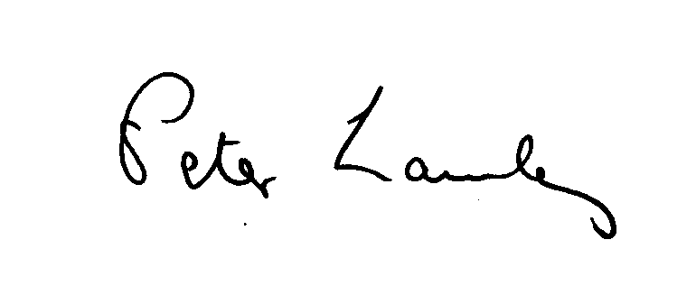

Peter Lawley
Business Development Manager
Pacific Solar Pty Limited

