"Regulatory Risk and how to live with it"*

by
Peter Lawley
Business Development Manager
Pacific Solar Pty Limited
Sydney, Australia
for
ESAA 8th Renewables & Sustainable Power Conference
Alice Springs, 12-13 August, 2002

*This is the second part of a presentation by Dr Muriel Watt and Peter Lawley. Dr Watt's first part provides a report on the findings of the 2001 National Survey of PV in Australia prepared for the IEA PVPS program.

Abstract:
This paper draws on the findings of the 2001 National Survey of PV in Australia. It compares the findings with those for the rest of the world. The main conclusion drawn from this is that Australia has slipped from a leadership position in PV manufacture and use. The reasons for this are advanced and recommendations given for reversing the trend.

Summary & Conclusions:
Australia has led the world in PV research, manufacture and sales. However, despite impressive manufacturing and sales growth, Australia has lost its per capita leadership position in both. This is due to an increasing number of Australia's trading partners introducing significant subsidies to foster the development of the grid-connected, residential PV market in their countries. As a consequence local PV manufacture and downstream industries and distribution channels have grown dramatically in those countries.

Unlike those of our trading partners the market stimulation programs introduced in Australia for PV and other renewables have been too small and not targeted at the grid-connected residential PV market. More specifically, the $31 million PV Rebate Program which provides rebates for both off-grid and grid-connected applications, is likely to end in late 2003. This program has enabled virtually all grid-connected residential sales by meeting approximately one third of the cost otherwise borne by the homeowner. Its demise will see PV system prices in this market rise approximately 50% and demand dry-up.

Australia can regain its leadership position in PV manufacture and usage by intelligently adapting the support programs of its competitive rivals. This can be achieved by:
- extending the PV rebate program for grid-connected residential systems in terms of duration and level of rebate with a controlled wind down
- increasing the mandatory renewable energy targets and introducing specific targets for PV to make this program more relevant for PV
- mandating the provision of net metering for all residential PV systems.

It is through initiatives such as these that Australia can utilise its comparative advantages to regain its leadership of a sunrise industry that can deliver sustainable benefits to Australia's peoples, its economy and the environment.
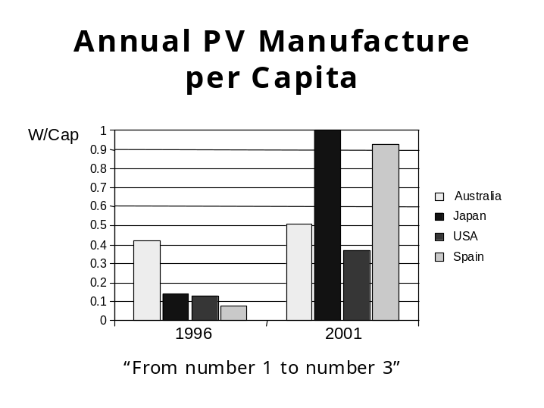
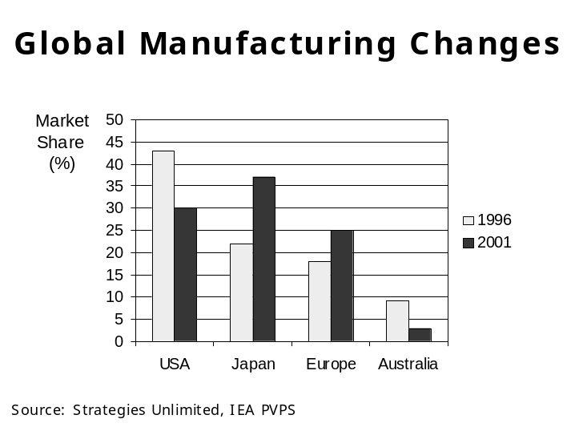
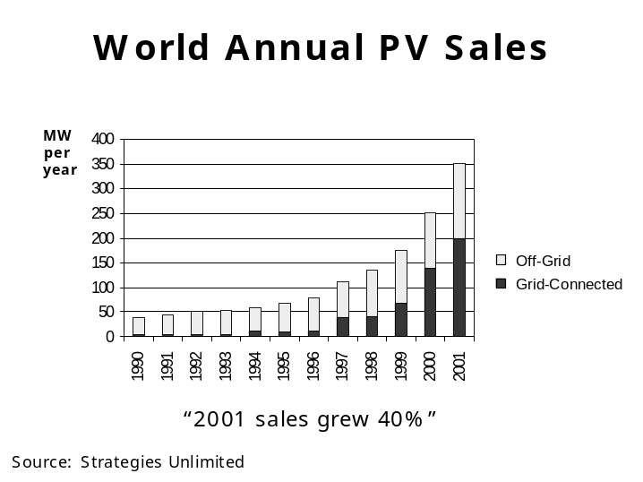
Australia falling behind in PV manufacture
PV manufacture in Australia rose 33% from 7.5MW in 1996 to 10MW in 2001.
However, over the same period Australia fell from being the highest per capita manufacturer of PV to the third highest behind Japan and Spain.
Global changes occurring in PV manufacture
Japan now dominates PV manufacture with Sharp and Kyocera the top two market leaders.
US manufacturing share down one third from 1996 market dominance.
Europe now rivaling US for manufacturing share.
Australia's share down 70%.
PV fastest growing energy source
World PV sales in 2001 grew 40% over 2000 sales.
Five-year annual compound growth rate is 33%.
Market revenues exceed US$3 billion.
Grid-connected share rising faster, accounting for 60% of 2001 sales.
By 2010 annual world sales projected at 2,000 MW to 4,000 MW.
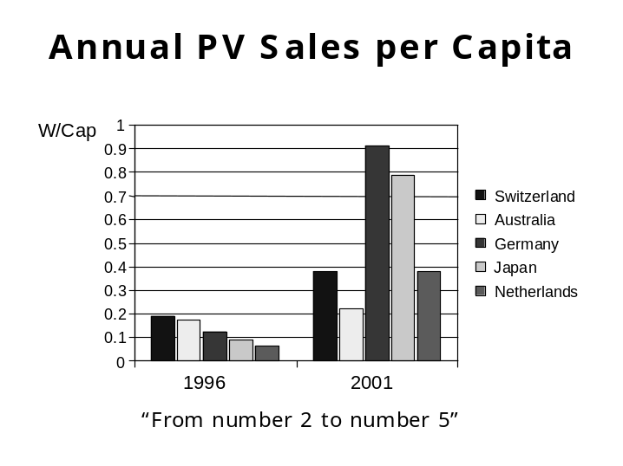
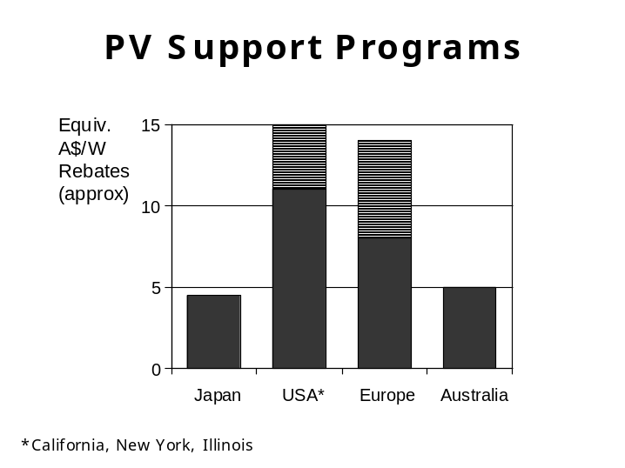
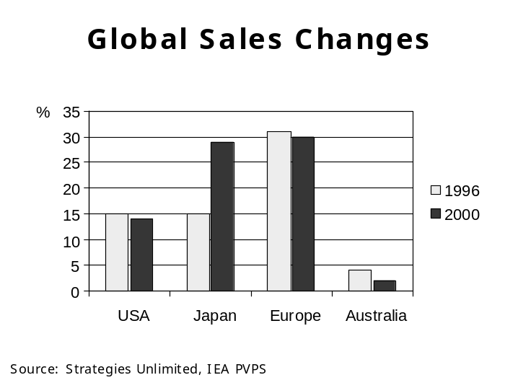
Australia falling behind in PV usage
PV sales in Australia rose 45% from 3MW in 1996 to 4.4MW in 2001.
However, Australia fell from being the second highest per capita user of PV in 1996 to fifth in 2001.
PV support programs major reason for Australia's relative decline
Japan launched its PV rebate program for residential customers in 1994 (rebates have declined in line with PV price falls and increased sales).
Many nations followed suit starting with Germany in 1999.
Growth has been greatest in those countries where PV subsidies make PV competitive with residential electricity prices (eg Germany, Italy, California).
In contrast, the PV rebate in Australia leaves PV two to three times as expensive.
Global changes occurring in PV sales
Japan doubled its relative market share of PV usage between 1996 and 2000 (the latest year reliable figures are available).
Japan and Europe accounted for 59% of world PV usage in 2000.
Australia's relative share of PV usage fell 50% between 1996 and 2000.

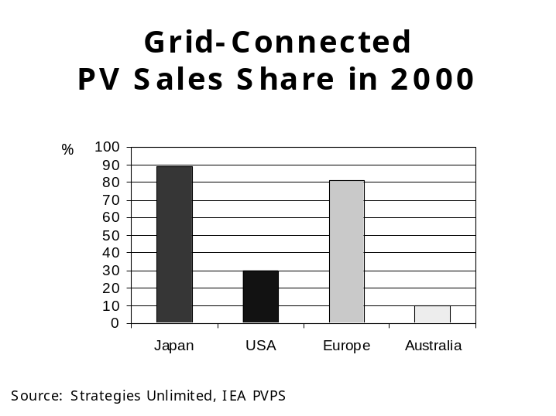
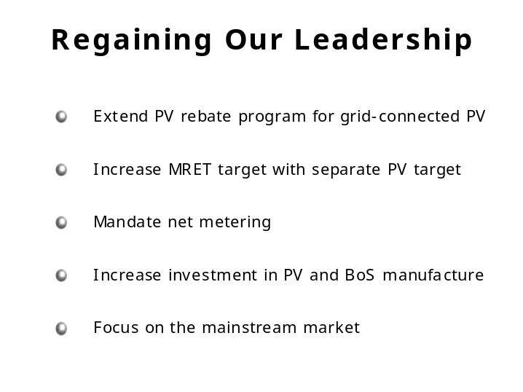
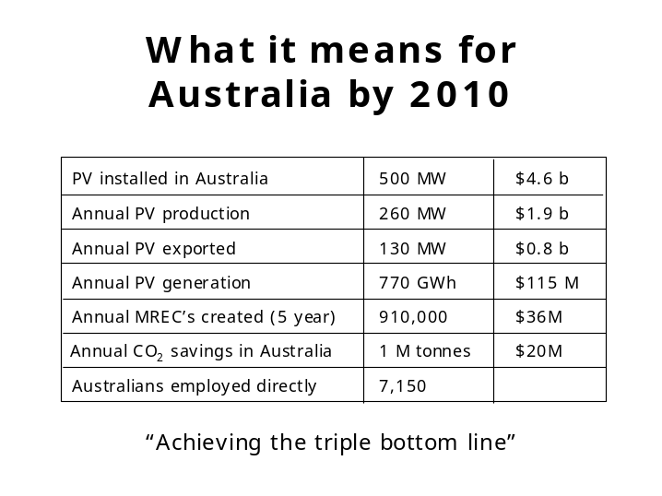
Australian PV usage different to other subsidising countries
More than 80% of PV sales in Japan and Europe are for grid-connected PV systems reflecting the focus of the rebate programs.
In contrast, Australian PV usage has historically been off-grid where unsubsidised PV is competitive with fossil fuels. Ironically, recently introduced rebate schemes favour this application over grid-connected PV.
It's not too late
In 2001 the PV rebate program accounted for 30% of PV sales in Australia. However, it is likely to close in late 2003.
Extension of the PV rebate for grid-connected use should see increased take-up if:
the magnitude is increased from $5/W to reduce the gap between PV and grid-electricity
the program is extended at least another four years
rebates are gradually reduced from 2005.
Towards sustainable energy use
The biggest market for PV is the grid-connected rooftop market (10 million potential customers versus 20 thousand in off-grid in Australia).
Australia can regain a leadership position in a sunrise, sustainable industry through investment by:
industry in manufacturing and distribution
governments in stimulating early grid-connected PV demand
customers in sustainable living.

In 2001 this market accounted for 60% of world PV sales up from less than 8% in 1991.
The off-grid market in Australia is estimated at 20,000 customers compared to an estimated potential of 10 million customers in the grid-connected PV market by 2010. It is growth in the grid-connected market that will lead to significant growth in the PV and related industries as well as material reductions in carbon dioxide emissions.

