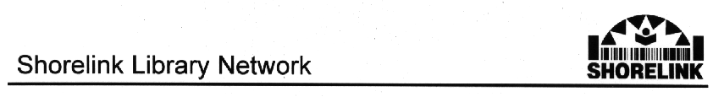

Chairperson: Clr Craig Carland
North Sydney Council

Secretary: Ms Jane Gornall
Lane Cove Library
139A Longueville Road
LANE COVE NSW 2066
Ph: (02) 9911 3634 Fax: (02) 9418 8054
e-mail:jgornall@lanecove.nsw.gov.au

14 August 2002

The Secretary
Senate ECITA References Committee
Parliament House
CANBERRA ACT 2600

Re: Inquiry into the Role of Libraries in the Online Environment

Please find attached the Shorelink Library Network’s submission to the Senate Inquiry into the role of Libraries in the Online Environment.

The Shorelink Library Network would welcome the opportunity to appear before the Committee to provide further information.

Yours faithfully

Jane Gornall
Shorelink Secretary

