Penrith City Library Services Review -
Critical Issues for the Future of the Penrith City Library Service

Compiled by: Graeme Pattingale, City Librarian

The critical issues for the future of the library service are the book collection and the branch
libraries, existing and future.

The book collection, in its broadest definition of reference & lending resources in any media format needs major additional funding as outlined in the previous report. The appropriate K of funding can be achieved by increasing the budget or rationalising the service. The larger Libraries make more efficient use of the resources with a higher turnover.

All branches now have greater resources available than when they opened. Despite the increasing of resources, usage has steadily declined. It is the public that find them inadequate for their changing needs. These libraries are no longer meeting the needs of the community and the declining use reflects that.

The experience of the relocated St Marys Library is that this facility defines the minimum level of comprehensive resources (books, electronic resources floor space staffing etc) that meets contemporary community expectations in Penrith City. Such a facility provides a high quality service due to an efficient and effective concentration of resources in an accessible location.

A Library Service of the size and quality of Penrith's has regional impacts. As can be seen in the previous report a significant level of usage comes from outside of the Penrith City boundaries. This role also has to be considered in the future of the Library services.

If Council were investing in the creation of a library service today, the current model would not be the one recommended to meet contemporary or projected community needs nor that of a regional role. Changes in community expectations, needs and the impact of new technology points to a new model of Library operations for future development.

The current or traditional model has been in operation since the 1940s. This is a large Central Library with dependant, and usually much smaller. Branch Libraries. This model could be described as the "quantity model" as it assumes that branch libraries are scaled down duplicates of the Central Library. The reality has always been that the branch libraries have only a fraction of the resources of a typical Central Library. It is an inflexible, high cost approach in terms of capital resources and staffing.

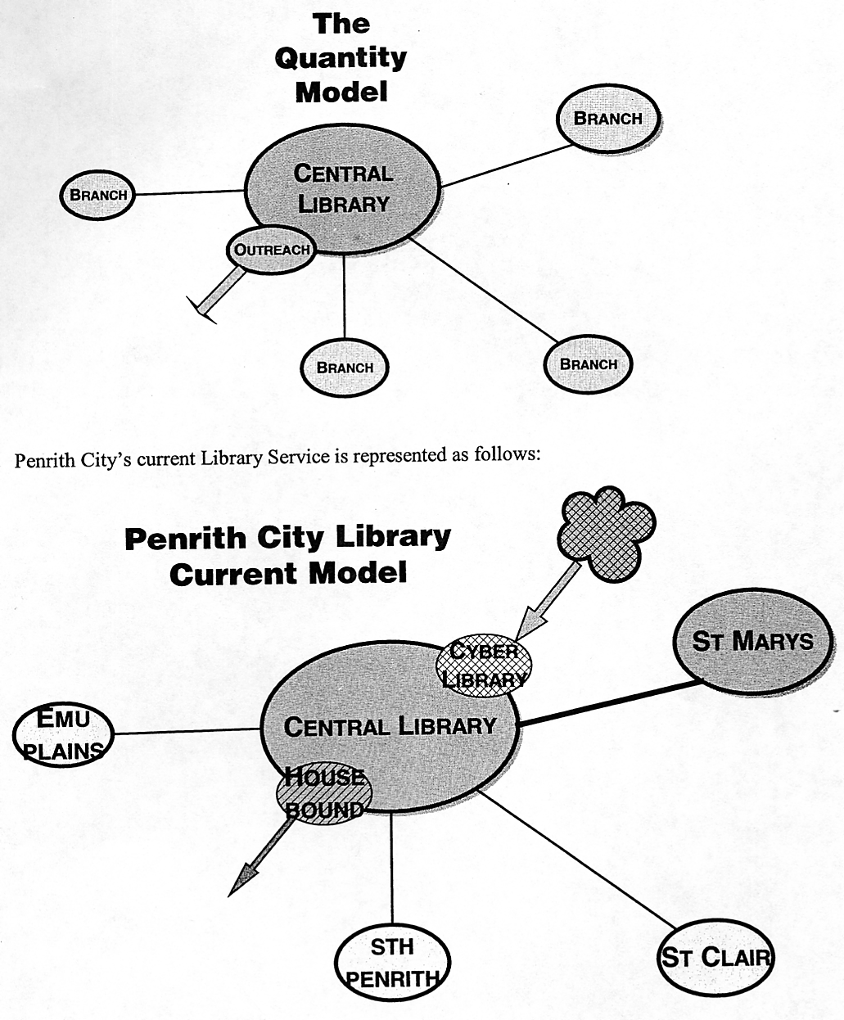

The current status of the branch libraries can be summarised as follows:

Emu Plains library is a grossly under used facility with declining usage. 60% of its users
actually use another library as well, so the actual numbers of dedicated users is very small.

South Penrith Library is in need of refurbishment which would cost an estimated $25,000.
60% of its users also use another library (Central Library) Annual rental and other costs total $40,000.

St Clair Library is under used for the size of facility with 60% of its users also using another
library. Rental and other costs total $50,000 pa.

Alternative Model

Technology and changing patterns of information usage firmly indicate an alternative to this
traditional structure. It is now possible to more widely distribute Library services using the
Networked Library Personal Computer. This computer integrates the Internet, CDROMs and
library catalogue and thus provides a wide and increasing range of information. It is specially
suited to meeting the needs of school projects and lifelong education.

These Networked Library PCs could be positioned in suitable locations throughout the City.
They would be coupled with a book delivery service ie find the book you want in the
catalogue, place an online reserve, delivered to the pickup point to which it can also be
returned. The greatest benefit of this approach is to provide library services to areas of the
City that are not currently serviced.

The function of these PCs can be further extended to include access to Council services and
payments. These PCs spread through the City would become convenient Electronic Service
Points for Council to service the community.

The incorporation of a telephone to directly contact a Librarian dedicated to providing phone support or Council itself, would further enhance the service. This would also meet the needs of those who are not computer literate. It is technically possible for information to be downloaded from the library directly to a local printer. This enables access to a great range of ready reference sources in hard copy and electronic format.

This model also provides for a great deal of flexibility as suburbs develop. A service point can be put in place as soon as a suitable location is available. That service point can be added to as demand warrants. Service points could also be moved to a better location if it is under used.

The Library's Outreach Services, such as the Housebound Service, would also be enhanced to provide a significantly increased level of service to those who are not able to get to a library.

This model can be represented as follows:

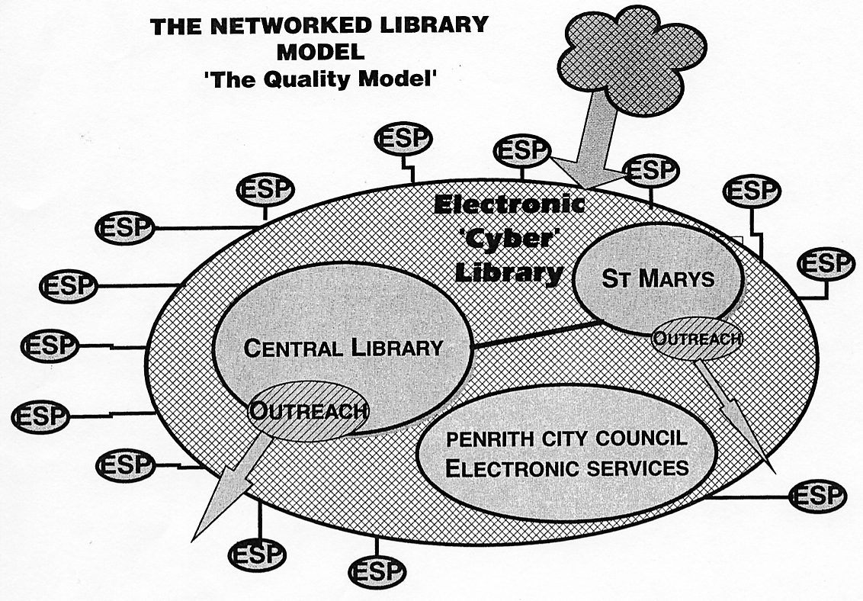

Ultimately this structure should be more convenient for a greater proportion of the community. They would have convenient and fast access to an array of electronic information services coupled with the ability to call up books within a matter of days. If that doesn't meet client needs then they have access to two large, well-resourced libraries which are open extended hours in easily accessible locations.

Implications of the New Model

The replacement of the small branches with appropriately distributed Electronic Service Points (ESPs) throughout the city, especially the outer areas, has major ramifications for tile current operational structure. The model would bring a range of services closer to a greater proportion of the community. A small proportion may perceive a reduction in local services even though the changes would represent a significant improvement in overall services.

Of the three buildings, only Emu Plains is owned by Council with South Penrith and St Clair leased. Emu Plains is an attractive building that would be highly suitable for other community uses such as extending the services of the Nepean Family History Society or as a special museum. The buildings value to the community would be retained if not significantly enhanced. South Penrith and St Clair would be vacated at the end of lease and would then be used as shops in their respective centres. The process of converting the service from a traditional branch to distributed ESP's may require a customised approach suited to the particular circumstances of the branch. This would be analysed and the options reported to Council.

If the present branch library structure was discontinued, the resources available for relocation comprise:

$100,000 cash from rental etc to be reallocated to the book vote which would be a significant contribution to funding the Book Collection Development Program.

Staff equivalent of 3 persons can be reallocated to providing a phone information service and expanding the outreach service.

Books would be transferred to the Central and St Mary's Libraries where they would be most effectively used with maximum turnover.

The ESP's and attendant delivery service would require additional technical support but no more than the equivalent of a new branch ie 2 persons when fully operational. Support overheads could be properly ascertained from a pilot project.

The additional significant advantage of widely distributed ESP's for the community would be the access to other Council services. This extension of access to a greater range of services, in addition to the library, would be a major benefit to the outlying areas.

