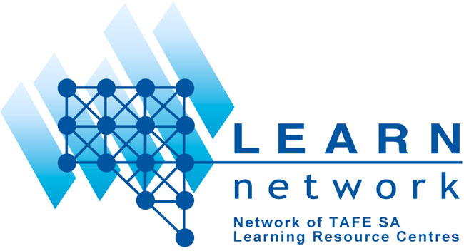
Convenor: Pam Menadue Executive Officer: Sue Isted
Phone: 08 8638 4246 Phone: 08 8207 1230
Email: pamelame@sp.tafe.sa.edu.au Email: susan.isted@tv.tafe.sa.edu.au

Inquiry into the Role of Libraries in the Online Environment:
Response from the TAFE SA LEARN Network

We submit the following response to the Senate Inquiry on the Role of Libraries in the Online Environment, on behalf of LEARN, the Network of SA TAFE Learning Resource Centres/Libraries.

- the current community patterns of demand for public information services through libraries, including the provision of such information online

- South Australian TAFE libraries provide a wide range of resources in both traditional and increasingly in electronic format. Among TAFE staff and students, there is a significant demand for online information to support student learning, with an increasing emphasis on current information.
- Our libraries provide and manage online resources across the whole range of AQF (Australian Qualification Framework) programs offered by Institutes.
- Students also require online access to information such as parliamentary papers and reports, Acts and regulations. This is obtained primarily through libraries, although not always in online format.
- Our libraries provide educational resources online for its users. Institutes are also developing tutorials that show learners how to use such resources online, further contributing to information literacy skills – for example the LILI online tutorial www.tafe.sa.edu.au/lili/)

- the response by libraries (public, university, research) to the changing information needs of Australians, including through the provision of online resources

  - South Australian TAFE libraries are actively working with online course developers to provide quality learning resources online to support the online learning process
  - At a national level TAFE libraries are also investigating consortia purchasing arrangements for online resources relevant to the full range of vocational education and training programs for those undertaking both online and face-to-face programs and where possible, providing access to those resources remotely
  - TAFE libraries in South Australia have established a state wide consortium arrangement for the purchase of online databases to ensure equitable access to TAFE students in South Australia.
- Within the context of SA TAFE, access to public information sources such as online curriculum documents and course material is generally managed through the libraries.
- TAFE libraries in South Australia and elsewhere identify, evaluate and synthesize online information resources for their clients, making these available in summary format to assist users in making effective use of the online environment (for example Subject springboards, www.tafe.sa.edu.au/lsrsc/learn/springboards/index.html)
- TAFE libraries in SA have developed and implemented an extensive information literacy program to teach students how to make sense of materials in the online environment.
- Given the increasing fluidity of the concept of ownership of online resources, the cost of acquiring these and the complexities of licence arrangements, libraries are centrally placed to provide the appropriate management of online resources
- All SA TAFE libraries provide access to their catalogues online – users can search globally across the LEARN network and link from the catalogue to the online resource.
- SA TAFE libraries provide an electronic reference service through various mechanisms including email and online forms to assist users with their information needs. With the increasing amount of information available online, few users are able to make optimal use of these resources and require the services of professional library staff trained to assist them in their information needs.
- SA TAFE Libraries have created web sites to provide one starting place to access the online resources available to their users – these range from ‘free’ Internet titles to search engines, online journals and databases. Effectively they provide a ‘one-stop shop’ to resources.
- The traditional activities of libraries have direct parallels in the online environment, SA TAFE libraries have simply made the natural and logical extension to traditional services by also providing information and resources to its users in the online format.

(c) possible strategies which would enhance the wider use and distribution of information resources held by libraries, including the establishment of networks, improved online access in libraries, online libraries, and greater public knowledge and skills in using library resources;

  - Some of these have been identified above and are currently being used by the SA TAFE library network, LEARN. They include the use of consortia purchasing arrangements, online tutorials and the development of library specific web pages which identify and link to relevant subject resources for the library clientele
  - The models developed by Singapore, TiARA http://www.libraryhub.com/ , Indiana INSPIRE (Indiana, USA) http://www.inspire-indiana.net/ and similar arrangements in other countries should be investigated to see if they provide an effective mechanism for ensuring equitable and widespread access to information sources.
- Although access to the Internet is becoming more universal, a large proportion of the population are still disadvantaged either through distance, cost or both and don’t have the same accessibility to the Internet. Libraries currently provide the most cost efficient and effective structures for such access and should be funded to provide additional online access to equipment and data communication networks to provide improved access. This should include access to broadband significantly cheaper than is presently available. Additionally they should be adequately staffed to ensure that users are provided with the assistance needed to access the resources effectively. Research recently completed by the NCVER (www.ncver.edu.au/-research/proj/nr0F02.pdf) indicates that personal contact and good technical support are essential requirements for successful online study and access. TAFE Libraries are uniquely placed to provide these.

  - Consolidated national initiative to promote the services of libraries, particularly to access online information. There are still significant sections of the population who either do not have access or are unaware of where they can get access to information, particularly in the online environment.

(d) the use of libraries to deliver information and services over the Internet to more effectively meet community demands for public information in the online environment

  - TAFE libraries provide access to public information in both print and electronic format. For example. SA TAFE libraries have had access to the ABS LEP program in both print and electronic format to assist clients with their information needs. Such programs of making public information available to the population through libraries should be enhanced to ensure that people have access to the information required to support their information needs, whether they be for formal study, informal learning or to satisfy immediate information requirements.
  - If governments are serious about their commitment to lifelong learning, the clever country and the promotiom of education and knowledge development at the local, regional and national level, libraries are in a key position to provide the resources and services to support lifelong learning. Librarians must continue to guide and advise Internet users that critical thinking and reading with understanding are required for learning and that the quality of information rather than the quantity is vital to lifelong learning and educational success.
  - SA TAFE libraries have made significant steps to provide and promote the use of online resources (see also points made under a-c). No other facility is more centrally placed to provide and maintain this information.

(e) the roles of various levels of government, the corporate sector and libraries themselves in ensuring the most effective use of libraries as a primary public information resource in the online environment

  - See the points raised above. Increased support is needed to address the information needs of library users and potential and non-users alike, particularly given the additional skills needed to access and evaluate online resources. All levels of government must be involved to ensure the effective use of the public information sources available in the online environment.
  - Recognize that the online environment still only provides a low % of information on the Internet in the forms of books, periodicals and official documents. Copyright laws may mean that it stays like this.

Pam Menadue
Convenor, LEARN PLANNING GROUP
On behalf of the LEARN Network (SA TAFE)

Through

Madeleine Woolley
Director, Adelaide Institute of TAFE

