16 August 2002

Secretary
Senate ECITA References Committee
Parliament House
CANBERRA ACT 2600

Dear Sir/Madam

MAV Submission to the Inquiry into the Role of Libraries in the Online Environment

The Municipal Association of Victoria (MAV) as the peak body for Victorian Local Government is pleased to make the following submission to the Senate inquiry on the role of libraries in the online environment. Public libraries which are provided and funded by Victorian councils are regarded as key community assets, poised to play a critical role in the development of online information and communications access to local communities.

The MAV submission provides an overview of the local government commitment to online development, and has been prepared in collaboration with the Victorian Public Library and Information Network (VICLINK) and Country Public Libraries Group of Victoria (CPLG), representing the interests of all public library practitioners. The VICLINK/CPLG submission, which has also been forwarded to the Inquiry, provides a comprehensive account of the current and potential role Victorian public libraries in the online environment and emphasises their value to the community.

As indicated in this submission, the MAV will be researching future directions with councils and public libraries over the next few months, and a copy of the research will be made available to the Commonwealth and the Australian Local Government Association (ALGA) upon completion.

The MAV is most willing to provide further input to the Inquiry if required.

Should you require any further information regarding this submission, please contact Clare Hargreaves, MAV Senior Policy Adviser – Social Policy, Ph. (03) 9667 5543 and email chargreaves@mav.asn.au

Yours sincerely


ROB SPENCE
Chief Executive Officer

Enc. MAV Response to the Senate Inquiry into the Role of Libraries in the Online Environment

Municipal Association of Victoria

Response to the Senate Inquiry into the Role of Libraries in the Online Environment

August 2002

Contact officer: Clare Hargreaves,
Senior Policy Adviser – Social Policy
Municipal Association of Victoria
GPO Box 4326 PP, Melbourne 3001
Ph. (03) 9667 5555 Fax (03) 9667 5550
Email : chargreaves@mav.asn.au

Preamble

The Municipal Association of Victoria (MAV) is the statutory peak body for Victorian Local Government. Within Victoria, local government has the major funding responsibility for public libraries. Victorian Local Government is committed to the provision of a responsive and efficient library services across Victoria, which is positioned to embrace the provision of public information in the on-line environment.

- Role of Local Government

The philosophy of a free universal library services is supported by local government as underpinning active citizenship in a democratic society, in conjunction with a universal public education system. Public library services provide a key local point of access in all municipalities to services and resources designed to meet the information, education, cultural and recreation needs of the community.

Local Government is able to position libraries and library professionals as one of the keys to the knowledge economy, enabling the public to effectively engage with information throughout their lives.

The MAV vision for future directions for library and information services delivery therefore aims to position libraries as a key element of the information and lifelong learning network with other key stakeholders including tertiary education institutions, schools, neighbourhood houses, information technology centres, multimedia initiatives and so on.

On-line service delivery would ideally link to on-line roll out by Local Government generally, particularly in rural Australia, and capitalise on the collective purchasing power. A key issue would be to maximise cost-effectiveness across all publicly funded library and information services - identifying and eliminating duplication, investigating consortia purchasing of information materials, Information technology (IT) hardware and software bandwidth.

The MAV Local Government Online project two year roll-out commenced in May 2001. The project aims to introduce electronically based services to councils across Victoria, and is expected to complement and extend existing online delivery services. The MAV is actively facilitating consortia purchasing with Victorian councils which could directly benefit the public library network development. The potential exists for the more common types of information technology (IT) infrastructure usage to be rolled out on a basis which supports ‘Whole of Government’ initiatives.
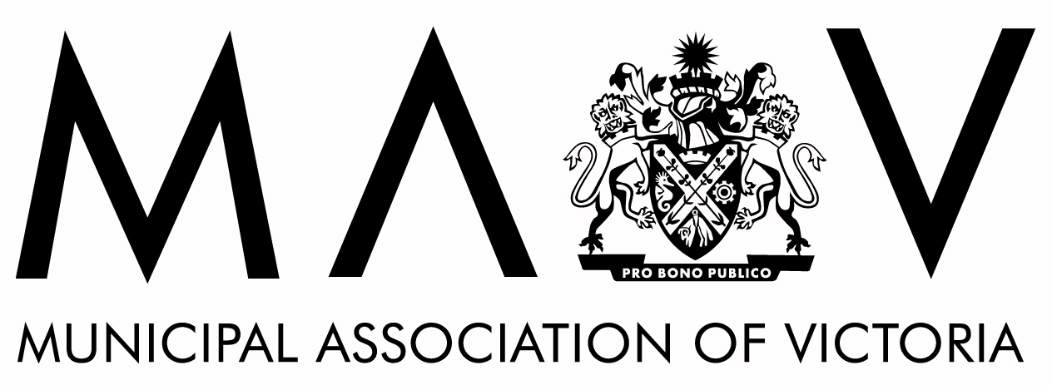

1. Role of Local Government cont.

Resources provided by public libraries also link closely to local government networks and service system with the community. Local government in Victoria has a key role in the planning, co-ordination and provision of human services at the local level. Public library services form an integral component of the service network which is highly valued by the community, and in addition, contribute to the promotion of 'social capital' as welcoming community meeting places.

- Delivering and Funding Information Provision over the Internet

Current internet use and demand is rapidly escalating in Victorian public libraries, which provide a key local access point to internet information and communication services. Research indicates that while demand for borrowing of books is relatively stable, the demand for internet provision of information services is rapidly on the increase. It is likely that libraries especially in rural communities will be utilised in the future as hubs for government and business internet access to services no longer provided in smaller towns (eg. banking). It is recognised that rapidly increasing bandwidth costs are likely to be associated with increased online usage.

Two specific issues have been raised by councils:

  - Online rates – it is suggested that the Commonwealth explore options to subsidize public institutions for online services, including libraries. It is understood that this is the case in for example, the United States, where telecommunications providers provide cheaper rates to public libraries, whereas public libraries are treated as business or domestic users in Australia.

  - Broadband speed demand - whilst the cost has reduced over time (for the actual bandwidth used) it is the communities insatiable appetite for broadband speed that is placing enormous pressures on public libraries to continue to invest in expensive IT infrastructure. For example, two Victorian country libraries have pulled out of online electronic data base consortia due to the inability to meet the cost (amounts of only up to $3000 per annum), and a further five cannot afford the ongoing maintenance costs of rack equipment associated with the recent satellite technology rollout (Swan Hill, North Central Goldfields, Wimmera, Campaspe). This clearly indicates that libraries in rural Victoria are struggling to keep pace with demand.

- Lifelong Learning / Employment / Economic Development

The development of ‘Learning Towns’ and ‘Local Learning and Employment Networks’ in regional areas recognises that viable communities and economies are dependent on people’s ability to adapt to change and learn new skills, which in turn create new economic, tourism, service and business opportunities. Libraries are key community assets which are well placed to adapt their roles to meet the challenge of the knowledge economy.

- Electronic Communication / Community Skills Development

Libraries provide the opportunity for a wide range of skills and knowledge to be developed for business professional and personal development, which ultimately strengthens the community and knowledge economy. In addition, personal skills training programs are offered free of charge through public libraries, targeting non-traditional computer/internet users (eg. older people). Libraries are regarded as universal, non-stigmatised community services, which play a key role in redressing community social structural inequities, and provide opportunities to lower socio-economic groups and groups with limited personal access to the internet and computers (eg older people, younger people and school students, people from diverse backgrounds). Local government support ensures universal geographic coverage and aims to achieve accessibility to all.

- Libraries as Community Building Meeting Places

As one of the most trusted and democratic spaces in the community, libraries facilitate the process of social engagement and networking amongst the local community and foster the development of mutual support and joint enterprise.

- Role of Federal Government in Supporting the National Public Library Network

Strategic planning and financial investment nationally in capital and on-line infrastructure will be required if of libraries are to form an essential part of the regional service development, knowledge economy and information and communications network.
Libraries need to have state of the art resources and network links to other library databases to maintain currency and relevance for the local community, and to ensure an active contribution to the economic development and social viability of communities. More detailed information regrading the support required is provided in the VICLINK/CPLG submission to the Inquiry from Victoria.

Future Directions

MAV Research Project

The MAV will be researching future directions with councils and public libraries in the next six months, and the issues raised in the terms of reference will form a key component of the research. A copy of research will be made available to the Commonwealth upon completion.

Australian Local Government Association (ALGA) - formation of 'Public Libraries Australia'.

Public Libraries, State Libraries, National Library of Australia, library associations and local government around Australia have all joined forces in a collaborative effort to establish a formal body for national representation that actively represents, advocates and promotes the interest of all public libraries in Australia.

The MAV regards this as a constructive development, as the Association will provide a co-ordinated mechanism to liaise with Federal Government as libraries ‘re-invent’ themselves in the on-line environment.

Recommendations:

The following recommendations are submitted to the Inquiry for consideration:

- That public libraries continue to be positioned as a key element of the knowledge economy, forming an essential component of urban and regional service development, and provides access to information and communications networks for local communities.

- That the more common types of information technology infrastructure usage be rolled out on a basis which supports ‘Whole of Government’ initiatives.

- That federal funding facilitate on-line service delivery for public libraries which is linked to on-line roll out by Local Government generally.

- That the Commonwealth explore options to subsidize online services to public institutions, including libraries.

- That a review be undertaken between federal, state and local government of the ongoing capacity of libraries to meet the community demand for broadband speed and develop options for sustaining the required on-line library network links over time.

