29 July, 2026

Mr Michael McLean
The Secretary
Senate Environment, Communications,
Information Technology and the Arts Legislation Committee
Parliament House
CANBERRA ACT 2600

Dear Michael,
AANA SUBMISSION
on
<< BROADCASTING SERVICES AMENDMENT (MEDIA OWNERSHIP) BILL 2002 >>

As Chair of the Australian advertising industry’s peak representative body, I am pleased to forward for your consideration our association’s submission to assist in your review of the Broadcasting Services Amendment (Media Ownership) Bill 2002.

You will be aware, I am sure, that our association represents the consensus view of the advertisers whose annual investment in excess of $8 billion funds the mainstream media industry and related sectors of the Australian economy.

With a proud history as advocates of advertisers’ rights to freedom of commercial speech, our association is an enthusiastic contributor to public debate and political policymaking on matters of concern to our membership.

To this end, I will be pleased to arrange for a personal presentation of our submission should this be appropriate to your procedures.

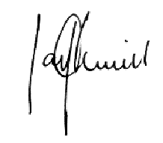
Yours sincerely
Ian Alwill
Chairman

