

BUREAU OF METEOROLOGY
SUBMISSION

TO THE

AUSTRALIAN SENATE

ENVIRONMENT, COMMUNICATIONS, INFORMATION TECHNOLOGY AND ARTS
LEGISLATION COMMITTEE

KYOTO PROTOCAL RATIFICATION BILL 2003 [NO. 2]

JANUARY 2004

SUMMARY

The scientific basis for expecting global warming as a result of increasing atmospheric concentrations of greenhouse gases is well understood and widely accepted in the relevant expert scientific community.

Global Warming

The world has warmed significantly over the past century and there is a high level confidence in the expert climate community that a large part of the observed warming is due to the enhanced greenhouse effect. While alternative explanations for the observed warming (and other observed changes in climate) have been examined and may have made some contribution, it is now considered unlikely that they have been of more than minor significance relative to greenhouse warming.

The general rise in Australian temperatures during the second half of the 20th century is in line with global warming trends indicated by independent records from surface observation networks, weather balloons, satellites and glaciers. According to a preliminary estimate released by the World Meteorological Organization (WMO) on 16 December 2003, the global mean temperature for 2003 was the third warmest on record (since 1861). Australia experienced warmer than normal conditions across much of the country in 2003. Preliminary data indicate that the all-Australian mean temperature for 2003 was 0.62°C above the 1961-90 average, making it Australia’s sixth warmest year on record since 1910. Australia’s annual mean maximum temperature was 0.65°C above normal (sixth highest), with the mean minimum temperature being 0.59°C above normal (fourth highest).

While presently unforeseeable influences such as a period of sustained volcanic activity or the onset of major instabilities in ocean circulation or the Antarctic ice sheet melting cannot be entirely ruled out (and such influences could cause major climate changes), these are currently seen by the scientific community as very low probability events and the main influence on global climate over the next century is considered almost certainly to be the enhanced greenhouse effect resulting from the continued build up of atmospheric concentrations of greenhouse gases.

Year to year fluctuations will still be dominated by natural climate variability, including the El Niño and Southern Oscillation phenomena. Although it is not possible to predict the magnitude of the future global warming (or other associated changes of climate) in the absence of confident knowledge of future emissions, the expert scientific community is able to provide projections of future warming for any of a wide range of greenhouse gas emission scenarios.

The Intergovernmental Panel on Climate Change

The Intergovernmental Panel on Climate Change (IPCC) which was established in 1988 by the World Meteorological Organization (WMO) and the United Nations Environment Programme (UNEP) is aimed at providing governments with the most informed, up-to-date and objective assessment possible of the current state of knowledge of the science of climate change. The
IPCC is not any particular group of scientists, it is not a research organisation and it has no policy agenda. It is an intergovernmental mechanism which is designed to enlist the expert scientific community to produce balanced and widely credible assessments of the science in an understandable and policy-relevant (but not policy prescriptive) form. Although still widely seen as an experiment in science-policy interaction, the experience so far suggests that the IPCC process is capable of providing a fully objective view of the science. The IPCC’s Third Assessment Report on the science of climate change, was released in 2001 (IPCC, 2001a, 2001b, 2001c, 2001d, 2001e) and preparation of its Fourth Assessment Report, due for completion in 2007, is now well underway.
Functions of the Bureau of Meteorology
The Bureau of Meteorology contributes to effective Australian participation in the work of the Intergovernmental Panel on Climate Change (IPCC), for example, through coordination of Australian activities in respect of Working Group I (Science), participation in the drafting of IPCC reports, input to reviews of IPCC documents and to briefing material, and representation at sessions of the IPCC and its Bureau.
As Australia’s National Meteorological Service, the Bureau is responsible for, inter alia:
- the taking and recording of meteorological observations and other observations required for the purposes of meteorology;
- the supply of meteorological information;
- the promotion of the use of meteorological information;
- the promotion of the advancement of meteorological science, by means of meteorological research and investigation or otherwise;
- the furnishing of advice on meteorological matters; and
- co-operation with the authority administering the meteorological service of any other country in relation to any of the matters specified in the preceding paragraphs of this sub-section (Meteorology Act 1955)

The purpose of the Bureau is to contribute to Australia's social, economic, cultural and environmental goals through the performance of the functions of a National Meteorological Service “in the public interest generally and, in particular, … for the purpose of assisting persons and authorities engaged in primary production, industry, trade and commerce” (Meteorology Act 1955).

The Greenhouse Effect - Cause and Effect

The relationship between the enhanced greenhouse effect and global climate change is far from simple. Not only do increased concentrations of greenhouse gases affect the atmosphere, but also the oceans, soil and biosphere. These effects are still not completely understood. Also, complex feedback mechanisms within the climate system can act to amplify greenhouse-induced climate change, or even counteract it.

This submission addresses three key issues of importance in relation to the scientific arguments that have been used to support of the adoption of the Kyoto Protocol. These issues are:
- Is climate change occurring and what are the drivers?
- Are these changes having an impact?
- If climate change is occurring what are the implications for policy makers?

On the basis that climate change is indeed occurring, it is essential that we continue to support and strengthen our capability to monitor climate change and to better predict what its implications will be.

TABLE OF CONTENTS

Page

Summary

- Introduction 1
- Key Issues 3

  - Is climate change occurring and what are the drivers? 3
  - Are these changes having an impact? 6
  - If climate change is occurring what are the implications
for policy makers? 8

- Conclusion 9

References 10

Attachments

A The Meteorology Act 1955

B Annual Australian Climate Summary 2003

C Climate Activities Australia 2003 (Bureau of Meteorology, 2003a)

D The Greenhouse Effect and Climate Change (Bureau of Meteorology, 2003b)

AUSTRALIAN SENATE

ENVIRONMENT, COMMUNICATIONS, INFORMATION TECHNOLOGY AND THE ARTS

LEGISLATIVE COMMITTEE

KYOTO RATIFICATION BILL 2003 [No. 2]

1. INTRODUCTION

The purpose of this submission is to inform the Australian Senate Environment, Communications, Information Technology and the Arts Legislative Committee of the role the Bureau of Meteorology plays in relation to the issue of climate change and, consistent with this role, outline its views on a number of basic scientific issues.

Understanding the greenhouse effect is fundamental to understanding climate change. The greenhouse effect is a natural process that plays a major part in shaping the earth’s climate. It produces the relatively warm and hospitable environment near the earth’s surface where humans and other life-forms have been able to develop and prosper. It is one of a large number of physical, chemical and biological processes that combine and interact to determine the earth’s climate. Climate, whether of the earth as a whole or of a single country or location, is often described as the synthesis of weather recorded over a long period of time. It is defined in terms of long-term averages and other statistics of weather conditions, including the frequencies of extreme events. Climate is far from static. Just as weather patterns change from day to day, the climate changes too, over a range of time frames from years, decades and centuries to millennia, and on the longer time-scales corresponding to the geological history of the earth. These naturally occurring changes, driven by factors both internal and external to the climate system, are intrinsic to climate itself.

But not all changes in climate are due to natural processes. Humans have also exerted an influence. Through building cities and altering patterns of land use, people have changed climate at the local scale. Through a range of activities since the industrial era of the mid-19th century, such as accelerated use of fossil fuels and broadscale deforestation and land use changes, humans have also contributed to an enhancement of the natural greenhouse effect. This enhanced greenhouse effect results from an increase in the atmospheric concentrations of the so-called greenhouse gases, such as carbon dioxide and methane, and is widely believed to be responsible for the observed increase in global mean temperatures through the 20th century.

The relationship between the enhanced greenhouse effect and global climate change is far from simple. Not only do increased concentrations of greenhouse gases affect the atmosphere, but also the oceans, soil and biosphere. These effects are still not completely understood. Also, complex feedback mechanisms within the climate system can act to amplify greenhouse-induced climate change, or even counteract it.

This submission is framed in terms of the statutory functions and responsibilities of the Bureau as set out in the Meteorology Act 1955 (Attachment A).

Under the Act, the Bureau of Meteorology has certain national responsibilities in respect of monitoring and understanding the Australian climate and research and systematic observations of the climate system.

The Bureau of Meteorology is Australia’s National Meteorological Services and is responsible for, inter alia:
- the taking and recording of meteorological observations and other observations required for the purposes of meteorology;
- the supply of meteorological information;
- the promotion of the use of meteorological information;
- the promotion of the advancement of meteorological science, by means of meteorological research and investigation or otherwise;
- the furnishing of advice on meteorological matters; and
- co-operation with the authority administering the meteorological service of any other country in relation to any of the matters specified in the preceding paragraphs of this sub-section (Meteorology Act 1955).

The Bureau performs these functions under the Act in the public interest generally and in particular for the purpose of assisting persons and authorities engaged in primary production, industry, trade and commerce.

The primary functions of the Bureau which relate to the climate change debate are the observation, understanding and prediction of Australian weather and climate. Its staff includes some 300 professional meteorologists with expertise in climate science and it operates both the National Climate Centre (NCC) which is responsible for continuous monitoring of the state of Australia’s climate and the Bureau of Meteorology Research Centre (BMRC) which includes, inter alia, internationally recognised experts in both the monitoring and modelling of long term climate change.

The Bureau represents Australia with the World Meteorological Organization (WMO). The WMO is the UN Specialised Agency which established and cosponsors (with the United Nations Environment Programme (UNEP)) the Intergovernmental Panel on Climate Change (IPCC).
The Bureau contributes to effective Australian participation in the work of the IPCC, for example, through coordination of Australian activities in respect of Working Group I (Science), participation in the drafting of IPCC reports, input to reviews of IPCC documents and to briefing material, and representation at sessions of the IPCC and its Bureau.
Bureau of Meteorology officers have participated in all sessions of the Conference of the Parties (COP) to the United Nations Framework Convention on Climate Change (FCCC) in their capacity as experts on climate science, as well as at all sessions of the COP Subsidiary Body for Scientific and Technological Advice (SBSTA).

In its role as the national climate authority since Federation, the Bureau of Meteorology:
- maintains an ongoing record of the state of the Australian climate (for example, see the Annual Australian Climate Summary for 2003 at Attachment B);
- carries out research into the mechanisms and behaviour of Australian and southern hemisphere climate;
- provides overall coordination of Australian linkages to, and participation in, the global climate observing, research and application programs of the World Meteorological Organization (for example, see the recent issue of ‘Climate Activities in Australia 2003' (Bureau of Meteorology, 2003a) at Attachment C).

- KEY ISSUES

In compiling this paper, the Bureau has identified three key issues which it believes should be considered by the Australian Senate Environment, Communications, Information Technology and the Arts Legislative Committee in undertaking its review of the Kyoto Ratification Bill 2003 [No. 2]. These issues include:
- Is climate change occurring and what are the drivers?
- Are these changes having an impact?
- If climate change is occurring what are the implications for policy makers?

2.1 Is climate change occurring and what are the drivers?

International Perspective

It is assumed that the Committee is aware of the general mechanisms of climate and the role of the so-called ‘greenhouse effect’ of the naturally occurring radiatively active trace gases such as carbon dioxide and methane in maintaining the earth’s surface at temperatures some tens of degrees warmer than it would otherwise be. This is often referred to as the natural greenhouse effect.

Although mathematically complex, the physical processes that maintain the three dimensional temperature structure of the atmosphere are generally well understood and reproducible with numerical models.

The Bureau of Meteorology (2003b), The Greenhouse Effect and Climate Change (Attachment D), presents the scientific basis for understanding the nature of human-induced climate change within the context of the complex and naturally-varying global climate system. It describes:
- the important role of the natural greenhouse effect together with a number of other large-scale processes in determining the range of temperatures observed at the earth’s surface;
- the natural and human influences that force changes in climate;
- the observed behaviour of climate in the recent and distant past;
- the basis for scientific concern at the prospect of human-induced climate change;
- how computer models of the global climate system are used to project potential changes in climate on a range of time and space scales;
- the coordinated actions being taken by the international scientific community to monitor, understand and assess potential future levels of climate change; and
- recent scientific assessments of possible human induced climate change.

It is also assumed that the Committee is aware of the most recent authoritative international scientific assessment of the state of knowledge of climate change science, the Third Assessment Report (TAR) of the IPCC, including, in particular, its Summary for Policymakers.
The IPCC (2001e) Climate Change 2001, The Scientific Basis, Summary for Policymakers and Technical Summary of the Working Group I Report concludes:
- An increasing body of observations gives a collective picture of a warming world and other changes in the climate system;
- Emissions of greenhouse gases and aerosols due to human activities continue to alter the atmosphere in ways that are expected to affect the climate;
- Confidence in the ability of models to project future climate has increased;
- There is new and stronger evidence that most of the warming observed over the last 50 years is attributable to human activities;
- Human influences will continue to change atmospheric composition throughout the 21st century;
- Global average temperature and sea level are projected to rise under all IPCC SRES (Special Report on Emissions Scenarios) scenarios;
- Anthropogenic climate change will persist for many centuries; and
- Further action is required to address remaining gaps in information and understanding.

The Bureau notes that there is a number of high profile papers that contradict these widely accepted views. The Bureau considers that these papers will, in due course, be appropriately assessed and judged by the scientific community.

National Perspective

The Australia State of the Environment 2001 – Atmosphere (Department of the Environment and Heritage (DoEH), 2001) provides detailed information on variability and trends in climate information recorded in Australia. The following extract from the Executive Summary summarises the climatic aspects of this information.

Australian average surface temperature has increased by 0.76°C over the past 90 years, which is consistent with the global temperature increase of 0.6 to 0.7°C. The average minimum temperature has increased by 0.96°C (Figure 1) and the maximum has increased by 0.56°C from 1910 to 2000 in Australia. The seven warmest years on record have all been recorded since 1980. The frequency of extreme warm days and nights has increased while the numbers of extreme cool days and nights have decreased. Frost frequency has also decreased.

The general rise in Australian temperatures during the second half of the 20th century is in line with global warming trends indicated by independent records from surface observation networks, weather balloons, satellites and glaciers. According to a preliminary estimate released by the World Meteorological Organization (WMO) on 16 December 2003, the global mean temperature for 2003 was the third warmest on record (since 1861). Australia experienced warmer than normal conditions across much of the country in 2003. Preliminary data indicate that the all-Australian mean temperature for 2003 was 0.62°C above the 1961-90 average, making it Australia’s sixth warmest year on record since 1910. Australia’s annual mean maximum temperature was 0.65°C above normal (sixth highest), with the mean minimum temperature being 0.59°C above normal (fourth highest).

Australian rainfall has increased slightly during the 1900s in most regions, except for southwest Western Australia and eastern Queensland, where decreases occurred (Figure 2). Australian rainfall shows strong interannual variability that is linked with variations in the El Niño–Southern Oscillation (ENSO) phenomenon. The area of Australia experiencing extreme wet conditions has increased slightly, while the area of extreme dryness has reduced slightly since 1910. Heavy rainfall amounts and the number of heavy rainfall events have also increased in some areas.

Figure 1 Annual Mean Temperature Anomalies for Australia

Figure 2 Rainfall trends in Australia from 1910 to 1999
Trends are shown as mm per 10 years, with positive numbers indicating increases

The number of tropical cyclones in the Australian region has decreased since the late 1960s, a trend that can be linked to the decrease in the Southern Oscillation Index. However, the number of intense tropical cyclones has slightly increased during the same period. There is a strong interannual variability in the formation of tropical cyclones that is largely related to ENSO. The last two decades (1980s and 1990s) were unusual in that there were more frequent occurrences of El Niño events compared with previous decades. Production of Australia’s major crops, such as wheat, rice and sugar shows strong interannual variability, which is associated with rainfall and ENSO. Of all severe weather events, tropical cyclones cause the most extensive damage to human settlements, infrastructure and crops, with hailstorms second. However, the largest cost for a single weather event was the Sydney hailstorm of 1999.

The Australian government spent $700 million on drought relief payments or exceptional circumstance relief payments to farmers from 1992 to 1999. These droughts are associated with El Niño events, particularly the early 1990s and 1997 to 1998 events. Mean sea level rise around Australia has been 12 to 16 cm during the 1900s. The estimated value of mean sea level rise around Australia is consistent with the global average given by the Intergovernmental Panel on Climate Change. Continued monitoring of sea level rise around Australia and correction of existing sea level measurements considering earth movements and other factors should lead to better future estimates.

2.2 Are these changes having an impact?

The impact of climate change will vary from region to region and depend on the nature and extent of the change and the climate related activities undertaken with the region. Climate change has the potential to have significant economic impacts depending on these activities. Three examples of impacts that may already be occurring because of climate change are provided below.

Impact of rainfall decrease in southwest Western Australia

During the mid-1980s, water resource managers in Perth became concerned about the reduced rainfall and consequent inflows into Perth reservoirs. In the mid-1990s, as these reduced flows persisted, the design basis for future water resources was adjusted downwards, by taking account of only observations from the recent (relatively dry) 25 years, rather than the entire record of rainfall and inflow. This adjustment led to an accelerated development of new water sources, having a current cost of some $500 million, as well as sharpening initiatives to reduce demand through water use efficiency measures (Indian Ocean Climate Initiative (IOCI), 2002). Most likely, both natural variability and the enhanced greenhouse effect have contributed to the rainfall decrease.

Spring snow depth in Snowy Mountains

The depth of snow in mid-spring (as measured in the first observation in October each year) at Spencers Creek near Mt Kosciusko has decreased about 40% since 1962 (Figure 3). October snow depth is closely correlated (r = -0.73, n = 41) with June-August mean maximum temperature at Cabramurra (35˚36’S, 148˚23’E). Mean maximum temperature at Cabramurra has increased since 1962 and this can account for all the decrease in snow depth in spring. The trend of the snow depth estimated with linear regression from the temperature variations almost exactly matches the observed snow depth trend (Figure 3).

Figure 3. Observed snow depth at Spencers Creek, first observation in October (solid lines), and depth estimated from Cabramurra mean winter maximum temperature (broken lines). Thick lines are linear trends.

The 2002/03 drought and the bush fire season

The mean daily maximum temperature averaged across the Murray Darling Basin in May-October 2002 was 0.7˚C warmer than the previous record (Nicholls, 2004). This substantial increase in the record maximum temperatures, which was a continuation of the warming observed since the middle of the 20th century, was associated with very high evaporation levels. As well as the elevated mean maximum temperature (by around 3ºC) another significant contribution to the severity of the bush fire season would have been the longer “curing” of the fuel, brought about by the shift of the onset of the warm season forward about a month (Figure 4).

Figure 4. Murray Darling Basin mean monthly temperatures in 2002/03 (solid line) and climatological temperatures (1961-90, broken line).

2.3 If climate change is occurring what are the implications for policy makers?

Governments have a public policy interest in ensuring that economic and social activities carried on by their citizens are compatible with the climatic regime. In an unvarying climate the annual cycle of temperature, precipitation and other variables would be repeated unendingly. Weather systems, integrated over time produce climate. Weather systems are chaotic with every day, month and year unlike any other, either before it or yet to come. Given that there is a chaotic component to climate, governments are faced with deciding which of two fundamental models apply. Is the chaotic climate system:

- Operating within stable limits (a naturally variable climate); or,
- Underpinned by a non-stationary mean, in which case the envelope of the climatic variables will be changing, possibly in a non-linear fashion (changing climate)?

Historically governments have assumed that situation (1) applies, that is, climate maybe variable but it is stable within definite limits. More recently however, driven by the analysis of climate data (eg. Figure 1, 2 and 3), the conventional wisdom is that we are faced with a changing climate (see IPCC 2001a, 2001b and 2001c) – that is, situation (2) applies.

Policy formulation in a non-stationary climate is far more complex than for the stationary case discussed above. In the first instance, the government would wish to determine the rate of underlying change. It would then be reasonable to seek to understand what was driving the change to determine such things as:
- whether the changes in climate were accelerating, and if so, at what rates;
- whether there were natural limits to the change, and if so, when these would be reached; and,
- whether, if deemed necessary, there were actions available to mitigate the change, and if it was sensible (cost effective, environmentally effective) to engage in these actions.

Three aspects of the climate change issue which the Bureau believes it is in a strong position to contribute to are:
- reducing the uncertainty – working to agree on what we do and don’t know;
- impacts of changes in extreme events (disaster mitigation – floods and droughts); and
- development of adaptation options (based on our understanding of the impact of natural climate variability).

The Global Climate Change Policy Environment

To better assess the causes and likely consequences governments have commissioned national research activities, sought to assess this research through an international process using the Intergovernmental Panel on Climate Change (IPCC) and sought to respond in a globally coordinated way using the United Nations Framework Convention on Climate Change (UN FCCC).

There is a wide range of timescales associated with the warming processes associated with the changing concentrations of Green House Gases (GHGs) (Figure 5) that introduces a significant time dimension to the policy formulation issues.

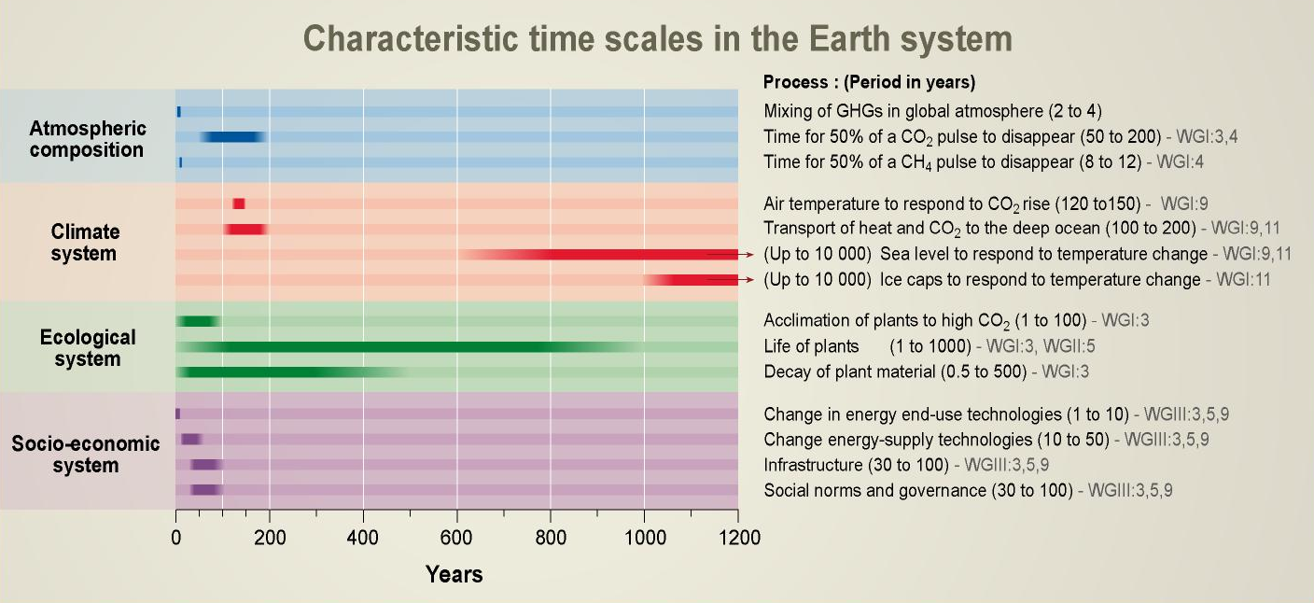
Figure 5 Estimates of the time scales of various processes that are involved in the climate change associated with the changing concentration of atmospheric carbon. (From the IPCC, 2001d, Figure 5.1).

A number of policy relevant messages have emerged from the science, technology and socio-economic assessments of the climate change issue. They include:
- The Earth’s climate is warming and human activities are primarily responsible. Furthermore climate change is inevitable without actions to reduce greenhouse gas emissions;
- Some socio-economic sectors, ecological systems and human health will be adversely affected by climate change, with developing countries being the most vulnerable; and,
- There are technologies available that have the potential to reduce greenhouse gas emissions.

It is essential to note that local activities can be affected by the global nature of warming, even if the direct climate change impact is small. For example, warming may increase areas available in the northern hemisphere for grain growing (northern China, Canada, northern Europe). This would affect the competitive position of Australian grains, even if the direct impact of climate change on Australian grain growing areas was small.

3. CONCLUSION

The scientific basis for expecting global warming as a result of increasing atmospheric concentrations of greenhouse gases is well understood and widely but not universally accepted in the relevant expert scientific community.

The available data show, unequivocally, that the world has warmed significantly over the past century and there is a high level confidence in the expert climate community that a large part of the observed warming is due to the enhanced greenhouse effect. While alternative explanations for the observed warming (and other observed changes in climate) have been examined and may have made some contribution, it is now considered unlikely that they have been of more than minor significance relative to greenhouse warming. The Bureau notes that there is a number of high profile papers that contradict these widely accepted views. In due course, these papers will be appropriately assessed and judged by the scientific community.

Over time, the impacts of climate change will differ substantially across the regions of the globe. The higher latitudes are expected to warm more, and rainfall patterns will be significantly altered with globally a more active hydrologic cycle but in some regions diminished rainfall. The climatology of extreme events will change in ways that are not yet known with any confidence. There will be surprises, but the underlying physics of climate change will not change – there will be global warming while the atmospheric concentrations of greenhouse gases increase.

The IPCC assessment process is aimed at providing policymakers with an objectively and transparently prepared statement of current scientific knowledge focused on the points on which there is widespread scientific agreement but highlighting also the areas where there are different views and where the state of knowledge is considered inadequate. Although some Working Group and Panel sessions have been characterised by intensive negotiations in which one or more governments have argued from what appeared to be a national interest rather than scientific perspective, the IPCC working procedures have so far succeeded in ensuring that the end products remain scientifically objective documents.

Experience so far suggests that the IPCC processes are sufficiently robust and sufficiently widely acceptable to ensure the integrity and objectivity of the content of IPCC Assessment Reports. The Bureau of Meteorology has strongly supported the IPCC assessment process.

It is essential that we continue to support and strengthen our capability to monitor climate change so we can better predict what its implications will be.

References

Bureau of Meteorology (2003a). Climate Activities in Australia 2003. Bureau of Meteorology. pp. 230.
Bureau of Meteorology (2003b). The Greenhouse Effect and Climate Change. Bureau of Meteorology. pp. 74.
Department of the Environment and Heritage (2001). Australian State of the Environment Report - Atmosphere. CSIRO Publishing. pp. 145.
IOCI (2002). Climate variability and change in south west Western Australia, Indian Ocean Climate Initiative Panel, Perth, pp.34.
IPCC (2001a). Climate Change 2001: The Scientific Basis. Cambridge University Press, pp 881.
IPCC (2001b). Climate Change 2001: Impacts, Adaptation and Vulnerability. Cambridge University Press, pp. 1032.
IPCC (2001c). Climate Change 2001: Mitigation. Cambridge University Press, pp. 752.
IPCC (2001d). Climate Change 2001: Synthesis Report. Cambridge University Press,
pp. 397.
IPCC (2001e). Climate Change 2001: The Scientific Basis, Summary for Policymakers and technical Summary of the Working Group I Report. Cambridge University Press, pp. 98.
Nicholls, N. (2004). The changing nature of Australian droughts, Climatic Change, in press.
ATTACHMENT A

THE METEOROLOGY ACT 1955
METEOROLOGY
No. 6 of 1955.¹
An Act relating to the Commonwealth Bureau of Meteorology.
[Assented to 23rd May, 1955]
[Date of Commencement, 20th June, 1955]
Be it enacted by the Queen's Most Excellent Majesty, the Senate, and the House of Representatives of the Commonwealth of Australia, as follows:
1. This Act may be cited as the Meteorology Act 1955. Short title
2. The Meteorology Act 1906 is repealed. Repeal
3. In this Act, unless the contrary intention appears - Definitions
"the Bureau" means the Commonwealth Bureau of
Meteorology established by this Act;
"the Director" means the Director of Meteorology.

4. This Act extends to all the Territories of the Commonwealth. Extension
to Territories

5. (1) For the purposes of this Act, there shall be a The Common-
Commonwealth Bureau of Meteorology and a wealth Bureau
Director of Meteorology. of Meteorology
(2) The Bureau shall be under the charge of the
Director of Meteorology, who shall, subject to the
directions of the Minister, have the general
administration of this Act.

6. (1) The functions of the Bureau are- Functions of (a) the taking and recording of meteorological the Bureau observations and other observations
required for the purposes of meteorology;
(b) the forecasting of weather and of the state of the
atmosphere;
(c) the issue of warnings of gales, storms and other weather
conditions likely to endanger life or property, including
weather conditions likely to give rise to floods or bush fires;
(d) the supply of meteorological information;
(e) the publication of meteorological reports and bulletins;
(f) the promotion of the use of meteorological information;
(g) the promotion of the advancement of meteorological science
by means of meteorological research and investigation or
otherwise;
(h) the furnishing of advice on meteorological matters; and
(i)¹ co-operation with the authority administering the meteorological
service of any other country in relation to any of the matters
specified in the preceding paragraphs of this sub-section.
(2) The Bureau shall perform its functions under this Act in
the public interest generally and in particular-
(a) for the purposes of the Defence Force;
(b) for the purposes of navigation and shipping and of civil
aviation; and
(c) for the purpose of assisting persons and authorities engaged
in primary production, industry, trade and commerce.

7. (1) The Director has such powers as are necessary to enable Powers of
the Bureau to perform its functions under the Director
last preceding the Director section, and, in particular, may-
(a) establish meteorological offices and observing stations;
(b) arrange with any Department, authority or person to take
and record meteorological observations and transmit
meteorological reports and information;
(c) arrange means of communication for the transmission and
reception of meteorological reports and information; and
(d) arrange for the training of persons in meteorology.
(2) The Departments and authorities with which, and the persons
with whom, arrangements may be made under the last
preceding sub-section include Departments and authorities
of a State or Territory of the Commonwealth and persons in
the service of such a State or Territory or of such a
Department or authority.
8. The Director may, subject to any directions of the Minister, Charges
make charges for forecasts, information, advice, publications
and other matter supplied in pursuance of this Act.

9. The Governor-General may make regulations, not inconsistent Regulations
with this Act, prescribing all matters which by
this Act are required or permitted to be prescribed, or which
are necessary or convenient to be prescribed for carrying out
or giving effect to this Act.

ATTACHMENT B

31 December 2003

ANNUAL AUSTRALIAN CLIMATE SUMMARY 2003
Another warm year, with a return to near normal rainfall totals

Australia experienced warmer than normal conditions across much of the country in 2003. Preliminary data indicate that the all-Australian mean temperature for 2003 was 0.62°C above the 1961-90 average, making it Australia’s sixth warmest year on record since 1910. Australia’s annual mean maximum temperature was 0.65°C above normal (sixth highest), with the mean minimum temperature being 0.59°C above normal (fourth highest).

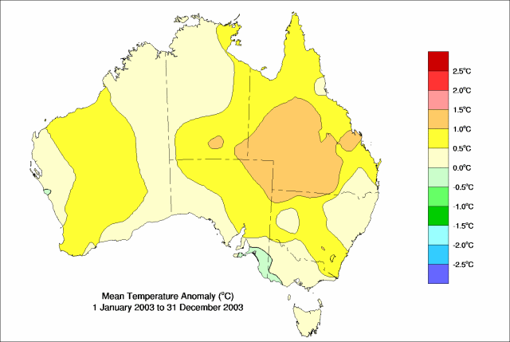

(Top) Australian annual mean temperature anomalies (based on 1961-90 normal) since 1910 and (bottom) annual mean temperature anomalies (°C) across Australia for 2003

Australian mean temperatures are calculated from a network of about 100 high-quality, mostly rural observing stations throughout the country. The temperature records at these locations have been adjusted for artificial discontinuities caused by changes in instrumentation and location. Many of the sites are included in Australia's contribution to the Global Climate Observing System - a comprehensive network established to monitor long-term climate trends and variability.

The general rise in Australian temperatures during the second half of the 20th century is in line with global warming trends indicated by independent records from surface observation networks, weather balloons, satellites and glaciers. According to a preliminary estimate released by the World Meteorological Organization (WMO) on 16 December 2003, the global mean temperature for 2003 was the third warmest on record (since 1861).
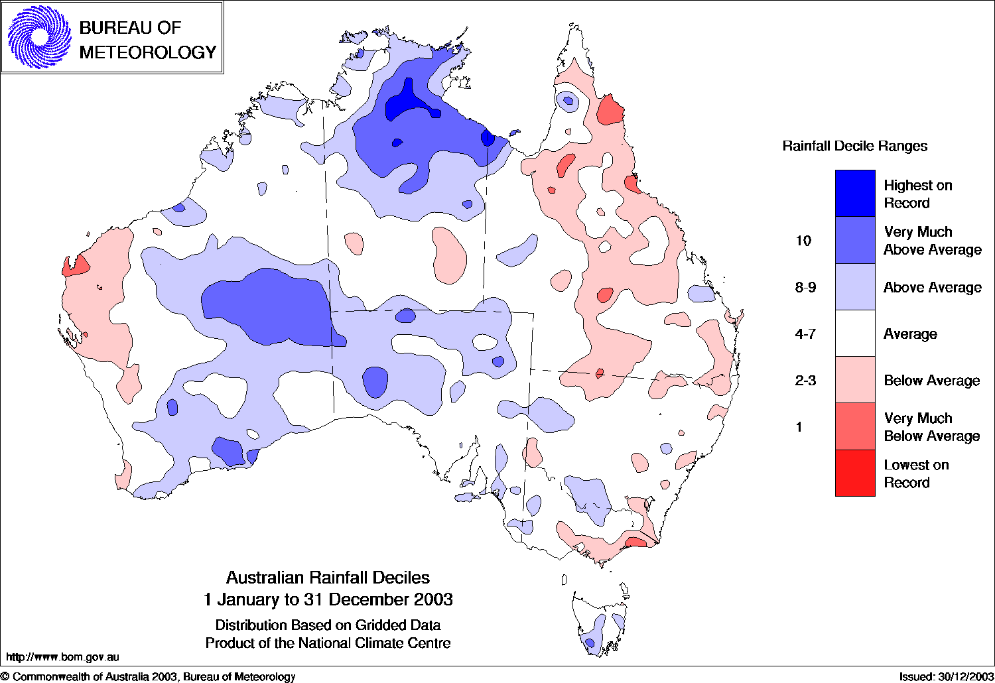

(Top) Australian annual mean rainfall (mm) since 1900

and (bottom) 2003 rainfall compared with the long-term rainfall distribution
Australian rainfall for 2003 was largely influenced by the breakdown of El Niño conditions in the equatorial Pacific Ocean early in the year. Preliminary data indicate that, for Australia as a whole, 2003 rainfall was equal to the long-term average of 472mm. However, recovery from the rainfall deficiencies that accumulated during the severe 2002/03 El Niño-related drought was slow and patchy, with some parts of eastern Australia yet to see a full recovery. Australia’s area-averaged rainfall is calculated from a network of around 5000 rainfall stations, most of which are staffed by volunteer observers.

Temperature observations averaged over each State reveal that Queensland had the highest temperature anomalies with a mean maximum temperature anomaly of +0.91°C and a mean minimum temperature anomaly of +0.99°C. These anomalies were reflected in shifts in the numbers of hot days and cold nights reported. State rainfall totals for 2003 remained below normal in Queensland, New South Wales and Victoria.

 | Rainfall (mm) |  |  | Maximum Temperature (°C) |  |  | Minimum Temperature (°C)
 | 2003 | Normal | Rank | 2003 | Normal | Rank | 2003 | Normal | Rank
Australia | 472 | 472 | 37th | +0.65 | 28.55 | 6th | +0.59 | 15.07 | 4th
New South Wales | 485 | 566 | 59th | +0.65 | 23.91 | 15th | +0.49 | 10.75 | 8th
Northern Territory | 675 | 548 | 13th | +0.60 | 31.88 | 15th | +0.40 | 18.45 | 20th
Queensland | 516 | 630 | 77th | +0.91 | 29.86 | 4th | +0.99 | 16.57 | 5th
South Australia | 258 | 236 | 29th | +0.78 | 26.71 | 6th | +0.49 | 12.20 | 8th
Tasmania | 1229 | 1168 | 31st | +0.22 | 14.71 | 21st | +0.11 | 5.99 | 16th
Victoria | 611 | 654 | 65th | +0.30 | 19.86 | 22nd | +0.21 | 8.34 | 16th
Western Australia | 384 | 352 | 31st | +0.49 | 29.27 | 11th | +0.53 | 15.66 | 7th

Summary of 2003 mean rainfall and temperatures for Australia and States. Normal values are calculated using 1961-90 average.

For more information:

Dean Collins Ph: (03) 9669 4780 E-mail: D.Collins@bom.gov.au

Blair Trewin Ph: (03) 9669 4603 E-mail: B.Trewin@bom.gov.au
Neil Plummer Ph: (03) 9669 4086 E-mail: N.Plummer@bom.gov.au

David Jones Ph: (03) 9669 4085 E-mail: D.Jones@bom.gov.au

WMO’s global climate statement for 2003 is at:

http://www.wmo.ch/web/Press/Press702_en.doc

ATTACHMENT C

CLIMATE ACTIVITIES AUSTRALIA 2003

Bureau of Meteorology (2003) Climate Activities in Australia, A Report on Australian Participation in International Scientific Programmes, Bureau of Meteorology. pp. 230.

ATTACHMENT D

THE GREENHOUSE EFFECT AND CLIMATE CHANGE

Bureau of Meteorology (2003). The Greenhouse Effect and Climate Change. Bureau of Meteorology. pp. 74.

Amended by No. 123 of 1973
Amended by No. 123 of 1973

