19 September 2003



Constituent Members













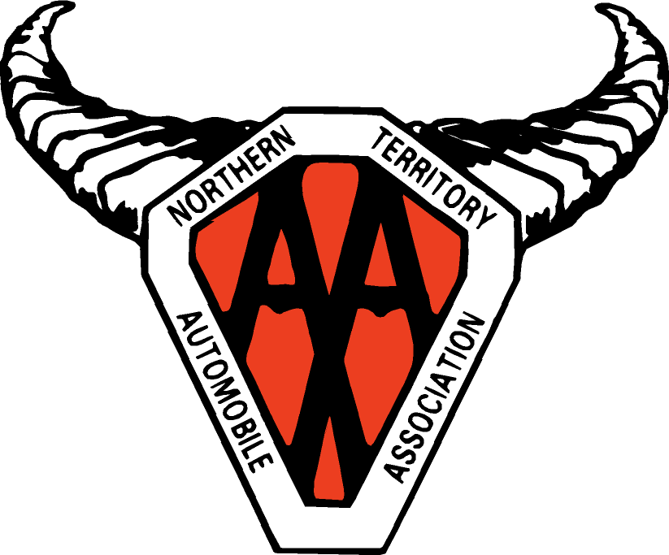

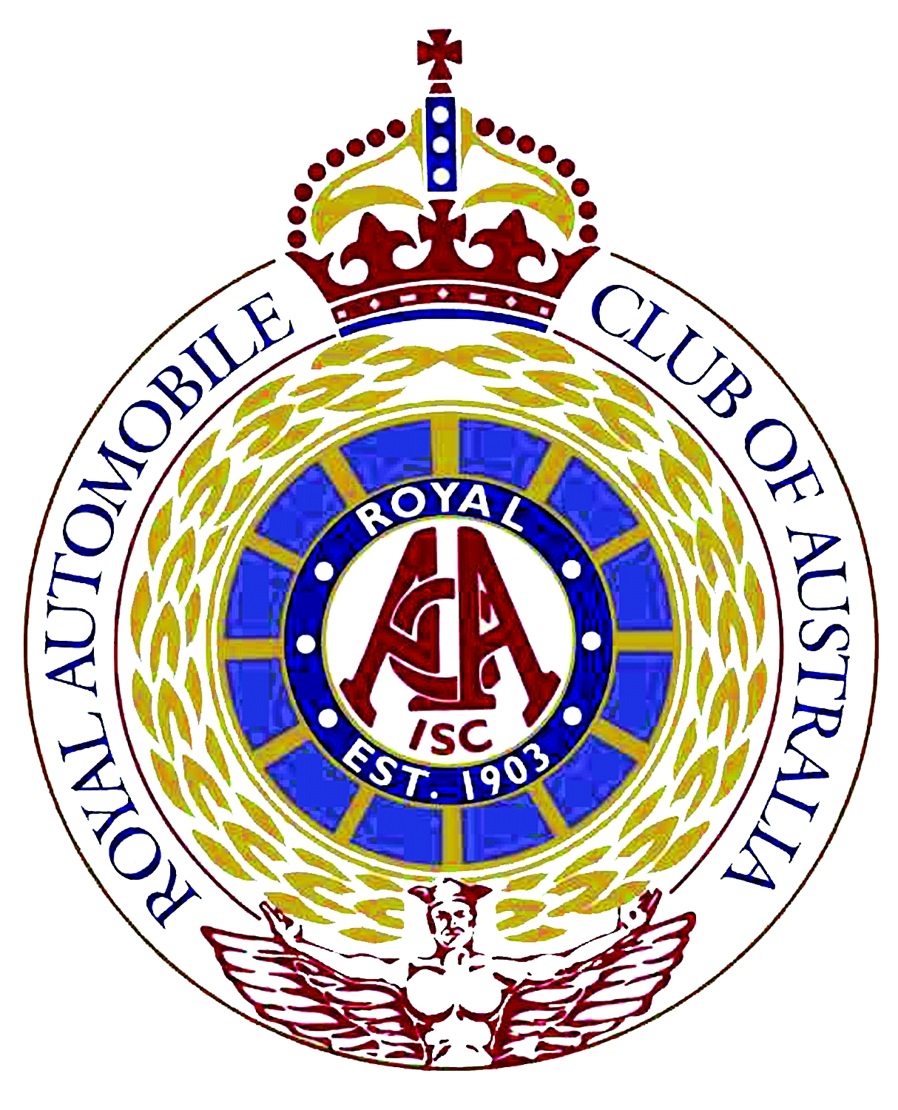



Senator Alan Eggleston,
Chairman
Senate Standing Committee on Environment,
Communications, Information Technology and the Arts
Parliament House
Canberra ACT 2601

Dear Senator,

The Australian Automobile Association (AAA) welcomes this opportunity to provide a submission to the Committee on the Fuel Quality Standards Amendment Bill 2003.

The AAA welcomes the Commonwealth’s moves to adopt a legislative approach to the labelling of fuels at the point of sale through setting a fuel quality information standard (FQIS). We note that in the first instance, the provisions are expected to be used to institute a labelling requirement for the supply of ethanol-petrol blends to the end user.

We support in particular the amendment which requires the Minister to consult the Fuel Standards Consultative Committee before making an FQIS - section 24A(1) - and that the standard must specify information which is in the public interest - section 22A.

We note that the legislation currently under consideration is enabling legislation and as such, gives no indication of what labelling might result or even when it may be applied. As Australia’s largest consumer organisation, representing over six million motorists through our constituent clubs, this lack of detail and potential delay are of significant concern to the AAA.

Adequate labelling is essential for a number of reasons which are in the public interest. Importantly, ethanol-blended fuels may not be suitable for all petrol engines in the Australian vehicle fleet, according to advice from vehicle manufacturers and importers and independent testing conducted for Environment Australia by the Orbital Engine Company.

Until the labelling regime is in place, motorists as consumers, have no way of knowing whether or not the fuel they are purchasing contains ethanol or, whether or not an ethanol blend is suitable for their vehicle.

Given that it appears vehicle manufacturers and importers recommend against the use of ethanol in at least 40 percent of the vehicle fleet, this is a very serious concern as consumers have been left exposed for an extended period
2.

of time. It should be noted that the Government indicated late in 2002 that it would require labelling of ethanol fuels and in April 2003 announced it would legislate to require that labelling. It now appears labelling is unlikely before the end of this year.

Another serious consumer concern is the reported lack of compatibility of a substantial part of the Australian vehicle fleet with ethanol blends.

It is generally accepted that vehicles built before 1986 should not use ethanol blends because of the materials used in pre-1986 fuel and engine systems. In Australia, 20% (2,066,916) of the current vehicle fleet or one in every five vehicles was built before 1986 (Source ABS 9309.0).

While this by itself is a serious enough problem, there have also been media reports (we note they have not been denied), that manufacturers have advised their national body, the Federal Chamber of Automotive Industries (FCAI), of a wide range of newer vehicles that also should not use ethanol blends (see attachment: 40.pdf).

According to the published list the following are among the vehicles manufacturers recommend should not use ethanol blends.

- Ford Falcons built between 1986 and 1998 (875,000 vehicles). (ABS 9309.0; 2003 Black and White Data Book, Glass’s Information Services);
- All Hondas (303,000 vehicles) (ABS 9309.0);
- A variety of Toyotas including Corolla’s built between 1989 and 1995 (440,000 vehicles) (estimate based on ABS and industry figures)

Together with the pre-1986 vehicles (2,066,916) this partial list totals over 36% of the current vehicle fleet or more than one in every three vehicles.

Despite the concerns raised here, we want to emphasise that the AAA is not opposed to ethanol in the Australian fuel mix. We do, however, believe that four conditions must apply to its use to provide adequate protection for consumers.

- A maximum limit of 10% should apply (based on notification from vehicle manufacturers and Orbital Engine Company research indicating that levels in excess of 10% may damage engines and/or void warranties);

- There should be no mandating of ethanol content (so as to allow consumer choice and because of practicality problems with a nationally mandated ethanol level and availability);
3.

- There should be detailed labelling at point-of-sale providing consumers with information that relates to the suitability of the use of ethanol blends in their particular vehicle, indicates the impact on fuel economy and potentially on warranty, and highlights potential problems with initial use (dislodged deposits in the system etc); and

- The use of ethanol in petrol should not increase petrol prices or the cost of motoring (noting in particular the lower energy content of ethanol fuel and the resulting impact on fuel economy).

AAA welcomes moves to introduce this legislation which aims to produce nationally consistent labelling of ethanol blended fuel and other biofuel blends. The AAA will work with the government through the Fuel Standards Consultative Committee in development of the labels meeting the minimum requirements outlined above once this enabling legislation is passed.

Yours sincerely



Lauchlan McIntosh
EXECUTIVE DIRECTOR

