AAD Brisbane:
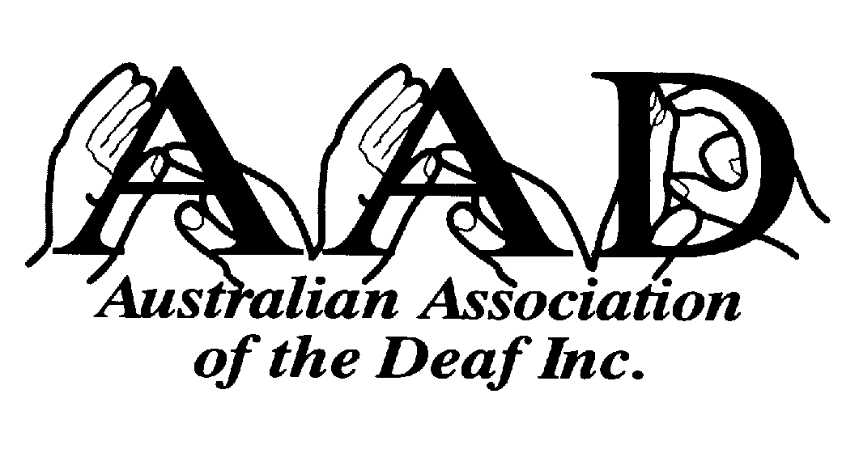
247 Stafford Rd PO Box 1083
Stafford Qld 4053 Stafford Qld 4053
Tel: (07) 3357 8277 (TTY only)
(07) 3357 8266 (voice only)
Fax: (07) 3357 8377

AAD Sydney:
N Block PO Box 4681
361-365 North Rocks Road North Rocks NSW 2151
North Rocks NSW 2151
Tel: (02) 9871 8400 (TTY only)
Fax: (02) 9871 8218

E-mail: aad@aad.org.au
Website: www.aad.org.au

Mr Michael McLean
Secretary,
Senate Environment, Communications, Information Technology and the Arts References Committee
Parliament House
CANBERRA
ACT 2600

Dear Mr McLean,

Australian Association of the Deaf (AAD) is pleased to have the opportunity to make this submission to the Inquiry into Competition in Broadband Services requested by References Committee. We have previously made submissions to other similar inquiries and this submission is essentially the same as these previous submissions.

As the national peak organisation representing Deaf people who use Auslan (Australian Sign Language), AAD covers a very broad base of advocacy and information provision. Deafness and the use of Auslan affect all aspects of a Deaf person’s life. Issues important to Deaf people on which AAD advocates include:

▪ Telecommunications
▪ Captioning of TV, movies, videos and DVDs
▪ Education
▪ Sign Language
▪ Interpreting
▪ Employment
▪ Youth
▪ Health, including Mental Health
▪ Legal issues
▪ Access and equity in general service provision

Although it is only one area in which AAD must involve itself, telecommunications is a large area and potentially impacts on many other areas.

According to a South Australian Department of Human Services study (The epidemiology of hearing impairment in an Australian adult population) completed by the Centre of Population Studies in Epidemiology in 1998, in Australia over 485,000 people have a hearing loss over 65dB (severe to profound loss), which would affect their ability to use the standard telephone satisfactorily.

AAD’s Deaf Telecommunication Access and Networking project (DTAN), funded by the Department of Communications, Information Technology and the Arts (DCITA), has the obligation to represent the views of Deaf people in relation to all telecommunication matters. DTAN consults widely with the Deaf community and researches issues and needs in relation to improving access to products and services within the Australian telecommunication industry. This submission is based on research undertaken to date by DTAN into issues raised by the Inquiry.

Our submission firstly summarises the issues that impact on Deaf people in relation to access to Broadband technologies then later provides detail on some of the issues.

SUMMARY
Broadband offers a great source for access to applications and services such as:

▪ Multi-media services
▪ Information sourcing (on demand)
▪ Visual communication (videotelephony)
▪ Video on demand
▪ Home banking and shopping
▪ Interactive games
▪ Education (database sourcing/online)
▪ Carer support (medical)
▪ Internet telephony

For the above functions to work, broadband services need optimum infrastructure and operational requirements. Factors such as:

▪ User computer/technology capacity
▪ Computer operating system
▪ Bandwidth access and capacity
▪ Capacity of server
▪ Volume of internet traffic
▪ Amount of simultaneous usage on the broadband network

And of course factors that allow access to the broadband network:

▪ Cost (access, equipment and usage)
▪ Universal service considerations (such as ‘Networking the Nation’ program through ‘Local Wireless Loop’)

For Deaf Australians, text communication via teletypewriters (TTYs) has been the vehicle that provided access to the telephone network, either directly with other TTY users or indirectly via the National Relay Service to non-TTY users.

The evolution of the internet and email, predominantly a text based information and communication source, has enabled Deaf people to access this on equal terms with everyone else, at least for those who have the required English fluency to comprehend and communicate information presented in English.

With the evolution of improved technology and diversity of applications, visual communication over the telephone network (videoconferencing, videophone, Video over Internet Protocol) has emerged. Not only have they advanced improved social, community and business community outcomes with their ability to add a visual dimension to the interaction taking place, videotelephony has also provided better results in staff work cost-savings, more effective time management, better relationship results (business), quicker and improved medical diagnosis and so on.

For Deaf people, videotelephony has the potential to allow Deaf people who use sign language to communicate in their preferred language. It already has shown positive results in recent international and Australian developments providing improved information, communication, social, education and employment opportunities and results for Deaf people.

However, access to the telephone network, computer applications/internet and videotelephony for many Deaf people is impacted by the following issues:

Affordability
It is well accepted that many Deaf people are of lower socio-economic background because of the inadequate standard of educational opportunities and also poor employment options and choices due to social attitudes towards Deaf (and disabled) people.

As their income is limited, so is their ability to purchase the tools and services to access the telephone network in the same way most others are able to.

Rural and remote
Deaf people who live in rural and remote areas are limited not only by cost factors to using the telephone network (it takes 6 - 8 times longer to have a TTY to TTY conversation than it does for a voice conversation, therefore a STD TTY call would cost 6 - 8 times more), but also by restrictions on network access availability (eg Wireless Local Loop is not currently designed to accommodate TTYs).

EFFECTIVE INTERFACE WITH BROADBAND TECHNOLOGIES FOR DEAF PEOPLE REQUIRE THE FOLLOWING OUTCOMES:

A) Regulations that include Universal Access clauses:

▪ Design principles that include accessibility provisions (eg; assistive or alternative technologies). In the USA a recent Federal Communications Commission (FCC) decision to force digital wireless service providers to be capable of transmitting 911 (emergency call number) calls made using TTY devices by June 30 2002, is an example of design adaptation to meet such requirements;
▪ Inclusion of alternative technologies relevant to broadband communication access for Deaf (and disabled) people in the Disability Telecommunication Equipment program regulations;
▪ Availability of basic services or their equivalent to all customers (including Deaf and disabled people) on affordable terms;
▪ Provision of subsidies that reduce the cost burden on Deaf people required to meet the extra expenses associated with the extra time it take to transmit TTY/video communications and also gaining access to services and products (equipment such as Nokia 9210 (with V.18), videophones/video software).

B) Adoption and/or use of international standards:

▪ ITU*-T’s H series Supplement 1 standards (H.323 , H.248) that enable video communication for Deaf people;
▪ ITU V.18 standard - an international standard for text telephony providing a compatibility gateway with all text communication devices around the world;
▪ ITU T.140 - a plain text protocol that can be used by all digital communication products;
▪ ITU T.134 relating to text communication through multi-media communication.

* ITU - International Telecommunication Union - makes international technical standards in telecommunications (www.itu.org)

C) Compatibility/Interconnectivity between wireless technology (mobiles) and TTYs:

▪ Adoption and inclusion of V.18 standard in mobile phones (such as Nokia 9210) allowing text communication between mobiles and TTYs (currently available in Europe);

▪ Creation of a 3rd generation mobile video telecommunication device along the lines of the WISDOM* project using the UMTS* network allowing Deaf people to access a video server through text/graphic menus and directly through sign language recognition;

▪ Standardising text telephony and text conversation in 3rd generation mobile systems.

* WISDOM - Wireless Information Services for Deaf people On the Move (details later in submission)
* UMTS - Universal Mobile Telecommunications System (3rd Generation Mobile communication systems being currently developed - www.umts.com)

D) Effective Broadband access

▪ With a minimum requirement of uninterrupted 128kb line access to enable Deaf people to communicate in sign language using videophones or videoconferencing, broadband access providers needs to consider the best cost-effective way to achieve this for their Deaf customers (optimum quality is gained when uninterrupted access to 384 kb is available);

▪ Emergence of IP-Relay (USA) (https://www.ip-relay.com/index.html) is a trend that will allow alternate communication between Deaf and hearing people via internet protocol and this requires good broadband access;

- Emergence of the Allan eC* ‘next generation total conversation’ system using computers, that allows an array of communication applications including video, text, email, fax, and voice, specifically designed for Deaf people. The Allan eC requires between 300 and 400 kbt/s of IP network connection in both directions for sign language to be effectively communicated;

▪ Multimedia applications for mobile phones (that include video) need to allow sufficient broadband access (128Kb or greater) enabling Deaf people to use them effectively.

* Allan eC is a swedish product designed for Deaf people now on the market. For more details see www.omnitor.se.

DETAILS:

The following provides further detail to key issues raised earlier in the submission.

A) Text communication requirements:

▪ TTY access that includes ASCII as well as baudot rate;
▪ Computer Modem software access that can communicate with TTYs (Telstra has installed the ‘NTS’ TTY modem software that allows their Disability Enquiry Hotline computers to communicate directly with TTYs);
▪ Mobile phones that can communicate in baudot text (eg European model of Nokia 9210 with V.18 standard included in the modem).

B) Videotelephony for Deaf people requirements:

▪ Computer/video hardware/software
▪ ITU-T H series Supplement 1 access
▪ Good bandwidth access (minimum 128kb, but for sign language 384kb is preferred)
▪ Good quality picture resolution
▪ 25 frames per second minimum
▪ High outward bound data rates helps quality of transmission

Videotelephony provides a viable solution not only for Deaf people communicating in sign language but also provides an excellent alternative for sign language interpreting in remote locations. Currently Deaf people who live in rural and regional areas are poorly serviced by specialist agencies because of distance difficulties and costs. Video communication technology has (as evidenced overseas and in Australian trials) illustrated cost savings (comparison of staff time/costs, travel, accommodation, etc.) and more regular and effective services.

Omnitor AB, a Swedish company dedicated to improving access to communication technology for Deaf people, has for many years worked on the development of a multi-functional computer terminal that allows communication in sign language, text and speech. Just recently they have improved their Allan 10 ‘total conversation’ project to enable access via the internet. It is called the Allan eC. It includes a hardware and software kit comprising of a camera, video capture board, headset, alerting system adaptor, manual and adaptive software.

The Allan eC enables a Deaf person to communicate in sign language, converse with TTY’s, have text conversations, send emails, faxes, download files and so on.

The benefits of videotelephony are many. They include:-

• Visual communication in Auslan
• Faster and more natural communication than by TTY
• Provide an alternative interpreting service - assists rural and remote areas
• Allows ‘face-to-face’ contact from a distance
• Can save on travel and work time costs
• Improved work / educational performance

C) Wireless mobile phone communication options:

▪ A 3rd generation ‘WISDOM’ type mobile phone should be globally accessible and not have to be trapped by regional standards that are not compatible. The European Commission-funded WISDOM mobile project includes:

WISDOM Objectives:

1. Develop and trial a video communication device for deaf people for use in UMTS networks in Europe.

The Bluetooth enabled Device includes:

a. Video camera - for sending user sign language (this has to allow control by the system to ensure the framing of the signer's head, shoulders and hands). This is to be designed and tested.
b. Pocket keyboard - for text interface to telecommunications devices, internet access and to integrate text/video communications. This is to be sourced and tested.
c. Portable screen unit - for display of video, text (compromise between screen size, viewing distance and location of camera for eye contact in sign communication and size of image). This is likely to be integrated with the camera and the video compression electronics and will support the main graphical user interface.
d. Alert device for incoming calls - wrist vibrator. This is to be sourced and tested.
e. UMTS Bluetooth enabled mobile receiver/transmission unit. This will be a standard unit and will simply provide the air interface to the network for the data being generated by the rest of the system.
f. All components are to be integrated and trialled in the field to pre-production stage.

Although in the life of the project, Bluetooth enabled devices will come to market, there remain unique features for the project to address such as wrist vibrator, adaptations (camera location and screen size has to be a compromise) and integration (Global Text Telephony is a means of ensuring that deaf people can have text conversations with deaf and hearing partners). MPEG4 as a potential video transport offers real advantages to mobile networks in its compression and in the way it handles video events and scenes.

2. Create a 24 hour, seven (7) days a week video information service for deaf people on the move allowing them to reach information sources, interactively from any part of the network and throughout Europe. This requires the setting up of a wireless LAN test bed for video interaction and file access for trials with deaf users.

3. Provide access to the information service and emergency services through sign language recognition by a user interface to the video server, activated directly by the users' signing.

4. Provide access to voice telephone users through a video relay service with sign language interpreters.

5. Develop a service and quality of service model for network operators which will support future developments in other Member States. This requires the implementation of a UMTS network and conduct of trials using project generated sign language scenarios with deaf users.

6. Incorporate standards for Global Text Telephony to ensure that a text/video interface is developed and trialled.

7. Interface the development with 3rd generation network services and provision to ensure that deaf people enter a new age of telecommunications with at least the same access to each other and information content as hearing people.

8. Involve deaf partners, deaf researchers, and deaf users throughout the project by the creation of video-telecommunications user groups to feed forward specifications and needs.

9. Evaluate outcomes according to each objective in the work packages.

• Australian adoption of ITU V.18 standard would enable mobile phones such as Nokia 9210 Communicators to include access baudot (TTY) rate allowing Deaf people to have a readily available mobile phone that is capable of communicating with TTY’s.

As can be seen, for Deaf people to gain equal access to broadband technologies, improvements in equipment access and development, broadband access, pricing and the regulatory environment need to occur. The DCITA funded Deaf Australian Online projects further established detailed evidence of the online needs and solutions for Deaf people which support our submission’s position. Deaf people like all others want and need to be an integral part of the evolving telecommunicating world - not on the tailshaft.

The Inquiry into Competition in Broadband Services is timely and a critical opportunity to assess the needs of all Australians, particularly in this case, Deaf Australians.

Should you require further information in relation to our submission, please feel free to contact us.

Yours sincerely,

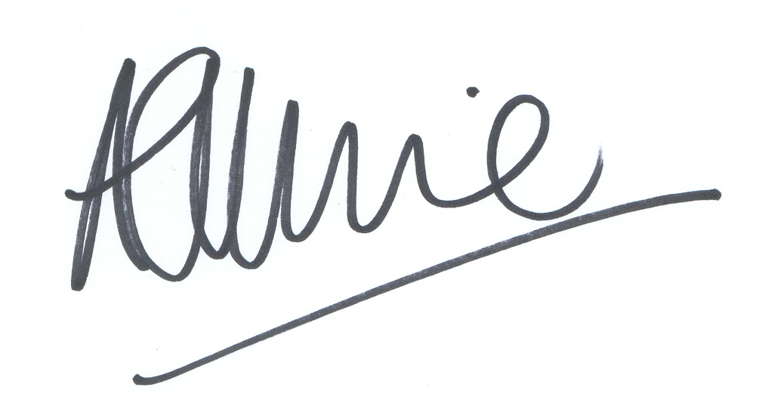

Andrew Wiltshire
Community Liaison and Projects Officer
References

Cattani, R. The European Disability Forum Manifesto on the Information Society and Disabled People. UAIS (2001) 1:77-79

Federal Communications Commission. Revision of Commission Rules to ensure compatibility with enhanced 911 emergency calling systems. www.fcc.gov. May 2002.

Harper,P. Videotelephony - The next telephone for Deaf people? Paper. Victorian Council of Deaf People State Conference 2002. www.vcod.com.au

Harkins, J. & Vanderheiden, G. Comments on the Rehabilitation Engineering Research Centre on Telecommunications Access at the Trace Centre, University of Wisconsin and Gallaudet University. FCC Inquiry submission. 1998. www.trace.edu/docs/fcc98-146.htm

Hellstrom, G. Equal opportunities to telecommunications: ITU approve suite of recommmedations to make communications easier for people with disabilities. February 1998. www.omnitor.se

Hellstrom, G. Allan eC. Next generation total conversation. 2002. www.omnitor.se

Victorian Deaf Society. Deaf Australia Online I & II: Final reports. 1999 / 2000. East Melbourne. http://www.vicdeaf.com.au/whatsnews/deafonline2/DeafAustraliaOnline2.htm

WISDOM. Wireless Information Services for Deaf people On the Move. European Commission 2000. www.mobilewisdom.org.

