From: Lee-Ann Barton
Sent: 30th September 2003-10-01
To: ECITA Committee(SEN)
CC: Lundy, Kate(SEN)
Subject: Inquiry into competition in broadband services

Lee-Ann Barton
Townsville Catholic Education
2 Gardenia Avenue
Kirwan, QLD, 4817

Dear Sir or Madam,

Thankyou for the invitation to respond to the “Inquiry into competition in broadband services”.

I write in reference to the broadband services that are NOT available to Catholic schools in North Queensland and more specifically Catholic schools in the Diocese of Townsville.

BACKGROUND
Currently, the ICT curriculum services at the Townsville Catholic Education have been negotiating with Telstra to install ADSL into our schools (see the map of our district below) with limited success.
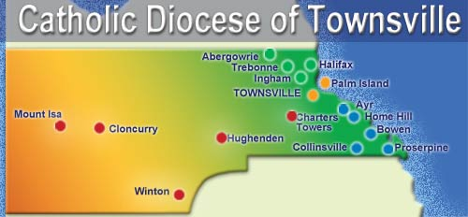

AVAILABLITY of ADSL in our district
Availability of ADSL is limited, showing a huge discrepancy in access between schools that are 30-45 minutes in distance from one another:
- ADSL is only available to schools in some parts of Townsville, ADSL is not available to Catholic schools in Deeragun, Annadale, Palm Island and Wulguru, just to name a few suburbs.
- ADSL is available to two Catholic schools in Ayr, ADSL is not available to the Catholic school over the Burdekin bridge (5 minutes) in Home Hill.
- ADSL is available to some Catholic schools in Mt. Isa, however ADSL is not available to schools on the eastern end of Mt. Isa and Cloncurry.
- ADSL is available to the Catholic school in Proserpine and Bowen, however ADSL is not available to the Catholic school in Collinsville.
- ADSL is available to one Catholic school in Charter Towers and it ADSL is not another on the other side of Charters Towers.
- ADSL ADSL is not available to Catholic schools in Hughenden and Winton.
- ADSL is available to two Catholic schools in Ingham, yet it ADSL is not available to the Catholic school in Halifax, Trebonne and Abergowie.

The ALTERNATIVE is not viable
The alternative is to install ISDN (128kb) or a Satellite dish (400kb).

THE PROBLEM WITH ISDN (128kb)
- Timed phone calls at 60 cents an hour (very expensive for schools when they would be online for a minimum of 7 hours a day.)
- Connection to bigpond at $38.95 a month for business plans for 700kb of data. No group plan available for a 128kb line.
- Rental rate per month of $69.00 a month.
- No static IP address, therefore no email accessibility through the school server, for staff at the school.
- With no static IP address there is no facility to have a Virtual LAN (VLAN) or private LAN between Catholic schools and our Catholic office.
- Bottlenecks occur when a class of 30 to 35 students are accessing information online , especially such multimedia as developed by the Commonwealth government learning federation initiatives as Learning Objects. In this situation 128kb is slow.

THE PROBLEM WITH SATELLITE DISHES (400kb) one way dial up
- High Latency
- Delay of data transfer for 5-10 seconds.
- Expensive for two-way satellite, so a dial-up for upload is the only option, which makes the transfer of data very slow.
- No static IP address
- Even if there were static IP address the latency would cause problems if the Catholic schools and the Catholic office were connected in a Virtual LAN (VLAN) or private LAN scenario (as we plan to implement in the near future).
- Bottlenecks occur when 30 to 35 students are accessing information online through a satellite, especially such multimedia as developed by the Commonwealth government learning federation initiatives as Learning Objects.

THE SOLUTION IS ADSL AVAILABLE TO ALL our Catholic schools!
TO ACHIEVE:
- The Queensland Government’s SMART STATE initiative and for it to become a reality in the classroom for every student and every teacher under the Education and Training Reforms for the Future (ETRF) package.
- The major achievements of the ETRF and allow for them to take place and create conditions where Information and Communication Technologies (ICTs) are integrated as everyday tools for learning and delivering curriculum.

REPORTING ON THE TERMS OF REFERENCE:

- the current and prospective levels of competition in broadband services, including interconnection and pricing in both the wholesale and retail markets;
- any impediments to competition and to the uptake of broadband technology;

For schools in the Townsville Catholic Diocese, Telstra is the only service that provides interconnectivity to and between our schools and our office. The price of ADSL, ISDN and FRAME RELAY services especially the rental and timed calls is very expensive, for our regional and remote schools which have small student enrolments (between 38 to 100).

For example;
FRAME RELAY rental prices as quoted for the Telstra Account manager for Catholic Schools in 2003 are $308,858 per annum. This is way out of our budget line for schools!

WAN Solution | # Schools | Installation | Annual Rental
Carriage Services
6 Mbps Frame Relay CEO | 1 | $ 22,000 | $ 75,037
1.5M/256K ADSL | 6 | $ 1,507 | $ 31,361
Frame Relay 128/64 | 9 | $ 8,663 | $ 141,150
Sub-total | 15 | $ 32,170 | $ 247,549
Network Hardware
CEO | 1 | $ 43,917 | $ 16,318
ADSL Router | 6 | $ 46,327 | $ 23,851
Frame Relay Router | 9 | $ 67,964 | $ 21,140
Sub-total | 16 | $ 158,207 | $ 61,309
Total |  | $ 190,377 | $ 308,858

For example;
ISDN rental for a static IP address is over $100 a month and the timed calls are 60 cents to $2.20 an hour.

ADSL is not an option in many remote and regional areas.

REPORTING ON THE TERMS OF REFERENCE:

- the implications of communications technology convergence on competition in broadband and other emerging markets;
- the impact and relationship between ownership of content and distribution of content on competition; and
- any opportunities to maximise the capacity and use of existing broadband infrastructure.

EQUALITY for ALL SCHOOLS NATIONALLY

HOW?
- There is a requirement for ADSL (1.5MB download and a static IP address) or its equivalent to be available to all schools.
- There is a requirement for one set cost nationally for all schools in all regions of Australia. One set cost should include:

    - very low rental to the broadband service;
    - no timed call rate on the broadband service;
    - Fast download speed (1.5mb);
    - Minimum 1 gigabyte of data per month.
- any opportunities to maximise the capacity and use of existing broadband infrastructure.

The Townsville Catholic Education is trying to achieve the following so as to maximise the capacity and use of existing broadband infrastructure.

A Wide Area Network covering all schools in the Townsville Diocese plus our Office at Kirwan. Internet access to be provided to the CEO with a high-speed Frame Relay link to Big Pond Internet Direct.
Schools connect to the CEO using 1.5M/256K ADSL HyperConnect and if that service is not available then the schools would connect using 256K/128K Telstra Frame Relay.

This potential WAN is RESTRICTED by the recurrent broadband cost of rental, low download speeds, data usage set to a minimum of 300mb a month, and high charges of $2.20 per megabyte over the minimum data use and timed call charges for broadband.

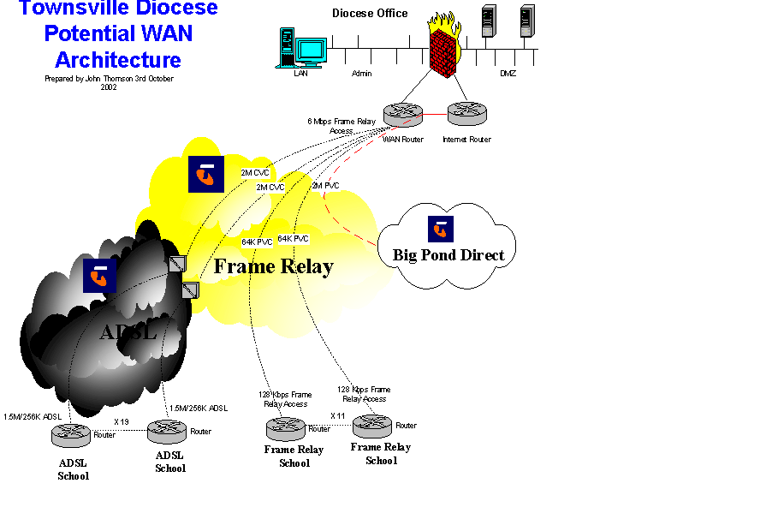

RESEARCH REQUIREMENTS
Australian research IS URGENTLY required by the government to investigate strategies to provide primary and secondary education with nationally low broadband access and costs, incorporating high data use at fast download and upload speeds.

