APPENDIX B: Examples of Credit Union announcements

Examples of CUSCAL press releases
1 August 2002 Credit Unions Open More Branches
15 April 2002 Credit Unions Support Banking Accessibility for All
11 February 2002 Forget High Bank Fees at Credit Unions
Jan 10 2002 Research Shows Credit Union membership across country
Jan 7 2002 Credit Unions Pay More Interest
4 October 2001 - Credit Union Regional Strength Grows
26 July 2001 Bank on Credit Unions for Customer Satisfaction

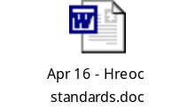

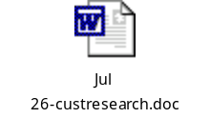

Examples of credit union announcements
WAW Credit Union
29 July 2002 Communities rally for hospital funding
28 February 2002 Energy Purchasing Project to reduce electricity prices in our community
25 March 2002 WAW Credit Union renews lease at Tallangatta
11 April 2002 Our Energy Community Meetings
WAW Credit Union Community Link Program – schematic



Holiday Coast Credit Union
History of Holiday Coast Credit Union available at http://www.hccu.com.au
27 August 2002 Holiday Coast Credit Union Committed to Region
29 July 1998 Cooperation Facilitates Restoration of ‘Banking Services’



New England Credit Union
10 September 2002 New Branch Blooming in Warialda



