Mr Elton Humphery
Secretary
Senate Community Affairs Committee
community.affairs.sen@aph.gov.au

Dear Mr Humphery

The Social Responsibilities Commission has been involved in advocacy for asylum seekers for approximately a decade. We have forged close links with other advocacy groups and with service delivery organisations.

Dr Judyth Watson, a member of the Commission, is also Secretary of the Coalition Assisting Refugees and Detainees (Inc) (“CARAD”). Dr Watson has written a detailed submission on behalf of CARAD, and has made CARAD’s concerns known to the Commission.

We endorse CARAD’s concerns and urge the Committee to recommend that the proposed changes to the Family and Community Services Legislation Amendment (Special Benefit Activity Test) Bill 2002 not proceed.

The Commission has long been of the view that successive Australian Governments have not fulfilled their obligations to asylum seekers, particularly since the introduction of the Temporary Protection Visas. For the Government to now argue ‘mutual obligation’ in relation to TPV holders’ access to Special Benefits is a travesty.

We wish the Committee well in its deliberations and look forward to an outcome which reflects a commitment to justice for all people judged to be refugees under the Refugee Convention of 1951 and the 1967 Protocols.

Yours sincerely

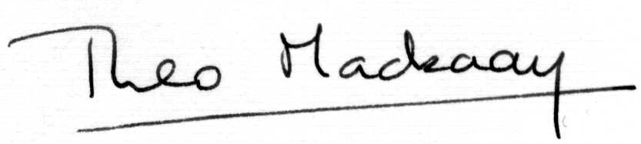

Theo Mackaay
Executive Officer

November 1st, 2002

