HEALTH INSURANCE RESTRICTED MEMBERSHIP ASSOCIATION OF AUSTRALIA
PO Box 77 Port Kembla NSW 2505

23 April 2003

Mr Elton Humphrey
Secretary
Australian Senate
Community Affairs
Legislation Committee

By email: community.affairs.sen@aph.gov.au

Dear Sir,

Introduction:

The Health Insurance Restricted Membership Association of Australia (HIRMAA) is pleased to be given the opportunity to provide a submission to the Senate for consideration with reference to the Health Legislation Amendment (Private Health Reform) Bill 2003.

The Senate will be aware that HIRMAA is the peak body representing all fourteen restricted membership health funds and we have provided all member funds with the opportunity to comment on the Bill currently before the Committee. The comments provided in this submission are a result of those consultations. Members of the Executive of the Association have also had the opportunity to discuss the detail of the proposed amendments with officers from the Department of Health and Ageing (DoHA).

HIRMAA is concerned whenever there are amendments to legislation effecting private health insurance, that the amendments are in the best long term interests of the constituents they represent, and these are the contributor members of the various health funds. It is with these long-term interests foremost in our deliberations that we offer the following optimistic assessment of the provisions of the current amendments.

Self Regulation of Rule Changes

The administrative inefficiencies associated with the current DoHA approval practice has long hindered the efficient operation of conducting health insurance business and the proposal to move to a less regulatory environment will result in benefits to the consumers.

HIRMAA views these changes enthusiastically as they will enable necessary variations to product and rules to be carried out with the speed necessary to cater for environmental changes in the market place and so ensure that the health funds are able to react quickly, with due consideration of the needs of their consumers. The current somewhat cumbersome approval mechanism has in the past resulted in actions being delayed to the detriment of the consumer.

Rule oversight will still be there to further protect consumers and the amendments contain various performance monitors and sanctions as additional safeguards. It is important that this rule oversight, either by the DoHA or the Private Health Insurance Ombudsman (PHIO) is in place to accept and act in a timely manner on any complaint by one fund against another, particularly if the issue could impact on the fundamental principle of community rating.

In an environment where there is a need to be wary of any unnecessary administrative expenditure increase, these amendments should assist in enabling the HIRMAA funds to continue to offer low administrative overheads and still meet the expectations of clients with developing administrative systems at best practice levels.

Performance Monitors

HIRMAA has been involved within the broader industry and with Government in developing a series of performance monitors which will be the key to being able to determine if funds are continuing to meet the expectations of their consumer body.

The real test of course as to whether a fund is meeting the consumer expectations lies in the overall retention of the membership base of the fund and meeting the long-term requirements of their constituents. This is the only real measure of effectiveness. Is the membership satisfied with the product they have purchased when compared with products offered by the competing funds.

The performance monitors currently before the Government seeks to provide consumers with assurances that their fund is performing well in the competitive market that has developed.

It should be noted that the current proposed measurements of performance are not static and the industry recognises that further measures might well be appropriate in the future as the environment changes.

Community Rating

The cornerstone to the current private health insurance system is the acceptance of the principle of community rating. It is essential that any amendments to the current provisions surrounding private health insurance do not in any way detract from this underlying principle.

HIRMAA has been assured by the regulators that community rating monitors to be put in place, accompanied by the threat of significant sanctions will deter any fund from adopting practices which could undermine the rights of the individual consumers currently protected implicitly by community rating. We have been assured that the proposed monitoring measures will be effective in quickly alerting the regulators to any suspected breach of the principle and that in the event a breach is suspected, they will be acted upon with vigour and in a timely manner.

Administrative Sanctions

It is to be hoped that the administrative sanctions detailed in these amendments and discussed with the industry will not need to be applied. Once applied, they ultimately affect the consumers, particularly if it means that a breach of conditions of registration by a health fund causes the imposition of the withdrawal of the ability to claim up front the thirty percent rebate on private health insurance contributions.

HIRMAA has been assured that the imposition of any sanction will only be effected when all other mechanisms for correcting abhorrent behaviour have first been applied. This is important to safeguard the expectations of the consumers.

DoHA guidelines should promulgate to industry, clearly defining the steps that can be taken in the event of any suspected breach that could ultimately result in the imposition of sanctions. HIRMAA is ready to assist in the development of industry guidelines.

Extension of Powers of the Private Health Insurance Ombudsman

It is important that consumers have the ultimate safeguard of an independent ombudsman for occasions when the system within their health fund fails to meet the standards they think should be applied.

It is likewise important that the PHIO has sufficient powers to carry out the responsibilities of the office.

The ability of the PHIO to require the presentation of material and adherence to formal recommendations should not only apply to health insurance funds, but likewise should be mandated for other bodies with whom the office is required to act, in particular hospitals and medical practitioners who are often the cause of protracted and expensive disputes.

HIRMAA recognises that the majority of the PHIO complaints arise because of administrative error on the part of a party rather than intent, but where the error is of a significant magnitude to warrant firm intervention, then the Office of the Ombudsman should have the appropriate power to enable appropriate redress by the consumer.

The proposed amendments go a long way to providing for this safeguard to the consumers.

State of the Health Funds Report

The PHIO has been given the almost impossible task of compiling data on health fund performance and service delivery to enable consumers to be able to make an assessment of the right product to provide for themselves and their family.

This is not the first attempt to provide this assistance to consumers - the 1995 legislation required PHIAC to produce a similar comparison and the Key Features Guide produced by each fund is likewise there to assist in the process. To date none has been successful and it is hoped this effort will be more useful as ultimately it must be paid for by consumers whether it is successful or not.

The difficulty in completion of this task in satisfactory manner arises because of the inability to directly compare the diverse product offerings of health funds and then produce a reliable quantitative measure. None-the-less it is important to try and assist the individual consumer make a more accurate choice, whilst still retaining the breadth of product in the market.

It is important though that the PHIO does not, through the production of this report, be seen to be recommending a particular product or health fund above another. This will not assist the office in retaining the absolute independence the PHIO's other responsibilities demand.

There is a cost to the consumer of maintaining the office of the PHIO and it is important that the money derived from the health fund levy which finances the office is used to the best benefit of the consumer and not wasted. The detail contained in the State of the Health Fund’s Report and its eventual use by consumers to assist in their decision on product, is the important issue. A report that does not provide these benefits to consumers will not justify the cost of production and distribution.

Lifetime Health Cover

The adoption of lifetime health cover has ensured that the Australian public, who had wanted to rely on both the public and private health sector, accepted that this was a long term decision and the legislation has set in place a regulatory environment which is there to protect all participants.

The current amendments before the Senate are welcomed by HIRMAA as they will, in the common birthday instance, reduce administrative complexity, and with the other proposed amendments incorporate safeguards for the small number of persons who were not adequately catered for in the initial legislation.

Conclusion

As was stated at the outset, HIRMAA funds are concerned that any amendments to health insurance legislation represents an advantage to the consumers we represent.

We have vigorously investigated the proposed amendments and while there is some possible initial short-term administrative cost with compliance, it is our feeling that ultimately the amendments will serve to further enhance the attractiveness of the health insurance product for our consumers.

Should you require any additional information or wish our association to appear before the committee please do not hesitate to contact me by return email or by phoning 02 4224 4301 or Mobile 0418 424 055.

Yours faithfully
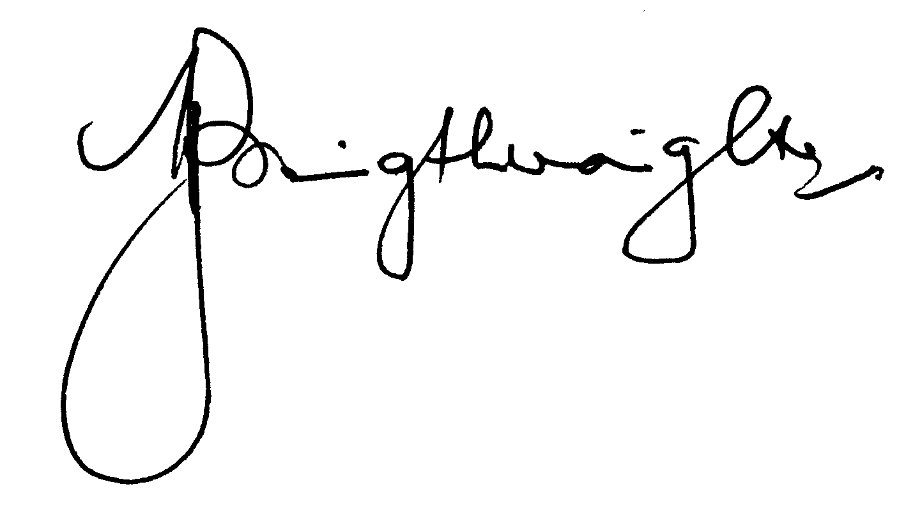
Michael Bassingthwaighte
Secretary

