7.2.1
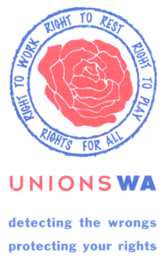

Address:
77-79 Stirling Street
Perth 6000

PO Box 8351
Perth Business Centre
Perth 6849

Telephone:
+61 8 9328 7877

Facsimile:
+61 8 9328 8132

Web site:
www.tlcwa.org.au

Email:
unionswa@tlcwa.org.au

Trades & Labor Council
Of Western Australia

State branch of the ACTU

Please address all
Correspondence
To the Secretary

28 May 2003

The Secretary
Senate Community Affairs References Committee
Suit S1 59
Parliament House
CANBERRA ACT 2600

Dear Secretary

Senate Inquiry into Poverty & Financial Hardship

UnionsWA is urgently calling for the Senate Standing Committee on Community Affairs (the Committee) to visit Western Australia to hold public hearings for the Senate Inquiry into Poverty and Financial Hardship. We note that the Committee has already held such hearing in Adelaide, Melbourne, Hobart, Sydney, other towns in New South Wales, and Canberra. UnionsWA and a number of our affiliates including individual workers seek to appear to give formal evidence before the Committee on this important issue.

Both the ACTU and the Federal Liquor, Hospitality & Miscellaneous Workers Union (LHMU) have submitted written submissions to the Committee which UnionsWA support. Further, we note that the WA branch of the LHMU wrote to the Committee highlighting some elements of the industrial relations legislation in WA and indicated they are looking forward to the opportunity to provide further material to the Committee on a visit to WA. We believe the Committee would be greatly assisted by holding a public hearing in Western Australia as there are some significant and unique features in the WA industrial relations environment which impact on the low paid in this State.

Western Australia is currently the only jurisdiction in the Australian labour market which determines two minimum wages. A minimum award wage is set by the Western Australian Industrial Relations Commission (WAIRC) having regard to the National Wage Decision of the Australian Industrial Relations Commission each year. There is also an Adult Minimum Wage pursuant to the Western Australian Minimum Conditions of Employment Act. The Adult Minimum Wage under the Minimum Conditions of Employment Act was until this year set at the discretion of the Minister for Labour Relations. Up until August of last year, there was a significant disparity between the two minimum wage levels. In fact, UnionsWA assert that the situation where the Minister set the Adult Minimum Wage created and perpetuated an unfair distribution of wages amongst the lowest paid
- 2 -

workers in Western Australia, that is, between those workers on awards and those employed pursuant to other instruments, or common law contracts of employment.

The table below indicates in the left hand column the Adult Minimum wage level set under the Minimum Conditions of Employment Act and in the right hand column indicates the Award Minimum Wage set in accordance with the National Wage Decision. We also attach a graph of these figures.

Adult Minimum Wage Award Minimum Wage
$301.10 29 August 1994
$317.10 29 September 1995
$332.00 29 October 1996
$335.00 10 November 1997 $359.40 10 November 1997
$346.70 7 December 1998 $373.40 1 August 1998
$385.40 1 August 1999
$368.00 1 March 2000 $400.40 1 August 2000
$400.40 22 March 2001 $413.40 1 August 2001
$413.40 29 April 2002 $431.40 1 August 2002

It is clearly demonstrated by the above figures and the attached graph that from the point at which the first Adult Minimum Wage rate was issued in August 1994 through to 2000 both the date of issuance and the numerical value of the Adult Minimum Wage has lagged significantly for those workers in Western Australia who were unable to access the increase in award wages.

The existence of the Adult Minimum Wage pursuant to the Minimum Conditions of Employment Act in Western Australia, has meant that WA has had the lowest minimum wage of any other jurisdiction in Australia, including the Commonwealth, for employees in either the deregulated or regulated labour market.

Furthermore, recent research demonstrates that Western Australian women are at a pecuniary disadvantage in relation to employment as compared with their Eastern States counterparts. The gender gap in Western Australia is more significant than in any other part of Australia including the Commonwealth, that is, the difference in wages between women and men in Western Australia is larger than the difference in wages between women and men elsewhere in Australia. The most recent ABS statistics on the average weekly ordinary time earnings indicate that this has not changed.

Western Australia also began the process of decentralising the labour market before other States and the Commonwealth and this led to the proliferation of individual contracts. However, the scheme of individual contracts in WA had a significant difference than at a Federal level. Individual contracts in WA were not subject to no disadvantage test similar to that for Australian Workplace Agreements under the federal legislation. Thus workers in Western Australia on individual contracts were subject to minimum wage levels that were lower than the level prescribed for rhe no disadvantage test for AWAs.
- 3 -

Given the above unique elements of the Western Australian labour relations environment UnionsWA would suggest that low paid workers in WA have experienced more intensive levels of financial hardship than elsewhere and would urge the Committee to ensure a public hearing in Western Australia so that the experiences of those in WA can be adequately considered.

I look forward to your immediate response.

Yours sincerely
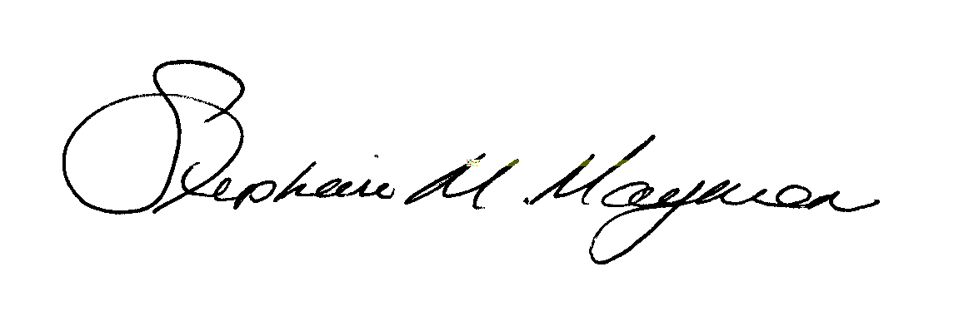

Stephanie Mayman
Secretary

