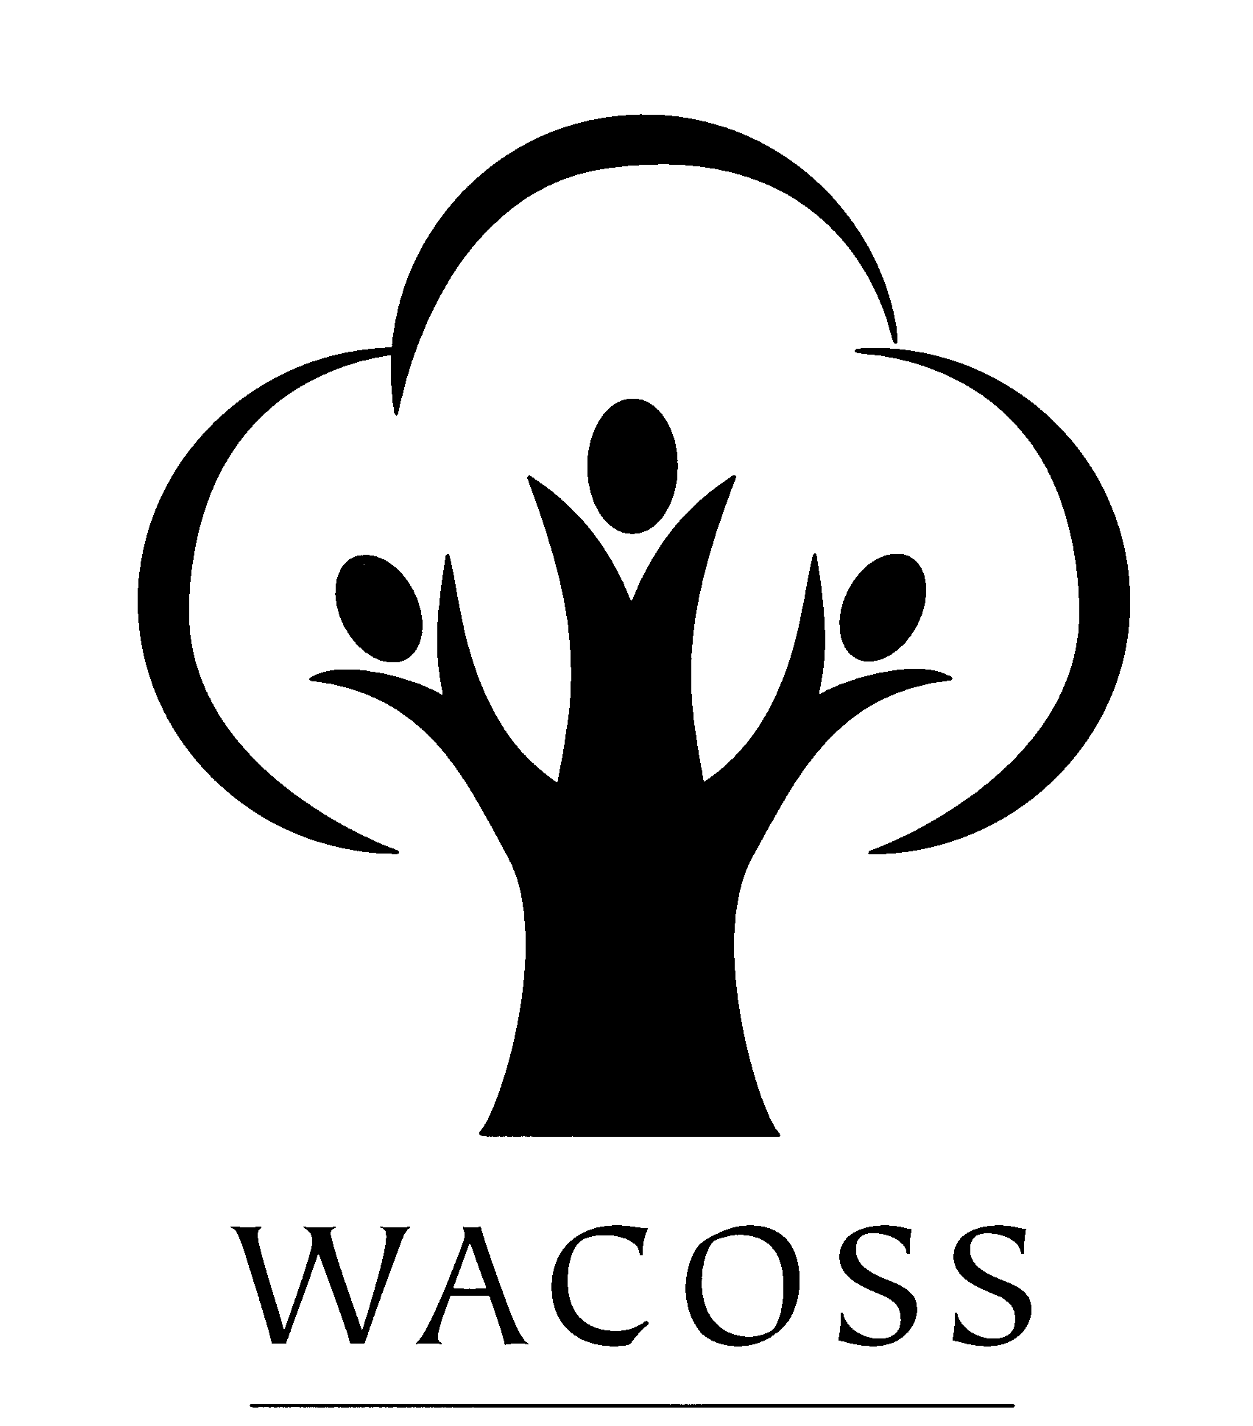
Western Australian Council of Social Service Inc

WACOSS Submission to the
Senate Community Affairs References Committee
Inquiry into Poverty and Financial Hardship in Australia

July 2003

Introduction

There is significant evidence provided on an ongoing basis by community sector agencies in Western Australia regarding the existence and impact of poverty on our citizens.

The existing literature regarding poverty in Western Australia as provided in our written submission attests to the fact that we face growing levels of deprivation within our communities.

Western Australia, the most geographically vast and isolated State in this country faces unique and complex issues in relation to increasing poverty levels and impact requiring amelioration.

WACOSS Background

The Western Australian Council of Social Service Inc (WACOSS) is the peak body of the community services sector in WA.

WACOSS and its members aim to improve the quality of life of people disadvantaged by the inequities of our society through:

Improving community services by exchanging ideas, information, skills and resources, creating a strong united and informed voice capable of advocating for the social needs of all Western Australians.

A continual consultation process with members, their clients, the general public and other professional organisations enables WACOSS to identify and endeavour to address social inequities within the community. This is achieved by:

- Contributing to the development of social policy;
- Promoting the provision of social services;
- Raising awareness of social issues in the community;
- Facilitating coordination and cooperation amongst social service agencies across the State; and
- Providing a range of services to member and non-member agencies.

WACOSS also provides government with feedback on policies and programs to ensure that they are relevant and offers an alternative avenue through which government can discuss sector issues with service providers and consumers.

WACOSS is part of a national network consisting of ACOSS and the State and Territory Councils of Social Service, who assist low income and disadvantaged people, Australia wide.

WACOSS supports more than 350 member agencies and individuals in the provision social and community services to disadvantaged people and low-income earners across Western Australia. In this capacity WACOSS works with and represents a range of agencies including:

- Emergency relief agencies;
- Financial counsellors;
- Neighbourhood centres;
- Community legal centres;
- Large church-based welfare organisations;
- Disability service organisations; and
- Housing and crisis accommodations services.

Overview

In starting I’d like to quote a woman who is well-known and well-respected in the Mid-West and Gascoyne region of WA - Sister Mary Ryan, which I think summarises how things are today:

" Over the past 12 months or so, we have seen an increasing number of people who have never needed to access ER before: 2 parent families, lower income working people, unemployed singles (particularly males), those who have been in small business but have been unable to cope with the overheads associated with employing workers (public liability insurance, workers comp, administrative requirements around the GST etc).
There is a combination of reasons for this increase in emergency relief clientele and the changing nature of these groups. The cost of living has always been higher in rural areas, but it is increasing to a level that is unmanageable for many. This has worsened since the introduction of the GST. As well, Centrelink breaching, and the impacts that breaching has on family budgets, means that both singles and families are often left for extended periods of time without enough money to live on. "

The extent and nature of poverty in WA

Measuring Poverty
There is significant social policy debate regarding the measurement methodologies utilised to determine poverty and poverty rates. Whilst we believe it is important that a nationally agreed poverty measure be developed or adopted the absence of an agreed indicator should not obstruct or delay efforts to reduce the level of poverty or ameliorate the impact of poverty.

Further, agreement regarding a poverty line or poverty indicators should not be seen as the “finishing line” in relation to social policy in this area. It is essential that policy –makers do not lose sight of addressing poverty and it’s impact during the search for theoretical agreement regarding measurement.

WACOSS agrees with the approach to measuring and understanding poverty as suggested by Mack & Lansley (1985):

“Poverty is an enforced lack of socially perceived necessities”

As ACOSS states in “The Bare Necessities” this definition and most others used in poverty research, has three core elements:
- A lack of necessities;
- That necessities are socially defined;
- The lack of necessities is caused by limited material resources.

Necessities are resources (good and services) that people cannot reasonably do without. A lack of necessities is not the same as a lack of resources. Two people may have identical resources but different needs. For example, a family with a child with chronic asthma may require and additional resource, a nebuliser, to stay alive. The adequacy of resources and whether or not they are necessary – is therefore gauged according to people’s need.

The WA Taskforce in the International Year of Poverty (1996) utilised the following definition of poverty, which focuses on the minimum requirements to live decently, which may vary depending upon needs:

Individuals, families and groups, in the population can be said to be in poverty when they lack the resources to obtain the types of diet, participate in the activities and have the living conditions and amenities which are customary, or at least widely encouraged or approved, in the societies to which they belong. Their resources are so seriously below those commanded by the average individual or family that they are, in effect, excluded form ordinary living patterns, customs and activities.

The nature and extent of deprivation
When understanding poverty it is essential that we look beyond income level indicators as the only marker defining poverty. ‘Hardship in Australia’ An analysis of financial stress indicators in the 1998-99 Australian Bureau of Statistics Household Expenditure Survey’ provides valuable analysis of the 1998 –99 Australian Bureau of Statistics Household Expenditure Survey.

The report found:

- In Western Australia 39.7% of households surveyed had experienced “missing out” in the previous year including being unable to have family and friends over for a meal, nights out, hobbies, holidays away from home, or having to buy second hand clothing, due to a shortage of money.

- A total of 19.9% of Western Australian households surveyed had experienced “cash-flow” deprivation including being unable to pay bills on time or needing to borrow money from family and friends.

- Astonishingly, 10.3% of WA households surveyed had experienced “hardship” including being unable to afford heating and meals, or having had to pawn or sell possessions, or needed assistance from community agencies.

- In terms of multiple deprivation (where the deprivation had occurred on a number of occasions or simultaneously) experienced in Western Australia. A total of 24.1% of respondents had experienced multiple “missing out” and 10.4% had experienced multiple “cash-flow” deprivation. A disturbing 4% of those surveyed had experienced or were experiencing multiple incidences of “hardship”.

In the analysis of outcomes by State, the author draws attention to the significantly higher proportions of deprivation in the less populous States. The author states:

“Both South Australia and Western Australia have outcomes above the national average on most of the factors. In Western Australia, this was most marked in the incidence of multiple hardship where, of all States, it was second only to Tasmania.”

The report raises clearly alarming statistical information regarding the level of deprivation experienced by those living in poverty in Australia and in particular in States such as Western Australia.

Causes of Poverty

Income / Means
In saying that income level is not in itself and by itself an adequate measure of poverty, the level of weekly income and the retained assets or financial means of a household are a significant cause of poverty.
Without encroaching on the specialist advice to be provided by our colleague Kate Beaumont from the Welfare Rights and Advocacy Service in a few moments. I will briefly make the following points:
There is clear anecdotal and empirical evidence that income support levels are insufficient and a clear cause of poverty in Australia.
That whilst pathways to employment – jobs - may be an escape route from poverty, reliance upon this strategy alone will lead to certain failure for two reasons. Firstly, increasing levels of underemployment and changes in the labour market mean that a job does not necessarily provide an adequate income.
Secondly, the level of disadvantage suffered by many Western Australians means that even if jobs exist, they will be unlikely to secure and hold in the long term. Disadvantage can relate to discrimination by employers, homelessness, racism, and drug or alcohol addiction.

Living Costs

The necessities, the goods and services that would be deemed reasonable to require dependent upon needs, are a major cause of poverty. Addressing issues of affordability through consistent pricing, concessions and services is essential to ensuring that poverty is reduced and its impact ameliorated.

Essential Services
This report presents the results of a survey undertaken by WACOSS that sought information about the costs of utility services and the nature and impact of those costs on Emergency Relief Agencies and their clients. The key findings of the survey were as follows:
- In the past twelve months Emergency Relief (ER) Agencies have paid approximately $1.34 million to the utility service providers to prevent disconnection or restriction of supply to low-income and disadvantaged consumers;
- Forty-six of the 200 ER Agencies paid out $255,782 to Western Power (i.e.: an average of $5560.48 per agency);
- Thirty-eight of the 200 ER Agencies paid out $119,569 to Alinta (i.e.: an average of $3146.55 per agency);
- Twenty-two of the 200 ER Agencies paid out $6922 to the Water Corporation (i.e.: an average of $314.64 per agency).

Housing Issues

Without impinging upon the presentation of our colleague Karel Eringa from Shelter WA, I wish to make a couple of comments regarding housing related poverty.
Access to affordable, appropriate and secure housing is crucial to people's
ability to avoid or escape poverty. Housing is essential in ensuring health, well-being and access to life opportunities such as education and employment.

The National Shelter 2001 report Creating the Links between Housing, Employment and Income Support, provides an analysis of the complex relationships between the labour market, income support, welfare reform and housing. The report indicates that inadequate or unaffordable housing is one of the fundamental drivers of poverty and that housing should be central to any measures aimed at reducing poverty.

In a similar vein the Western Australian State Homelessness Taskforce (2002) identified a range of housing issues, which impact primarily on low income and disadvantaged Wester Australians.

A key factor identified was housing related poverty brought about by a contraction in new development and a reduction in supply of low cost housing brought about by:

- Declining funding from the Commonwealth and State Government seen in significant reductions to the Commonwealth State Housing Agreement (CSHA). Resulting in significant negative impact as low-income households in public housing have historically less housing related poverty than those in the private rental market; and
- A fall in low cost private rental stock by 20% in Perth and by 67% in the rest of the State between 1986 and 1996; and a 151% increase in rent rates, at 1996 dollars, for low cost rental in non-metropolitan.

In addition, housing related research has consistently identified Indigenous Australians as facing significantly greater disadvantage in relation to housing than any other group (eg. ABS; National Housing Strategy; Neutz).

The WACOSS Poverty Commission report Housing for a Sustainable Community refers to a draft ATSIC report, which states that:

- The average household size was 4.0 persons for Indigenous households compared to 2.7 persons for non-Indigenous households;
- There were 1063 homeless Indigenous families (based on families living in improvised dwellings and living with other families) in 1996 compared to 940 families in 1991, representing a 13% increase;
- There were 1353 (13.8%) Indigenous families living in overcrowded housing.

Given these figures, it is critical that the Inquiry give particular consideration to housing related poverty and the situation facing Indigenous people.

Food

The kids eat a lot of food and sometimes we’re short of it. Occasionally we have what we call a ‘pretend chicken dinner’. We’ll have baked potatos, cauliflower, carrots and gravy but no chicken.

The increasing cost of food, in particular meat and the impact of the GST on the price of grocery shopping has had a significant impact on many low-income families.

Emergency Relief agencies report a constant demand for food from families who have spent their entire weekly pay on essential services, housing costs and debt.

Transport

Urban renewal has seen the relocation of many low-income families to the outer fringe areas of the Perth metropolitan area. Public transport infrastructure in many of these areas is inadequate with only one or two buses running per day.

Many families now face increased costs in public transport as they are housed in public housing a large distance from the city centre. For example:

Jeannie had lived in Queens Park for a number of years until she was transferred to Swan View as part of the Department of Housing and Works redevelopment project. Her Mother still lives in Queens Park and often cares for her three children aged 6,7 and 8. Jeannie has four trips to her Mothers home per week. With concessions on these fares Jeannie could spend up to $12.80 for every return journey to visit her Mother. If she does this four times per week, it will cost her $51.20. $51.20 makes up a significant % of her weekly pay.

Health

Community service agencies report that the decrease in the availability of bulk billing medical care, particularly in regional areas, has resulted in clients going without medical treatment.

Agencies report that people living in small country towns in Western Australia are seek emergency relief funds to travel to get medical attention, as there is no bulk billing Dr in their community.

Indigenous Issues

The poverty and disadvantage suffered by Indigenous Australians is well documented.

As Hunter states in “Three Nations, not one: Indigenous and other Australian poverty”:

The metaphor that Australia contains three Nations, the rich the poor and indigenous Australians is easily justified. Indigenous living standards are qualitatively and quantitatively different to other poor and rich Australians. Health and justice issues probably require the concerted attention of policy makers if there is to be any hope that indigenous welfare will catch up with that of the rest of the Australian community.

The conceptional problems for measuring Indigenous poverty are recognised as problems as problems in the poverty literature. The problems for poverty analysis arising from non-market work, family size and composition, relative process and the geographic distribution of the population indicate that there is a need for a more complete measure of poverty that a specific measure for indigenous poverty.

More attention needs to be paid to the depth of indigenous poverty in the other spheres of life.”

(Three Nations, not one: Indigenous and other Australian poverty)
B Hunter CAEPR (Centre for Aboriginal Economic Policy Research) working paper No 1/1999

In Western Australia, Indigenous people make up a disproportionately high number of the client base of community service agencies, in particular, those agencies providing welfare services.

Of particular note is the added cost of cultural obligation in relation to ‘sorry business’. Whilst the State, in certain circumstances, will cover the cost of funeral, the cost of travel, wake and associated costs falls to the family. Culturally obliged to pay, without the means and as a result falling further into financial crisis and debt. The issue of financial assistance for ‘sorry business’ is an important and pressing one that needs federal attention.

Women and Parenting

Women continue to be over represented among Australia's living in poverty with female sole parents continuing to be significantly at risk of experiencing poverty, with just over one in five (22%) of female sole parents living in income poverty.

The key causes of poverty among sole parents, particularly female sole parents are the continuing inequity in wage levels with women’s wages still being generally lower than those of males; the type of work which women are more inclined to do than males to do, which is more likely to be casual or part time work and is more likely to be precarious in nature, and that sole parents income security payments are insufficient for the needs of many families.

These factors, when combined with the high cost of childcare, mean that for many families, the goal of obtaining adequate levels of paid employment is always unreachable.

Regional Issues
- People living in poverty in rural, regional and remote areas of Western Australia are ‘doubly disadvantaged’ as a result of higher living costs and reduced access to services; and

Concessions

There is significant disparity in concession eligibility and rates between the States. We do not believe that this disparity is taken into account when Commonwealth funds are allocated to the States for programs such as the Emergency Relief program. (e.g. Victorian Utility Relief Grant Scheme provides $3.5 million in assistance for Utility consumers to pay their bills. In WA we have no government-funded scheme, we have two of the Utilities contributing $50,000 and $30,000 respectively)

We support a national review of concessions based on achieving best practice across the country not eroding current entitlements.

Provision of social support services

Anecdotally WACOSS currently hears the following messages from our constituent agencies:

- The number of people seeking assistance with poverty-related issues is growing;
- There is an increase in new groups of clients, i.e. people seeking assistance who have not previously sought assistance, and in particular a growth in the number of ‘working poor’ approaching agencies for assistance;
- Interventions attempted by social service organizations to assist people in poverty, particularly with regards to the provision of housing or crisis accommodation, can be thwarted by negative community attitudes towards those in poverty, particularly youth, Indigenous people, women escaping domestic violence and people with mental health and/or drug and alcohol related issues.

257 agencies were surveyed in Western Australia for the 2003 “Australians Living on the Edge Survey Report”, representing a substantial proportion of the community services sector across this State.

Together, the 112 respondents to the survey delivered services to over 531,299 low-income and disadvantaged clients in the 12 months to June 2002.

Key findings that reflect the degree and impact of poverty and financial hardship in Western Australia in the latest survey included:

- There has been a 6% increase in the number of people assisted by respondent WA agencies between the 2000-01 and 2001-02 financial years, rising from 500,310 to 531,299 people.

- There has been a 24% increase in the numbers of people seeking but not receiving the service(s) they sought between the 2000-01 and 2001-02 financial years, rising from 15,747 to 19,580 people. The areas where the greatest proportional increases occurred were in aged care (86%) and disability services (38%).

- Agencies stated that the primary reasons for increased pressure included that the existing clients had more complex needs (16%) and that there were more people seeking a service (16%).

What can be done?

Generally the Federal Government has the capacity to reduce poverty levels in Australia through taxation and social security measures.
The Federal Government also has the opportunity to address the impact of poverty through the provision of programs such as Financial Counselling and Emergency Relief.
The Federal and State Governments together have the responsibility and opportunity to address poverty through the provision of services (such as Health and Education) and subsidies for those living in poverty such as concessions.
It is our sincere belief that the public has become increasingly perturbed by what they perceive as the dodging of responsibility by the State and Federal Government in the argument regarding who should pay for or provide much needed services such as Education and Health.

There has been significant effectiveness of programs such as financial counselling which focus on advocacy for debt negotiation and building strengths in budgeting. However, the existence of these programs is limited by an absence of significant investment by Governments. Financial Counsellors in many areas of Western Australia report waiting lists of 3 – 4 weeks for appointments, by which time the crisis has worsened and often bankruptcy is one of the only options remaining.

WACOSS strongly supports the need for national anti-poverty strategies as outlined by ACOSS in the Bare Necessities.
Better, more secure and more flexible funding needs to be provided to the community sector to address the both the symptoms and the cause. It is essential that programs such as the Commonwealth ER program continue and are better resourced. Whilst the program is sometimes labelled “band-aid” it is important that we do not lose sight of the difference ER can make to the lives of those at risk of falling deeper into poverty and despair. As one ER worker recently said:
“ What’s wrong with a band-aid per se, sometimes a band-aid is all you need, if you fall over and cut your knee, you need a band-aid and if you don’t get one you could bleed to death.”

WACOSS strongly supports the need for strategies in a range of inter-connected areas including income support; employment, education and training; housing and homelessness; health and community services; Indigenous communities; and individual and community capacity building.

WACOSS strongly supports the re-instatement of the Federal Dental Health Program.

The WA Taskforce during the International Year for the Eradication of poverty made a range of recommendations to alleviate poverty in Western Australia, including:

- The need for social, economic and cultural equality for Aboriginal people, through for example the implementation of the recommendations contained in the reports of the Royal Commission into Aboriginal Deaths in Custody (1991) and the National Inquiry into the Separation of Aboriginal and Torres Strait Islander Children from their Families (1997);
- The need for a range of schemes to assist people on low incomes to manage their finances as a mechanism for ameliorating some of the effects of poverty;
- Social policy responses, such as acknowledging the cost of poverty to individuals, the private sector and governments, and annual reporting on the impact of social, fiscal and economic policy on those in greatest need;
- Full employment as an economic and social priority using an integrated approach based on sustainable economic policy, industry policy, regional and community economic development, taxation reform, equitable job distribution and a social security safety net;
- Strengthening the educational opportunities available for children and young people from low income families;
- Increasing access to housing and housing options for low income households; and
- The provision of community education to assist in community understandings of poverty and the development of whole-of-community solutions.

The Taskforce also identified the need for further investigation of the following areas, where there is still significant work to be done:

- The connection between urban form issues and poverty, which highlights the need for an interdisciplinary approach to policy development and analysis;
- The cost of poverty to the community;
- The need for consultation with people living in poverty; and
- The links between poverty and health, criminal justice and substance abuse.

In making this submission WACOSS wishes to draw attention to a range of work, which is relevant to the Inquiry, i.e. - ACOSS Submission to the Senate Inquiry ‘The Bare Necessities: Poverty and Deprivation in Australia Today’ - Department of Family and Community Services ‘Occasional Paper No. 4 ‘Hardship in Australia’ An analysis of financial stress indicators in the 1998-99 Australian Bureau of Statistics Household Expenditure Survey’, by J Rob Bray, 2001 - Western Australian International Year for the Eradication of Poverty (1996) Taskforce - Western Australian results of the Australians Living on the Edge Survey (2003), - National Shelter’s report ‘Creating the Links between Housing, Employment and Income Support’, Adelaide, 2001, and - Western Australian Homelessness Taskforce.
Travers, P and Richardson, S Living Decently: Material Well-being in Australia, Oxford University press, Melbourne 1993
This figure is extrapolated from the raw survey data based on the assumption that demand was constant across the 200 ER Agencies. As only 68 out of 200 agencies returned surveys we have allowed for a sampling error of +/- 8% when calculating this and similarly noted figures in this report [calculated via a 95% confidence interval, i.e.: +/-1.96xsqrt((200-68)/200x(0.75x0.25/68))]. It is assumed that non-return of surveys happened at random.
Cited in Office of Housing Policy Housing 2029 Background paper: Housing Requirements, November 2000
Australian Bureau of Statistics Census of Population and Housing: Aboriginal and Torres Strait Islander People, Western Australia, ABS, Canberra; 1998
National Housing Strategy Housing choice: Reducing the barriers, Commonwealth of Australia
Neutz, M. “Indigenous Housing: Needs and Public Spending” in Shelter SA, Shelter Newsletter, August 1999
WACOSS Poverty Commission op cit
Dane,G. Indigenous Housing, Homelessness, Overcrowding and Poverty - Western Australia: an analysis of the 1996 census data, Draft, ATSIC, 1999

