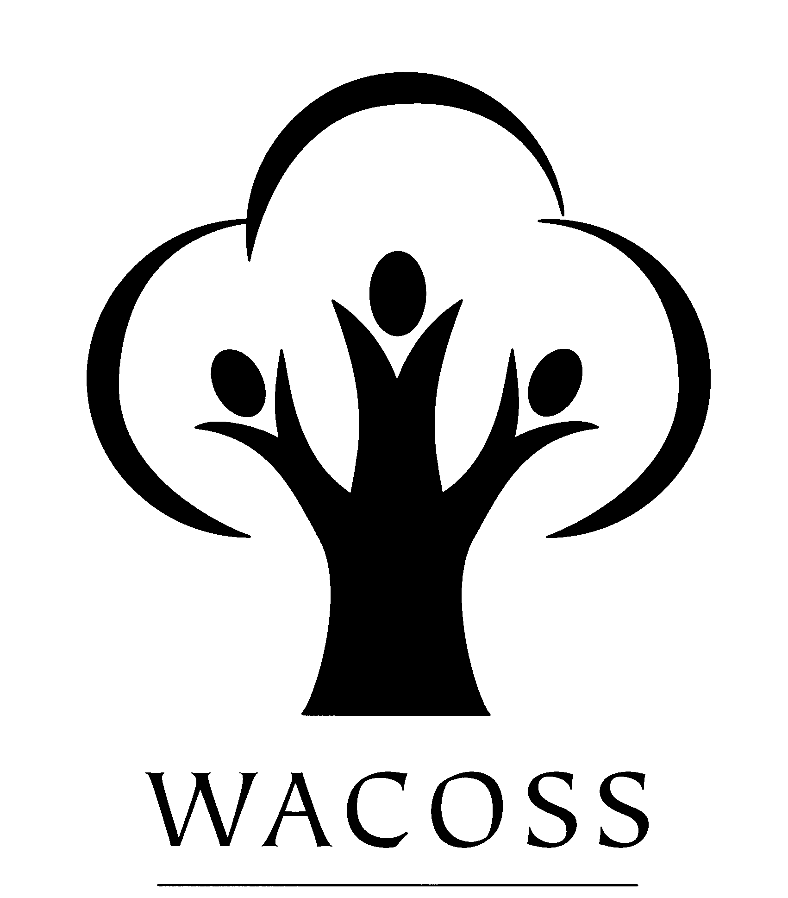
Western Australian Council of Social Service Inc

WACOSS Submission to the
Senate Community Affairs References Committee
Inquiry into Poverty and Financial Hardship in Australia

March 2003
Contents

Background 3
Current trends reported by community service agencies in Western Australia 4
Literature and Research regarding Poverty in Western Australia 4
ACOSS Submission to the Senate Inquiry 5
‘Hardship in Australia’ An analysis of financial stress indicators in the 1998-99 Australian Bureau of Statistics Household Expenditure Survey’ 5
Western Australian Taskforce in the International Year for the Eradication of Poverty (1996) 6
WA results from the ACOSS Australians Living on the Edge V (2003) Survey 8
Housing Issues and Poverty 8
Conclusion 9

Background

The Western Australian Council of Social Service Inc (WACOSS) is the peak body of the community services sector in WA. Since 1956, WACOSS has been developing and strengthening the non-government community services sector’s capacity to assist all Western Australians. At the heart of its activities, lies the belief that the mark of a civilised community is the support and help it gives to those most in need.

WACOSS and its members aim to improve the quality of life of people disadvantaged by the inequities of our society through:

Improving community services by exchanging ideas, information, skills and resources, creating a strong united and informed voice capable of advocating for the social needs of all Western Australians.

A continual consultation process with members, their clients, the general public and other professional organisations enables WACOSS to identify and address social inequities within the community. This is achieved by:

- Contributing to the development of social policy;
- Promoting the provision of social services;
- Raising awareness of social issues in the community;
- Facilitating coordination and cooperation amongst social service agencies across the State; and
- Providing a range of services to member and non-member agencies.

WACOSS also provides government with feedback on policies and programs to ensure that they are relevant and offers an alternative avenue through which government can discuss sector issues with service providers and consumers.

WACOSS is part of a national network consisting of ACOSS and the State and Territory Councils of Social Service, who assist low income and disadvantaged people, Australia wide.

WACOSS supports more than 350 member agencies and individuals in the provision social and community services to disadvantaged people and low-income earners across Western Australia. In this capacity WACOSS works with and represents a range of agencies including:

- Emergency relief agencies;
- Financial counsellors;
- Neighbourhood centres;
- Community legal centres;
- Large church-based welfare organisations;
- Disability service organisations; and
- Housing and crisis accommodations services.

Current trends reported by community service agencies in Western Australia

These agencies consistently report a number of issues in relation to people living in poverty in Western Australia, including:

- The number of people seeking assistance with poverty-related issues is growing;
- There is an increase in new groups of clients, i.e. people seeking assistance who have not previously sought assistance, and in particular a growth in the number of ‘working poor’ approaching agencies for assistance;
- The system of ‘breaches’ imposed by Centrelink as part of ‘mutual obligations’ holds considerable risks in that it can cause individuals and households to spiral further into poverty;
- That children are frequently the ‘innocent victims’ of policies directed at or impacting on families in poverty;
- People living in poverty in rural, regional and remote areas of Western Australia are ‘doubly disadvantaged’ as a result of higher living costs and reduced access to services; and
- Interventions attempted by social service organizations to assist people in poverty, particularly with regards to the provision of housing or crisis accommodation, can be thwarted by negative community attitudes towards those in poverty, particularly youth, Indigenous people, women escaping domestic violence and people with mental health and/or drug and alcohol related issues.

Literature and Research regarding Poverty in Western Australia

In making this submission WACOSS wishes to draw attention to a range of work, which is relevant to the Inquiry, i.e.

- ACOSS Submission to the Senate Inquiry ‘The Bare Necessities: Poverty and Deprivation in Australia Today’
- Department of Family and Community Services ‘Occasional Paper No. 4 ‘Hardship in Australia’ An analysis of financial stress indicators in the 1998-99 Australian Bureau of Statistics Household Expenditure Survey’, by J Rob Bray, 2001
- Western Australian International Year for the Eradication of Poverty (1996) Taskforce
- Western Australian results of the Australians Living on the Edge Survey (2003),
- National Shelter’s report ‘Creating the Links between Housing, Employment and Income Support’, Adelaide, 2001, and
- Western Australian Homelessness Taskforce.

This work is discussed in more detail below and full copies of these documents are available on request.

ACOSS Submission to the Senate Inquiry

WACOSS supports the ACOSS Submission to the Senate Inquiry ‘The Bare Necessities: Poverty and Deprivation in Australia Today’ (2003) as broadly reflecting the issues around poverty and financial hardship in Western Australia. In particular, we support:

- ACOSS’ suggested approach to measuring and understanding poverty, and that this approach be grounded in research into people’s actual living standards;
- the need for national anti-poverty strategies; and
- the need for strategies in a range of inter-connected areas including income support; employment, education and training; housing and homelessness; health and community services; Indigenous communities; and individual and community capacity building.

‘Hardship in Australia’ An analysis of financial stress indicators in the 1998-99 Australian Bureau of Statistics Household Expenditure Survey’

This occasional paper produced by the Department of Family and Community Services provides valuable analysis of the 1998 –99 Australian Bureau of Statistics Household Expenditure Survey. The paper, whilst recognising the value of income analysis as a social policy research tool, focuses on the reported outcomes of utilization of household resources.

The paper provides a statistical analysis of deprivation in Australia based around the following three types of experience that may occur in isolation, or in different combinations:

- Missing out – such as being unable to have family and friends over for a meal, nights out, hobbies, holidays away from home, or having to buy second hand clothing, due to a shortage of money;

- Cash-flow problems – being unable to pay bills on time or needing to borrow money from family and friends; and

- Hardship – being unable to afford heating and meals, or having had to pawn or sell possessions, or needed assistance from community agencies.

The report provides detailed analysis of these forms of deprivation across Australia and specifc comparisons by State. Key information regarding deprivation in Western Australia is reported as follows:

- In Western Australia 39.7% of households surveyed had experienced “missing out” in the previous year. A total of 19.9% of Western Australian households surveyed had experienced “cash-flow” deprivation and 10.3% of households had experienced “hardship”.

- In terms of multiple deprivation (where the deprivation had occurred on a number of occasions or simultaneously) experienced in Western Australia. A total of 24.1% of respondents had experienced multiple “missing out” and 10.4% had experienced multiple “cash-flow” deprivation. A disturbing 4% of those surveyed had experienced or were experiencing multiple incidences of “hardship”.

In the analysis of outcomes by State, the author draws attention to the significantly higher proportions of deprivation in the less populous States. The author states:

“Both South Australia and Western Australia have outcomes above the national average on most of the factors. In Western Australia, this was most marked in the incidence of multiple hardship where, of all States, it was second only to Tasmania.”

The report raises clearly alarming statistical information regarding the level of deprivation experienced by those living in poverty in Australia and in particular in States such as Western Australia.

Western Australian Taskforce in the International Year for the Eradication of Poverty (1996)

The most recent investigation into poverty in Western Australia was undertaken by the Western Australian Government’s Taskforce during the International Year for the Eradication of Poverty (1996).

The Taskforce utilised the following definition of poverty, which focuses on the minimum requirements to live decently:

Individuals, families and groups, in the population can be said to be in poverty when they lack the resources to obtain the types of diet, participate in the activities and have the living conditions and amenities which are customary, or at least widely encouraged or approved, in the societies to which they belong. Their resources are so seriously below those commanded by the average individual or family that they are, in effect, excluded form ordinary living patterns, customs and activities.

The Taskforce made a range of recommendations to alleviate poverty in Western Australia, including:

- The need for social, economic and cultural equality for Aboriginal people, through for example the implementation of the recommendations contained in the reports of the Royal Commission into Aboriginal Deaths in Custody (1991) and the National Inquiry into the Separation of Aboriginal and Torres Strait Islander Children from their Families (1997);
- The need for a range of schemes to assist people on low incomes to manage their finances as a mechanism for ameliorating some of the effects of poverty;
- Social policy responses, such as acknowledging the cost of poverty to individuals, the private sector and governments, and annual reporting on the impact of social, fiscal and economic policy on those in greatest need;
- Full employment as an economic and social priority using an integrated approach based on sustainable economic policy, industry policy, regional and community economic development, taxation reform, equitable job distribution and a social security safety net;
- Strengthening the educational opportunities available for children and young people from low income families;
- Increasing access to housing and housing options for low income households; and
- The provision of community education to assist in community understandings of poverty and the development of whole-of-community solutions.

The Taskforce also identified the need for further investigation of the following areas:

- The connection between urban form issues and poverty, which highlights the need for an interdisciplinary approach to policy development and analysis;
- The cost of poverty to the community;
- The need for consultation with people living in poverty; and
- The links between poverty and health, criminal justice and substance abuse.

WACOSS recommends that the Senate Inquiry consider the Taskforce report and findings in its deliberations.

WA results from the ACOSS Australians Living on the Edge V (2003) Survey

This survey of the community services sector is conducted annually by ACOSS and the state and territory Councils of Social Service. It examines key changes in the operating environment of community organisations, major issues of concern to organisations, and how the community services sector is responding. The survey also provides an indication of how low-income and disadvantaged Australians who use community services are faring.

The 257 agencies surveyed In Western Australia represent a substantial proportion of the community services sector across the State. Together, the 112 respondents to the survey delivered services to over 531,299 low-income and disadvantaged clients in the 12 months to June 2002.

Key findings that reflect the degree and impact of poverty and financial hardship in Western Australia in the latest survey included:

- There has been a 6% increase in the number of people assisted by respondent WA agencies between the 2000-01 and 2001-02 financial years, rising from 500,310 to 531,299 people.

- There has been a 24% increase in the numbers of people seeking but not receiving the service(s) they sought between the 2000-01 and 2001-02 financial years, rising from 15,747 to 19,580 people. The areas where the greatest proportional increases occurred were in aged care (86%) and disability services (38%).

Housing Issues and Poverty
Access to affordable, appropriate and secure housing is a crucial to people's
ability to avoid or escape poverty. Housing is essential in ensuring health, well-being and access to life opportunities such as education and employment.

The National Shelter 2001 report Creating the Links between Housing, Employment and Income Support, provides an analysis of the complex relationships between the labour market, income support, welfare reform and housing. The report indicates that inadequate or unaffordable housing is one of the fundamental drivers of poverty and that housing should be central to any measures aimed at reducing poverty.

In a similar vein the Western Australian State Homelessness Taskforce (2002) identified a range of housing issues, which impact primarily on low income and disadvantaged Wester Australians.

A key factor identified was housing related poverty brought about by a contraction in new development and a reduction in supply of low cost housing brought about by:

- Declining funding from the Commonwealth and State Government seen in significant reductions to the Commonwealth State Housing Agreement (CSHA). Resulting in significant negative impact as low-income households in public housing have historically less housing related poverty than those in the private rental market; and
- A fall in low cost private rental stock by 20% in Perth and by 67% in the rest of the State between 1986 and 1996; and a 151% increase in rent rates, at 1996 dollars, for low cost rental in non-metropolitan.

In addition, housing related research has consistently identified Indigenous Australians as facing significantly greater disadvantage in relation to housing than any other group (eg. ABS; National Housing Strategy; Neutz).

The WACOSS Poverty Commission report Housing for a Sustainable Community refers to a draft ATSIC report, which states that:

- The average household size was 4.0 persons for Indigenous households compared to 2.7 persons for non-Indigenous households;
- There were 1063 homeless Indigenous families (based on families living in improvised dwellings and living with other families) in 1996 compared to 940 families in 1991, representing a 13% increase;
- There were 1353 (13.8%) Indigenous families living in overcrowded housing.

Given these figures, it is critical that the Inquiry give particular consideration to housing related poverty and the situation facing Indigenous people.

Conclusion

There is significant evidence provided on an ongoing basis by community sector agencies in Western Australia regarding the impact of poverty on our citizens. The existing literature regarding poverty in Western Australia attests to the fact that we face growing levels of deprivation within our community. Western Australia, the most geographically vast and isolated State in this country faces unique and complex issues in relation to increasing poverty levels and impact requiring amelioration. Given this evidence, we strongly urge the Senate Community Affairs References Committee Inquiry into Poverty and Financial Hardship in Australia to visit both Perth and at least one Western Australian regional centre to hear evidence from those experiencing deprivation and those attempting to redress poverty.

IYEP Taskforce Community choices – individual lives: A report to the Government of Western Australia through the Minister for Family and Children’s Services, May 1998
Travers, P and Richardson, S Living Decently: Material Well-being in Australia, Oxford University press, Melbourne 1993
Cited in Office of Housing Policy Housing 2029 Background paper: Housing Requirements, November 2000
Australian Bureau of Statistics Census of Population and Housing: Aboriginal and Torres Strait Islander People, Western Australia, ABS, Canberra; 1998
National Housing Strategy Housing choice: Reducing the barriers, Commonwealth of Australia
Neutz, M. “Indigenous Housing: Needs and Public Spending” in Shelter SA, Shelter Newsletter, August 1999
WACOSS Poverty Commission op cit
Dane,G. Indigenous Housing, Homelessness, Overcrowding and Poverty - Western Australia: an analysis of the 1996 census data, Draft, ATSIC, 1999

