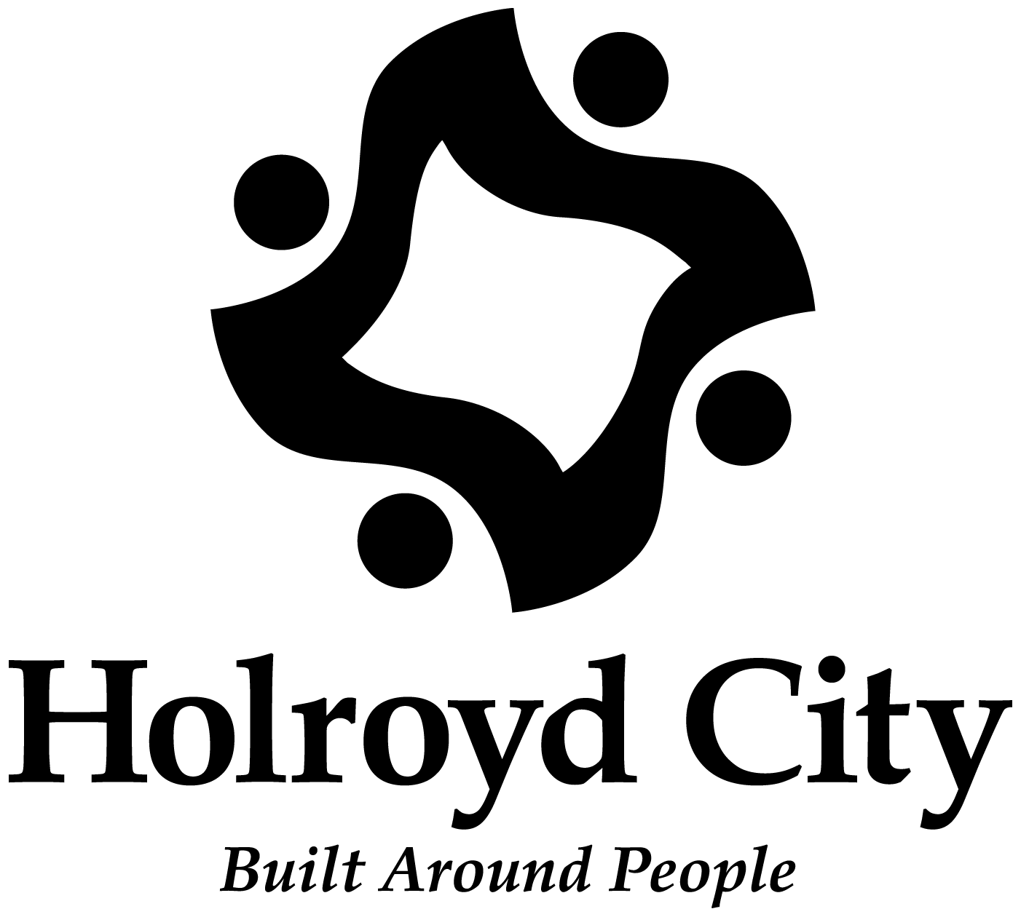

SUBMISSION

TO THE

SENATE COMMUNITY AFFAIRS REFERENCES COMMITTEE

INQUIRY INTO POVERTY IN AUSTRALIA

MARCH 2003

CONTENTS

Page Nos.

Overview of Holroyd City 1

Poverty Issues in Holroyd 9

Impact of Youth Homelessness 11

People with Disabilities 18

Indigenous People 19

People from Culturally and Linguistically Diverse Backgrounds 19

Temporary Protection Visa Holders 20

Recommendations 26

Bibliography 28

OVERVIEW OF HOLROYD CITY

The City of Holroyd is situated in Western Sydney and is approximately 25 kilometres west of the Sydney Central Business District.

Holroyd is bounded by the cities of Parramatta (north-east), Fairfield (south) and Blacktown (west). Physical boundaries such as Prospect and Toongabbie Creeks, Prospect Quarry and the main south-western and western railway lines mark the parameters of the local government area.

Passing through Holroyd are some major road links for Western Sydney. The Great Western Highway and the M4 bisect Holroyd east-west and provide access to Parramatta and Sydney from the outer western suburbs. The Cumberland Highway bisects Holroyd north-south and provides a road of highway standards between Liverpool and Hornsby.

Both the western and south-western railway lines as mentioned above service the City. The rail connection (Y link) between Parramatta and Campbelltown has improved cross regional transportation.

The City is also well provided with private bus routes.

LAND USE

Thirty percent (30%) of the City is zoned industrial with major estates located at Smithfield, Yennora, Guildford and Girraween.

A large number of important industries have established in Holroyd including such well known names as Capral Aluminium Ltd., Tubemakers Australia Ltd., J Blackwood and Son Ltd., Woolworths Ltd. (distribution centre), Coles Supermarkets (warehouse), Visyboard Industrial Packaging, James Hardie Industries, Boral and Bonds.

The growth of Parramatta as the second Central Business District will provide employment opportunities. In addition, the Westmead Campus of the University of Western Sydney, Westmead Hospital and Children’s Hospital provide significant employment opportunities. These hospitals are having an impact on housing demand for student accommodation and temporary accommodation for country people needing to stay with relatives undergoing hospital treatment.

Seven percent (7%) of the City is zoned open space including a number of sporting fields and two significant passive recreation areas (Central Gardens and Holroyd Gardens Park).

Three percent (3%) of the City is zoned commercial, the major area of development being the centre of Merrylands. Smaller but significant areas have also developed at Greystanes, Pendle Hill and Wentworthville.

The remaining sixty percent (60%) of the City is zoned residential and is virtually fully developed. Any significant increases in either population or housing stock will be the result of redevelopment.

The Department of Housing owns seven percent (7%) of the current housing stock. There is a range of housing including residential flats, medium density housing and detached housing.

There has been considerable redevelopment of the residential sectors of the City over the past five years. There are also residential redevelopments proposed for brown field areas such as the Boral site on Prospect Hill and the old brickworks site in the suburb of Holroyd. These new proposed areas and the commercial growth in Parramatta will have a major impact on development, housing demand and community service provision in Holroyd in the future.

HOLROYD MAP

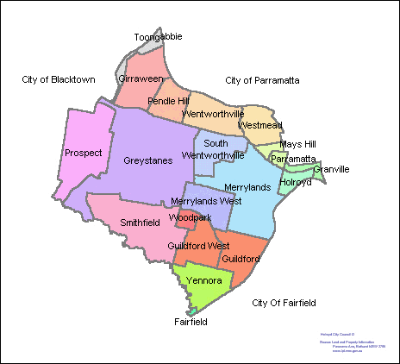

Summary of 2001 Census Data for Holroyd

Total Persons | 85,760
Aged 15 years and over | 68,227
Aged 65 years and over | 10,103
Total Indigenous Persons | 680
Born in Australia | 48,467
Born Overseas (36.1%) | 30,991
Speaks English only | 46,279
Speaks other languages | 33,740
Australian Citizen | 70,832
Birthplace (Country)
Australia | 48,467
China | 1,974
Fiji | 1,144
India | 1,584
Italy | 1,209
Lebanon | 3,806
Malta | 1,883
New Zealand | 1,745
Philippines | 1,414
Sri Lanka | 1,065
United Kingdom | 2,202

The Holroyd Local Government Area has an increasing population due to the urban consolidation process.

The population base is characterised as mainly an Australian born population with a diverse migrant population that is increasing. Holroyd has large established communities of post-World War II migrants, i.e. Maltese, Italian and British, together with the current trend of an increasing number of Lebanese, Chinese, Fijian, Indian, Filippino and Sri Lankan settlers.

Population by Age
0-4 years | 6,137
5-9 years | 5,842
10-14 years | 5,499
15-19 years | 5,547
20-24 years | 6,711
25-29 years | 7,276
30-34 years | 6,916
35-39 years | 6,633
40-44 years | 6,058
45-49 years | 5,367
50-54 years | 5,386
55-59 years | 4,284
60-64 years | 3,590
65-69 years | 2,859
70-74 years | 2,652
75-79 years | 2,187
80-84 years | 1,323
85-89 years | 673
90-94 years | 236
95-99 years | 76
100 years and over | 9

Between 1996 and 2001 the population increased by 5,523 people or 6.5%.

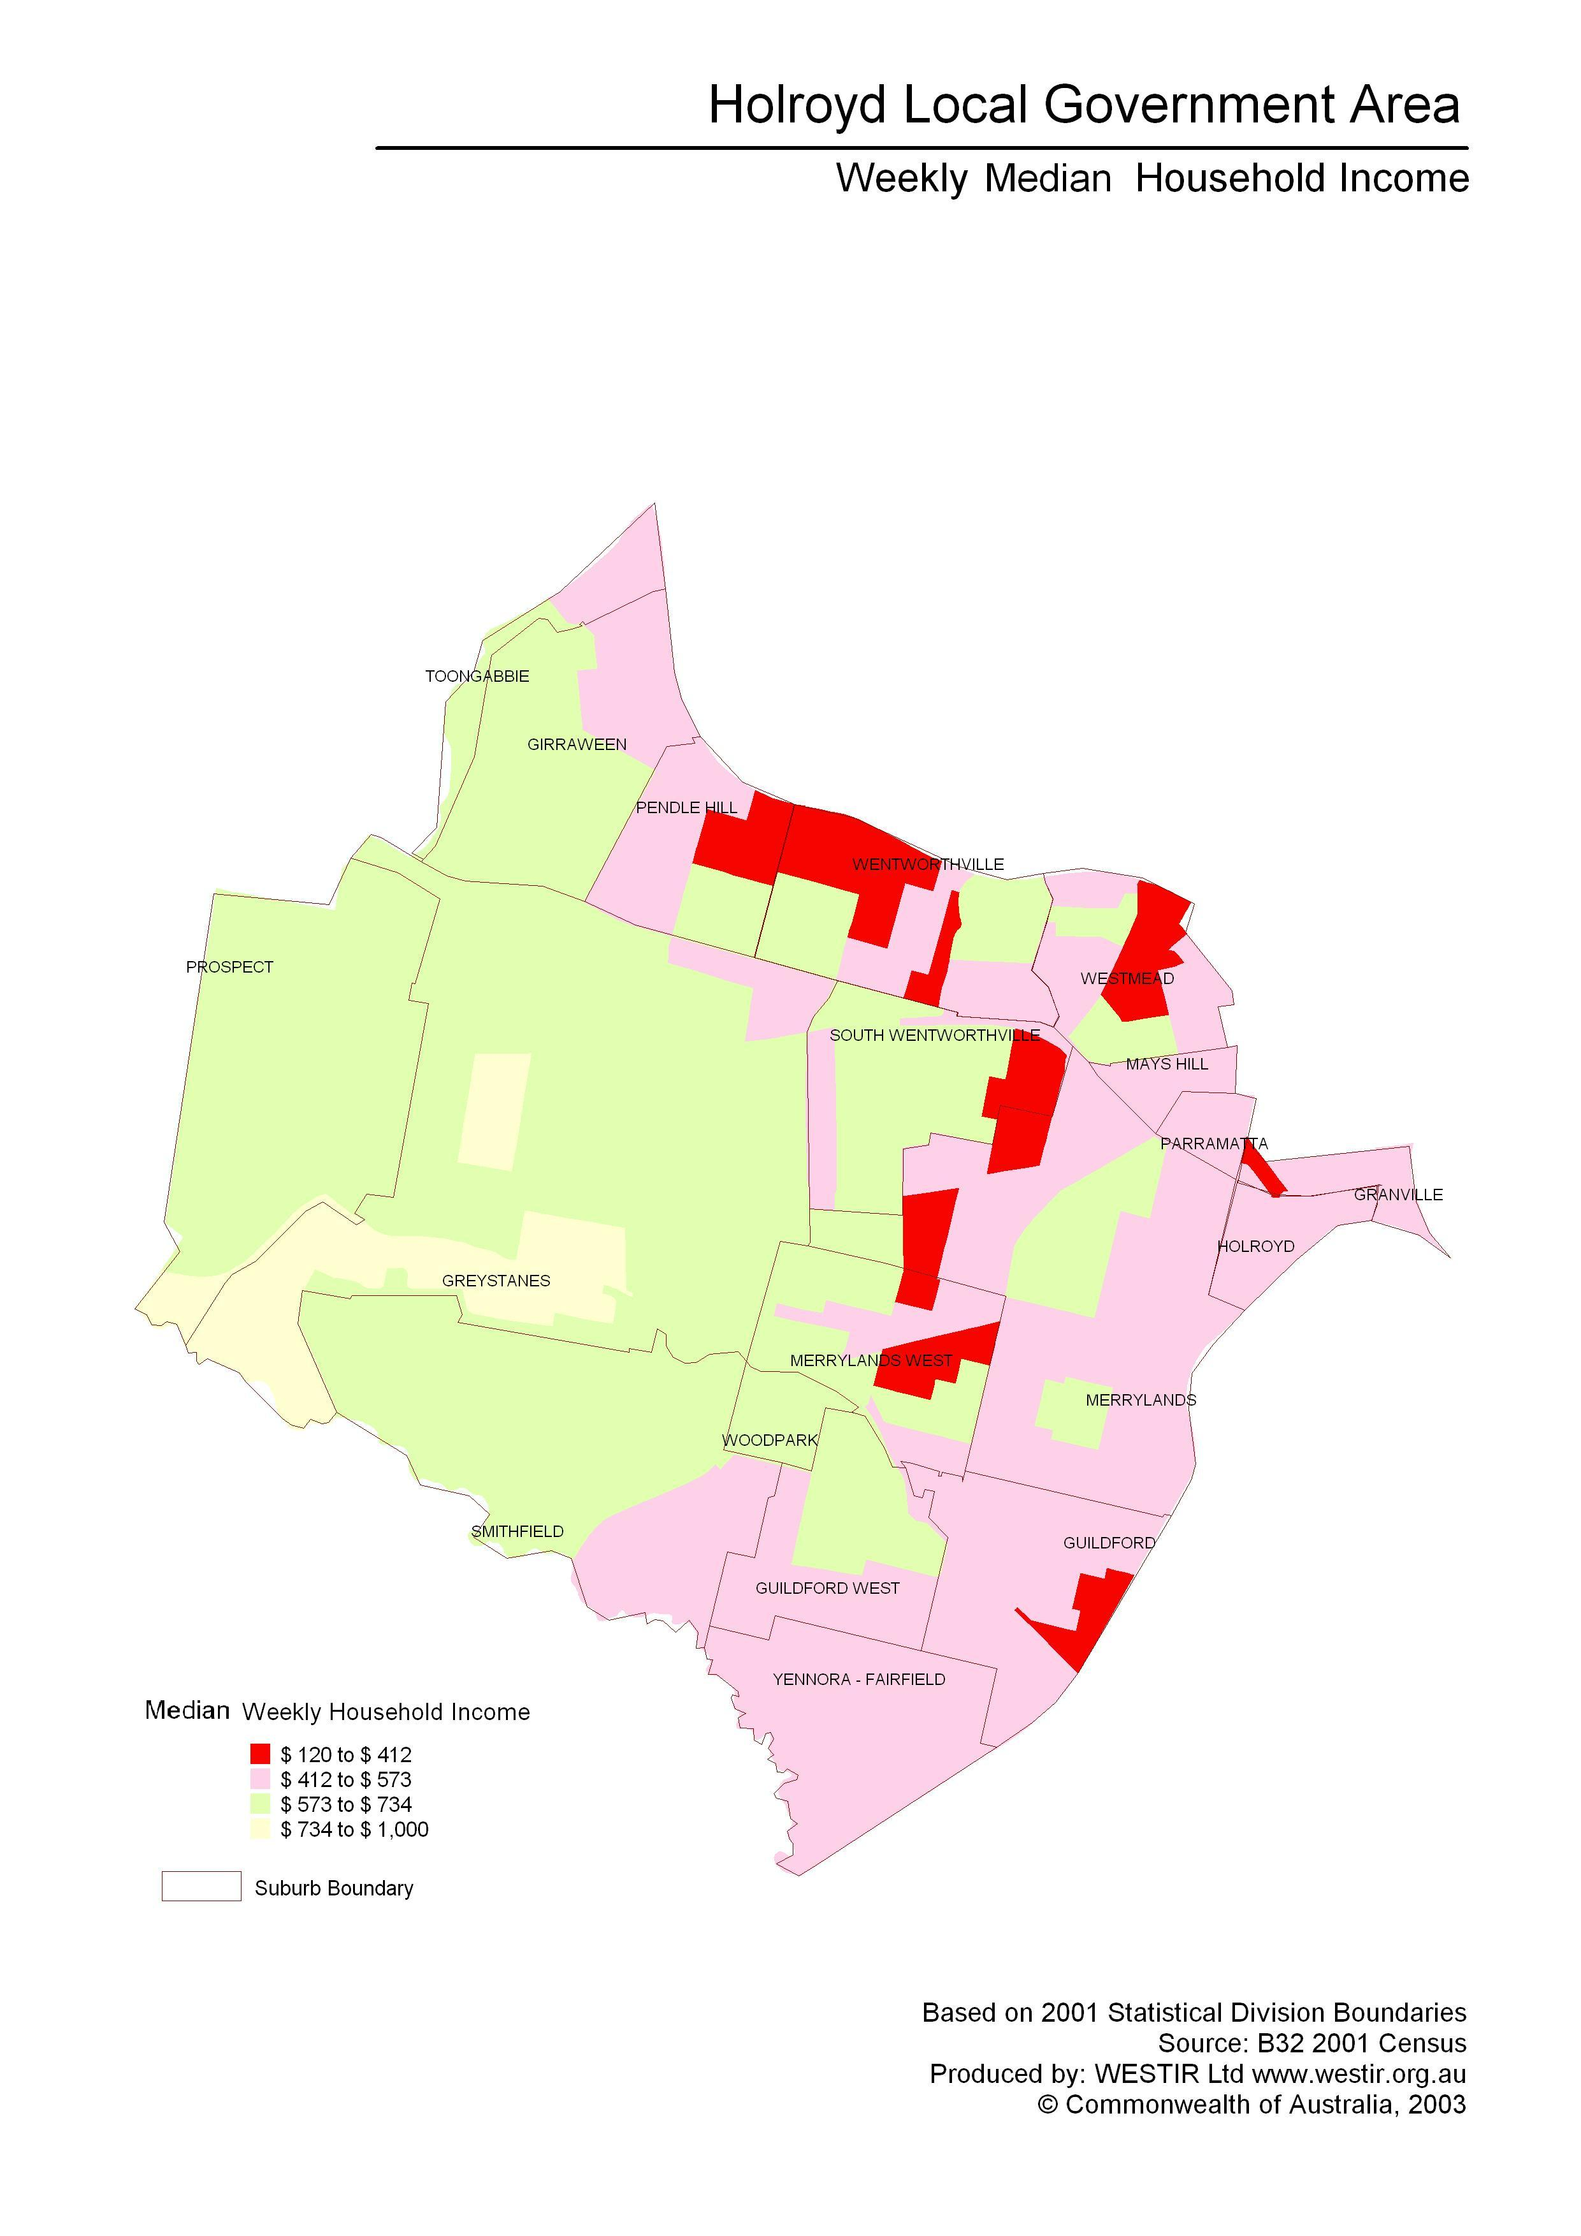

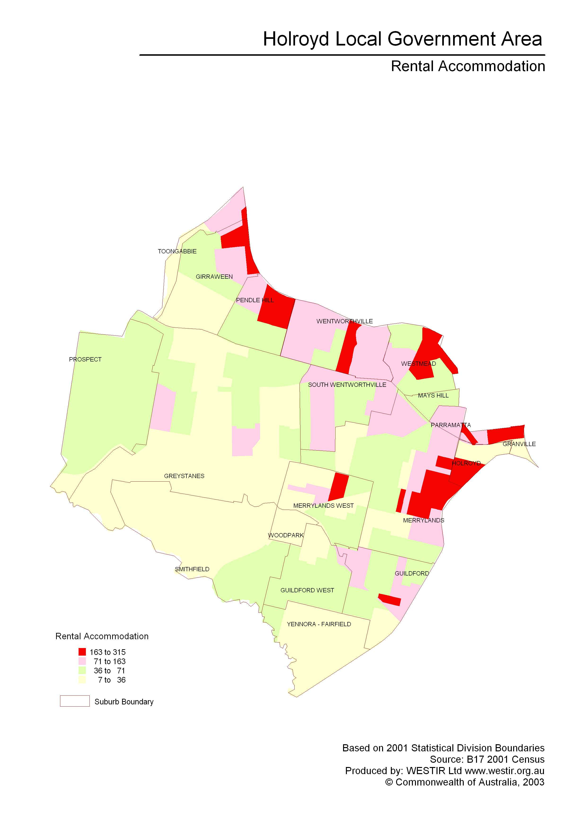

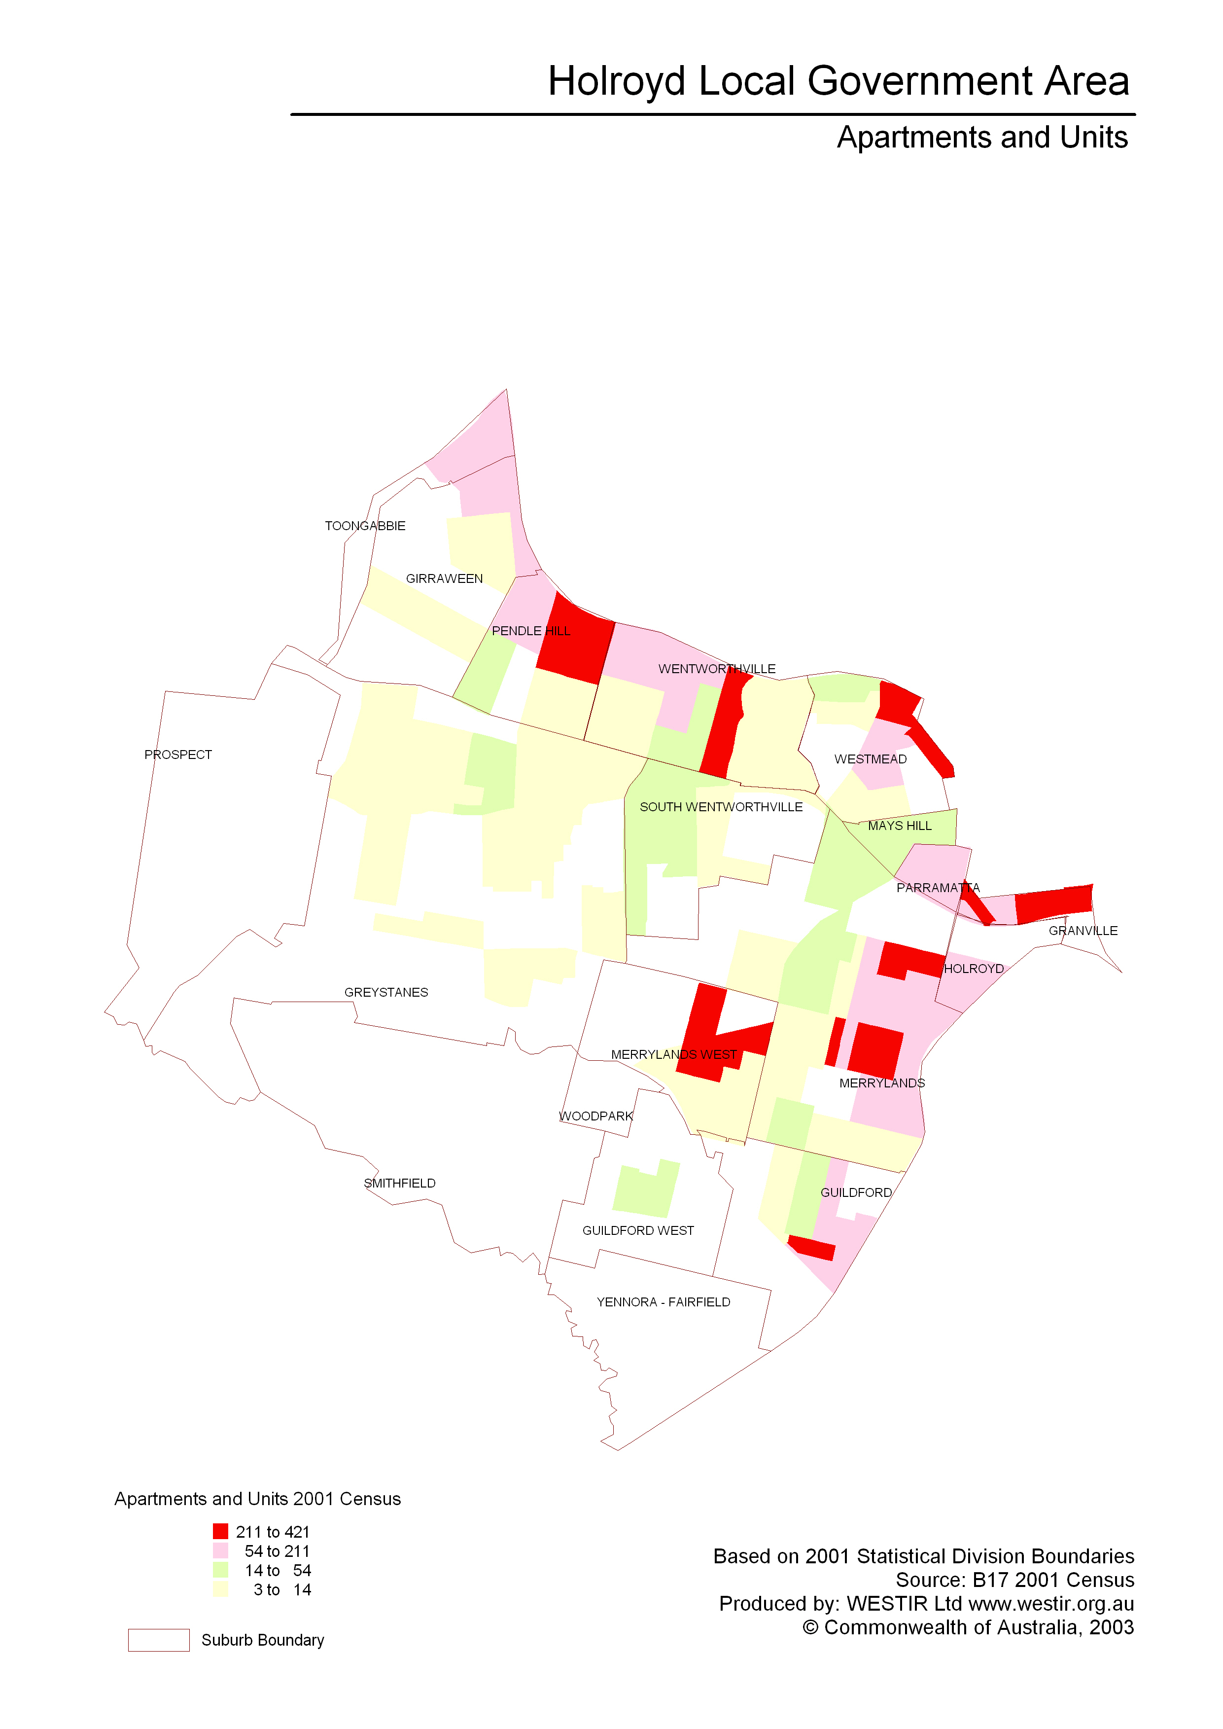

POVERTY ISSUES IN HOLROYD

The following information illustrates the incidence of, and issues around, poverty in the Holroyd Local Government Area. Information has been gathered from published and unpublished documents, and discussions with key welfare and community organisations serving Holroyd and surrounding areas.

In June 1999 The Society of St Vincent de Paul (SVDP) commissioned a study into poverty and wealth in Western Sydney and Outer South-Western Sydney titled “The Great Divide”. The principal consultant for the study was Professor Tony Vinson, Emeritus Professor, School of Social Work, University of NSW.

The study found that:

- poverty within Western and South-Western Sydney is being concentrated in particular suburbs.

- Aboriginal people and single-parent families are the most disadvantaged social groups.

- suburbs with the highest concentrations of public housing are the most disadvantaged.

Holroyd has 22,519 families of which 4,467 (19.8%) have an income less than $500 per week.

These figures are further broken down showing that:

- 1,327 one-parent families have an income less than $500 per week

- 922 couple-families-with-children have an income less than $500 per week

- 2,124 couple-families-without-children have an income less than $500 per week

- 94 other-families have an income less than $500 per week

The SVDP study indicated that Holroyd had pockets of poverty in the suburbs of Pendle Hill, Wentworthville, Westmead, South Wentworthville, Merrylands, Merrylands West and Guildford.

The 2001 Census figures show that the concentrations of low income families fall in the same suburbs as indicated in the SVDP report.

Holroyd, unlike other areas in Western Sydney, does not have large Department of Housing estates, but has smaller clusters. Low income families in Holroyd tend to live in residential flat zones and renting in the private sector.

Holroyd’s main emergency relief provider is Holroyd Community Aid & Information Service (HCAIS). HCAIS in 2001/2002 assisted 2,722 clients:

- Single persons 1,137
- Single parent families 973
- Couples 175
- Couples with children 437

Over $100,000 in emergency relief was given out for food vouchers, pharmacy prescriptions and cash assistance.

Church based organisations such as SVDP and the Church of Christ also provide emergency relief funded solely by local parishioners.

SVDP in Holroyd gave out $75,674 for emergency relief in 2001/2002.

The Church of Christ on average gives out $5,000 per month for emergency relief.

Total assistance given to the Holroyd community in 2001/2002 is therefore over $235,600. This does not include in-kind assistance through op shops for clothing and furniture and also does not include any government vouchers distributed for electricity or water, e.g. EAPA and WAPA.

SVDP and the Church of Christ are seeing many more clients who are single women with children usually coming out of domestic violence situations.

Both organisations operate women’s refuges which are totally self-funded (no assistance from either the State or Federal Government).

Both organisations also provide crisis accommodation to more women from non-English speaking countries than in the past, e.g., Polish, South American, Sudanese, Kurdish and Iranian.

Young single parents are on long waiting lists for Dept. of Housing properties. In the meantime they are struggling to pay rent and frequently seek assistance for food in order to feed their child/children. Baby food is commonly requested along with basic essentials such as bread, milk and breakfast cereals.

As noted in the statistics, high numbers of single people are seeking assistance. The local agencies report that nearly 75% of these clients have a mental illness, which is further complicated with drug and alcohol abuse.

Youth homelessness has been a documented ongoing issue since 2000; additional information is provided in the following section.

IMPACT OF YOUTH HOMELESSNESS

The issues confronting today’s young people are many and varied. Difficulties in accessing appropriate accommodation can lead to severe shortages of disposable income for young people, whose earning power is lower than other age groups, and may even lead to homelessness.

The problem of youth homelessness has no easy solution in Holroyd or across the State. Additional funding is needed to provide more accommodation as well as additional support services.

Council has funded local youth services to install showers and equipped kitchens in youth centres which can be used by homeless young people. However, the bigger issue remains that these young people cannot find long-term accommodation.

The following information provides more detail on the youth homelessness issue, and is taken from the Report into the Needs of Homeless Youth in Holroyd (September 2001).

Consultations with youth workers from Holroyd identified the following issues for young people who are homeless:
- Absence of locally based Crisis accommodation services;
- Issues with young people who have mental health or drug and alcohol problems;
- Issues with young people and State wards who have left their accommodation and are unable to access Centrelink or accommodation because they are State Wards;
- The age of youth homeless is decreasing. Anecdotal evidence suggests that there are children as young as nine who are homeless;
- DOCS are not responding to requests – young people are reported to them as being at risk or homeless but they are not picked up;
- DOCS are difficult to contact;
- Young people have no money to get to accommodation if it is available;
- Young people come from diverse cultural backgrounds;
- 14 – 18 years male are the hardest to place in a refuge;
- Homeless young people have a number of issues that do not make family restoration an option.

Consultations with other service providers in Holroyd identified the following issues:
- There are increasing numbers of young people and families with young people seeking accommodation;
- The age of young people is decreasing and services are seeing more State Wards;
- Numbers of requests for assistance are increasing. For example Holroyd HATCH had 14 requests in May for accommodation or food parcels and 27 requests in June of this year;
- Local High School Counsellors are having increasing number of students presenting with accommodation issues for either themselves or for their family;
- People are seen more than once – their immediate crisis may be met but they continue to have housing issues;
- People need to be referred out of the area, as there are few accommodation options. This presents problems as funds are required for transport costs;
- Homeless young people gravitate to Parramatta;
- Young people need to leave the area in the absence of accommodation and this impacts on their education and social supports;
- The homeless problem is not unique to Holroyd.

Local Housing Costs

One of the issues in the local area is there are few private housing options for young people that are affordable. Western Housing for Youth provides some accommodation for young people under 18 and Western Suburbs Community Housing and the Department of Housing provide assisted accommodation for those over 18 years. Otherwise there is the private rental market where costs are unaffordable and young people face difficulties in securing tenancies.

Table A: The Rent Report for the March quarter 2001 listed median rents in the area at:
Type | One Bedroom | Two Bedrooms | Three Bedrooms | Four Bedrooms

HOLROYD
Unit | $150 | $215 | N/A | N/A
Separate House | N/A | $210 | $240 | N/A
All Dwellings | $145 | $220 | $250 | $280

PARRAMATTA
Unit | $170 | $210 | N/A | N/A
Separate House | N/A | $220 | $270 | N/A
All Dwellings | $165 | $210 | $280 | $300

A 2 bedroom unit in the area would cost on average of $215 per week ($430 per fortnight) and a young person receiving Youth Allowance would get approximately $290.10 per fortnight plus rent assistance.

State Wide Research
Across NSW Homelessness is a growing problem. In 1989 when the Burdekin report was written there were 70, 000 Australian children and young people homeless. Now it is estimated that there are over 100,000. According to the Homeless Persons Information Service in NSW in 1999, people seeking crisis accommodation and support rose 24.8% to 33, 462.

Shelter NSW reported in 1999 that in the previous five years, over $231 million had been cut from the supply of public housing with $99 million of those cuts in 1999.

In 1999 the new Commonwealth / State Housing agreement took effect and resulted in an amount of funding available to the states being reduced by over $10 million per year. At the end of 2000 in NSW there were 96, 500 people on the public housing waiting list yet only 1, 285 public housing dwellings were constructed in that year.

Quantifying the number of homeless people is difficult at both a local area such as Holroyd LGA and across the State. Not all homeless people use services like accommodation or welfare and they do not fill in forms such as the census.

On the Census night in 1996 across Australia there were:

- 20, 579 people in improvised dwellings or sleeping out
- 23, 299 in boarding houses
- 12, 926 in SAAP funded accommodation
- Estimated 48, 500 staying with friends or relatives.

This meant that on Census night in 1996 there were an estimated 105, 304 people homeless nationally.

When Burdekin completed his report in 1989 it was estimated that there were 70, 000 children and young people across Australia who were homeless.

Reasons for young people being homeless may include:

- serious abuse at home
- sustained family conflict or complete family breakdown
- lack of income or social standing
- discrimination in the housing sector

Homeless young people are at high risk of serious illness. Malnutrition, lack of hygiene facilities, inadequate sleep, exposure, violent injury, substance abuse and sexual exploitation are all factors they face living on the streets.

What is being done locally?

There are a number of local agencies that are assisting homeless young people as well as Holroyd and Parramatta Council.

Holroyd City Council had HATCH as its beneficiary of funds raised at the family festival this year.

Parramatta City Council provides some assistance for homeless young people through its Community Donations Program. Each year they give $800 to 8 homeless youth services to be spent on manchester, school aids etcetera. They also provide blankets to Parramatta Community Aid and Telopea Family Support at the beginning of each winter for distribution to needy people. They have facilitated the Safe Haven project within the Parramatta LGA and they have funds set aside to provide a local one off brokerage service.

Table B outlines what is available locally in Holroyd, Parramatta and across Western Sydney.

Table B: Assistance available
Type of assistance | Within Holroyd | Within Parramatta | Within the region
Crisis Accommodation up to 17 years | No | 8 beds  4 male/4 female | 47 beds  25 male/ 22 female
Crisis Accommodation over 18 years | No | 36 beds male | N/A
Crisis Accommodation women and children under 25 | 7 rooms | No | N/A
Substitute Care beds | Yes | 12 beds | N/A
Medium term Accommodation up to 17 years | No | 23 beds  16 male / 7 female | 24 Beds of which 8 are dedicated for mental health
Medium term Accommodation 18 years and over | 16 yrs – 25 yrs  6 beds | No | 10 beds
Medium term Accommodation women and children under 25 | 2 houses | 6 beds
Community Placements | Yes  15 – 19 years | Yes
Long term accommodation | Yes  4 services | Yes  4 services | N/A
Assistance with food | Yes  weekdays | Yes- weekdays , nights and weekends | N/A
Availability of showers and laundry | Yes  Monday mornings only | Yes  Mornings M - F | N/A
Assistance with financial | Yes  Centrelink  Limited travel assistance - weekdays | Yes  Centrelink  Limited travel assistance- weekdays | N/A

This is based on information contained within the Youth Resource Directory.
PEOPLE WITH DISABILITIES

There are a number of factors which lead to poverty issues affecting the lives of people with disabilities.

In general, there are additional costs associated with living with a disability, e.g.
- medication and other health-related costs
- equipment
- mobility/travel expenses
- costs of home help and yard maintenance services
- decreased opportunities for full-time employment
- restricted opportunities for carers to take up full-time employment

Difficulties are also faced by people who suddenly find themselves on a Disability Support Pension, e.g. when parents/carers die, or when a person acquires a disability as an adult. People are frequently unable to cope with these sudden and major changes in circumstances, and require assistance to gain knowledge/training/skills in areas such as:

- budgeting
- cooking and cleaning
- health and hygiene
- communication
- accessing services

Lack of these skills and knowledge can lead to chronic poverty issues.

Mental health issues are also linked with cases of poverty. People suffering from a mental illness are frequently affected by poverty-related factors such as:

- homelessness
- poor employment prospects
- poor social/coping skills
- high health-related costs

INDIGENOUS PEOPLE

Australia’s indigenous community is widely recognised as a group which is severely impacted by poverty issues.

Holroyd City Council’s Aboriginal and Torres Strait Islander Consultative Committee has identified the following significant issues in relation to poverty and indigenous people:

- employment difficulties resulting from an interrupted education and/or lower educational levels

- the high incidence of pregnancy amongst young women (from 15-16 years)

- relocation: costs and disruption of frequently moving house

- cultural expectation that people will support large extended families

- feelings of cultural alienation make it difficult for indigenous people to cope with a non-Koori workplace

PEOPLE FROM CULTURALLY AND LINGUISTICALLY DIVERSE (CALD) BACKGROUNDS

Consultation with representatives of the Baulkham Hills Holroyd Parramatta Migrant Resource Centre indicated the following major issues related to poverty in local CALD communities:

- the cost of sponsorship: the sponsor must deposit $4,000 to be held in trust until the sponsored person is eligible for benefits (2 years)

- cultural expectations: residents are expected to support extended family members who arrive on permanent residence visas. If these new arrivals have difficulty in securing employment, as frequently happens, providing support can lead to poverty issues for the “host” family

- domestic violence: migrant women who leave their home or make a complaint about domestic violence frequently lose the support of their community, leading to loss of home, income, social support and family contact

- unrealistic expectations: it is often the case that sponsored highly-qualified professionals believe they will easily get jobs in Australia commensurate with homeland pay and benefits. They are reluctant to accept lower-level or lower-paid jobs, even as a starting point, and are also reluctant to apply for welfare benefits. This can lead to poverty issues for themselves, their immediate families, and any relatives or communities who are providing support

TEMPORARY PROTECTION VISA HOLDERS (TPV REFUGEES)

Holders of Temporary Protection Visas are a group of people identified as refugees by Australian law and thus as requiring protection. The limitations currently placed on their access to basic services, and the potential psychological impact of limited rights and temporary status, cause further hardship to a group already traumatized and significantly disadvantaged. There is a risk to the whole community in turn both from the failure to meet the obligation to protect, and in the unreasonable strain placed on charities and small, unfunded community organisations as they attempt to meet the needs of TPV refugees with very limited resources.

Temporary Protection Visas – Refugees with Limited Rights and Access

TPV holders have been determined by the Australian Government to be entitled to refugee status. This means that they have a well-founded fear of persecution in their home country. They have also passed character and health checks before a visa is issued. They are given temporary visas rather than permanent visas because they have arrived in Australia without correct and valid entry documents or clearance from immigration. This places them in a distinctly different category from those who have permanent protection visas. The differences, and limitations on access to services, are set out below.

Differences Between the Rights / Access of Permanent and Temporary
Protection Visa Holders (1)

Item | Permanent Protection Visa  Visa Subclass 866 | Temporary Protection Visa  Visa Subclass 785  (and Subclasses 447 & 451)
Social Security | Immediate access to the full range of Social Security benefits. | Access only to Special Benefit for which a range of eligibility criteria apply. Ineligible for Newstart, Sickness Allowance, Parenting Payment, Youth Allowance, Austudy and other benefits.
Education | Same access to education as any other permanent resident. | Access to school education subject to State policy (NSW requires payment for tuition at school level). Effective exclusion from tertiary education due to imposition of full fees.
Settlement Support | Access to full range of DIMIA settlement support services. | Not eligible for most DIMIA funded services such as MRCs and ethno-specific community welfare agencies. Access to Early Health Assessment and Intervention Programs.
Family Reunion | Able to bring members of immediate family (spouse and children) to Australia. | No family reunion rights (including reunion with spouse and children).
Work Rights | Permission to work. | Permission to work but barriers to finding work due to ineligibility for most employment assistance programs, temporary nature of visas and poor English skills.
Language Training | Access to 510 hours of English language training. | Not eligible for the federally funded English programs (Adult Migrant English Program – AMEP and Advance English for Migrants – AEMP).
Medical Benefits | Automatic eligibility for Medicare. | Currently eligible for temporary Medicare cards.
Travel | Able to leave the country and return without jeopardising their visa. | No automatic right of return.

Of approximately 8,500 TPVs issued to October 2002, over 90% were to people from just two countries – Iraq and Afghanistan. When the category was first introduced, TPVs were eligible to apply after 3 years for a permanent visa with a reasonable chance of success. As the legislation has been amended the likelihood of all but the earlier recipients ever receiving permanent visas has grown slimmer. Since most TPV holders are likely to be assessed at the end of their 3 year visa as still needing protection, they are expected to continue on temporary status.

Evidence has long been available that refugees face a range of issues, especially in the first few years of settlement. These include the ongoing effects of past trauma suffered in their own countries and on journeys of escape, and alienation from the Australian community due to lack of English language skills. In working with other agencies locally to provide some basic services such as English classes and other education sessions to TPV holders, the experience of Council staff is that this group is made even more vulnerable by:

- The traumatization, depression and demobilisation which can result from long stays in detention facilities;
- Depression and despair over apparent indefinite separation from spouse and children;
- Uncertainty about the future due to temporary visas;
- Alienation from the rest of the Australian community due to perceived views on detainees and absence of support programs which they can access;
- Poverty as a result of difficulties in obtaining employment without access to language and job seeker programs, recognition of overseas qualifications, or local labour market experience.

Difficulties for TPV Refugees in Finding Work

Like most immigrants, one of the earliest goals on arrival in Australia for many refugees is to find work. Success in this area not only provides income to meet material needs, but also provides a sense of contribution, status and self-worth as it does for other members of the community. In addition, refugees may be trying to help support family members still overseas.

Those refugees whose visa is only temporary face a number of additional barriers to finding their way into the labour market:

- English language skills - No subsidized language classes – the only option is to find places within short term classes run by a range of community agencies and charities. There are always waiting lists and quality varies;

- Knowledge of Australian labour market and workplace – access to programs to assist in how to apply and translating their experience to the Australian setting is missing;

- Local work experience – no demonstrated work history here or local referees to assist in securing a position;

- No access to translation services – other refugees have access to free translation services to have their employment-related documents translated into English;

- Employer attitude to temporary visa - many employers are not keen to take on staff on temporary visas, especially later in the visa period;

- Community prejudice against people from the Middle East - Most TPV holders are middle eastern and there is considerable prejudice within the broader community following the events of 11.9.01. This is especially an issue for those of Islamic background. Anti-discrimination legislation provides insufficient protection.

While TPV holders are eligible to use the Job Network job matching service and the physical facilities at Centrelink (fax, photocopier etc), they are not entitled to any of the more intensive programs which are designed for people facing additional barriers to finding work. They are also ineligible for those programs designed to provide interest free loans to assist people with overseas qualifications to undertake study towards gaining professional recognition (National Office of Overseas Skills Recognition) or the Work for the Dole scheme which provides local experience.

Income Support for TPV Refugees

TPV refugees are paid a Social Security Special Benefit which is only 80% of the normal unemployment benefit. There are no additional benefits for people with disabilities and any money earned reduces the benefit paid on a dollar for dollar basis.

This Special Benefit comes with Newstart conditions such as the requirement to lodge forms fortnightly and to demonstrate that employment has been sought from a minimum of six employers per fortnight. They are not subject to the breaching regime.

Transfer of Burden onto the Local Community

Holroyd City Council is involved with a number of its local service partners in providing services to TPV refugees where possible. These include English language classes, computer skills development, and access to computer facilities. Where appropriate these customers are also referred to agencies which can assist with material aid, family support and counselling. These services are, however, being provided at the margin – they are usually unfunded and always vulnerable to withdrawal.

Newly emerging communities, themselves refugees, recently arrived and significantly under-resourced, are faced with attempting to support an even more vulnerable group. The poverty and uncertainty created by the restrictions on access to services for TPV refugees threatens to undermine the community and charity work of those who are trying to help. Those often best equipped to support – such as DIMIA funded Migrant Resource Centres or ethnic-specific organisations - are prevented from doing so by the very specific restrictions placed on their grants by the funding body.

- Table from Refugee Council of Australia paper October 2002: Submission to the Senate Community Affairs Committee on the Family and Community Services Legislation Amendment (Special Benefit Activity Test) Bill 2002

RECOMMENDATIONS

- That the Federal Government review Commonwealth State Housing Agreement allocations with a view to significantly increasing funds for additional housing stock and for allowing States the capacity to develop appropriate support for tenants.

- That the Federal Government review the current level of Commonwealth Rental Assistance with a view to providing realistic support to people in private rental, especially in high-cost markets such as Sydney.

- That the Federal Government replace the Youth Allowance for young people who are not living at home with a full adult benefit.

- That the Federal Government provide increased funding for administration purposes to Emergency Relief providers, which are mainly volunteer agencies and are struggling to cope with increasing demands on their services.

- That the Federal Government regularly review the level of emergency relief funds allocated to agencies to ensure that grants are sufficient to meet needs.

- That there be no reductions in the Pharmaceutical Benefits Scheme as people with a disability are very vulnerable to increasing poverty levels as a result of higher costs of essential items.

- That there be a greater investment in employment programs which involve indigenous people in their planning and design, and which result in real job opportunities for the indigenous community.

- That the Federal Government develop a program of additional funding for schools based on the socio-economic profile of the school community and tied to the development of a local management plan to meet identified local needs.

- That the Federal Government review the financial and access conditions associated with sponsoring immigrants to reduce the stress on host families.

- That the Federal Government give TPV refugees the same access to services and benefits as other refugees, in particular English language training, settlement services and employment services.

- That the Federal Government increase the availability of English language training for migrants and refugees to a realistic level where people can derive a true benefit from classes.

- That the Federal Government increase the length of time that migrants can stay in DIMIA settlement accommodation as well as the provision of funded services to assist in the transition to private accommodation.

BIBLIOGRAPHY

The Great Divide: Poverty and Wealth in Western and Outer South Western Sydney - Society of St Vincent de Paul (Parramatta and Wollongong Diocesan Councils), June 1999.

Holroyd Census Summary - Australian Bureau of Statistics, 2002.

Holroyd Community Profile 2002 - Holroyd City Council, 2002.

Holroyd Youth Profile 2001 - Holroyd City Council, 2001.

Report into the Needs of Homeless Youth in Holroyd - Western Sydney Housing Information and Resource Network Inc., 2001.

Submission to the Senate Community Affairs Committee on the Family and Community Services Legislation Amendment (Special Benefit Activity Test) Bill 2002 - Refugee Council of Australia, 2002.

