I Can’t
…We Can!

Community Housing &
Employment Co-op
Executive Summary

As in fire, flood and drought, the Community Housing and Employment Co-op (CHEC) is about people banding together in challenging times.

CHEC is a group of 12 low-income people who have not found solutions in conventional employment and housing. Among us are long-term unemployed and people on various pensions (single parent, old age and disability). We are all on the waiting list for public housing.

Banding together to make a difference
In our submission we show how banding together will make a difference to our housing and employment situation. Together we can achieve:
- secure self-build housing (Long-term lease with Dept of Housing - DOH)
- cooperative employment (Produce and sell necessities)

As a group we have found a way forward. “I Can’t ….We Can!” Has become CHEC’s motto.

Financial Viability
CHEC’s business plan sets down a path to long-term self-reliance and independence. In the plan, land and materials that are normally dedicated to housing by the Dept of Housing can also provide the basis for sustainable employment. This is the innovation of CHEC - it offers savings, reducing government administration costs, building costs, maintenance costs and getting people off welfare.

Self-reliance
Self-reliance for low-income people is being promoted as a positive way forward.
In a statement this year the NSW minister for housing Dr. Refshauge said:

"Our goal is to provide people with a pathway out of dependency and
towards self-fulfillment and sell-reliance. 'This is a sea-change, ensuring
public and community housing is not just about bricks and mortar, but a
new way forward for our tenants…”

A New Way Forward

Participants in CHEC integrate a social, economic and environmental response to the problems they themselves face. This can provide a better outcome than fragmented, top down responses.
In the McClure report on welfare it is stated that:

“…significant community development only takes place when local
community people are committed to investing themselves and their
resources in the effort. That's why you can't develop communities
from the top down or from the outside in (Kretzmann and McKnight 1993).”

“Self-directed action of this kind is often more effective than government
intervention on its own.”

Through cooperation with each other and with government, CHEC can provide a positive and productive way for people to regain control of their housing and employment needs.

What CHEC members say:
“CHEC creates an opening for people like me.” “CHEC makes me wake up keen to work.”
“CHEC gives me hope for future generations.” “CHEC’s great mate”
INDEX

Key Objectives And Time Line………………………….……..…….1

CHEC Has A Response To……………………………………….…..2

Justification Of Need…………………………………………….…...3

Why This Alternative………………………………………..…….…4

Plan Of Operation
Business Plan…….…………………..…………….…….…..6
Housing Design……………………………...….…….….…...8

Sustainable Development…………………………………………….9

Population To Be Served…………...……………….………………10

Community Profiles……………………………………………...….11

Successes and Failures……………………………………..………..12

Agencies Involved………………………………………….…...…..13

CHEC’s Key Structures…………………………………………......14
Foundation Documents, Administration, Group & Business Management
Community Processes, Manual Work, Personnel

Evaluation………………….…………………………………….….15

Budget……………………………………………………………….16

Is CHEC Viable? / Our Request From……………………………...17

In Summary…………………………………………………………18

Appendices………………………………………………………….19

KEY OBJECTIVES AND TIME LINE

- Groundwork
- Group formation – members working16 hrs/wk
- Submission preparation

- Lodging Submission
Establish partnership with Dept of Housing

3. Self build Housing
Onsite 6month TAFE training course to build housing

4. Establish cooperative enterprise
- 12 month NEIS training course to set up business

5. Financial Independence
Ongoing paid employment

6. Three important ongoing objectives are:
- Develop effective and caring community
- Develop and use sustainable and enjoyable living practices
- Actively promote CHEC as a sustainable employment and housing model

CHEC HAS AN INTEGRATED RESPONSE TO…

(Social)
- …unemployment
where conventional employment has not been a solution

- …insecure housing
creating family and community breakdown, isolation and poverty.

(Economic)
- …the high cost to government
resulting from welfare dependency and lost productivity.

(Environment)
- … unsustainable urban development.

JUSTIFICATION OF NEED

Social
“Paid employment is a major source of self-esteem. Without it, people can become disengaged from, or fail to develop employment, family and community networks. This can lead to physical and psychological ill-health, for individuals and their families.”

Reference group on welfare reform July 2000

Economic
“If the trend of increasing income support reliance among workforce age people is not halted or reversed, the sustainability of the social support system may be compromised.”
Reference group on welfare reform July 2000

Environment
“If everyone is to enjoy the benefits of a modern lifestyle, a much greater emphasis on local community development is needed.” “…while greener industries and greener technologies will play an important role in the future, sustainability must also involve more self sufficiency and more cooperation at both household and neighbourhood levels. “

Dr. Ted Trainer NSW University

WHY THIS ALTERNATIVE?

CHEC integrates a social, economic and environmental response. This can provide a better outcome than fragmented responses.

(Social)
- CHEC provides cooperative employment
…creating income security and a meaningful role.

- CHEC provides cooperative housing
…creating housing security and supportive community

(Economic)
- CHEC provides income and housing for members

- CHEC is a financial win for government
CHEC members get off welfare while independently renting and improving a public asset.

(Environment)
- …CHEC reduces environmental impact
Land set aside for housing hosts; food production, employment and sustainable housing.

PLAN OF DEVELOPMENT

CHEC’s Business Plan

CHEC’s Housing Design

BUSINESS PLAN

After the 6 month self-build stage, we will spend 12 months establishing a neighbourhood co-op. This co-op would produce some basic necessities.

Package Attraction

Our package represents a 50% saving on:
- fresh locally grown food, baked goods and selected groceries
- café style lunch
- child activities

Other attraction include:
- 2 hours of interesting work and skill development
- a unique and attractive community atmosphere and family environment
- recycle, swap and repair of items: children’s cloths, book & toys etc.
- neighbourhood location with reduced need to drive

CHEC’s Goods and Services |  | Market Value
 |  | Adult Pack |  | Child Pack
Fresh veggie and fruit box +  Preserves, eggs jams, herbs etc. |  | $20.00 |  | $10.00
Breads, cakes and biscuits |  | $5.00 |  | $ 2.50
Bulk food buying  (Selected Items) |  | $4.00 |  | $ 1.00
Lunch |  | $6.00 |  | $4.00
2 hr children activities |  | N/A |  | $ 5.00
Repair, recycle and exchange: furniture, Toy, clothing, tools etc.. |  | $5.00 |  | $ 2.50
Diner and Entertainment |  | $10.00 |  | $5.00
Total Market Value: $50 | Total Market Value: $30
Our Price - $25 (+ 2 hrs wk) | Our Price - $15

CHEC’s customers would spend their 2 hours in highly coordinated food gardens, bakery, lunch preparations, child activities and recycle and repair.

Coordination of activities would be a big job and would constitute a large part of the CHEC members 16hour week.

This 50% saving and 2 hour interaction would be particularly inviting to people who stay at home such as primary cares of young children, retirees etc

Financial Viability
For financial viability we will need 15 customers per day.
This would earn CHEC $4000 per week for the co-op.

Wage

For their 16 hour week each CHEC member earns a package worth $200.

It includes:
- $100
- secure DOH housing (worth $75/adult)
- many co-op produced goods and services (worth $25/adult)

Time line
6 - 12 months after building stage (see above section ‘Key Objectives and Time Line’ point 3) the full package would be available to customers.

Overheads
After resident wages are paid, $2000 remains from the $4000 gross profit. This would cover other overheads. Weekly costs of $70 water, $900 rent, $400 tax, $150 maintenance and petty cash funds, $100 servicing of a loan for start up costs, $25 electricity, $150 insurance and $160 / wk for running a work van. This is a total of: $1955

Conclusion
CHEC has developed a practical business plan that demonstrates the viability of a package of goods and services. CHEC resident members would receive an independent income and new skills for a more secure future.
HOUSING DESIGN

Our Building Objectives:

1. Business and community facilities with 70% of land available.

2. Privacy for individuals and families

3. A design that meets Department of Housing (DOH) priorities for:
- cost – 14% below DOH current cost
- size of housing – meets DOH tenant needs
- amount of land – 2 acres is a typical area for ten families
- location – close to amenities

- Self build – many precedents exist.

- Security – independent rental in a long-term lease with DOH

- Environmental Features - passive Solar, reduced materials, water efficiency

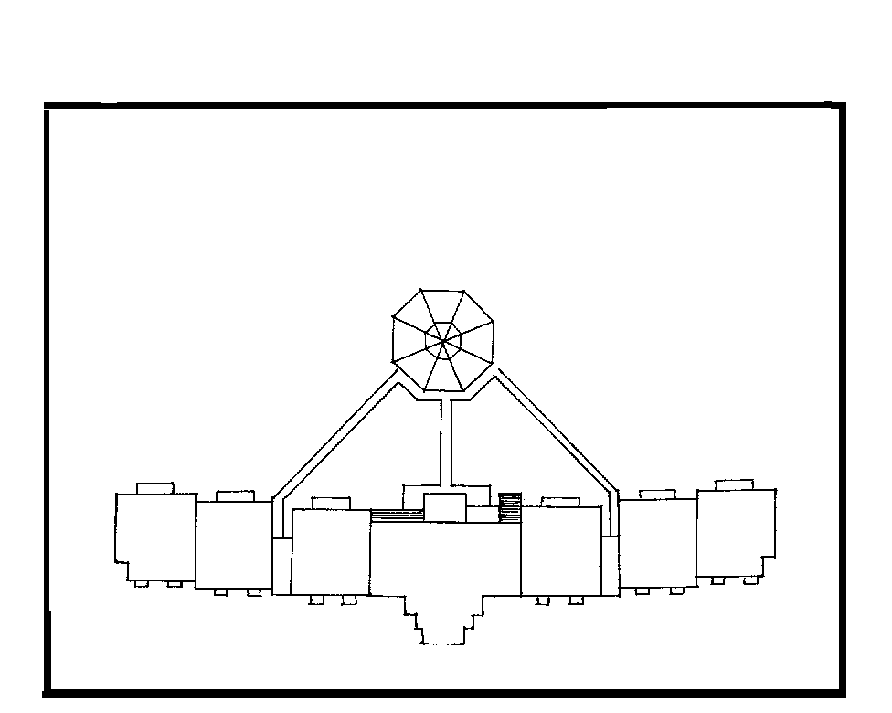

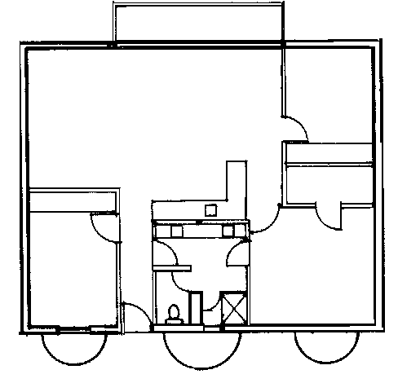
Building Design Family Unit
Dining
Living
B/R
B/R
B/R
70% of 2 acres for food gardens
Work shop
Balcony
Light wells
100m2 – family of 4 fresh food
Common Facilities

SUSTAINABLE DEVELOPMENT

Dr. Ted Trainer NSW University says that:

“If everyone is to enjoy the benefits of a modern lifestyle, a
much greater emphasis on local community development is
needed.”

“…while greener industries and greener technologies
will play an important role in the future, sustainability must also involve more self sufficiency and more cooperation at both
household and neighbourhood levels. “

Using public land for the type of housing and employment CHEC proposes would create the sort of localised cooperation and productivity we often only dream about.
POPULATION TO BE SERVED

CHEC serves people who don’t have an economic role or secure housing but do have energy, creativity and want to work.

People who have already found a role in CHEC include:
- Low income earners
- People with a low level of skill and education
- People with some physical disabilities
- Those with low self-esteem

Through its model for secure housing and cooperative employment, CHEC can develop to serve a wide range of people who are willing to work and develop new skills.

As a business, CHEC residents serve the customers of their neighbourhood cooperative. These people would include: retirees, single stay at home parents and others in the neighbourhood.

CHEC’s integrated approach to housing, employment, community and the environment is particularly appropriate to the needs of developing communities.

Our interest goes beyond setting ourselves up. We would like to be part of demonstrating a sustainable way forward.

COMMUNITY PROFILE

Mary Caldbeck-Moore, Tony Rogers, Gwen Bocci and Ben Sheppard and two children, Chris Baulman, Kali Baumann and Alex Baumann and two children, Kylie Mott with one child, and Brian Rowe.

Eligibility
- People looking for a way out of welfare dependency
- and who are on the waiting list for public housing

‘I can’t, we can’
With combined group effort we will sustainably re-enter the marketplace.

Our range of skills include
Office skills, management, trades, arts and healing, agricultural, and domestic skills.

History of our viability and accountability
- personal weekly time sheets
- weekly formal meeting records
- meetings twice a week since February 2002

Our Successes include…
- our submission and our community structures
- low income financial management
- established office space
- quality endorsements

Our motivation
The project has given many of us hope – “CHEC creates an opening for people like me.”, “CHEC makes me wake up keen to work.”, “CHEC feels like an integrated response that gives hope for future generations.”

SUCCESSES & FAILURES

Successes
Successful precedents for the various elements of CHEC are shown in TAFE’s recent ‘WomenBuild’ program, CDEP’s recent ‘Tingha market gardens’ program, and many of DOH’s tenant participation initiatives.
CHEC’s innovation is in the combination of these precedents.

Failure
‘Community housing’ and ‘cooperative initiatives’ involve cooperation.
Such cooperation has had a history of both success and failure.

Documented failures point to:
- lack of a sustaining and unifying purpose
- inadequate planning
- poor community support structures & agreements
- lack of financial viability / insecure work and housing
- focus of time and energy on off site employment
- isolation and costs when geographically remote

CHEC acknowledge these failures and responds with:
- a clear vision along with extensive planning
- effective and complete structures
- secure work and housing
- suburban work & housing that relies on and feeds back into society

AGENCIES INVOLVED

There are established precedents for every element of what CHEC proposes. CHEC’s innovation is in the combination of these precedents.

Key Organisations Include:

Centrelink

At the groundwork and submission stage of the project all participants are on some form of Centrelink support. At the 6 month building stage a training wage would be needed to equip us for self-building. For the 12 month business establishment stage the NEIS program would be used.

Department of Housing (DOH)
DOH would either use a block they already own or purchase a two-acre block of land. DOH would purchase the building materials. To secure the housing CHEC would enter into a long-term lease arrangement with DOH.

TAFE

For the self build component of CHEC, we would draw on TAFE’s existing onsite self-build training program. This would also provide us with qualified job supervision.

Support agencies
To help us both develop and present our submission we would like to involve key organisations such as Mission Australia, Shelter and the
Association Resourcing Community Housing (ARCH)

CHEC’s KEY STRUCTURES

Foundation documents
Constitution, Work and Housing agreement

Administration
Filing and other office management, accountability for monies, maintenance of records, time sheets, building maintenance, etc.

Legal Arrangements
CHEC is currently investigating options for its legal status.

Group/Business Management
Business Plan, Meeting process, decision making, facilitation, Occupational Health and Safety, shared domestic roles.

Community processes
Effective communication, conflict management, having fun, and relationship building.

PERSONNEL/STAFF REQUIRED

CHEC’s personnel are the residents who have an ongoing 16 hour commitment.

Where needed, we will be supervised and trained for roles by TAFE, NEIS. In our groundwork stage we have already worked as volunteers, learning new skills and performing roles in CHEC.

CHEC has developed job descriptions for a secretary, treasurer
Cook/ kitchen hand, Building and mechanical maintenance, Cleaners, Skills development officer, Gardener, Legal clerk etc….

We are already working out of an office that we have established in Woodford NSW.

EVALUATION

CHEC’s measures of success will be :

- Accountability of members time resulting in the submission and endorsement
- Approval of submission
- Residency in the 6th month
- Financial independence at the 12th month after residency
- CHEC seen as an appropriate response to sustainable employment and housing and is being applied more widely

Who will evaluate?
It would be in the interests of the relevant government departments and in our own interests to have all progress evaluated. For each measure of success, we will also have a contingency plan.

BUDGET
There are two budgets in CHEC:

1. Costs to Government

An approximate figure of $1.2 million has been calculated.

Compared with traditional public housing, CHEC reduces:
- welfare cost as residents find financial independence
- administration cost through self management
- building costs - CHEC is a 14% reduction in building materials
- maintenance through self build benefits

In CHEC, government outlay is secured in a public asset, rent is paid through independent earnings and participants find productive employment. CHEC is a safe investment for government that gives tangible returns.

2. CHEC resident and business costs

CHEC’s business would turnover $4000 / week

Each adult member would receive $100 disposable income (20 adults = $2000)
Out of this would have to come about $5/week for the servicing of a $24,402 household equipment loan shared by the residents, as well as personal bills, food not grown etc.

After resident wages are paid, $2000 remains from the $4000 gross turnover. This would cover business overheads, including residents’ personal rent which is part of the wage package.

This money would also cover other weekly costs of $70 water, $900 rent, $400 tax, $150 maintenance and petty cash funds, $100 servicing of a loan for $16,000 start up costs, $25 electricity, $150 insurance and $160 / wk for running a work van. This is a total of: $1955

IS CHEC VIABLE?

The viability of CHEC could only be determined by reviewing the detail of our plans.

While further development of detail is crucial, we believe what has already been done on the building design, the business plan and the community structures is extensive enough to warrant endorsement and funding.

OUR REQUEST FROM YOU

A full endorsement and support presenting our submission to minister for public housing Dr. Andrew Refshauge.

IN SUMMARY

In CHEC’s submission we show how we can achieve:
- secure self-build housing (Long-term lease with DOH)
- employment (We produce and sell basic necessities)

CHEC can do this while reducing the cost of public housing

CHEC members get off welfare while:
- independently renting and
- improving a public asset.

The beauty is that, not only does this project come in at 14% under current material costs, but it also provides secure employment and all the benefits of tenant participation.

Support Needed
We need your support with our submission to government.

APPENDICES

- HOUSING
  - TAFE Self Build Module
  - Architect’s Drawings
  - Architect’s Report
  - Architect’s C.V
  - Cost Comparison
  - Rational for 14% savings
  - 3D Internal Drawings

- BUSINESS
  - N.E.I.S Training Program
  - Business Plan
  - Overheads List
  - Dining Area Inventory
  - Table of Vegies and In Season Prices
  - Table of Veggie Prices 1999 – 2002 (ABS)
  - Food Coop Spring Prices
  - Harvest and Preserve Table

- COMMUNITY
  - Personal Profiles and Motivations
  - Timesheet
  - Initial Enquiry Presentation
  - Child Care Roster
  - Car Sharing
  - Treasurer’s Report
  - Meeting Procedures (A and B)
  - Primary Carer Involvement
  - Meeting Times
  - Inquiry Form
  - Moved to Speak Guidelines
  - Open Day Invite
  - Finding your Feet
  - Stages of Involvement
  - Looking at Home Page
  - Value (Sustainability)
  - Survey and Results
  - Meeting Attendance Record
  - Publicity Leaflet
  - Conflict Management
  - Constitutional Reference
  - Decision Making

- ENVIRONMENT
  - Develop and Use Sustainable and Enjoyable Living Practices
  - Promote CHEC Sustainable Housing and Employment Features
  - Sustainable Urban Development

- ECONOMIC
  - High Cost to Government & 5.2 Integrated Response
- AGENCIES INVOLVED
  - Department of Housing
  - Centrelink
  - TAFE
  - Council
  - Support Agencies

- KEY STRUCTURES
  - Constitution
  - Model Rules for Incorporation of Association / Dept of Fair Trading
  - Decision Making
  - Incorporated and Unincorporated Organisations
  - UniLodge – Licence to Occupy
  - UniLodge – Rules of Occupancy
  - Residential Tenancies Act 1987 – Division 2 Notice of Termination
  - Co-operatives – What does it mean to be part of
- What are responsibilities of members
- Table – Objectives
  - Business Card – Graham Monday – Registry of Co-operatives
  - Non Legal Identity
  - Deed of Management Agreement for “Bougainvillea”
  - Perspective’s on Risk Management
  - Draft 24/12/96 – Agreement between Members of CHEC and
Another by which they become part.
  - Incorporation (Booklet)
  - Note of Material required – Legal Identity, Insurance, Zoning
  - Simple Steps to forming a Co-operative
  - “Thinking Business? Think Co-operative” Dept of Fair Trading
  - Application for Reservation/ Extension of Name
  - Dept of Fair Trading – Association Incorporation Act 1984
  - Dept of Fair Trading – Schedule of Fees for Association
  - Dept of Fair Trading – Public Liability Insurance requirements for
Associations
  - Dept of Fair Trading – Associations Incorporations Act – Letter of
Evidence.
  - A.T.O – Tax and Non Profit Organisations
  - The Objects and Rules of an Association

- PERSONNEL
  - Job Descriptions for all CHEC Roles

- FACILITIES
  - Present and Future

- EVALUTION
  - Stages and Organisations of Evaluation

- BUDGET

  - Cost to Government
  - Cost to CHEC residents

12. CONTINGENCY PLANNING
12.1

