WESLEY MISSION, PO Box A5555, Sydney South NSW 1235, Ph 02 9263 5555

July 17 2002

Mr. Elton Humphery
Secretary
Australian Senate
Community Affairs
Parliament House
CANBERRA ACT 2600

Dear Mr Humphery,

Thank you for your e-mail of July 9 inviting Wesley Mission, Sydney to make a submission to the Inquiry into Participation Requirements and Penalties.

We have downloaded the 97 pages of the Bill and the 56 pages of the Explanatory Memorandum. It is simply not possible for us to consider all this material within the 10 days provided for in your e-mail.

I would, however, like to comment that some progress has been made on breaching.

As part of the long-term unemployeds’ mutual obligation, they are required to attend information sessions on Work for the Dole. Failure to attend these sessions in the past has resulted in our recommending a breach to Centrelink for non-attendance.

The problem with that process was that it took about six weeks for the breach to go through the system. Because of the long delay between the failure to attend, and the consequences being felt, this method had little impact on changing the long-term unemployeds’ behaviour, or addressing possible issues involved in the non-attendance.

The new system, introduced on July 1 2002, where payments are suspended immediately for failure to attend, is a great improvement. This suspension will have an immediate impact on the job seeker, and will encourage them to contact Centrelink quickly, so that any issues that may exist can be gone through, and the jobseeker quickly be rescheduled for another appointment.

Yours sincerely,

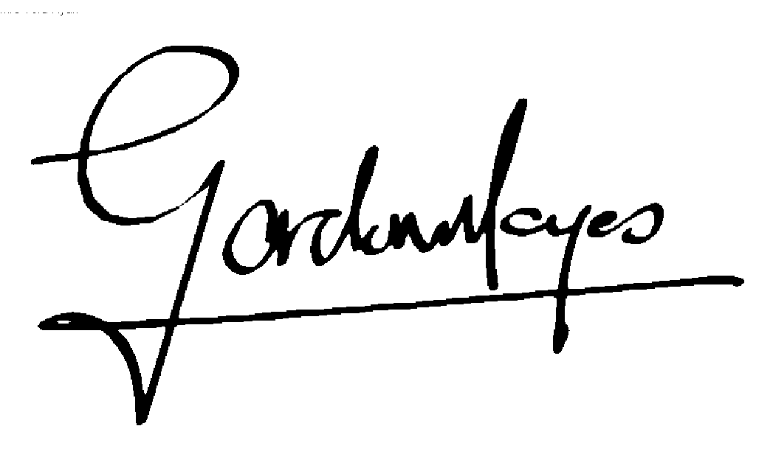

REV. DR. GORDON MOYES AC

