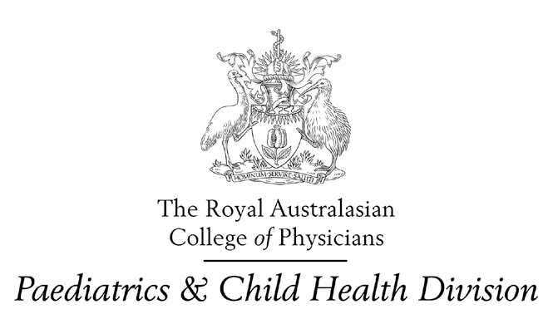

2 August 2001

The Secretary
Senate Inquiry into Nursing
Senate Community Affairs References Committee
Parliament House
Canberra ACT 2600

Dear Sir/Madam

Re: Senate enquiry into Nursing

The Paediatrics & Child Health Division of the RACP generally supports the submission to the Senate Community Affairs References Committee on behalf of Women’s Hospital Australasia and Children Hospital Australasia. On behalf of the Paediatrics & Child Health Division, I would like to make some separate comments.

Firstly, the Division cannot comment on the issues relating to women’s hospitals and in particular midwives, except that there is an appropriately trained and professionally supported nursing contribution to the safe management of pregnancy and delivery of healthy babies.

We strongly support a national approach to address problems in the nursing profession related to nursing education, career development and work place retention. We consider that a re-statement of the definition of the nursing profession is required, not just in relationship to tertiary education and the increasing technical requirements of the profession but also regarding the roles and responsibilities that nurses undertake in their daily work in hospitals and other settings ie: in the real world. Recommendations 9 and 11 from WHA/CHA indicate the need for appropriate clinical placements during vocational education so that issues such as personal patient care and the realities of rostering do not come as a total surprise to nurses when they actually enter the workforce.

The increasingly stressed working environment in public hospitals has meant a trend in some settings that doctors and nurses work in parallel rather than as true partners. Clear understanding of lines of responsibility and ultimate responsibility for patient management and outcomes is essential, particularly in relationship to safety and quality.

- 2 -

As in other areas of the health industry, increasing flexibility of work practices is being demanded to ensure job satisfaction and long term retention within the profession. It is important that such flexibility is shared across all members of the profession. Family responsibility is often cited as a reason for work flexibility. This can be true of mothers and fathers with young children, men and women with responsibilities towards their elderly parents or other members of their families with special needs, and of men and women with opportunities for life activities outside their profession. These issues are particularly true for a profession which requires shift work to cover all 24 hours of the day as a fundamental component of the workplace requirements.

The Division strongly supports a national approach to standards of education, nursing registration and opportunities for professional development within the nursing profession. The Division also supports the notion of medical and nursing workforce planning being integrated to the extent that much of their work, particularly in hospitals and other institutional settings is closely related and dependent on each other.

We wish you well in your deliberations on this complex subject.

Yours sincerely
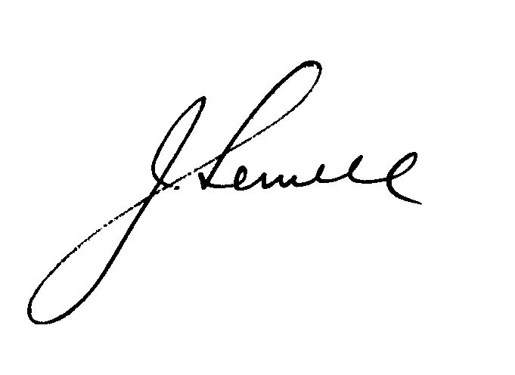
DR JILL SEWELL
President

