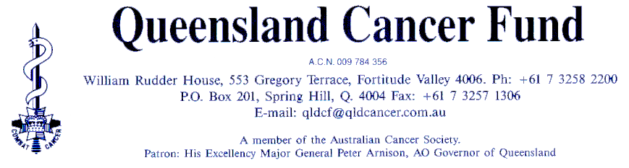
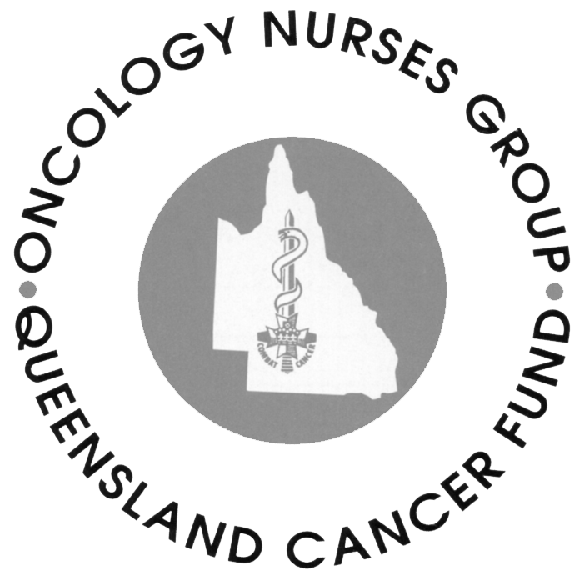
Oncology Nurses Group

10th July 2001

Senator Rosemary Crowley
Senate Inquiry into Nursing
Email: community.affairs.sen@aph.gov.au

Dear Senator Crowley,

Thank you for this opportunity to provide a response to the 2001 Senate Inquiry into Nursing.

The response enclosed is a summary of the views of the statewide membership of the Oncology Nurses Group of the Queensland Cancer Fund. Specifically the Oncology Nurses Group is a special interest group which operates in Queensland and supports nurses who care for people with cancer. The Oncology Nurses Group has a membership in excess of 500 nurses who work across a broad range of health settings, including acute and ambulatory oncology, palliative and hospice care, general medical and surgical, domiciliary and community. Members range from beginner to advanced practice and are clinicians, educators, administrators, researchers, academics and counsellors.

In spite of the diversity of the membership four main themes were identifiable from the submissions from members.

- Cancer nurses want recognition for the demands of caring for people with cancer. “Why would you want to look after cancer patients – that would be terrible – it must be so depressing.”
- Nurses need a reasonable workload. “They like the work, but unreasonable workloads, lack of acknowledgment and education cause frustration and disillusionment.”
- Nurses need adequate staffing (with experienced staff) “We don’t want cars and bonuses – we’re not asking for more money. We just want enough staff. I know there are enough nurses in the area, but they are not practising – they are too frustrated with the situation. The last 5 years have been the worst. They love nursing, but they don’t want the frustration.”
- Nurses need time for education. “We’ll get to inservice time and we’ll be too busy and we can’t hold it”.

The Oncology Nurses Group membership believe that the development of strategies to meet these four identified needs will contribute significantly to reversing the current recruitment and retention trends.

I look forward to learning of the outcomes of the Senate Inquiry.

Yours sincerely

Jane Roach
President Brisbane Oncology Nurses Group
and
Spokesperson for the Statewide Body Oncology Nurses Group

Response from: The Oncology Nurses Group of the Queensland Cancer Fund

To: Senator Rosemary Crowley
The 2001 Senate Inquiry into Nursing

At: community.affairs.sen@aph.gov.au

Date: 11th July 2001

Description of the Oncology Nurses Group/Membership

The Oncology Nurses Group is a nursing special interest group which operates statewide in Queensland. The Oncology Nurses Group has 15 regional groups across the state which contribute to the work of the statewide body. Membership is open to any nurse who has an interest in cancer and palliative care.

The Oncology Nurses Group has a membership in excess of 500 nurses who work across a broad range of health settings, including acute and ambulatory oncology, palliative and hospice care, general medical and surgical, domiciliary and community. Members range from beginner to advanced practice and are clinicians, educators, administrators, researchers, academics and counsellors.

The Oncology Nurses Group aims to promote cancer nursing and to support nurses caring for people with cancer. It is an extremely active group with a quarterly newsletter, regular professional development activities and a high profile two day annual conference. The Oncology Nurses Group is also a member organisation of the International Society of Nurses in Cancer Care.

About the submission from the Oncology Nurses Group

Submissions for the Senate Inquiry into Nursing were invited from the membership of the Oncology Nurses Group. The submission offers a unique view of the experiences of nurses caring for people with cancer in Queensland. The response includes comments from beginner and advanced practice nurses, rural and remote area nurses, public and private sector nurses, specialist and generalist nurses. The nurses were asked to address two broad questions:
- What are the factors impacting on nurses caring for people with cancer?
- What strategies do you think would assist in the recruitment and retention of cancer care nurses?

Briefly describe factors impacting on nurses caring for people with cancer

The demands of caring for people with cancer
Cancer is now considered to be a chronic illness with the treatment trajectory extending over a long period. It is not unusual for the cancer care nurse to see their patients on a weekly basis over a long period of time. Cancer care nurses develop long term relationships with their patients. Because of the intimacy of the relationship in terms of the intense emotions experienced by cancer patients, there is greater dependency on nurses for emotional and physical support than in other nursing areas.

Oncology Nurses Group members provided the following comments relating to this issue:
- Difficulties providing cancer care in rural and remote communities. "In rural and remote areas the cancer care nurse will support the patient from the pre-diagnostic clinic through diagnoses, surgery, chemotherapy and often palliative care." “You are in the diagnostic clinic, the operating theatre, the chemo ward and then you meet them (the patients) at the kids soccer match. Sometimes I time my supermarket trips to avoid patients who might be doing their shopping on the day before their chemotherapy. It just gets too much.” “Sometimes there is a reluctance to get involved because you are looking after school friends and nurses don’t want to care for them. However in rural and remote areas there is no luxury and nurses have to provide the care. This contributes to attrition”.
- Lack of acknowledgement of the uniqueness of the cancer nursing role. Because of the emotional demands of cancer care wherever it is delivered, nurses become emotionally drained. " Experienced nurses carry the greatest burden in terms of patient support and support for other staff. There is a lack of appreciation from management levels of the difficulty of the role of the cancer care nurse. Skilled nurses become dissatisfied because of the lack of support and appreciation and these nurses are leaving."

Education in cancer care
Cancer care nurses in Queensland believe that they have a moral and professional imperative to continue learning throughout the course of their career. Education improves knowledge and skill base, increases self-esteem and importantly improves the standard of care to people with cancer. Nurses describe the urgency of “keeping up with the latest technology or you get left behind”. Nurses also comment that ongoing education, knowledge development and increasing expertise levels are expected from the employer. However the general feeling is that the workplace is not supportive and does not provide the means for a workplace education programme.

The respondents provided the following comments about education:
- Competing priorities. One of the most significant barriers to workplace education is the competing demands on the cancer care nurse (often the result of inadequate staffing, particularly experienced staff). “We’ll get to in-service time and we’ll be too busy and we have to cancel”. “It’s increasingly difficult to get the time for educational activities such as conferences and workshops." “Education tends to suffer because of workloads – this becomes frustrating – and ultimately the patients are missing out”. In rural and remote areas - “With such a diversity of services in rural and remote areas oncology is competing with everything else eg operating theatre and ICU"
- Lack of time. “There is simply not enough time for education. Even for part time nurses, there needs to be time for education and updates and they miss out."
- Lack of dedicated education programmes. "There is no education built into the part time or permanent staffing structure”.
- Difficulties with distance. Nurses in rural and remote areas need to travel long distances to access education programmes.
- Inequity across health sectors in relation to educational support. “My mum works in a remote area health facility where nurses receive five paid education days annually. I know she also receives other assistance for educational activities. This support is not provided at my health facility. They (management) see education as important but do not acknowledge the difficulties or provide support”.
- Retaining educated staff. Experienced nurses in rural and remote areas report the frustration which occurs when training and education is provided to new staff who then leave the workplace. “Our training for chemotherapy is in-house and it is a very good training programme. However we get nurses trained and with the difficulties of staffing and workloads the nurses leave and we have to start training again. When you only have a small population of nurses in the first place, this exacerbates the problem.”
- Loss of clinical skills. Rural and remote area nurses described the difficulties of maintaining skills particularly in relation to chemotherapy administration. Education and skills training is not an isolated event and nurses described the difficulties with supporting ‘maintenance’ education programmes.

Staff shortages and workload
Nurses who responded to the inquiry questions appeared most frustrated about staff shortages and their unreasonable workload. This is reflected across metropolitan and rural and remote areas and public and private health sectors. One nurse described the situation with brutal clarity:
“If there is enough staffing and I enjoy my patient care, that is the measure of a good day. However, this doesn’t happen very often. I am passionate about cancer care, but if I could find another job tomorrow with a reasonable workload I would leave.”

Oncology Nurses Group members outlined the following difficulties related to staff shortage and workload issues:
- Movement away from the clinical area. “We have a shortage of nurses that have training in oncology in rural areas. Nurses are taking up other opportunities in quasi management positions – they are looking for a change of pace. It’s a break - the nurses are clever so they get the jobs and it provides some professional and personal development." “Many of the wards (in rural hospitals and health facilities) are geriatric and nurses feel that there is limited scope for development. The career structure is so flat that nurses are taking on new roles to get professional and personal development”. “We have lost two level 2 nurses in the past 18 months – these nurses have a burning desire to do oncology nursing but without decent staffing levels and educational support they won’t stay”
- Difficulties with attracting staff to rural and remote areas. "In 1992 I couldn’t get a job here (a small country town in far north Queensland). During the last 2 – 3 years we can’t get enough staff for the shift." "There is insufficient recognition for health system changes (increasing demands on health care services) and no anticipating and managing the changes – no progressive management style."
- Increased burden on experienced cancer care nurses. “The experienced nurses are tired because they have a patient and management workload and they are continually providing orientation and support to new staff. Nurses are so tired.” “Insufficient staff equals lots of ‘agencies’ which increases the workload for the experienced nurse having to provide support and supervision and carry their own workload”

- Overtime. Nurses also noted across the private and public sector that overtime is routine. Most overtime was paid overtime. However money doesn’t appear to be the major issue. “We are consistently doing overtime and while the money is nice, I would rather go home on time to my familiy”. "There is a demand to finish work on time but this is unrealistic and unlikely."
- Burnout. “Nurses get burnt out and need a break."
- Extension of patient services. 24 Hour a day telephone support services to ambulatory cancer care patients was also noted by one nurse as an important development in the support for patients. However, this new service is also increasing the workload for nurses.

Health systems – influences on cancer care
Nurses caring for people with cancer in Queensland described several ‘health systems’ factors impacting on the work of cancer care nurses. These factors are:
- The reduction of allied health services to some units. One respondent noted that social work services in a metropolitan oncology unit had been cut and nurses felt that this placed extra demands in terms of emotional support. Patients with unmet emotional needs related to their cancer diagnosis and treatment tend not to cope as well.
- The absence of allied health services in the private sector. Nurses noted that social work, counselling and psychology services are not routinely provided in the private sector in Queensland. People with cancer often have greater need than other health care consumers for support of this nature. Nurses felt that this placed extra demands in terms of the provision of emotional support.
- Role changes. One nurse noted that nurses in cancer care are “doing more” of what doctors used to do.
- Political Influences. A nurse from a rural setting made the following comment: “For the last five years we have had a ‘One Nation’ member for our region and the area is being punnished for who they have voted for. Services have dimished, capital works have diminished. The physician and surgeon are suffering too – they have committed themselves to rural health care and the politics will drive them away."
- Population Influences. The ‘baby boomers’ represents the largest mass of ageing population in history. Cancer is primarily a disease of ageing organs. This ageing population mass represents an increased demand on cancer nursing services. Cancer as a disease is increasing in incidence with 1 in 3 Australians now diagnosed with cancer. This also has impacted on the demand for cancer nursing services.
- The changing dynamic of hospitalised cancer patients. Oncology patients who are in hospital are very ill and have a high dependency rating. "I don't believe that staffing needs in oncology recognize the high dependency needs, both physical and emotional. It sometimes feels as though managers have little idea of what's going on in the clinical area".
- Inability to keep up with patient volume. “The doctors are double booked all day because of the increase in patient load in the private sector. I don’t think nurses keep patients waiting to the same extent. We tend to hear more of the complaints because of the long waits.”
- Increasing demands of the person with cancer. “Patients are becoming more demanding – they use the internet and question everything you do. They want to know why they can’t participate in a particular clinical trial. This puts a lot of pressure on you to know about everything. This also puts more importance on access to education.”
- Ageing population of cancer nurses. "Oncology Nurses with specialised knowledge are getting older – there are not the new nurses coming through to replace us."

- Reluctance of new graduates to work in cancer care. "The new nurses don’t even consider working in oncology. They have a perception that they need to get a broad knowledge base first. I suppose this has always been the case, but desperate shortages are challenging this development pathway. It's time to change this mind set and start new graduates early in cancer care."
- The nursing career structure. The career structure currently does not provide scope for the development of clinical practice. The present structure places importance on research, academic, educational and management nursing roles. However clinical nursing roles are viewed as 'lower' in the structure hierarchy. This is in spite of the advanced level skills demonstrated in clinical roles eg the community based palliative care nurse working in isolation and making decisions about complex pain issues. Research, academic, educational and management nursing roles should be the support structure for good clinical practice. “The career structure is more detrimental in rural and remote areas – there are simply no positions. I have settled in the area, I have built a house – I am staying – but I will change jobs for need of development and a break.”
- The shortage of specialised medical practitioners in rural and remote areas. “This affects the provision of services and nurses again take on roles and responsibilities that strictly fall with the medical realm”.

What strategies do you think would assist in the recruitment and retention of cancer care nurses?

Recognition of the demands of caring for people with cancer

Recognition of the special relationships with patients in cancer care
- Routine debreifing
- Debriefing for traumatic situations eg the very emotional client

Education in cancer care
- Consistent standard training in cancer care. “eg Qld Health transitional programme” “Bring everyone up to speed and to the same standard.” “We need education, skills and support to do the job.”
- Advanced skill development. “Extra workshops/training for management and communication skills eg dealing with difficult people/health professionals and situations.”
- Review the preceptorship programme. “We need to look at who is preceptoring our new graduates. Who is taking on the role of clinical facilitator – it has to be the right person – someone who can inspire and someone who is a very experienced clinician. There must be staffing allowances for this as well.” “We need to make sure that new nurses are not ‘in charge’ too early – ensure that junior nurses are supported and that we have the right mix of staff on shifts”.
- Opportunities for education in rural and remote areas:
-Workshops in the local area and access to speakers who might be visiting the local area;
-Time out for education,
-Travel assistance,
-Financial assistance for education,
-Flexible rostering for education,
-Development of the Graduate Nurse Programme. “I think that the programme needs to be 2 years in duration. Rural and remote areas could keep more graduates with better support and a better programme. They (new graduates) don’t receive adequate support – they always carry a workload. We often have appointed preceptors who don’t get to work with the new graduates. The hospital is given funding, but no measures are in place to make sure that programme works and that new nurses are supported.
-Rural nurses want indepth education not just generalist education eg education about radiation therapy and paediatric malignancies.

Transitional Programmes. Appropriate transition support is needed to facilitate movement to oncology eg preceptor support. “A lot of new people think that it would be good to move around to different wards and they get skilled and then they leave and the skills are lost. Even though the new people are registered nurses they can’t be expected to function as a skilled Registered Nurse when they enter oncology. The Queensland Nursing Council model for beginner to advanced practice nurse needs wider application in the clinical setting.

Address Staff shortages and workload
- Maintain adequate staffing levels.
- Avoid the situation of inexperienced casual staff working in the oncology unit.
- Examine clinical workloads.
- Re-examine the ‘make-up’ of cancer patients in hospital. “Patients are sicker and nurse dependency ratios really need looking at.”

Health systems – influences on cancer care
- Promotion of cancer nursing. “We need to tell new graduates that nursing cancer patients can give a wide variety of skills eg good assessment and observation skills are essential and are taught in oncology. “Cancer patients often have complex medical problems eg ageing related diseases, diabetes and cardiac disease so nurses can get the general grounding as well as oncology experience and develop a wide variety of skills” “We need to talk to the new graduates about what oncology nursing is and highlight the advantages”.

Encourage better relationships with management. “Saying thank you is important. In our unit on international cancer nurses day each nurse received a potted plant and we always hold a morning tea on the day of the unit birthday. It’s not important that we receive a gift, but it is important to know that we are appreciated.”
- Educate the community about cancer nursing. “Family, friends and the general public often say to us ‘Why would you want to look after cancer patients – that would be terrible – it must be so depressing’. We need to be responsible for spreading the word”
- Encourage better support in nursing teams. “We need to support each other better in our teams. “We need to get the negativity out of nursing.” “We need to be advocates for our fellow colleagues”. “I think it’s important to have staff that are dedicated and passionate to the area they work in.” “I think a professional look in terms of dress code helps with image and self esteem”

Recognition of the contribution made by staff who are studying. “Being valued by the administration for the qualifications you have or the study you are doing is important to me”
- Target strategies at a statewide level. “Look at Queensland Health Strategies eg business planning framework for nurses that looks at skilling up the nurses who are running the wards, including looking at appropriate staffing levels and factoring in education. Education should be factored into staffing establishment.”
- Provide support to nurses in management roles. “If nurses are going to be able to effectively manage their area, then they need the training to do this. A lot of problems result from a break down in communication between management and the clinical area”.
- Examine the better use of nursing models and roles. “The breast care nurse model works well in our rural/remote area settings because we see the patients across the board (from pre-diagnosis to surgery, chemotherapy, etc). I don’t think the model works well in large health facilities, because each area is so separate. Breast care nurses in metropolitan hospitals see patients in the surgical units and patients only stay for 24 to 48 hours. The woman with breast cancer then moves on to chemotherapy or radiotherapy and the breast care nurse does not cross over into these areas.

