The Secretary
Senate Community Affairs Reference Committee
Suite S1 59
Parliament House
Canberra A.C.T. 2600

In reference to:

INQUIRY INTO NURSING 2001

Submission from:

CONCERNED NURSES OF EAST GIPPSLAND, VICTORIA

Attached document - Prototype of a disillusioned Student nurse

STATEMENT

We, the ‘Concerned Nurses of East Gippsland, Victoria’, wish to express our deep concern for the current College based Nurse Training Program, and the subsequent result.

Increased focus on technology, academia and professionalism have contributed to suppression of humanity needed to perform the “Art” and “Science” of Nursing.

We have entered the realms of distanced and digital degrees, further removing the nurse from their main source of learning:- the Patient.

Technology cannot teach a Student Nurse how to look, listen, touch and smell elements that build on the overall clinical picture of the persons in their care.

The routine use of automated Sphygmomanometers or Pulse Oximeters, (although they may save time), can be the cause of the loss of vital skills, and changes to the patients wellbeing.

The continual erosion of quality face to face teaching and productive time spent on the Ward, to keep in congruence with a university year seems to have led to a less
confident / competent novitiate being produced, to the detriment of the people nurses have been committed to care for. This increases the stress levels of nurses at all levels of practice, novice to expert, and lowers job satisfaction: A main contributor of the prime reason for resignation from the profession.

There is definite evidence of not enough practical experience gained by our graduate nurses, with disturbing and alarming instances to relate.

It is easy to feel the current nurse shortage is being compensated by:
- Past Hospital trained S.E.N.S
- Refresher R.N.’s
- Lowered Tertiary Entrance Scores to encourage school leavers into nursing.

RECOMMENDATIONS

We recommend that Year One of Student Nurse Training be paid Hospital based. This would provide a continuity of Clinical and Patient care with supervision undertaken by qualified personnel. This fulltime experience/employment would advantage the student nurse financially to continue University studies if desired. Not only would this relieve the hospitals of the increasingly glaring situation of the shortage of nurses in the clinical field, this period will enable Student nurses to gain for example, such skills as:-
- Practical experience in observation and ability to anticipate problems
- Time management skills
- How to function as a Team Member
- Compassion and patient reassurance
- Gained confidence
This better balance of nurse Training between Universities and Practical side will no doubt assist the retention of student nurses.

Due to the current high drop-out rate of students and expense of a qualification being unused, we would suggest that these problems be resolved by:-
Returning to the ‘old’ system of Interview / Assessment, actually talking to prospective students, instead of first viewing Academic results.

There is no reason why, having completed a 3 year training and a post graduate year that they can then upgrade their knowledge in a specialized field with the good grounding they have received in the clinical area.

Referees:
Mrs Maureen Newcomen
Mrs Audrey Johnston
13 Power Street
Bairnsdale, Vic. 3875
(03) 5152 4984
160 Moroney Street
Bairnsdale, Vic. 3875
(03) 5152 1035

Mrs Angela Bird
1/20 Langford Parade
Paynesville, Vic. 3880
(03) 5156 0526
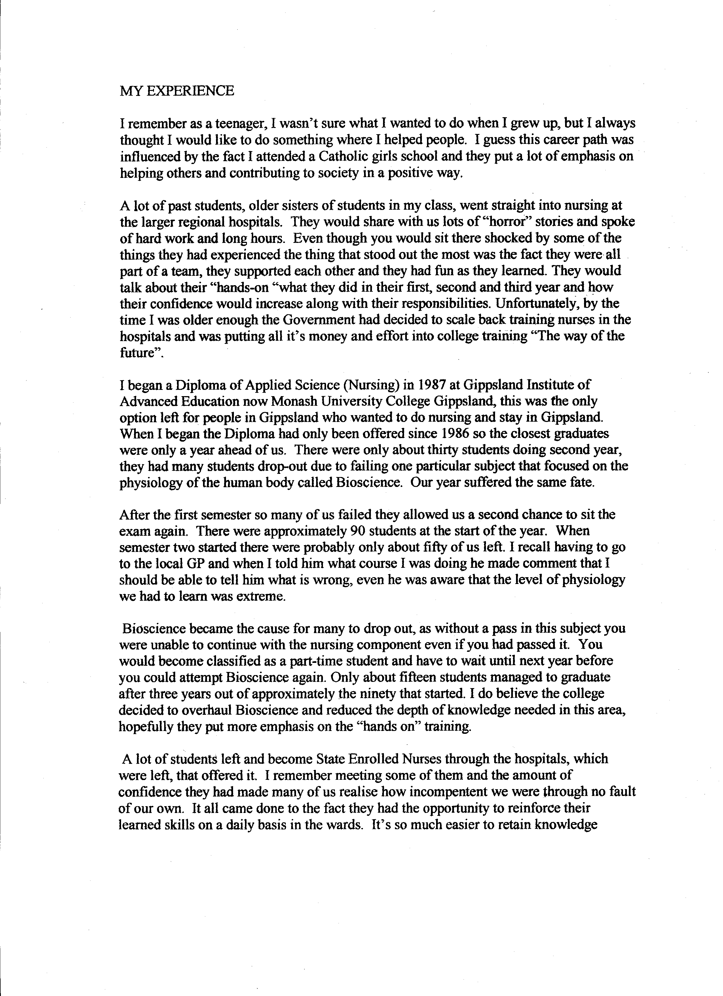

through repetition and practice. There were so many aspects of basic nursing skills and patient care that are missed in the c6llege setting. You never felt part of the team because you usually only at a health setting for a week, a couple of weeks at best you would just get your bearings and begin to grasp certain techniques and you'd be back in the classroom.
By the end of second semester more of us failed the dreaded Bioscience, myself included. I along with others had become very disillusioned, we had little practical experience. In the first semester we visited community groups as part of our practical experience we didn't even see inside a real hospital ward. Second semester I spent a week with the district nurse in Warragul, and three weeks experience in two different long-term nursing units.
I was able to continue with certain subjects in 1988 but not the nursing component even though I had passed it because I had failed Bioscience. Financially it became a strain and I didn't want to work in nursing with the little experience I had, I felt I would be putting patients lives at risk with my minimal experience, so I decided that I would quit and apply to become a State Enrolled Nurse through a hospital, which I successfully completed in 1991.
7~'- I learnt so much in the twelve months training to become a S.E.N. compared with the first twelve months of college it was unbelievable. I could now understand why those who
went into the college with an S.E.N. background were so more self-assured than those of us who didn't. They had a distinct advantage, they didn't share the same level of fear that the rest of us had. They knew the level of responsibility that was expected of them, they - had already learnt basic nursing skills, and it was second nature to most of them. This allowed them to focus on the harder subjects; they were really the only ones who stood a chance of becoming competent nurses.
It was not uncommon for the rest of us to be terrified by the responsibilities associated with being a registered nurse. You became anxious and doubted your skills because you didn't really have any to speak of, you usually learnt such things as giving enemas, intramuscular/subcutaneous injection in a two hour practical and that was the only chance you had to practice your technique. You always felt you were "winging it", you were
very unsure of yourself and the only way to cure that was with experience. Your dealing with real people not dummies out on the wards and you get a greater understanding of
how to read certain situations and how to deal with them. Many students would burst into tears when on placement and couldn't cope just because they weren't properly prepared for the reality of nursing.
Personally I think it's the worst thing they have ever done to nursing. Nursing care
offered to patients by freshly trained college students cannot be of the same level given by hospital trained nurses for the simple reason experience leads to confidence. The college put too much emphasis on theory and studying and left out the importance of quality patient care. I was and still am envious of those nurses who had the opportunity to train for three years in a hospital, they were lucky. I hope that eventually the Government will realise that the only way to become a competent nurse is through daily/weekly patient contact and care it put training back into the hospitals for everyone's sake and wellbeing.

