Australian  College of  Emergency  Nursing Ltd | 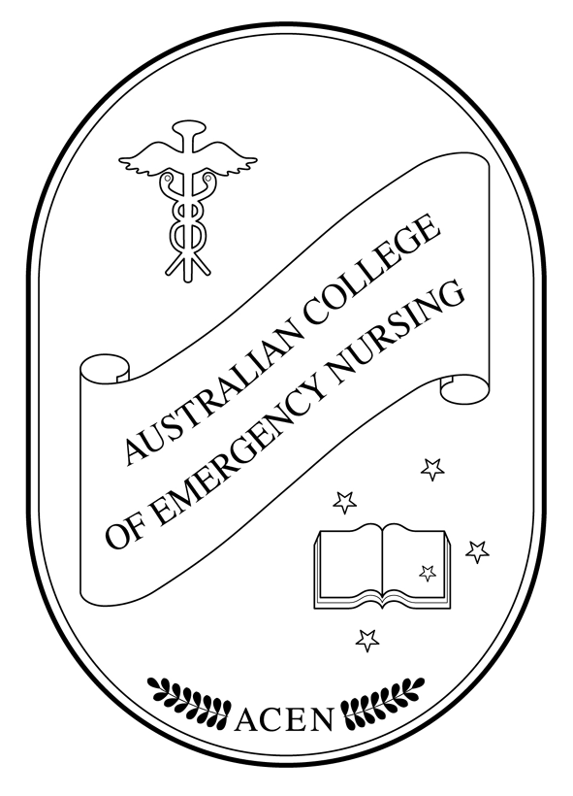 | Postal Address:  PO Box 141  Toongabbie NSW 2146  Tel: (02) 9631 6111  Fax: (02) 9631 6655  Email: acenl@bigpond.com  ABN: 71 092 680 727

3 July, 2001

The Secretary
Senate Community Affairs Reference Committee
Suite S1, 59 Parliament House
CANBERRA ACT 2600

Thank you for the opportunity to contribute to the Senate enquiry into Nursing.

The Australian College of Emergency Nursing is the National body for representing Emergency Nursing.

The College Aims and Objective are;

- To promote and maintain a high standard of Emergency Health Care.
- To further the professional standards for Emergency Nursing Practice.
- To maintain and improve the education and specialised practice of Emergency Nurses.
- To actively promote and support research in the field of Emergency Health Care.
- To provide official representation for Emergency Nurses at local, state, national and international levels.
- To liaise with educational, scientific and professional organisations which are involved in or associated with Emergency Nursing.
- To provide professional communication through publications and meetings; to allow opportunity for the membership to present and discuss the practice, research and study of Emergency Health Care and allied subjects.
- To establish and maintain a national membership of Emergency Nurses.
- To provide leadership.

The content of this document will only address Emergency Nursing issues.

- Shortage of Nurses and it’s impact on service delivery

There is a national shortage of experienced Emergency Nurses and the impact on quality health care as a result of this is enormous putting stress on existing staff.

Significant roster shortfalls need to be filled by casual or agency nursing staff. These nurses do not possess the specialist skills required to function at an advanced level in the Emergency Nursing setting. This creates additional stress on the existing Emergency Nurses who are then forced to “carry” the shortfalls in care created by the less experienced staff.

- Opportunities to improve current arrangements for the education and training of nurses

The College actively supports any educational activity that enhances the knowledge and skills involved in the delivery of Emergency Care.

The College currently conducts three educational programs that have International recognition. These courses are conducted by Emergency Nurses who have qualified as instructors. The courses are taught by the instructors in their own time.

  - Trauma Nursing Core Course – Trauma nursing as a discipline refers to the process and content of all the different roles nurses have in the care of the trauma patient. Knowledge is the core of any discipline. The purpose of TNCC is to present core-level knowledge, refine skills and build a firm foundation in trauma nursing. The TNCC is a four to six week home/external/private study course with a 16-hour face to face component, designed to provide the learner with cognitive knowledge and psychomotor skills.

Since 1992 the College has conducted 235 courses throughout Australia and New Zealand and have trained 3942 nurses.

State distribution of courses: NSW = 92
QLD = 62
VIC = 31
TAS = 7
WA = 15
SA = 4
NT = 9
NZ = 15

- Emergency Nursing Paediatric Course – ENPC is a four to six week home/external/private study course with a 16-hour face to face component designed to provide core-level paediatric knowledge and psychomotor skills needed to care for paediatric patients. The course presents a systematic assessment model, integrates the associated anatomy, physiology and pathophysiology and identifies appropriate interventions.

Since 1994 the College has conducted 81 courses throughout Australia and New Zealand and have trained 1303 nurses.

State distribution of courses: NSW = 42
QLD = 24
VIC = 2
TAS = 2
WA = 1
NT = 6
NZ = 4

- Course in Advanced Trauma Nursing – By taking this course, trauma nurses can strengthen their critical decision-making skills to optimally impact the outcome of critically injured patients.
CATN will benefit nurses caring for patients throughout the trauma continuum. The course was developed to reinforce the interlocking psychophysiologic concepts central to trauma nursing.

Since 1998 the College has conducted 8 courses throughout Australia and have trained 90 nurses.

State distribution of courses: NSW = 4
QLD = 1
NT = 3

These courses are heavily supported by the Emergency Nurses within Australia but over the years we have seen a steady decline in the support for nurses to undertake the programs.

While the courses remain popular, very few nurses received financial assistance or paid study leave.

Recommendation - That TNCC, ENPC, and CATN be recognised as core educational opportunities for Emergency Nurses and attendance by supported where possible.

- Recruitment and retention strategies

Emergency Departments are predominantly not experiencing recruitment problems of registered nurses. The difficulty is that they are unable to recruit experienced Emergency Nurses. The majority of vacancies are filled by either new graduate nurses or nurses who have gained experience in other areas of nursing. This creates an additional burden on the Emergency Nurses as they are then required to “carry” the other nurses who are unable to fulfil an independent role.

The current working environment in Emergency departments is so difficult that many experienced Emergency Nurses are leaving not just the hospital of employment, but the system.

Access block, waiting times and abuse are the main reasons that nurses are leaving the workforce.

Another significant reason is the lack of professional recognition of knowledge, skills and educational qualifications. Emergency Nurses feel devalued.

Recommendation - A national competency based career pathway should be established to allow for the transfer of skills between Emergency Departments.

- Interface between Universities and the Health System

The College actively supports educational involvement between the University section of the Health System.

An important area that needs to be developed and reintroduced is the hospital based post registration specialists program that provides functional knowledge and skills for Emergency Nurses.

Many University programs provide Academic content that participants find difficult to understand the relevance of and introduce into their everyday practice.

Recommendation - To support the development of hospital based speciality post registration program that articulates into higher degrees currently offered by the tertiary sector.

5. Strategies to improve occupational health and safety

Many significant improvements in OH&S have occurred within Emergency Departments. Areas such as manual handling and infection control need to be commended for their initiatives in improving the working environment.

Violence remains the single greatest issue in OH&S for Emergency Nurses. This violence takes many forms.

- Verbal and physical abuse from patients and relatives.
- Horizontal violence from professional colleagues.

Recommendation
i) To publicize behavioural limits expected of the public and staff and areas
of legal regress that staff will be supported to purse in the event of a
violent incident.
ii) To increase the educational opportunities for Emergency Nurses in
dealing with stress and violence.

I trust this document is of assistance in your endeavours.

I would welcome the opportunity to address the enquiry or to provide further information if required. My contact numbers are as follows;

Work: (02) 9845 7607
Email: acenl@bigpond.com
Mobile: 0419 427 417

Your Sincerely,

Liz Cloughessy
EXECUTIVE DIRECTOR

