Senate Community Affairs
References Committee
Parliament House
CANBERRA ACT 2600

Monday 4 June 2001

RE: INQUIRY INTO NURSING

Dear Sir/Madam,

I write on behalf of the Nursing Board of the Northern Territory. The Board is the statutory body established under the Nursing Act 1999 (NT) which is responsible for the regulation of nursing in the Northern Territory.

One of the major functions of our Board and all other nursing Boards and Councils in all the Australian states and territories is the accreditation of nursing education programs in the tertiary and vocational, education and training sector and the ongoing monitoring of these programs.

While all Boards and Councils have developed guidelines and criteria which have to be met prior to a nursing education program being granted accreditation status, the mere fact that eight different organisations are accrediting nursing programs does have the potential to lead to variations in the accreditation process, differences in core components of nursing education programs and potentially, varying quality in the students graduating at the end of the program.

It is the firm belief of the Nursing Board of the Northern Territory, that a national approach needs to be introduced for the accreditation of nursing education programs. This national approach to the accreditation should be undertaken by the Australian Nursing Council Incorporated. This would be in line with other peak national bodies such as the Australian Medical Council, the Australian Dental Council and the Australian Council of Physiotherapy Registering Authorities who undertake the accreditation of education programs which lead to registration in their particular profession.

The Australian Nursing Council Incorporated was established in 1992. Since that time all Boards and Councils throughout Australia have worked closely with the Australian Nursing Council Incorporated for the development of national standards and processes for the regulation of nursing in Australia. The Australian Nursing Council Incorporated is well placed to undertake the accreditation and ongoing monitoring of Nursing education programs on behalf of the Boards and Councils in Australia.

I wish to thank you for the opportunity to participate in this inquiry.

Yours sincerely
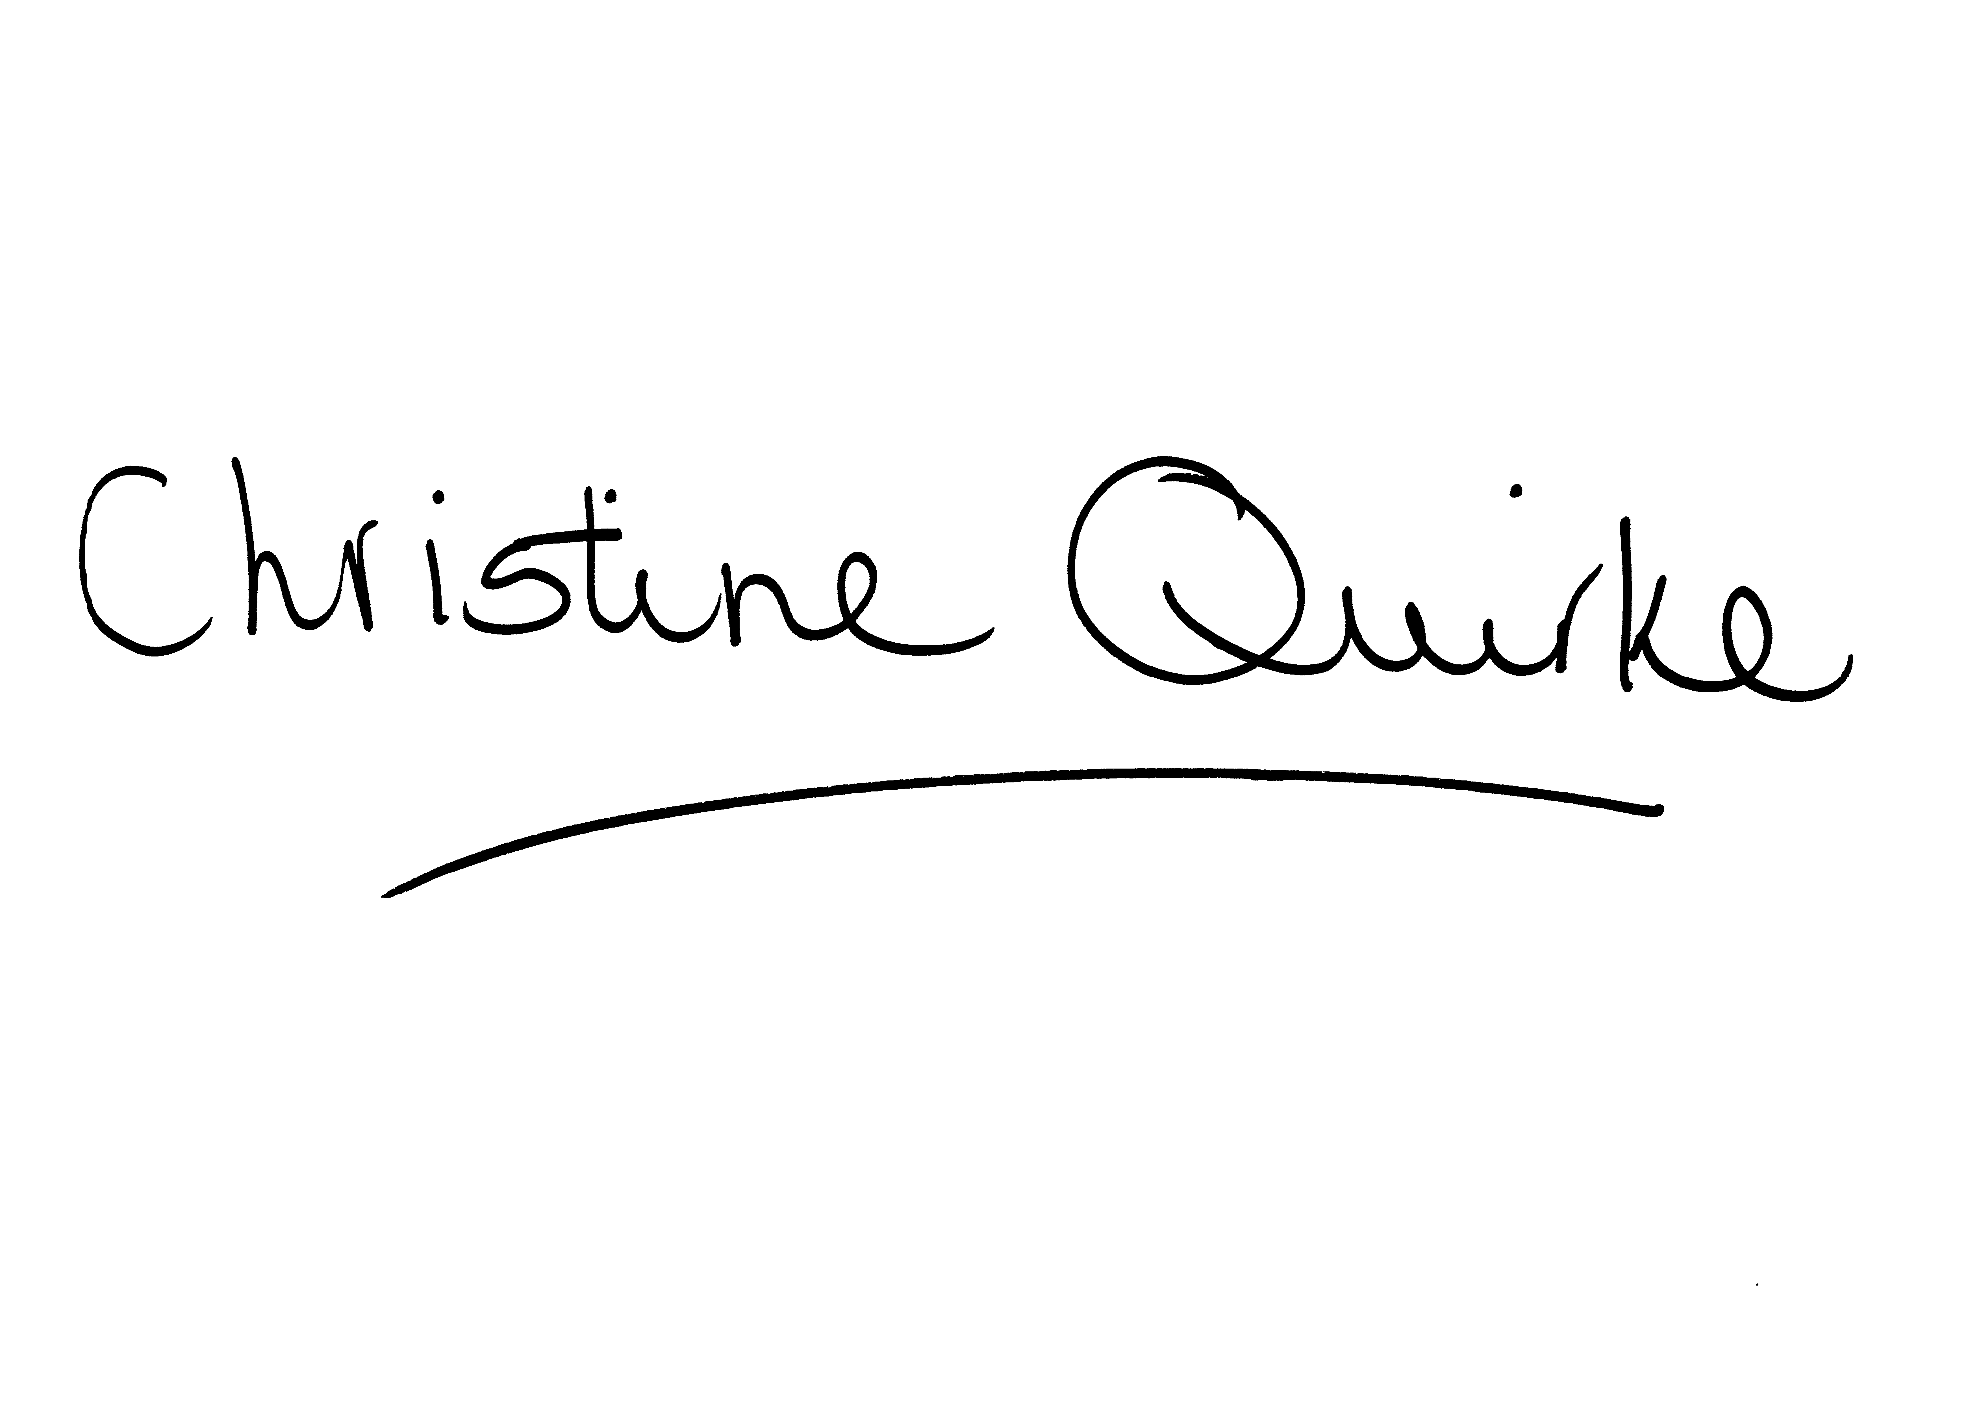
Christine F. Quirke
Policy & Research Officer
for the Nursing Board of the Northern Territory

