28 June 2001

The Secretary
Senate Community Affairs References Committee
Suite S1 59
Parliament House
Canberra ACT 2600

Re: INQUIRY INTO NURSING

The Australian Physiotherapy Association draws the Committee’s attention to the impact on the nursing profession of issues related to physiotherapy and other allied health professions in Australia.

We urge the Committee to recognise that problems affecting nursing are intertwined with broader health services issues, and that tackling allied health issues will in many cases generate a spin-off improvement in the situation for nurses. The healthcare system operates in a complex environment, where all health professionals have an important role in the achievement of better health outcomes for patients, and decisions made in isolation can have critical flow-on effects.

One of the Association’s immediate priorities is to develop more comprehensive data on shortfalls in public sector physiotherapy resources and services, in order to encourage better funding in the most critical areas.

The APA would particularly like to draw the Committee’s attention to the following points.

Rural workforce issues
Nurses, like doctors, are more likely to want to work in rural and remote areas where there are other health professionals, so that a multi-disciplinary team is available for clinical and professional support. But there is a critical shortage of allied health professionals across much of rural and remote Australia. For example, the latest Australian Institute of Health and Welfare workforce figures indicate that it is nearly twice as hard to find a physiotherapist in rural areas as in the cities, and 3 times as hard in remote areas. So there is a need for more services, and definitely more support for all health professionals working in isolated locations. Improvements in the allied health environment would help make rural/remote work more attractive to nurses, and thereby help tackle the shortage of nurses in these areas.

Aged Care
Working in the aged care sector is more attractive to nurses in situations where there are other professionals to share the load. The burden of care for nurses in this sector, and the resultant workplace health and safety issues, can be reduced by increasing access to the rehabilitation skills of physiotherapists who ensure patients are functioning at their maximum level. Physiotherapy can play a crucial role in helping older and more frail people regain or maintain mobility and independence, and so improve their quality of life within aged care facilities or while living in the community. However, this role is insufficiently recognised within aged care services: an improvement would benefit nurses as well as patients.

Public hospital services
There is a critical funding shortfall in Australian public hospitals, an issue highlighted in very strong terms in the recent Senate Inquiry Report on Public Hospital Funding. Allied health services, notably physiotherapy, have suffered from cost-shifting between the Commonwealth and the States, and there are now major shortfalls in in-patient, out-patient and emergency department physiotherapy services at public hospitals throughout the country. This situation impacts on nursing by its tendency to slow down patient recovery and make the working environment less efficient and satisfactory than it should be.

Public health services
The skills required to achieve better health outcomes are derived from a team of health professionals including doctors, nurses, and allied health professionals. Achieving better health outcomes for the Australian population depends on access to a range of interventions along the continuum of care. Physiotherapists play an important part in the multi-disciplinary healthcare team, with regard to health promotion and injury prevention, acute and post acute care, rehabilitation following injury or illness, and support and maintenance in the chronic phase of their disease process and palliative care. In all of these situations, physiotherapists and nurses work together to enhance patient outcomes, and problems in one profession can have an impact on the other.

The demand for allied health services is escalating as incidences of workplace and other accidents, cardio-vascular disease and asthma increase. Such increases call for the skills of various allied health professionals, especially physiotherapists. The healthcare environment needs to be examined as a whole to ensure the team is functioning at its most efficient in order to achieve better health outcomes for all Australians, the patients and the health care professionals.

In summary
Issues facing physiotherapy and other allied health professionals have a profound impact on the nursing profession, and need to be recognised in the context of this Inquiry. The APA would be pleased to provide additional information to the Senate Community Affairs References Committee on any of the issues raised in this submission.

Yours sincerely
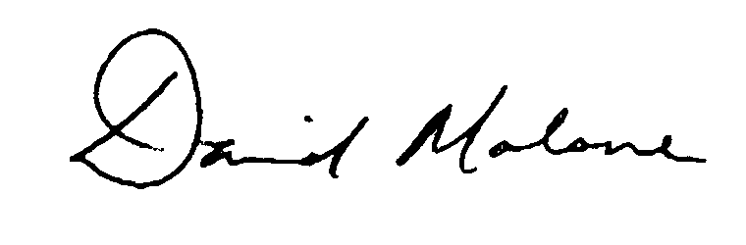
David Malone
National President
Australian Physiotherapy Association

