NATIONAL CIVIC COUNCIL

N.S.W State Office
12th Floor, Suite 4
456 Kent Street, Sydney, 2000

Postal Address
PO Box Q69
Queen Victoria Building,
Sydney, 1230

Telephone: (02) 9267 6159
Facsimile: (02) 9283 1472
Email: dtudehope@ohara.com.au

13 September 2002

The Secretary
Senate Community Affairs Legislation Committee
Suite S1, 59 Parliament House
CANBERRA ACT 2600

VIA EMAIL: community.affairs.sen@aph.gov.au

Dear Sirs,

RE: EMRYONIC STEM CELL RESEARCH

It is submitted that any legislation to allow research on human embryos ought not be permitted by the Australian Parliament.

It is the submission of the National Civic Council, that in rejecting the legislation the Senate ought accept the following:

- There are currently no proven benefits to be had from experimenting on human embryos.

- The behaviour of Professor Trounsen in promoting the human embryo research is such that it would give legislators cause for pause as to the true motors for his engaging in the research. On one view of it, it is arguable that principle benefits to be obtained from research on human embryos are not so much the curing of diseases but the pharmaceutical benefits to be obtained by experimentation relating to the toxicology for various pharmaceutical products.

- The normal process which would be adopted in relation to such research is that the benefits would be clearly able to be demonstrated on other species (non human). There has been no such demonstration and until such time as the scientific community is able to demonstrate the benefits which they suggest are available for experimentation on human embryos on other species then such experimentation ought be prohibited. There is currently no impediment to conducting research on any other species and yet there are no results which have been offered which demonstrate that such experimentation has been in any way productive (other than an experiment on a rat which turned out to in fact be an experiment which used adult stem cells).

- There is abundant evidence that research relating to adult stem cells (which does not necessitate the destruction of a human life) are producing significant and tangible benefits for medical research and for the treatment of diseases.

There is significant disquiet within the Community as to the moral issues which are raised by the Legislation.

It is our submission that because of the significant disquiet that such legislation raises that it is fundamentally more preferable to err on the side of caution rather than to embark upon a process which is clearly so morally debateable. There can never be any suggestion that in refusing to adopt the legislation the legislature would be acting contrary to the moral conscience of the nation. However the contrary is most certainly true, that is should the legislature enact such legislation then a significant proportion of the electorate would form the view that such legislation is morally unacceptable. In the circumstances, it would be our submission that the legislature ought err on the side of caution in respect of such legislation and in the absence of some overwhelming reason, not pass it at the current stage of scientific endeavour.

There is almost a logical imperative which would invoke the legislature to demand that scientists show that such research at least has provided significant benefits in respect of animal experimentation before giving scientists an open cheque book in respect of experimenting on human beings.

We can think of no scientific endeavour which has proceeded in the past where human beings have been the primary source of research before prior experimentation on animals.

For these reasons and for other reasons which have no doubt been submitted to you by others, it would be the submission of the National Civic Council (NSW) that the Parliament ought refuse to countenance the legislation and it ought reject it.

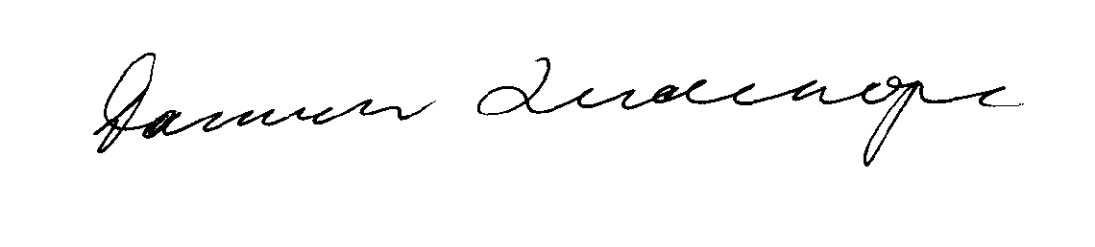
Yours faithfully,

Damien Francis Tudehope
State President
NSW National Civic Council

