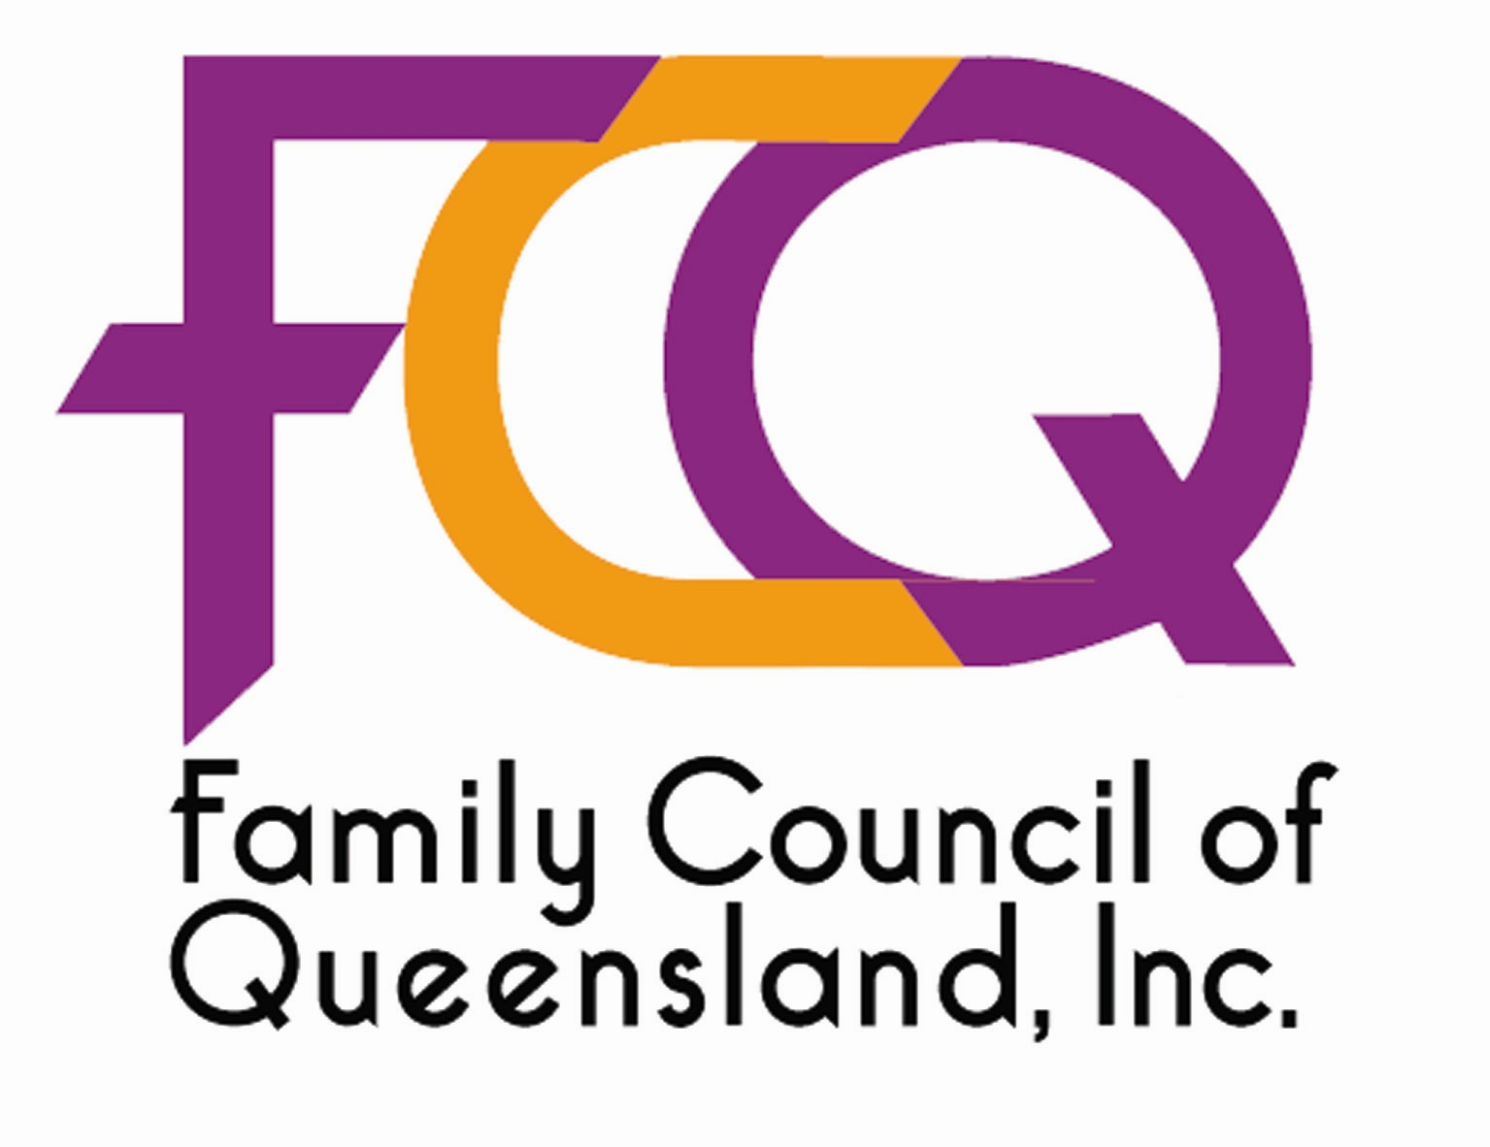
September 13, 2002

The Secretary
Senate Community Affairs Legislation Committee
Parliament House
Canberra ACT 2600

Dear Sir/Madam

On behalf of the tens of thousands of Queenslanders represented by the member organisations of the Family Council of Queensland, I write regarding the Research Involving Embryos and Prohibition of Human Cloning Bill 2002 on which you are conducting an inquiry.

We oppose embryonic stem cell research and urge the committee to recommend that Senators vote against the provisions of the bill allowing destructive experimentation on human embryos for the following reasons:

- It is unethical to destroy innocent human life, even for medical research. It is a scientific fact that human life begins at fertilisation. Quite clearly, the embryo is human (with 46 chromosomes) – not animal or vegetable – and is growing and multiplying and is therefore alive. Embryo, foetus, infant, child, adolescent, adult and geriatric are all just descriptions of human life at various stages of development. The human embryo is not a potential person, but rather a unique and irreplaceable person with potential, requiring only nutrition, oxygen and shelter to develop into someone like you or me.

- It is unnecessary, as adult stem cell research is much more effective and is actually curing many patients with serious illnesses today. In contrast, embryonic stem cell research has not yet cured one patient of anything and even animal studies have not shown promise. If we are truly concerned with obtaining “miracle cures” as quickly as possible, the limited funding available should be directed to the successful and exciting area of adult stem cell research.

- It is potentially dangerous to human patients, given the problems of embryonic stem cells facing immune rejection and their predisposition to cause cancer.

Leading Australian scientists oppose embryonic stem cell research, with the notable exception of those who may profit commercially from it. For example, Professor Michael Good, director of the Queensland Institute of Medical Research, said: “The scientific arguments in favor of embryonic stem cell research do not stack up.” Dr Peter Silburn, Adjunct Professor of Molecular Neurobiology at Griffith University, said: “Adult neural stem cell work has the clear advantage of being able to use the patient’s own cells to repair any deficits – and avoids the issues of rejection and cancer formation.” And Associate Professor Joanne Shaw, endocrinologist and diabetes researcher at the Princess Alexandra Hospital, said: “Adult stem cells show promise in diabetes, however funding is being diverted into the medically doubtful and ethically disturbing field of embryo research.”

Allowing human life – at any age or stage – to be taken for medical research would be setting a very dangerous precedent.

Kind regards


ALAN BAKER, President, Family Council of Queensland
PO Box 2020, Mansfield DC, QLD 4122
Phone 07 3221 1122 Fax 07 3221 3322 Email alanbaker@retirewell.com.au

