Parliamentary Joint Committee on the Australian Crime Commission

Inquiry into trafficking in women for sexual servitude

Submission No:38
Received 31 October 2003
Mr Vincent McMahon
Executive Coordinator
Border Control and Compliance Division
Department of Immigration and Multicultural and Indigenous Affairs
PO Box 25
BELCONNEN ACT 2616
02 6264 1111 02 6264 2747
E-mail:

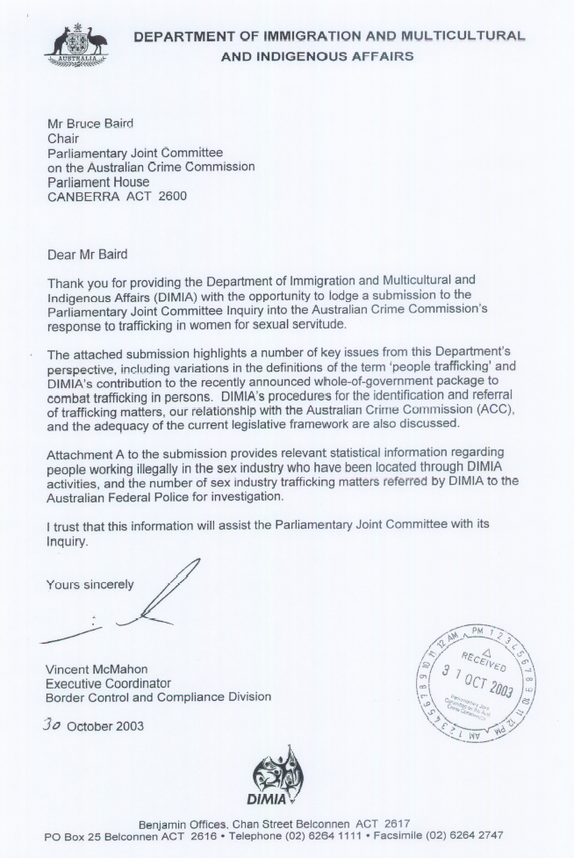

SUBMISSION TO THE PARLIAMENTARY JOINT COMMITTEE ON THE AUSTRALIAN CRIME COMMISSION BY THE DEPARTMENT OF IMMIGRATION AND MULTICULTURAL AND INDIGENOUS AFFAIRS (DIMIA)

Background

Australia is signatory to a range of international conventions that prohibit slavery. The most important of these are the International Convention to Suppress the Slave Trade and Slavery, its 1953 Protocol and the 1956 Supplementary Convention on the Abolition of Slavery, the Slave Trade and Institutions and Practices Similar to Slavery.

More recently, Australia has signed the UN Protocol to Prevent, Suppress and Punish Trafficking in Persons, especially Women and Children (‘the People Trafficking Protocol’). The People Trafficking Protocol aims to address a growing trend in transnational organised crime to physically move people through deception, coercion or force for the purpose of their exploitation.

Under the UN Protocol, people trafficking is defined as:

“the recruitment, transportation, transfer, harbouring or receipt of persons, by means of the threat or use of force or other forms of coercion, of abduction, of fraud, of deception, of the abuse of power or of a position of vulnerability or of the giving or receiving of benefits to achieve the consent of a person having control over another person for the purpose of exploitation. Exploitation shall include, at a minimum, the exploitation of the prostitution of others or other forms of sexual exploitation, forced labour or services, slavery or practices similar to slavery, servitude or the removal of organs.”

The term ‘people trafficking’ has been subject to a range of interpretations and this has resulted in confusion over the prevalence of the crime within Australia. The term ‘people trafficking’ is sometimes used to describe the organised illegal movement of people across borders, a definition that falls within the Australian description of ‘people smuggling’. It is important to note that the existence of people working illegally in the sex industry does not necessarily mean that they have been trafficked. Similarly individuals who find that the conditions which they experience working in the sex industry are different to that which they anticipated are not necessarily trafficked. On the other hand, people agreeing to come to Australia to work in the sex industry may have been trafficked through coercion on arrival.

Australia has formally adopted the UN Protocol definition of ‘people trafficking’, targeting the key elements of movement across borders, deception, coercion, fraud and exploitation. It is only in circumstances where persons are subject to the elements contained in the definition that they can be said to be subject to trafficking.

The role of DIMIA in the detection and referral of people trafficking matters

The UN Protocol provides a very broad definition of people trafficking and Commonwealth legislation has not yet been enacted that encompasses all offences that may potentially arise under the Protocol. However, offences relating to slavery, sexual servitude and deceptive recruiting for sexual services were identified in the Criminal Code Amendment (Slavery and Sexual Servitude) Act 1999 (incorporated in the Commonwealth Criminal Code Act 1995). In 2002 the Government introduced further offences for facilitating the illegal entry of a person into a foreign country for the purposes of exploitation.

In accordance with their responsibility for the investigation of offences under the Commonwealth Criminal Code, the Australian Federal Police (AFP) has carriage of the investigation of people trafficking offences. Offences may come to the attention of the AFP through its own investigations or via referral of allegations from members of the public or from other government agencies.

DIMIA has responsibility for the enforcement of matters contained in the Migration Act 1958, including the detection and detention of unlawful non-citizens as well as people smuggling and migration fraud-related offences. Matters involving trafficking may come to the attention of DIMIA staff in the course of the enforcement of migration law such as during the service of search warrants on brothels or private residences. Any matters involving indications of trafficking coming to the attention of DIMIA staff are referred to the AFP for investigation.

In February 2002 DIMIA and the AFP signed a service agreement which created a framework for cooperation and collaboration between the two agencies to combat organised illegal immigration and serious or complex migration fraud. Through the Service Agreement, DIMIA has in place formal arrangements with the AFP for the referral of investigations. Under the terms of the agreement the AFP is obliged to advise DIMIA whether the matter is accepted for investigation. Where a matter is not accepted for investigation, the AFP is required to advise DIMIA why the matter was not accepted and, where appropriate, to recommend alternative methods of handling the matter.

A protocol governing the referral of matters involving indications of trafficking from DIMIA to the AFP was agreed upon by the two agencies in May 2003. Prior to this the referral of matters for investigation to the AFP occurred under the AFP/DIMIA Service Agreement. The May 2003 protocol has been designed with very low thresholds for referral to the AFP. In practice this translates to any possible trafficking-related matters that come to DIMIA attention being immediately referred to the AFP for further investigation regardless of whether elements of sexual servitude offences are detected. This is a change in practice as previously DIMIA staff investigated matters more thoroughly to establish and validate facts before referring to the AFP.

The recent arrests of alleged trafficking offenders in Melbourne and Sydney provide clear examples of the close cooperation between DIMIA staff, the AFP and State/Territory police in tackling this serious crime.

Attachment A provides a summary of locations of persons working in the sex industry by nationality and details of matters that have been referred to the AFP since the enactment of the Criminal Code Amendment Act 1999.

Since the enactment of the Criminal Code Amendment Act 1999, DIMIA has referred 34 matters involving indications of trafficking to the AFP.

DIMIA procedures for the identification and referral of trafficking matters

Indicators of people trafficking can come to attention during Compliance or Investigations operations but may also come to attention via allegations received from the community and external agencies and/or through the normal business activities of DIMIA program areas.

To date, the majority of cases involving indications of people trafficking have been where the person has been located working in the sex industry. DIMIA officers have been provided with guidelines to identify any indicators of trafficking to assist them during their involvement in Compliance visits to brothels or other premises.

The guidelines for recognition of indicators of trafficking were determined in consultation with the AFP. Guidelines for the questioning of persons where there are some indications of people trafficking have been circulated to DIMIA Compliance and Investigations staff and formal training sessions are being prepared for delivery in coming weeks. These guidelines have significant operational implications and are not public.

A network of sex industry contact staff has also been put into place in all State and Territory offices to act as the first point of contact for all DIMIA sex industry-related activities. As well as supporting DIMIA activities focussing on the sex industry these officers and other DIMIA staff are involved in the interviewing of persons located working illegally or contrary to visa conditions in the sex industry. As part of the interview process all sex workers located are questioned in relation to the circumstances of their recruitment, working conditions and freedom of movement in Australia. Where there is any indication of trafficking they are referred to the AFP for investigation.

DIMIA’s relationship with the ACC
Australia has developed a ‘whole-of-government’ approach to people trafficking. Senior Commonwealth officials from all relevant departments and law enforcement agencies (including the ACC) are closely cooperating in identifying ways Australia can improve its capability to combat people trafficking. An Interdepartmental Committee (IDC) was formed in April 2003 to examine all aspects of Australia’s current response to trafficking and to formulate a number of recommendations to enhance the government’s response to trafficking. Flowing from the IDC recommendations the Government has recently announced a comprehensive package of measures (see below).
DIMIA’s Intelligence Analysis Section (IAS) liaises regularly with the ACC as part of normal communication within the intelligence community. More recently there has been a developing exchange of factual information and statistics between the area of DIMIA charged with coordination of all trafficking related information and activities – the Migration Fraud and Investigations Section – and the ACC.
Whole-of-Government measures to combat people trafficking
On 13 October 2003, the Minister for Justice and Customs, Senator Ellison, announced whole-of-government measures to further combat people trafficking. Supported by $20 million funding over four years, the package of measures includes:
DIMIA Specific Measures
- The creation of a new Senior Migration Officer (Compliance) position in Thailand, with associated locally engaged staff to focus on regional trafficking issues;
- New visa arrangements for persons where there are indications that they may have been trafficked;
- Introduction of special care arrangements in immigration centres where there are indications that persons may have been trafficked, but cannot be granted a bridging visa because of problems such as the identification of the person. These arrangements will include placement of women in women-only accommodation in the Villawood Immigration Detention Centre and prompt referral to a case manager to organise and facilitate access to support services;
- Closer links between the AFP and DIMIA officers in the detection and investigation of trafficking, including the provision of general awareness training to DIMIA and AFP officers working on trafficking issues; and
- Periodic evaluation of new protocols and interview procedures for DIMIA and AFP staff in consultation with relevant agencies, including State and Territory Police.
Other Measures:
- A new community awareness campaign to raise awareness of trafficking issues within Australia;
- A new 23-member Australian Federal Police (AFP) mobile strike team (the Transnational Sexual Exploitation and Trafficking Team) to investigate trafficking and sexual servitude;
- Victim support measures provided through contracted case managers, including appropriate accommodation and living expenses and access for victims to a wide range of social support, legal, medical and counselling services;
- Development of a reintegration assistance project for trafficking victims who are returned to key source countries in South East Asia;
- Improvements to legislation to criminalise comprehensively trafficking activity;
- Legislative amendments to make telecommunications interception available

for investigating trafficking offences; and
- Ratification, once all domestic requirements are in place, of the United Nations Protocol to Prevent, Suppress and Punish Trafficking in Persons, especially Women and Children.
A Commonwealth Action Plan to Eradicate Trafficking in Persons will be developed to coordinate these initiatives.
The adequacy of the legislative framework

Under the current migration legislation framework Criminal Justice Stay Visas (CJSVs) provide a mechanism for unlawful non-citizens to remain in Australia and in the community while they provide assistance to law enforcement agencies with their investigations into trafficking matters and while any subsequent trial takes place.

Criminal Justice Stay Certificates are issued in the first instance by the Commonwealth Attorney General or a relevant State/Territory Attorney General, the Director of Public Prosecutions or Police Commissioner. The issuing of this Certificate allows a CJSV to be granted which will remain in force until such time as the Criminal Justice Stay Certificate is cancelled.

As part of the whole-of-government measures outlined above DIMIA is developing a new bridging visa that will allow unlawful non-citizens who are providing assistance to law enforcement agencies in their investigations of trafficking matters to remain in Australia for up to 30 days. During this time law enforcement agencies will have the opportunity to assess whether they wish to have the person remain in Australia to provide further assistance with the investigation. Support measures will be provided during this time. If the law enforcement agency assesses that they require the continued presence of the person in Australia to assist with their investigations in trafficking matters they can seek the issuance of a Criminal Justice Certificate and then a CJSV as outlined in the preceding paragraph.

In May 2003, the then Minister for Immigration and Multicultural and Indigenous Affairs announced an intention to introduce a new visa class which would complement the CJSV provisions. This new visa class will enable witnesses who provide information that assists in a prosecution and who are assessed at risk if they were to return to their home country to remain in Australia temporarily or permanently.

These new visa arrangements outlined above enhance the current CJSV regime and provide a comprehensive visa framework to allow persons to remain lawfully in Australia to assist law enforcement agencies investigating trafficking matters.

These initiatives and associated support measures, together with initiatives being developed by other agencies, will better support and protect suspected victims of trafficking and assist them to testify against the alleged offenders.

The Department is also investigating the suspected involvement of a number of registered migration agents in the organisation of the bringing to Australia of persons to work unlawfully in the sex industry. While these may not be trafficking cases, a recently created multi-disciplinary Migration Agents Taskforce is examining the activities of certain agents with a view to prosecution. This is in addition to other work the Department undertakes in relation to the prevention and deterrence of people smuggling.

ATTACHMENT A:

1. Compliance Locations FY 2002/2003

There were 257 locations of people working illegally in the sex industry for 2002/2003, with the following citizenship:

Nationality | Total
Burma (Myanmar) | 1
Cambodia | 1
Canada | 1
China, Peoples Republic of | 42
Colombia | 2
HKSAR of the PRC | 9
Hungary | 1
Indonesia | 6
Korea, Republic of | 39
Malaysia | 49
Nepal | 1
Philippines | 2
Thailand | 100
United States of America | 2
Unknown | 1
TOTAL | 257

2. AFP Referrals

Overall
Since the enactment of the Criminal Code Amendment Act 1999, 34 sex industry matters suspected of involving offences under the Slavery and Sexual Servitude provisions of the Crimes Act, or otherwise involving trafficking, have been referred to the AFP for investigation. These 34 matters comprised 66 persons suspected of being trafficked in the sex industry. This is an average of approximately 17 people referred per year. These 66 persons held the following citizenship and visa class/lawful status at time of location:

Nationality | Visa Class / Status |  | Total
Thailand | Bridging Visa A (WA010)  Tourist (Short Stay) (TR676)  Bridging Visa E (WE050)  Unlawful Non-Citizens | 14  18  4  11 | 47
Taiwan | Electronic Travel Authority (Visitor) (UD976) | 2 | 2
Indonesia | Bridging Visa A (WA010)  Tourist (Short Stay) (TR676)  Business (Short Stay) (UC456) | 1  2  2 | 5
Laos | Unlawful non-citizen | 1 | 1
Malaysia | Tourist (Long Stay) (TR686) | 1 | 1
PRC | Bridging Visa A (WA010) | 1 | 1
South Korea | Electronic Travel Authority (Visitor) (UD976)  Student/Temporary (TU575)  Unlawful Non-Citizen | 1  1  6 | 8
Uzbekistan | Bridging Visa A (WA010) | 1 | 1

DIMIA officers refer matters to the AFP where there are indicators that suggest a trafficking offence has occurred. Following assessment the AFP may conclude that there is insufficient evidence to support an allegation of sexual servitude or related trafficking offences. Of the 34 matters referred, 24 have been formally accepted by the AFP for investigation, 7 are under evaluation and 3 have not been accepted.

FY 2002/2003
Of the 34 sex industry trafficking matters referred to the AFP for investigation since the enactment of the Criminal Code Amendment Act 1999, 16 were referred in FY 2002/2003; these 16 comprised 41 persons suspected of being trafficked in the sex industry who held the following citizenship:

Nationality | Total
Thailand  Indonesia  Laos  South Korea  Uzbekistan | 33  4  1  2  1

The increase in referrals in 2002/2003 involves to some degree a change in DIMIA processes. Formerly, DIMIA conducted formal investigations of trafficking allegations to determine whether there were sufficient indicators to refer a case to the AFP or DPP. However, the practice is to now refer quickly and let the AFP make those judgements.

Since June 2003 a total of eight persons have been charged by the AFP in relation to sexual servitude offences.

