Parliamentary Joint Committee on the Australian Crime Commission

Inquiry into trafficking in women for sexual servitude

Submission No:33
Received 2 October 2003
Ms Sabina Lauber
Board member
Women's Rights Action Network of Australia
0416 185 615 
E-mail: sabina.lauber@bigpond.com

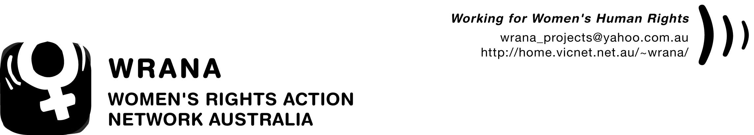

The Secretary
Parliamentary Joint Committee on the Australian Crime Commission
Parliament House
CANBERRA ACT 2600

Dear Sir/ Madam,

Re: Senate Inquiry into Trafficking for Sexual Servitude

The Women’s Rights Action Network Australia (WRANA) welcomes the chance to provide a submission to the Senate Inquiry into Trafficking for Sexual Servitude. WRANA is a nation wide feminist human-rights organisation, focusing on community education and policy advocacy.

Full implementation of Australia’s obligations under the United Nations Convention on the Elimination of All Forms of Discrimination Against Women requires that there be appropriate measures in place to address the trafficking of women and children. We applaud the Committee for taking actions to ensure that Australia is meeting its obligations.

In this context, WRANA also calls on the Australian government to ratify the UN Protocol to Prevent, Suppress and Punish Trafficking in Persons, Especially Women and Children. The Protocol recognises a range of difficulties facing women who have been trafficked, and calls for measures to protect victims and to ensure counselling and information about their legal rights and protection of their physical safety. The role of Non Government Organisations is recognised as pivotal in addressing these issues.

We commend to you a whole-of-government approach to trafficking that puts trafficked women and children's protection at the centre of the approach, and involves NGOs and local, state and federal government authorities.

WRANA calls on Parliament to introduce legislative changes to better protect trafficked women, including women who have consented to engage in sex work, but who have been deceived about the conditions of that sex work. The Special Rapporteur on Violence against Women has pointed out that most women are trafficked as a result of deception and false promises. Changes to legislation should include provisions to protect the privacy of trafficked women that come forward and give evidence about their situation.

Currently in Australia, most trafficking victims do not have legal immigration status, which, under the present scheme, means that they must be detained. Current detention and deportation arrangements do not take into consideration the fact that trafficking victims have been victims of grave human rights abuses within Australia. Many of these abuses are in breach of Australia’s criminal law. While these women are frequently encouraged to cooperate with Australian police by providing information and evidence on the crimes committed by others, they are still subject to the detention system and often required to pay for their detention accommodation at a daily rate while assisting police. They are then deported without any regard for the abuse they have suffered in Australia or without any victim support services. Only this year have we seen this system result in the suicide of trafficking victims placed in detention. We strongly urge you to consider the establishment of an alternative system so that potential trafficked victims are not detained at Villawood or Maribyrnong Immigration Detention Centres if they are detained by DIMIA, and that a full range of recovery services to be provided to trafficked women, including appropriate accommodation, health care, counselling and legal advice.
Further, WRANA urges the Committee to recommend a change in the Migration Act to introduce a trafficking-victims' visa to allow women to stay in Australia if they give information to police or testify in a trafficking case. This category of visa should be able to be applied for on-shore, should be permanent and should have a humanitarian basis. Police should be required to advise victims of their right to apply for this visa. Such visas are already available in the United States and other countries.

We also urge you to consider the introduction of a visa that provides a 'reflection delay' of three months that allows suspected trafficked women to recover from the violence they have experienced and consider whether they wish to provide information to the authorities. Again, such visas are already available in countries such as the Netherlands.

In addressing root-causes of trafficking, we urge you to recommend that more overseas aid be directed at addressing the factors that make trafficked women vulnerable, including violence against women, war, inequality and poverty, and that bi-lateral and multi-lateral initiatives are initiated to ensure that trafficked women who return to sending countries are linked in with support agencies in those countries. This recommendation is essential to the recognition that trafficking crimes that occur within Australia are part of a broader international phenomenon and must be dealt with in Australia’s foreign policy as well as in its domestic policy.
Finally, we commend government support for specialist NGOs such as Project Respect. The role of NGOs in assisting trafficking victims has been internationally recognised, and the ability for NGOs to undertake educative and support activities in Australia and overseas assists in the prevention of trafficking. To this end, WRANA also supports the detailed submission prepared by Project Respect.

If the Committee would like to discuss issues with us further, please don’t hesitate to contact us as detailed below.

Sincerely,

Sabina Lauber  Board Member  Women’s Rights Action Network Australia  Ph: 0416 185 615  sabina.lauber@bigpond.com | Caroline Lambert  Board Member  Women’s Rights Action Network of Australia  Ph: (03) 9443 0086  cmlambert@optusnet.com.au
Evelyn Loh
Board Member
Women’s Rights Action Network Australia
Ph: 0403 065 963
evelyn.loh@bigpond.com

